[HEREDITY AND EVOLUTION]
| BIOLOGY| STUDYNOTES

Chapter- 9.

HEREDITY AND EVOLUTION.

Genetics: Branch of science that deals with Heredity and variation.
Heredity: It means the transmission of features/ characters/ traits from one generation to the next generation.
Variation: The differences among the individuals of a species/ population are called variations.

MENDELAND HIS WORK ON INHERITANCE
Gregor Johann Mendel (1822&1884): Started his experiments on plant breeding and hybridization
Mendel was known as
Father of Genetics
Plant selected by Mendel: Pisum sativum (garden pea). Mendel used a number of contrasting characters for garden pea.

TABLE OF CONTRASTING CHARACTERS. (SEVEN PARTS)
CHARACTER | DOMINANT TRAIT | RECESSIVE TRAIT
Flower colour | Purple | White
Flower position | Axial | Terminal
Seed colour | Yellow | Green
Seed shape | Round | Wrinkled
Pod shape | Inflated | Constricted
Pod colour | Green | Yellow
Height of plant | Tall | Dwarf
Seven pairs of contrasting characters in Garden
Pea
Mendel’s Experiments: Mendel conducted a series of experiments in which he crossed the pollinated plants to study one character (at a time)

Monohybrid Cross:
Cross between two pea plants with one pair (monohybrid cross) contrasting characters
Example: Tall / Short Plants.

Tall plant • Dwarf plant
PARENT
GENERATION
GAMETES
F1 GENERATION
(first filal generation)
SELF POLLINATION

TT • tt
T

T

Tt
All tall plants



GAMETES
Tt
•
Tt
(F ) Tt
1
(F )
1
T
t
T
E

F2 GENERATION
(Second Final Gneration
TT TALL
Tt Tt tt TALL TALL SHORT

Phenotypic ratio
Phenotypic ratio
3:1
1:2:1

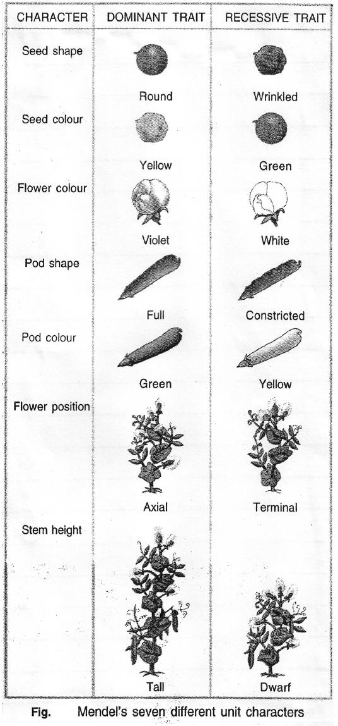

TT Both dominant gene tt Both recessive gene
Pure or conditon

Tt One dominant, one recessive gene
homozygous

Hetrozygous condition.
[Hybrid]

Phenotypic ratio: 3:1
Genotypic ratio: 1:2:1
Phenotype Physical appearance [Tall or Short] Genotype Genetic makeup [TT, Tt or tt]
Observations: 1. All F1 progeny were tall
(No medium height plant (half way characteristic)
- F2 progeny ¼ were short
- Phenotypic ratio F2 – 3:1 Genotypic ratio F2 – 1:2:1
Conclusions: 1. TT and Tt both are tall plants while tt is a short plant.
- A single copy of T is enough to make the plant tall, while both copies have to be 't' for the plant to be short.
- Characters/Traits like 'T' are called dominant trait (because it expresses itself) 't' are recessive trait (because it remains suppressed)
Dihybrid Cross: A cross between two plants having two pairs of contrasting characters is called dihybrid cross.

PARENT GENERATION
ROUND GREEN SEEDS
- WRINKLED YELLOW SEEDS

GAMETES F1
RRYY RY
rryy ry

RrYy [round, yellow]

Selfing F1
F1 • F1 RY

RY G A

Rr Yy Ry
rY ry
  - Rr Yy
Ry H E
rY T
E
ry S

F2
 | RY | Ry | rY | ry
RY | RRYY | RRYy | RrYy | RrYy
Ry | RRYy | RRyy | RrYy | Rryy
rY | RrYY | RrYy | rrYY | rrYy
ry | RrYy | Rryy | rrYy | rryy

PHENOTYPIC RATIO: Round, yellow 9
Round, green 3
Wrinkled, yellow 3
Wrinkled, green 1

GENOTYPIC RATIO: | RRYY | ; | 1
 | RRYy | : | 2
 | RrYY | : | 2
 | RRyy | : | 1
 | RrYy | : | 4
 | Rryy | : | 2
 | rrYY | : | 1
 | rrYy | : | 2
 | rryy | : | 1
RATIO: 1: 2: 2: 1: 4: 2: 1: 2: 1
Observations: 1. When RRYY was crossed with rryy in F1 generation all were Rr Yy round and yellow seeds.
2. Self-pollination of F1 plants gave parental phenotype + two mixtures (recombinants) Round wrinkled, green yellow: seeds plants appeared in the ratio of 9:3:3:1
Conclusions : 1. Round and yellow seeds are DOMINANT characters
2. Occurrence of new phenotypic combinations show that genes for round and yellow seeds are inherited independently of each other.

Sex Determination
Phenomenon of decision or determination of sex of an offspring

FACTORS
Responsible for Sex Determination

Environmental Genetic

In some animals the temperature at which the fertilised eggs are kept decides the gender.
eg. in Turtle
In some animals like humans gender or individual is determined by a pair of chromosome called sex chromosome
- Female
XX
- Male
XY

Sex Chromosomes: In human beings there are 23 pairs of chromosomes. Out of these 22 chromosomes pairs are called autosomes and the last pair of chromosomes that help in deciding gender of that individual are called sex chromosome.
XX – female XY – male

Sex determination in Human beings
PARENTS : FATHER MOTHER XY XX
GAMETES
X
Y
X
X
(Reproductive cells)

Zygote

XX XX

XY XY

formed after fusion
FEMALE
FEMALE MALE
MALE

of gametes
50% probability of a female child
50% probability of a male child

This shows that half the children will be boys and half will be girls. All children will in herit an X chromosome from their mother regardless whether they are boys or girls. Thus sex of children will be determined by what they inherit from their father, and not from their mother.

Evolution

SITUATION-I

Group of red beetles

Colour variation arises during reproduction

All beetle’s red except
one that is green Crows feed on red beetle No. of beetles reduces
One beetle Green
Reproduction Progeny beetles green
Crow could not feed on green beetles as they got camouflaged
in green bushes

Number of green
beetles increases Situation 1: Green beetles got the survival advantage or they were naturally selected as they were not visible in green bushes. This natural selection is exerted
by crows resulting in adaptations in the beetles to fit better in their environment

SITUATION-II

Group of red beetles
Reproduction
All beetles are red except one
that is blue Reproduces
Number of red beetle increases

One blue beetle
Reproduces
No. of blue beetle increases

Crows can see both blue and red beetles and can eat them Number reduces but still red beetles are more and blue ones are few
Suddenly elephant comes and stamps on the bushes But now beetles left are mostly blue.

Situation 2 : Blue beetles did not get survivals advantage. Elephant suddenly caused major havoc in beetle population otherwise there number would have been considerably large.
From this we can conclude that accidents can change the frequency of some genes even if they do not get survival advantage: This is called genetic drift and it leads to variation.

Mechanism of Heredity

Characters or traits of an organism are controlled by the genes
A Section of DNA (cellular)
Gene
Provides information
For synthesis of Proteins
Proteins controls a character

Example:
Gene T responsible for synthesis of efficient enzyme (Protein)

Gene t responsible for synthesis of less efficient enzyme

More production of growth hormone
Less production of growth hormone

Results in
Tall Plants
Results in short Plants

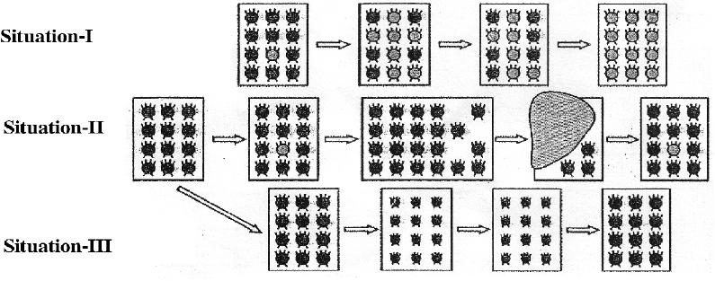

Genetic drift. It leads to diversity without any adaptation

SITUATION-III
Group of red beetles
Habitat of beetles (bushes) Suffer from plant disease
Average weight of beetles decreases due to poor nourishment
No of beetles kept on reducing Later plant disease gets eliminated
Number and average weight of the beetles increases again
Situation 3 : No genetic change has occured in the population of beetle. The population gets affected for a short duration only due to environmental changes
Acquired and Inherited Traits
Acquired Traits | Inherited Traits
- These are the traits which are developed in an individual due to special conditions  - They cannot be transferred to the progeny  - They cannot direct evolution  eg. Low weight of starving beetles. | - These are the traits which are passed from one generation to the next.  - They get transferred to the progeny.  - They are helpful in evolution. eg. Colour of eyes and hair

Speciation
Micro evolution: It is the evolution which is on a small scale. eg. change in body colour of beetles.
Speciation: it is the process of formation of new species.
Species: A group of similar individuals that along to a population that can interbreed and produce ferrite off spring.
Geneflow: It is exchange of genetic material by interbreeding between populations of same species or individuals
WAYS BY WHICH SPECIATION TAKES PLACE
Speciation takes place when variation is combined with geographical isolation.
Gene flow : occurs between population that are partly but not completely seperated

Variation in
Sub Population
X1 (local)
Interbreeding
[Reproduction]
Gene flow
Local population
Sub Population X1 (migrant)

Genetic Drift
It is the random change in the frequency of alleles (gene pair) in a population over successive generations.
*Natural Selection: The process by which nature selects and consolidate those organisms which are more suitably adapted and posesses favorable variations

POPULATION Z

Sub Population
Z1
GEOGRAPHICAL
BARRIER ISOLATION
(River, Mountain)
Sub Population
Z2

Over many-many generations

Results in Accumulation of different variations in Sub population Z1 and Z2

Genetic drift Natural selection
Sub population Z1 and Z2 incapable of interbreeding
Species 2
Reproductive Barrier

Formation of new
Species 1
Formation of new

Genetic drift takes place due to
- Severe changes in the DNA
- Change in number of chromosomes

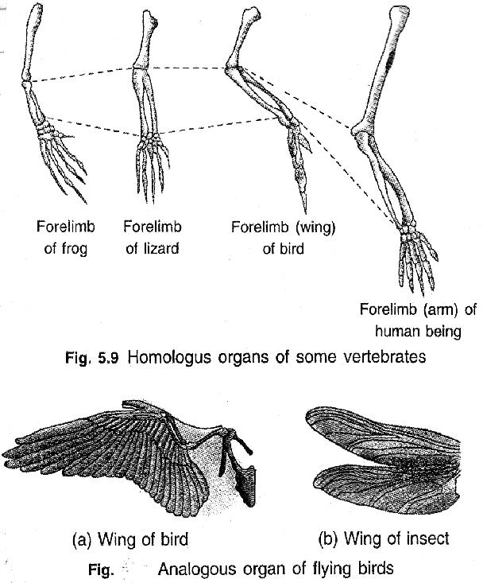
Evolution and classification Both evolution and classification are interlinked.
- Classification of species is r e f l e c t i o n o f t h e i r evolutionary relationship.
- The more characteristic two species have in common the more closely they are related.
- The more closely they are related, the more recently they have a common ancestor.
- S i m i l a r i t i e s a m o n g organisms allow us to group them together and to study their characteristic

Tracing Evolutionary Relationships

(Evidences of Evolution)

- Homologous Organs: (Morphological and anatomical evidences. These are the organs that have same basic structural plan and origin but different functions.

Example:
Forelimb of Horse (Running) Same basic
Winds of bat (flying) plan,
Paw of a cat (walk/scratch/attack) different functions
- Analogous Organs: These are the organs that have different origin and

structural plan but same function example:
Wings of bat elongated fingers with skin folds Wings of bird Feathery covering along the arm
- Fossils: (Paleontological evidences)
The remains and relics of dead organisms of the past. Example:
  - Fossil of wooly mammoth
  - Archeopteryx (fossil bird)
  - Dead insect caught in hot mud.
Design different same function ie. flight

FOSSILS ARE PRESERVED TRACES OF LIVING ORGANISMS
Eg. AMMONITE - Fossil invertebrate TRILOBITE - Fossil in vertebrate KNIGHTIA - Fossil fish RAJASAURUS - Fossil dinosaur skull

AGE OF THE FOSSILS
1. ...........................

i. Deeper the fossil, older it is.
II. Detecting the ratios of different of the same element in the fossil material ie Radio-carbon dating. [C-(14) dating)
Recent
2. ...........................
3. ...........................
4. ...........................
5. ..........................
6. .......................... Older

Evolution by stages
Evolution takes place in stages ie bit by bit over generations.

Fitness advantage
Evolution of Eyes
Evolution of complex organs is not sudden it occurs due to minor changes in DNA, however takes place bit by bit over generations.
Flat worm has rudimentary eyes enough to
give fitness
advantage
Insects have compound eyes
Humans have binocular eyes

Functional Advantage
Evolutions of feathers Feathers provide insulation in cold weather
but later they might become useful for flight.
Example :
Dinosaurs had feathers, but could not fly using feathers. Birds seem to have later adapted the feathers to flight.

Artificial Selection:
Humans have been a powerful agent in modifying wild species to suit their own requirement throughout ages by using artificial selection. e.g. (i) Wild cabbage the dissimilar looking structures have evolved from a common ancestral design. (ii) Wheat (many varieties obtained due to artificial selection)

CABBAGE

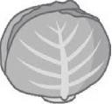
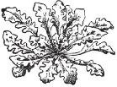
with short distance between the leaves
BROCCOLI
CAULIFLOWER

with larger leaves
KOHL RABI
KALE
WILD CABBAGE

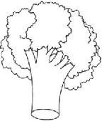
Arrested flower development

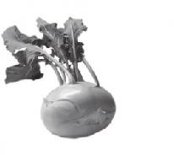
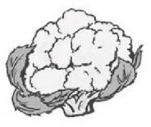
flowers
Has sterile

With Swollen parts

Molecular Phylogeny :
•It is based on the idea that changes in DNA during reproduction are the basic events in evolution
•Organisms which are more distantly related will accumulate greater differences in their DNA

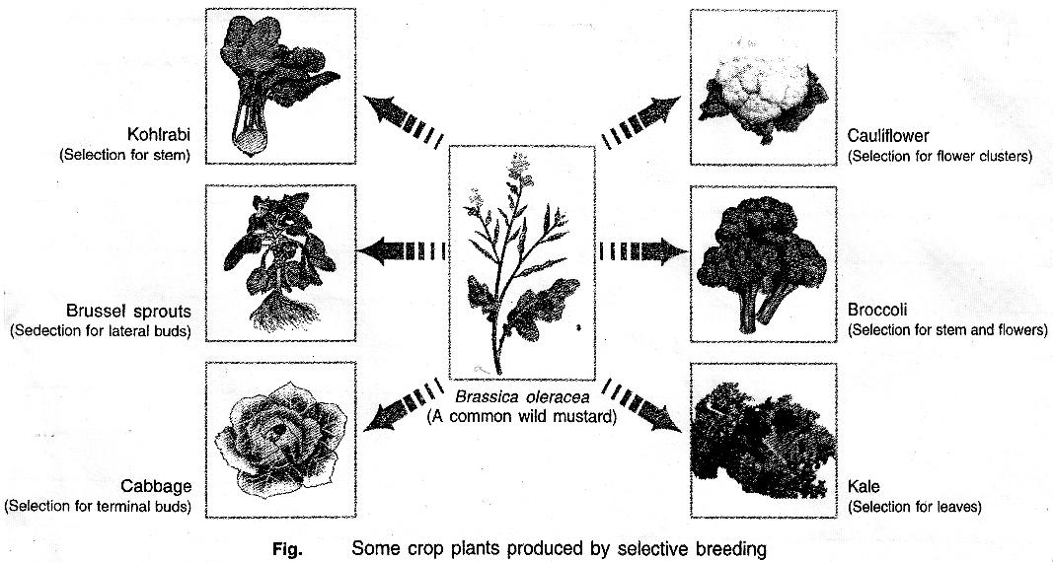

Human Evolution
Tools to Study Human Evolutionary Relationship
Excavating Time dating Fossils Determining
DNA
Sequences
Although there is great diversity of human forms all over the world get all humans are a single species

GENETIC FOOTPRINTS OF HUMANS
Hundreds/thousands of years ago
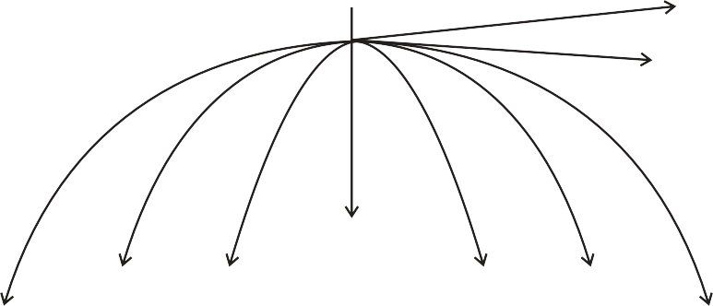
Earliest members arose in Africa
East Asia
South Africa

Philippines
Africa Island
of Indonesia
West Asia
Central Asia
Australia

Eurasia

•They did'nt go in a single line
•They went forward and backward
•Moved in and out of Africa
•Sometimes came back to mix with each other.

