DCP FOR CHAPTER-2. The Rise of Nationalism in Europe

NO. OF PERIODS | SUB-TOPICS
01 | The French Revolution and The Idea of The Nation.
02 | The making of Nationalism in Europe
03 | The Conservatives, Liberals and Radicals
04 | The Age of Revolution: 1830-1848, The Romantic Imagination and National Feeling
05 | Hunger, Hardship and Popular Revolt
06 | 1848: The Revolution of the Liberals
07 | The Making of German and Italy
08 | The Strange Case of Britain, Visualising the Nation, Nationalism and Imperialism


ODM Teachers’ Note

Class | X | Subject | History | Plan For | Normal class

Prd | 1 | Chapter | The Rise of Nationalism in Europe
T
Sub-Concepts | The French Revolution and The Idea of Nation
Teaching Aid To be used | A / V Aid, PPT, Pictures

Perticulars | Step Wise (What to be done)
Learning Outcomes | Pupil will be able to:  - Recall the previous knowledge.  - Relate French Revolution with the idea of Nation.  - Analyze the role of Napoleon Bonaparte in the History of France
Introduction | Teacher will introduce the topic by asking questions based on previous knowledge.  Expected Question:  - What was the basic principle of French Revolution?  - Why French Revolution started?  - What was the legacy of the French revolution?
The first revolution started in France | Explaining to the pupils about the first revolution started in France.  In 1789 Nationalism came with French Revolution and the political and constitutional changes led to the transfer of sovereignty. 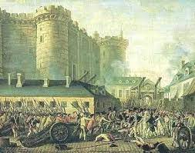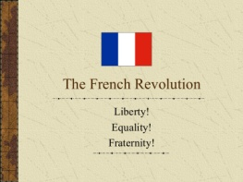  Various measures and practices were introduced such as the ideas of la patrie (the fatherland) and le citoyen ( the citizen). A new French flag, the tricolour was chosen to replace the former one.
Role of Napoleon Bonaparte in the History of France | 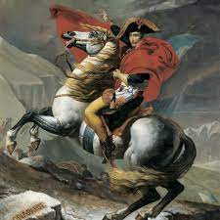  Democracy destroyed in France by Napoleon and the Civil Code of 1804 known as Napoleonic Code did away with all privileges based on birth, established equality before the law and secured the right to property.
Home Assignment | Worksheet Q. No: 1, 2, 3, 4, 13

ODM Teachers’ Note

Class | X | Subject | History | Plan For | Normal class

Prd | 2 | Chapter | The Rise of Nationalism in Europe
T
Sub-Concepts | The Making of Nationalism in Europe
Teaching Aid To be used | A / V Aid, Painting by Frederic Sorrieu, PPT.

Perticulars | Step Wise (What to be done)
Leaning Outcomes | Pupil will be able to:  - Analyze the painting presented by Frederic Sorrieu.  - Identify the message behind the painting.  - Establish connection between Nationalism and the idea of Frederic Sorrieu.
Introduction | Introduction of the topic by explaining and interacting with the pupils about their previous knowledge  - What symbols and signs were used during French Revolution?  - What was their importance?
Painting by Frederic Sorrieu | Discussing with pupils about the Painting by Frederic Sorrieu given in the textbook.  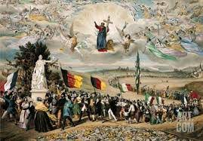
Visualizing dream of a world made up of democratic and Social Republics. | 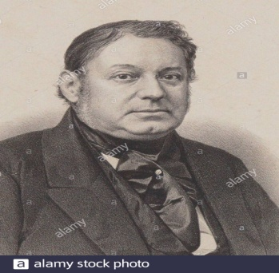  Frédéric Sorrieu, a French artist, in 1848 prepared a series of four prints visualizing his dream of a world made up of democratic and Social Republics.
Home Assignment | Worksheet Q. No: 5, 8, 9, 16

ODM Teachers’ Note
X | Subject | History | Plan For | Normal class

Prd | 3 | Chapter | The Rise of Nationalism in Europe
T
Sub-Concepts | The Conservatives, Liberals, Radicals
Teaching Aid To be used | A / V Aid, Comparative Chart, PPT

Sl. No | Step Wise (What to be done)
Learning Outcomes | Pupil will be able to:  - Understand the idea of Conservatives, Liberals and Radicals.  - Identify the principles of Conservatives, Liberals and Radicals.  - Differentiate between Conservatives, Liberals and Radicals.
Introduction | Introducing the topic by asking some Questions: Expected Question:  - What do you mean by conservative in general?  - What do you mean by liberals?  - What do you mean by radicals?
Political Conservatives | Explaining to the Pupils about the Political Conservatives  - In 1815, European governments were driven by a spirit of conservatism. Conservatives believed in monarchy, the Church, social hierarchies, property and that the family should be preserved.  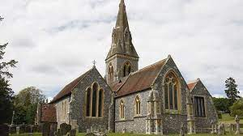
Political Liberals | Explaining to the Pupils about the Political Liberals.   The term ‘liberalism’ derives from the Latin root liber, meaning free. The right to vote and to get elected was granted exclusively to property-owning men. Men without property and all women were excluded from political rights.
Political Radicals | Explaining to the Pupils about the Political Liberals


- In 1815, secret societies were formed in many European states to train revolutionaries and spread their ideas. Revolutionary opposed monarchical forms, fight for liberty and freedom.
- The Italian revolutionary Giuseppe Mazzini, born in Genoa in 1807, founded two more underground societies, first, Young Italy in Marseilles.
- Secondly, he founded Young Europe in Berne, whose members were like-minded young men from Poland, France, Italy and the German states.
Comparing The Conservatives, Liberals, Radicals | 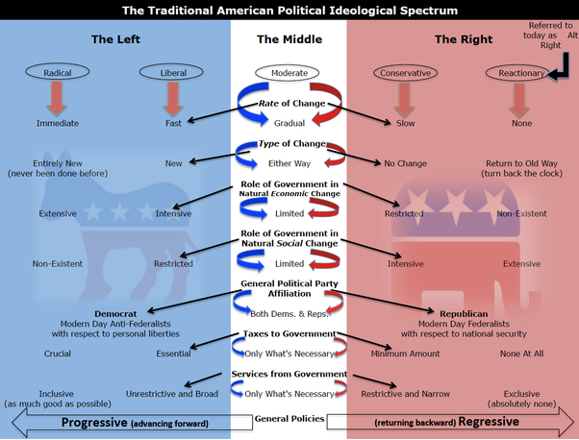
Home Assignment | Worksheet Q. No: 10, 11, 15

ODM Teachers’ Note

Class | X | Subject | History | Plan For | Normal class

Prd | 4 | Chapter | The Rise of Nationalism in Europe
T
Sub-Concepts | The Age of Revolution: 1830-1848, The Romantic Imagination National Feeling.
Teaching Aid To be used | A / V Aid, Pictures Showing National Identity, PPT

Sl. No | Step Wise (What to be done)
Learning Outcomes | Pupil will be able to:  - Understand the causes of Revolution and about the people who involved in the Revolution.  - Analyze the idea of Romanticism.  - Identify different symbols used for National feeling.
Introduction | Introducing the topic by recapitulating and making pupil understand about the struggle of the people.  - Why people revolt?  - What were the causes of French Revolution?  - What Changes it brought into the lives of the people?

July Revolution | 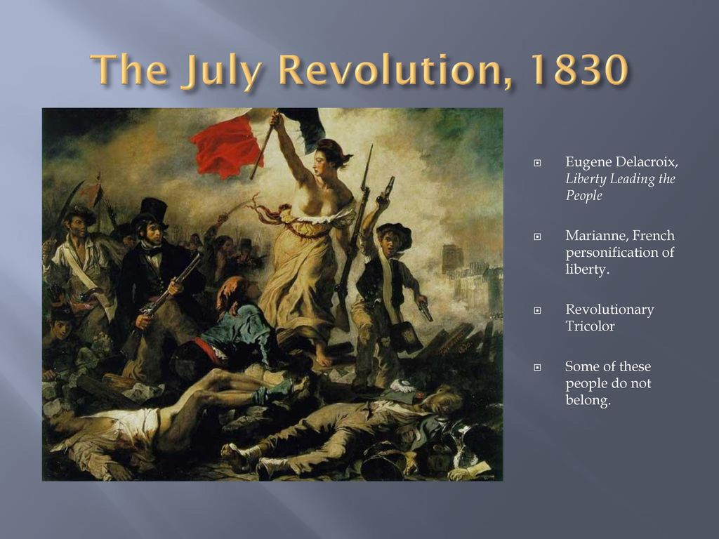  In July 1830, Bourbon Kings were overthrown by liberal revolutionaries who installed a constitutional monarchy with Louis Philippe at its head. The July Revolution sparked an uprising in Brussels which led to Belgium breaking away from the United Kingdom of the Netherlands. In 1821, Greeks struggled for independence.
Activity | Discussing with the pupils about Romantic Imagination and National Feelings by asking questions.  Expected Questions:  - What is Nationalism?  - What is patriotism?  - Why we love our nation?
Romantic Imagination and National Feelings. | Explaining to the pupils about Romantic Imagination and National Feelings.  - Culture played an important role in creating the idea of the nation: art and poetry, stories and music helped express and shape nationalist feelings.  - Romanticism, a cultural movement which sought to develop a particular form of nationalist sentiment. Language also played an important role in developing nationalist sentiments.  - Russian language was imposed everywhere and in 1831 an armed rebellion against Russian rule took place which was ultimately crushed.
Home Assignment | Worksheet Q.No: 06

ODM Teachers’ Note

Class | X | Subject | History | Plan For | Normal class

Prd | 5 | Chapter | The Rise of Nationalism in Europe
T
Sub-Concepts | Hunger, Hardship and Popular Revolt
Teaching Aid To be used | A / V Aid, PPT, Pictures

Sl. No | Step Wise (What to be done)
Learning Outcomes | Pupil will be able to:  - Realize the sufferings of the people and empathized with the people.  - Understand the reasons for those sufferings.  - Develop courage to voice against injustice.
Introduction | Introduction of the topic by recapitulation of all previous topics.  - What is Nationalism?  - What is patriotism?  - Why we love our nation?
Suffering of the people. | Making students understand and realize the suffering of the people.  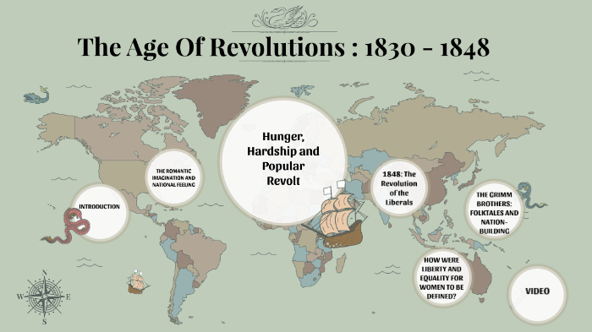  Europe faced economic hardships in the 1830s. The first half of the nineteenth century saw an enormous increase in population all over Europe. The rise of food prices or a year of bad harvest led to widespread pauperism in town and country. In 1848, food shortages and widespread unemployment brought the population of Paris out on the roads.
Home Assignment. | Worksheet Q.No: 12

ODM Teachers’ Note

Class | X | Subject | History | Plan For | Normal class

Prd | 6 | Chapter | The Rise of Nationalism in Europe
T
Sub-Concepts | 1848: The Revolution of the Liberals.
Teaching Aid To be used | A/V Aid, Pictures of the revolt, PPT

Sl. No | Step Wise (What to be done)
Learning Outcomes | Pupil will be able to:  - Understand the causes of the revolt started by Liberals against Conservatives.  - Realize the need for Revolution.  - Familiarize with the condition of Europe during Revolution.
Introduction | Introducing the topic by showing the pictures of the Revolt.  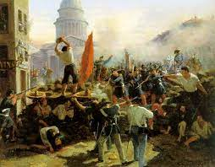
Recapitulation | Asking pupil questions about the revolt. Expected Questions:  - What is Revolt?  - Why people revolt?
Why people revolted? | Explaining to the pupils about how and why people revolted.  In 1848, a revolution led by the educated middle classes was underway. Men and women of the liberal middle class demanded creation of a nation-state on parliamentary principles – a constitution, freedom of the press and freedom of association. 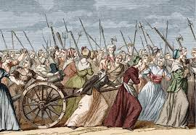
Home Assignment | Worksheet Q.No: 18

ODM Teachers’ Note

Class | X | Subject | History | Plan For | Normal class

Prd | 7 | Chapter | The Rise of Nationalism in Europe
T
Sub-Concepts | The Making of Germany and Italy

Teaching Aid To be used | A / V Aid, Outline map of Europe, Germany and Italy.

Sl. No | Step Wise (What to be done)
Learning Outcomes | Pupil will be able to:  - Identify the location of Germany and Italy on World Map.  - Familiarize with the Situation and condition of Germany and Italy during their unification.  - Realize the need for their unification.
Unification of Germany | Explaining to the pupil about the Unification of Germany. 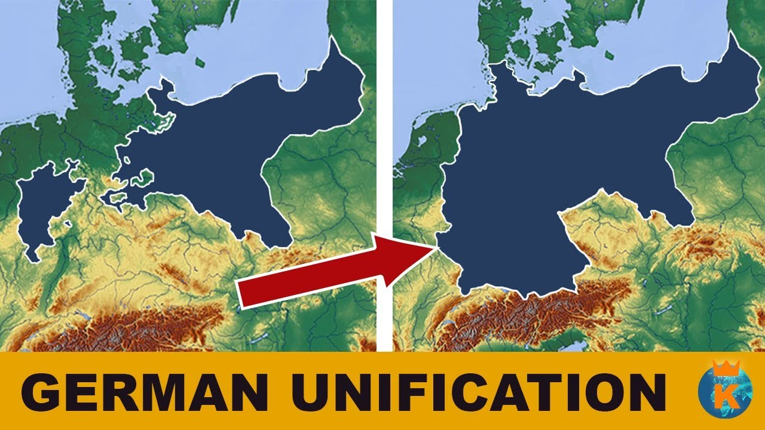  Germany – Can the Army be the Architect of a Nation?
Prussia took over the leadership | Nationalism in Europe moved away after 1848 and Germany and Italy came to be unified as nation-states. Prussia took over the leadership of the movement for national unification. The architect of this process was its chief minister, Otto von Bismarck, carried out with the help of the Prussian army and bureaucracy.  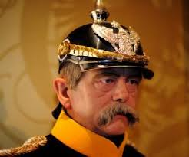
World Map | 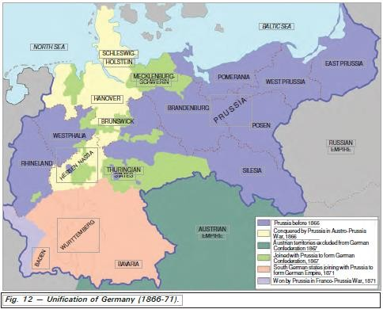
Unification of Italy | Explaining to the pupil about the Unification of Italy.

Italy Unified.+
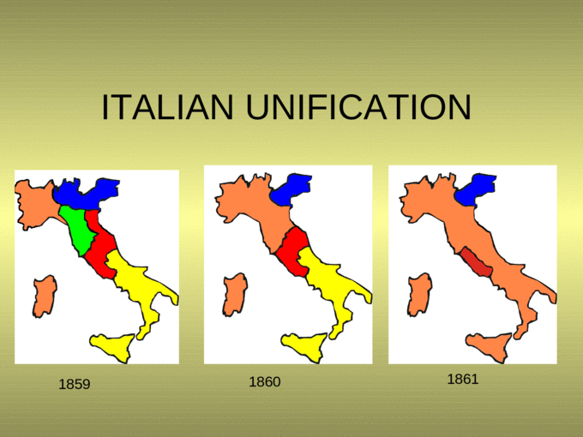
Italy was divided into seven states, in the middle of the nineteenth century, and among all the seven states, Sardinia-Piedmont, was ruled by an Italian princely house. All the regions were dominated by different kings. In the 1830’s Giuseppe Mazzini formed a secret society called Young Italy.

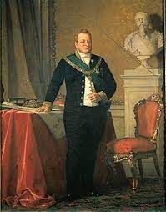
The movement was led by Chief Minister Cavour. In 1859, Sardinia-Piedmont defeated Austrian forces. In 1860, they marched into South Italy and the Kingdom of the Two Sicilies and succeeded in winning the support of the local peasants. In 1861 Victor Emmanuel II was proclaimed king of united Italy.
Home Assiognment | Worksheet Q.No: 14

ODM Teachers’ Note

Class | X | Subject | History | Plan For | Normal class

Prd | 8 | Chapter | The Rise of Nationalism in Europe

Sub-Concepts | The Strange Case of Britain, Visualising the Nation, Nationalism and Imperialism.
Teaching Aid To be used | A / V Aid, Pictures of national importance given in the book.

Sl. No | Step Wise (What to be done)
Learning Outcomes | Pupil will be able to:  - Locate Britain on World Map.  - Understand the process behind the unification of Britain.  - Familiarize with the idea of Nation.  - Identify the reasons for Balkan Crisis.  - Analize how independent nation established their autonomy over other countries.
Unification of Britain. | Explaining to the pupil about the Unification of Britain. Content:

The Strange Case of Britain
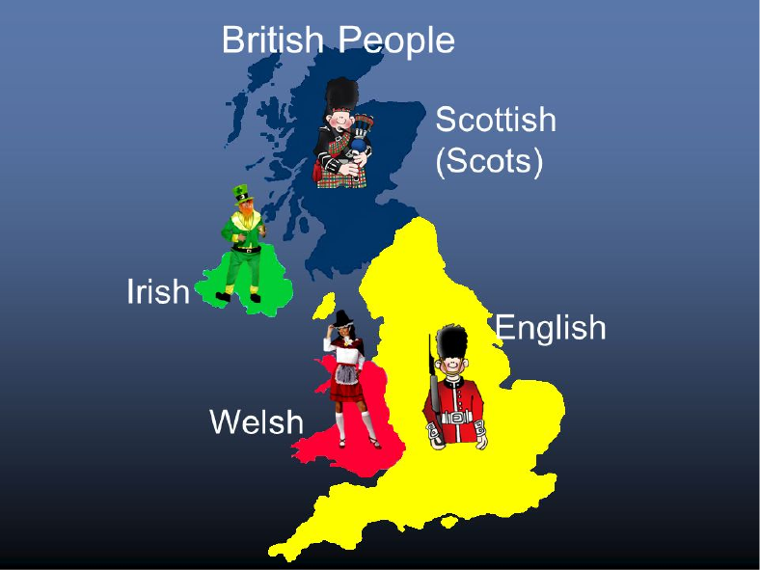
Great Britain was the model of the nation and prior to the eighteenth century there was no British nation. The nation became powerful as it steadily grew in wealth, importance and power.
Visualising the Nation | 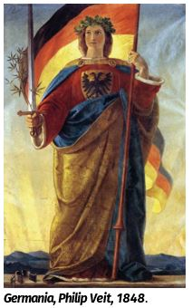  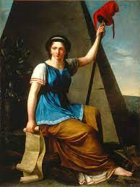  Discussing and analysing with the pupils about the idea and vision of a Nation.  Visualising the Nation
Nationalism and Imperialism | Analysing how independent nation established their autonomy over other countries.  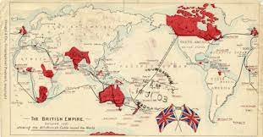  Nationalism and Imperialism states.
Home Assignment | Worksheet Q.No: 07, 17, 19, 20

