Chapter- 3
Farmers and Herders
STUDY NOTES
NEOLITHIC AGE—FROM FOOD GATHERER TO FOOD PRODUCER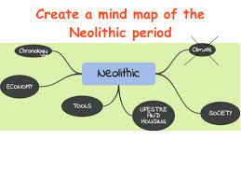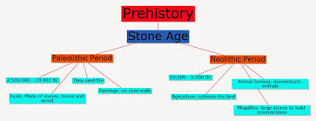
- The period from around 8000 to 4000BCE is known as the Neolithic Age .
- The beginning of Neolithic Age shows a remarkable change in the life of humans. During this period, humans changed from hunters & gatherers to farmers and herders.
- Around 8000 BC, the ice which had covered during the Palaeolithic age and Mesolithic ages started to melt.
- The warmer climate encouraged the spread of plants and animals so they learnt to grow crops of grains, and vegetables. They also started taming animals.
- Neolithic settlements have been found in several regions of South Africa.
- The excavated sites are at Mehrgarh in Pakistan, Burzahom in Kashmir, Daojali Hading and Sarutaru in Assam etc.

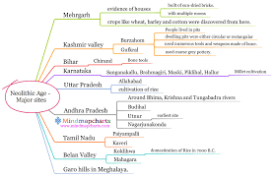
AGRICULTURE
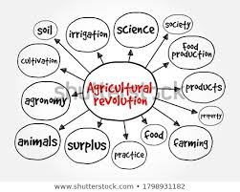
- In this age the most important development was when they learnt to cultivate their own food.
- They probably discovered the value of the seeds of some grasses like barley and wheat. They also learnt to use the plough to prepare the land for sowing the seeds.
- They began by cultivating wheat, barley and rice become food producers.
- The knowledge of cultivation reduced their need to wander from place to place in search of food.
- They started to settle at one place as they had to tend their crops, water them and protect from animals.
- They started to lead a settled life and began to live in places which were near sources of water like rivers and lakes.
- This agricultural revolution brought about many changes and improvements.

DOMESTICATION AND HERDING OF ANIMALS
- Humans slowly started the domestication of animals like dog, sheep, goat and cattle. Remains of animal bones and shelters found at Neolithic Sites tell us what kinds of animals were domesticated.
- It is believed that the first animal to be tamed was the dog, as dogs helped them in protecting their crops.
- With the domestication of animals like pigs, sheep and goat, there was a regular supply of meat & milk.
- Neolithic humans became herders. Herding is the management of the domestic animals. The animals domesticated by the humans needed to be fed and kept safe.
SETTLEMENTS
- Due to the growth of agriculture, settled community was developed. Settled life would also have needed a leader and someone to maintain law and order.
- Division Labour:- This period probably saw the beginning of division of labour. As the community became more and more close- knit they started dividing work amongst themselves.
- This eventually gave rise to new occupations and division of labour. People in this period engaged in farming, hunting, fishing, pottery making, weaving , dyeing, etc.
- Megaliths:- In many parts of South India, burial places have been marked with huge rectangular blocks of stone. They are called Megaliths means ‘large’. Neolithic people buried their dead with the objects like tools, weapons and pottery used by them.
- Thatched huts :- Neolithic people began to live in thatched huts or pit houses. People constructed huts of dried grass and mud as shelter. Huts were huddled together as if in a colony.
TOOLS
- Tools of the Neolithic Age were better than the earlier Stone Age ones. They were given a finer edge and started to get handles. Axes, blades, arrows, spearheads, hammers, chisel, pestle mortar have been found from this age.
- Sickles and reaping knives were developed to harvest crops. Grinding stones were invented for processing cereals and other plant food.
- Stone was ground and polished into sharper and more refined implements. Along with these tools, they also used tools made of bones of animals which were mainly used in fishing.
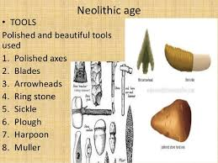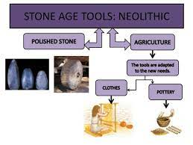
POTTERY
- The cultivation of food gave rise to the need for pots to store and cook food.
- Earthen pots have been found at several sites from this period, some of them were decorated with designs.
- Neolithic human learnt to make vessels of clay and bake them on fire. The pottery found in northern India was black grey ware, with a matt (not shiny) finish.
INVENTION OF THE AXLE
- One of the greatest inventions of the Neolithic humans was the wheel with an axle. The axle had various uses: - * The potter’s wheel was used to work clay to make better pots.
- Heavy objects could be transported on wheels.
- It improved transport and quickened the pace of development.
- Possibly, the wheel was used to spin cotton thread which could then be woven into cloth.
RELIGION
- Probably, nature was worshipped in different forms. The cave paintings of Old Stone Age hunters may have had a religious significance.
- Several statues and figurines of mother goddesses have been found at Neolithic sites, suggesting the prevalence of goddess- worship.
ORNAMENTS
- People made ornaments of conch shells, lapis lazuli and turquoise beads. Remains of necklaces, bracelets and earrings have been found from Neolithic sites.
CASE STUDY: MEHRGARH
- It is one of the most important Neolithic site which was discovered 1974.
- Located near the Bolan pass which lies to the west of Indus River. It is presently in Baluchistan which is a part of Pakistan.
- Evidence of growing wheat and barley have been found in this area, and animals like sheep, goat and cattle were domesticated.
- Mehrgarh was inhibited from 7000BC to 2500 BC. Ornaments and figurines of seashell, stone and copper were buried with dead.
- Tools were made of polished stone and bone. The pottery was simple handmade coarse ware, reddish brown in colour, with geometric shapes painted in black.
- A large granary for storing grain has been found. There was also a marked increase in terracotta figurines. Mud brick houses have been found.
CASE STUDY: BURZAHOM
- Some of the Neolithic sites in Kashmir include Burzahom, Gofkral, Hariparigom, pampur Wazal. Burzahom means place of birth in Kashmiri.It is located on the bed of a dried up lake. The lakes and forests around Burzahom indicate there was a good supply of food and water available here.
- Neolithic houses found at Burzahom—they are below ground level.
- Such dwellings are called pit dwellings. The people dug pits into the ground with the help of stone tools. Then they plastered the sides of the pit with mud.
- The pits were usually round or oval, a few were rectangular.
- The people of Burzahom made simple pots by hand in different shapes and sizes, and grey, red and brown in colour.
- The bone tools included harpoons for fishing needles for sewing an arrowheads, spearheads and daggers for hunting.
CASE STUDY: THE NORTH EAST
- Neolithic settlements have been found in several places i North- East India.
- Stone tools along with cord- impressed pottery have been found at Daojali- Hading and Sarutaru in Assam and Selbalgiri in Meghalaya.
- Many sherds of pottery found here have marks made by cord or string and wooden mallets, on their surface.
- Several ground and polished stone axes have also been found. The people practised shifting cultivation and grew root vegetables like yams and taro.

*********************************

