
Chapter-3
FORCE
Force - A Push or a Pull
Actions like picking, opening, shutting, kicking, hitting, lifting, flicking, pushing, pulling are often used to describe certain tasks. Each of these actions usually results in some kind of change in the motion of an object. These terms be replaced with one or more terms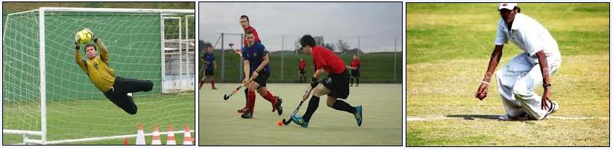
Below table gives some examples of familiar situations involving motion of objects. Try to identify action involved in each case as a push and/or a pull and record your observations.
S.No | Description of the situation
1 | Moving a book placed on a table
2 | Opening or shutting a door
3 | Drawing a bucket of water from a well
4 | A football player taking a penalty kick
5 | A cricket ball hit by a batsman
6 | Moving a loaded cart
8 | Opening a drawer

In science, a push or a pull on an object is called a force. Thus, we can say that the motion imparted to objects was due to the action of a force. The international unit used to measure force is newton. A force can change the shape and size of an object.

FORCE AS STRECH AND SQUEEZE
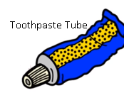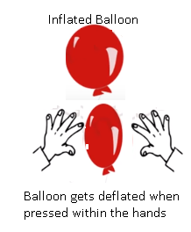
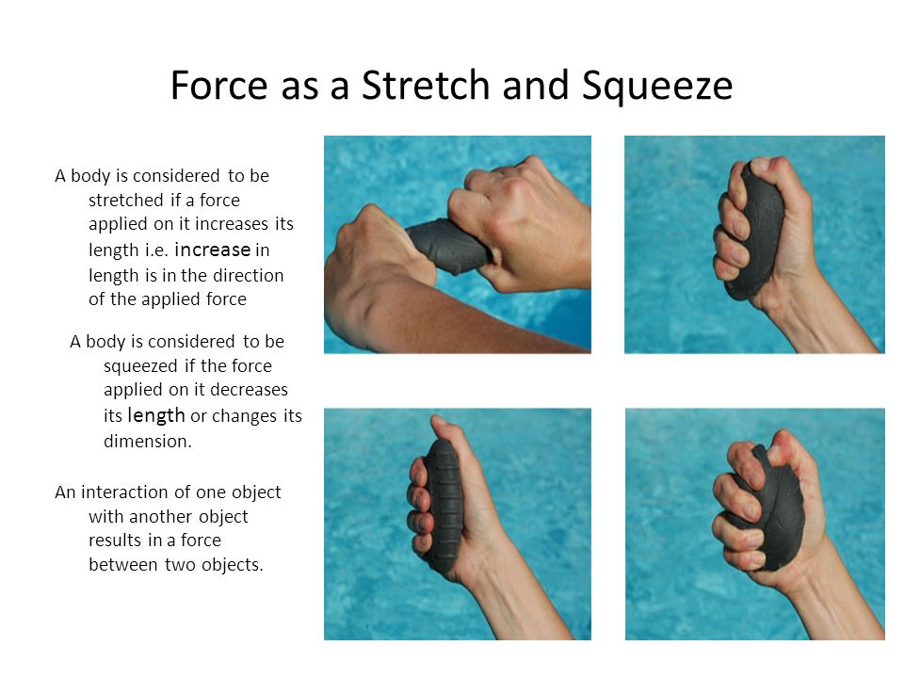

Forces due to an Interaction
Suppose a man is standing behind a stationary car. Will the car move due to his presence? Suppose the man now begins to push the car, that is, he applies a force on it. The car may begin to move in the direction of the applied force. Note that the man has to push the car to make it move.
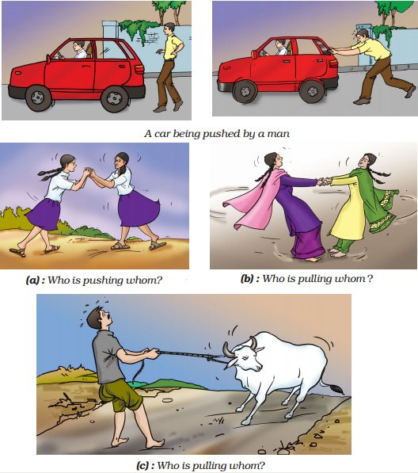

From these examples, we can infer that at least two objects must interact for a force to come into play. Thus, an interaction of one object with another object results in a force between the two objects.
EFFECTS OF FORCE
Change in State of Motion
Let us now find out what happens when a force acts on an object.
A change in either the speed of an object, or its direction of motion, or both, is described as a change in its state of motion. Thus, a force may bring a change in the state of motion of an object.
State of Motion
The state of motion of an object is described by its speed and the direction of motion. The state of rest is considered to be the state of zero speed. An object may be at rest or in motion; both are its states of motion.
It is common experience that many a time application of force does not result in a change in the state of motion. For example, a heavy box may not move at all even if you apply the maximum force that you can exert. Again, no effect of force is observed when you try to push a wall.
Change in Shape of an Object
What do you conclude from the observations noted in below table.
What happens when you apply a force on an inflated balloon by pressing it between your palms? What happens to the shape of a ball of dough when it is rolled to make a chapati? What happens when you press a rubber ball placed on a table? In all these examples you saw that the application of force on an object may change its shape.

Having performed all the above activities, you would have realised that a force:
- may make an object move from rest.
- may change the speed of an object if it is moving.
- may change the direction of motion of an object.
may bring about a change in the shape of an object.
- may cause some or all of these effects.
Studying the Effect of Force on Objects
Description of  situation | How to apply  force | Diagram | Action of force
Description of  situation | How to apply  force | Diagram | Change in  state of motion | Change in  shape
Description of  situation | How to apply  force | Diagram | Yes/No | Yes/No
A lump of dough on  a plate | Pressing it down  with your hands | 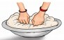 | No | Yes
Spring fixed to the  seat of a bicycle | By sitting on the  seat | 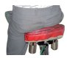 | No | Yes
A rubber band  suspended from a  hook/nail fixed on a  wall | By hanging a  weight or by  pulling its free end | 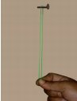 | No | Yes
A plastic or metal  scale placed  between two bricks | By putting a weight  at the centre of the  scale  Tab | 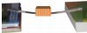 | No | Yes

KINDS OF FORCES
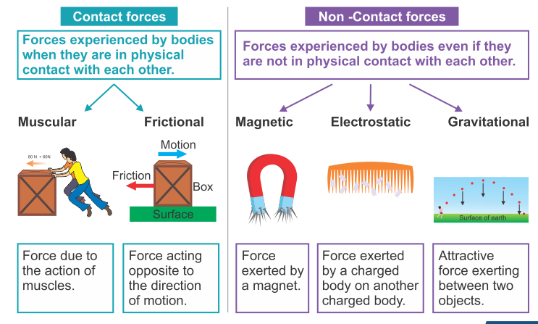
Contact Forces
Muscular Force
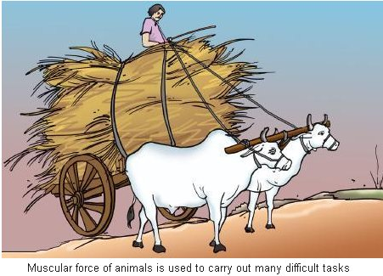
Can you push or lift a book lying on a table without touching it? Can you lift a bucket of water without holding it?
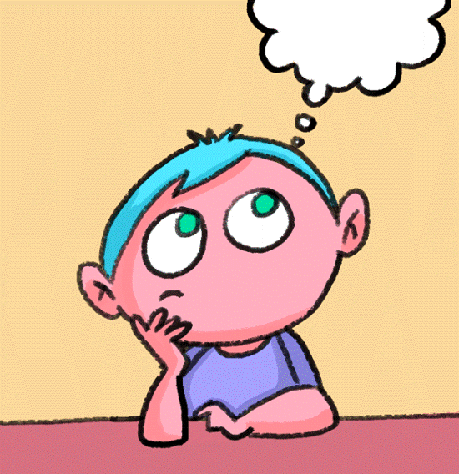
Generally, to apply a force on an object, your body has to be in contact with the object.
The force resulting due to the action of muscles is known as the muscular force.
Animals also make use of muscular force to carry out their physical activities and other tasks. Animals like bullocks, horses, donkeys and camels are used to perform various tasks for us. In performing these tasks they use muscular force.
Since muscular force can be applied only when it is in contact with an object, it is also called a contact force. It is the muscular force that enables us to perform all activities involving movement or bending of our body.
Friction
A ball rolling along the ground gradually slows down and finally comes to rest. When we stop pedalling a bicycle, it gradually slows down and finally comes to a stop. A car or a scooter also comes to rest once its engine is switched off. Similarly, a boat comes to rest if we stop rowing it.

REAL LIFE SITUATIONS
In all these situations no force appears to be acting on the objects, yet their speed gradually decreases and they come to rest after some time.
The force responsible for changing the state of motion of objects in all these examples is the force of friction.
- It is the force of friction between the surface of the ball and the ground that brings the moving ball to rest.
- Similarly, friction between water and the boat brings it to a stop once you stop rowing
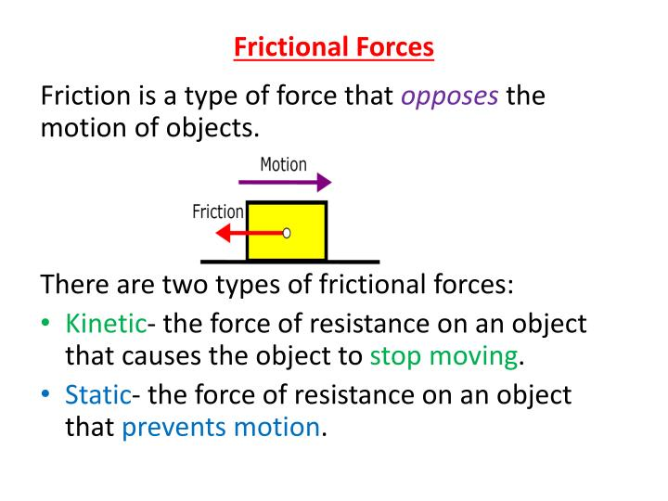

Non-contact Forces
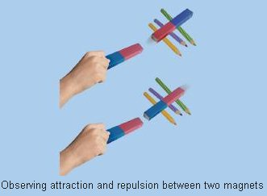
Magnetic Force
Take a pair of bar magnets. Place the longer side of one of the magnets over three round shaped pencils or wooden rollers. Now bring one end of the other magnet near the end of the magnet placed on the rollers. Make sure that the two magnets do not touch each other. Observe what happens. Next, bring the other end of the magnet near the same end of the magnet placed on the rollers. Note what happens to the magnet placed on the rollers every time another magnet is brought near it.
Does the magnet on the rollers begin to move when the other magnet is brought near it? Does it always move in the direction of the approaching magnet? What do these observations suggest? Does it mean that some force must be acting between the two magnets?
Like poles of two magnets repel each other and unlike poles attract each other. Attraction or repulsion between objects can also be seen as another form of pull or push. Do you have to bring the magnets in contact for observing the force between them? A magnet can exert a force on another magnet without being in contact with it. The force exerted by a magnet is an example of a non-contact force.
Similarly, the force exerted by a magnet on a piece of iron is also a non-contact force.
Electrostatic Force
Take a plastic straw and cut it into nearly two equal pieces. Suspend one of the pieces from the edge of a table with the help of a piece of thread. Now hold the other piece of straw in your hand and rub its free end with a sheet of paper. Bring the rubbed end of the straw near the suspended straw. Make sure that the two pieces do not touch each other. Next, rub the free end of the suspended piece of straw with a sheet of paper. Again, bring the piece of straw that was rubbed earlier with paper near the free end of the suspended straw.
A straw is said to have acquired electrostatic charge after it has been rubbed with a sheet of paper. Such a straw is an example of a charged body.
The force exerted by a charged body on another charged or uncharged body is known as electrostatic force. This force comes into play even when the bodies are not in contact. The electrostatic force, therefore, is another example of a non-contact force.
Gravitational Force
You know that a coin or a pen falls to the ground when it slips off your hand. The leaves or fruits also fall to the ground when they get detached from the plant. When the coin is held in your hand it is at rest. As soon as it is released, it begins to move downwards. It is clear that the state of motion of the coin undergoes a change.
Objects or things fall towards the earth because it pulls them. This force is called the force of gravity, or just gravity. This is an attractive force. The force of gravity acts on all objects. The force of gravity acts on all of us all the time without our being aware of it. Water begins to flow towards the ground as soon as we open a tap.

Effects of friction
- Friction opposes motion-

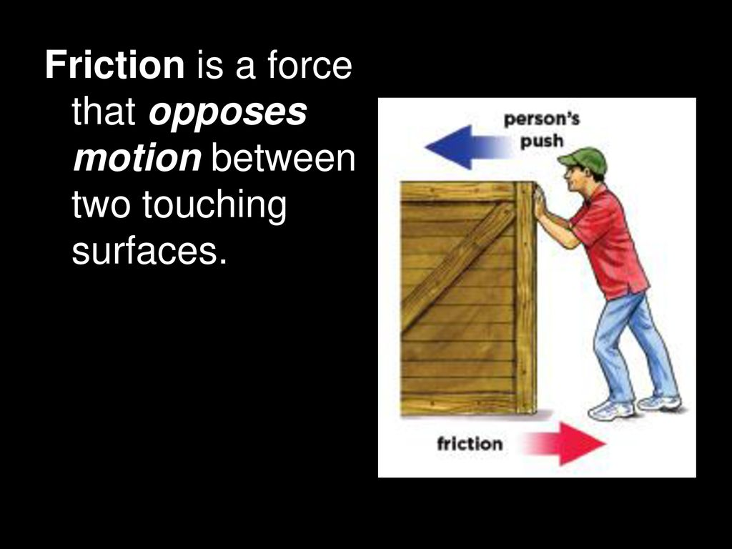

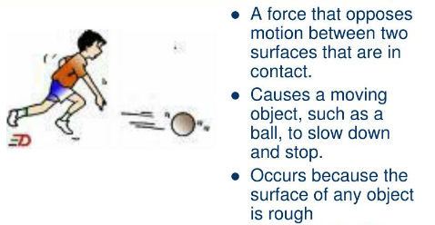

- Friction acts in a direction opposite to the direction of motion
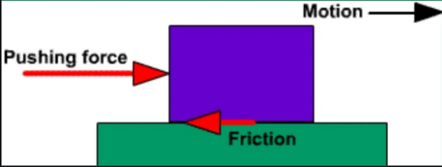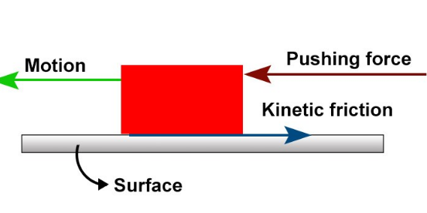

- Friction produces heat

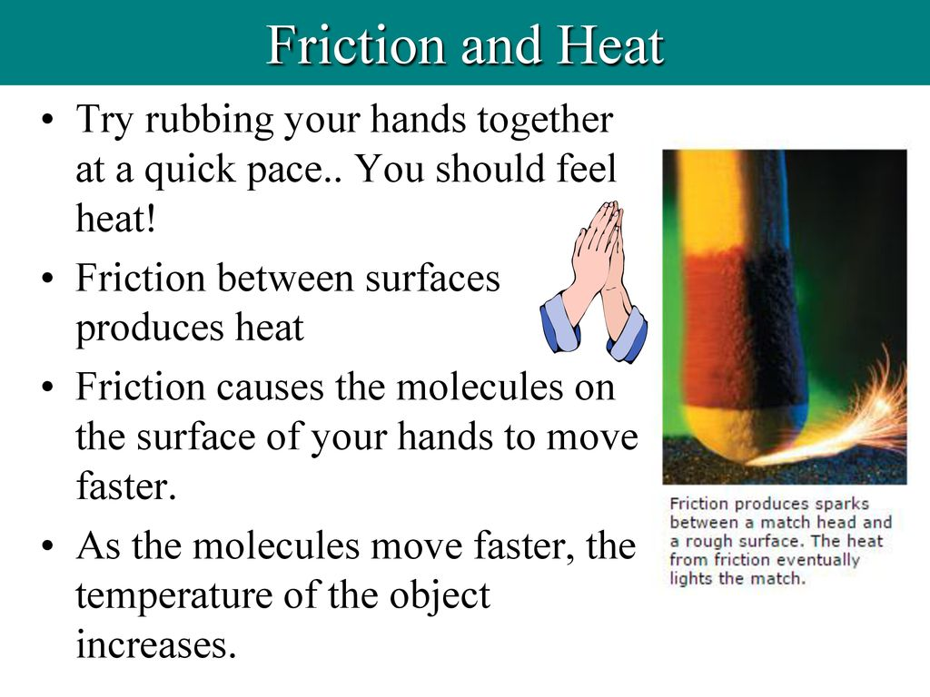
- Friction causes wear and tear
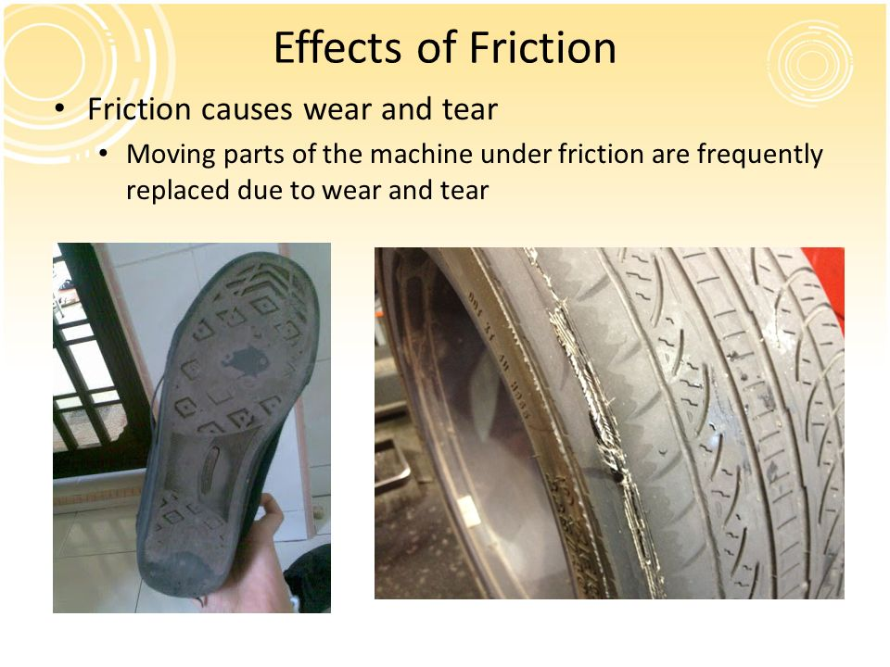

KINDS OF FORCES
- STATIC FRICTION
- ROLLING FRICTION
- SLIDING FRICTION
STATIC FRICTION: is the friction exerted on an object at rest.
Sliding FRICTION: is the friction exerted when an object slides over surface with a working fluid in between the two bodies.
When one body rolls over the surface of another body, the resistance to its motion is called the rolling friction
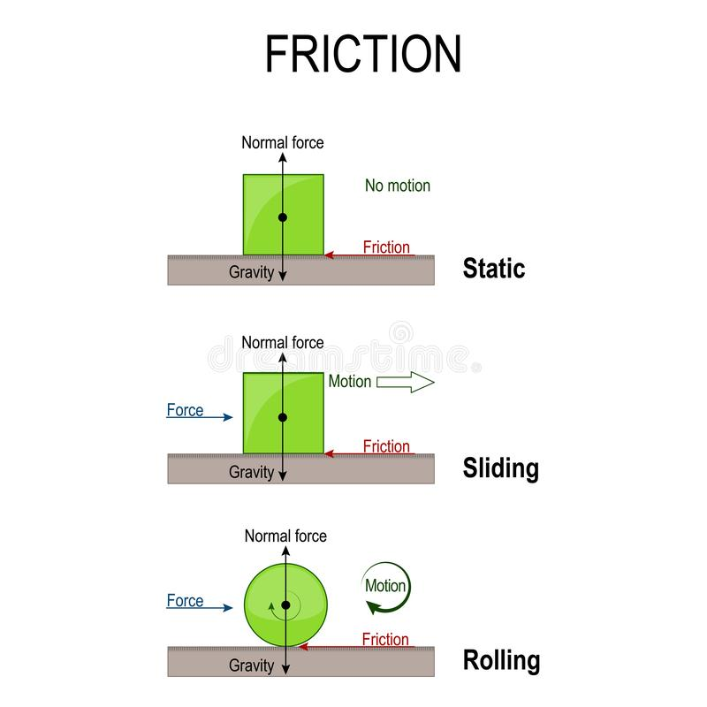

DISADVANTAGES OF FRICTION
1. Friction produces a lot of heat in various parts of the machinery and this leads to wastage of energy as heat
2. Opposes motion, hence more energy is needed to overcome friction
3. Noise production in machines is irritating as well as leads to energy loss
4. Forest fires are caused due to friction between branches of trees
5. Lot of effort and money goes in using techniques like greasing and oiling to overcome friction and usual wear and tear caused by it
WAYS OF REDUCING FRICTION
Method 1: Objects that move in fluids such as boats, planes, cars, etc, the shape of their body must be streamlined in order to reduce the friction between the bodies of the objects as the fluid.
Method 2: Friction can be reduced by polishing the surface of a body as polishing makes the surface smooth and even.
Method 3: Lubricants such as oil or grease must be applied to machine parts regularly to reduce the friction between them.
Method 4: Suppose an object is rolled over a surface, the friction between the rolled object and surface can be reduced by using ball bearings.
Method 5: Friction between two surfaces can also be reduced by reducing the contact between the surfaces.
Method 6: Ball bearings are used in manufacturing vehicles, bicycles, and vehicles to reduce friction.
ADVANTAGES OF FRICTION
Friction plays a vital role in our daily life.
1. It is becomes difficult to walk on a slippery road due to low friction. When we move on ice, it becomes difficult to walk due to low friction of ice.
2. We cannot fix nail in the wood or wall if there is no friction. It is friction which holds the nail.
3. A horse cannot pull a cart unless friction furnishes him a secure Foothold.
4. We can write on a paper or on a board due to friction.
5. Friction helps in applying the brakes.
6. It helps in walking on floor.
7. Coffee mug stays on the dashboard
8. Asteroids are burnt in the atmosphere before reaching Earth due to friction.
9. It helps in the generation of heat when we rub our hands.

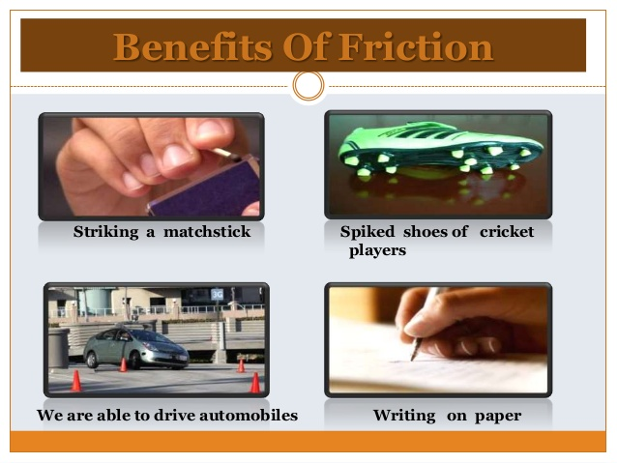
WAYS OF INCREASING FRICTION
- Increase the irregularities between the two surfaces.
- Increase the normal forces between the surfaces.
- Remove any kind of lubrication.
- By increasing weight
- By using dry surfaces

Frictional force causes a lot of losses in general upkeep and wear and tear of machinery. Hence it is considered as an evil.
Basic activities like walking and writing on a surface are possible due to friction. Hence it is considered as a necessary evil.

MIND MAP-

