Chapter- 18
Patterns
STUDY NOTES
At the end of this chapter, you will be able to:
- Understand geometrical patterns
- Answer numerical patterns

- Understand progressive patterns

What is pattern ?
The arrangement in which colours, designs, shapes or numbers are arranged according to a rule is called pattern.
Types of patterns:
- Geometrical Pattern
- Number Pattern

- Geometrical pattern:
Pattern consisting of colours, designs or shapes is called a geometrical pattern.

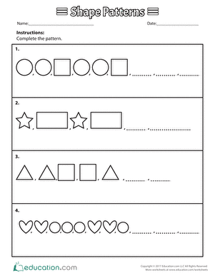

- Observe the pattern and complete the last figure.
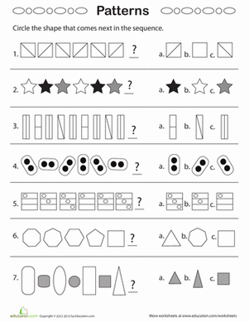

- Number Pattern
The pattern consisting of numbers is called a number pattern.

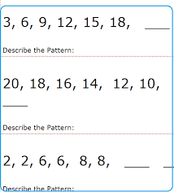

- Complete the number pattern:

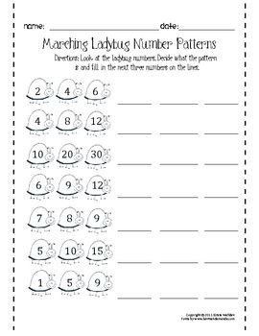

- Progressive Geometric Pattern

The pattern which can go on and on without coming to an end is called progressive pattern. Such patterns are infinite.

- Progressive Number Pattern

- 7, 10, 13, 16, 19, 22, 25....
Each term of the given pattern is obtained by adding 3 to the previous number.

- 80, 90, 100, 110, 120, 130...
Each term of the given pattern is obtained by adding 10 to the previous number.

- 4. 7, 13, 25, 49...
Each term of the given pattern is obtained by multiplying 2 to the previous number and subtracting 1.

MIND MAP

PATTERNS

Progressive Number Pattern
Progressive Geometrical Pattern
- Number
- Pictures
- Symbols
- Figures

Geometrical
Number

