[CLASSIFICATION OF ANIMALS] | SCIENCE(BIO)| STUDY NOTES
CHAPTER 3
CLASSIFICATION OF ANIMALS
The Animal Kingdom has the maximum number of species among all kingdoms. All the organisms in this kingdom share three main characteristics: they are multicellular, are mobile and rely on other animals and plants for nourishment.

Most animals reproduce sexually and have sense organs. They are made of cells, tissue, organs, and organ system. These levels of organization are unique to Animal Kingdom.
Hierarchy of classification
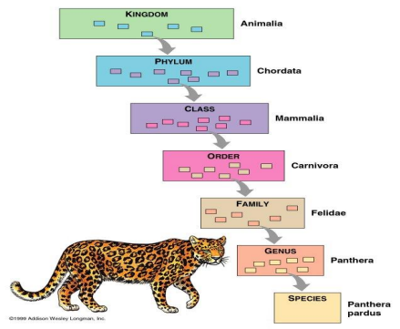SN_STD VII BIO_CHAPTER3_CLASSIFICATION OF ANIMALS/ODM
[CLASSIFICATION OF ANIMALS] | SCIENCE(BIO)| STUDY NOTES
Broadly they are divided into on the basis of presence/absence of backbone: A) Vertebrates (backbone or vertebral column present)
B) Invertebrates (backbone or vertebral column absent)
Kingdom Animalia: -
The animal kingdom is classified into different phyla.
Porifera:
▪ These animals have pores all over their body that lead into the canal system.
▪ Water flows through the canal system and facilitates entry of food and exchange of other materials.
▪ The animal body is not differentiated into tissues.
▪ The body is covered with a hard outer skeleton and are attached to some object or bottom of ocean.
▪ These are commonly known as sponges.
▪ They are marine animals.
▪ Examples: Sycon, spongilla, euplectelea, etc
Coelenterata
▪ The body is made up of a coelom (cavity) with a single opening (mouth) surrounded by tentacles.
▪ The body wall is made up of two layers of cells.
▪ May be solitary or colonial
▪ Examples: Hydra, Jellyfish, Sea anemone, etc.
Platyhelminthes
▪ The body is flattened from top to bottom
▪ These are commonly known as flatworms.
▪ The body wall is composed of three layers of cells (triploblastic).
SN_STD VII BIO_CHAPTER3_CLASSIFICATION OF ANIMALS/ODM
[CLASSIFICATION OF ANIMALS] | SCIENCE(BIO)| STUDY NOTES
▪ They are free-living or parasitic animals.
▪ Examples: Planaria, liver fluke, tapeworm, etc
Nemathelminthes or Nematoda
▪ The body is rounded and unsegmented.
▪ Three layered body walls.
▪ Parasitic mode of nutrition.
▪ Examples: Roundworms, pinworms, filarial parasite (Wuchereria), etc. Annelida
▪ The body is divided into segments.
▪ Each segment is lined one after another and contains a set of organs. ▪ Nephridia help in excretion.
▪ Examples: Earthworm, leech etc.
Arthropoda
▪ Animals have jointed appendages.
▪ Chitinous exo skeleton is present
▪ This is the largest group of animals; in terms of a number of species divided into
a) Crustacea-crabs, prawn
b) Myriapoda-centipede, millipede
c) Insecta-Ant, Butterfly
d) Arachnida- Spider, Scorpion
▪ The circulatory system is open, which means blood flows in the coelomic cavity. Examples: cockroach, housefly, spider, prawn, scorpion, etc. Mollusca
▪ The animal has a soft body; which is enclosed in a hard shell, made of calcium carbonate.
▪ Circulatory system is open
▪ kidney-like organ is present for excretion.
▪ The body has well developed muscular feet for locomotion. ▪ Examples: Snail, mussels, octopus, etc.
Echinodermata
▪ The body is covered with spines,
SN_STD VII BIO_CHAPTER3_CLASSIFICATION OF ANIMALS/ODM
[CLASSIFICATION OF ANIMALS] | SCIENCE(BIO)| STUDY NOTES
▪ The body is radially symmetrical.
▪ The animals have well-developed water canal system, which is used for locomotion (tube feet)
▪ Skeleton is made of calcium carbonate.
▪ Examples: Starfish, sea urchins, etc
Chordata
Backbone is present.
Vertebrates are divided into Pisces, Amphibia, Reptilia, Aves and Mammalia Pisces
▪ They are commonly known as fish.
▪ The body is streamlined.
▪ Muscular tail is present which assists in locomotion.
▪ Body is covered with scales.
▪ Paired gills are present; which can breathe oxygen dissolved in water. ▪ They are cold-blooded animals.
▪ The heart has only two chambers.
▪ They lay eggs.
▪ Fishes can be bony or cartilaginous.
▪ Shark is an example of cartilaginous fish. Rohu and Katla are examples of bony fish.
▪ Amphibia, Reptiles, birds and mammals use four limbs for locomotion Amphibia
▪ These animals are adapted to live both in water and land.
▪ Mucus glands on skin keep the skin moist.
▪ The animals breathe through skin when in water and through lungs when on land.
▪ The heart has three chambers.
▪ These are cold blooded animals.
▪ Examples: Frog, toad, salamander, etc.
Reptilia
▪ These animals show crawling movement for locomotion.
▪ Skin is hardened to form scales.
SN_STD VII BIO_CHAPTER3_CLASSIFICATION OF ANIMALS/ODM
[CLASSIFICATION OF ANIMALS] | SCIENCE(BIO)| STUDY NOTES
▪ Most of the reptilians have three chambered heart but crocodile has four-chambered heart.
▪ They don’t need water to lay eggs, rather eggs are covered with hard shells and laid on land.
▪ Examples: snakes, lizards, crocodile, turtle, etc.
Aves
▪ The body is covered with feathers.
▪ Forelimbs are modified into wings. These are warm-blooded animals. ▪ The heart has four chambers.
▪ Bones are hollow (pneumatic); which assists in flying. All the birds belong to this class.
Mammalia
▪ The body is covered with hairs.
▪ Skin has sweat glands and sebaceous glands.
▪ Mammary glands are present in females and are used for nourishing the young ones. Most of the mammalians give birth to young ones and are called viviparous.
▪ Two species of mammals – echidna and platypus lay eggs and are called oviparous.
▪ Examples: human, chimpanzee, lion, platypus, horse, etc.
SN_STD VII BIO_CHAPTER3_CLASSIFICATION OF ANIMALS/ODM
[CLASSIFICATION OF ANIMALS] | SCIENCE(BIO)| STUDY NOTES
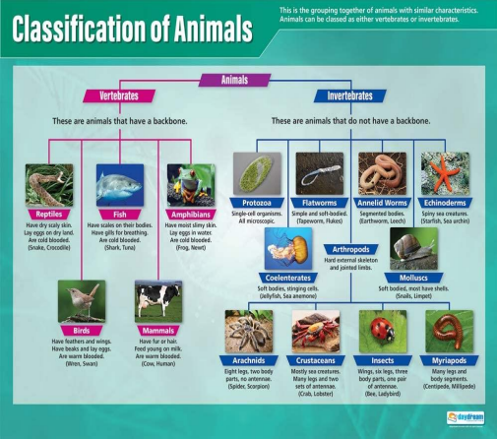SN_STD VII BIO_CHAPTER3_CLASSIFICATION OF ANIMALS/ODM

