f STUDY NOTE [CLASS-VI] | MATHEMATICS STUDY NOTES

PERCENTAGE
CHAPTER 1

Percentage
This is another way to compare the quantities. It means for every hundred. In the fraction form if the denominator is 100 then the numerator is the percentage and is represented by a special symbol %, read as a percent.
There are two methods to find the percentage.

1. By Fraction Method
Example
If there are 20 boys out of 50 students in the class then find the percentage of boys.
To make the denominator hundred we need to multiply both the denominator and numerator with 2.
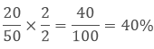
So the percentage of boys is 40%.

Finding the Increase or Decrease Percent
To find the increase or decrease in percent there are two methods.
1. Calculate the percentage of the given value then add or subtract it to the original value.
Example
If the price of the refrigerator was 50000 Rs. last year and it increases by 20 % this year. Then what is its price now?
Solution
First, we will calculate the 20% of 50000 Rs.
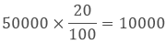
Current Value = Original Value + Increased Price
= 50000 + 10000
= 60000 Rs.
The current value of the refrigerator is 60000 Rs.
2. Unitary Method
As we know that 20% increase means 100 Rs. will increase to 120 Rs.
So 50000 will increase to
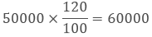
Hence the increased value of the refrigerator has come directly.

Finding Discounts
It’s very common these days that there is a sale and the products are at a discounted price.
Basically discount is the reduction in the Market price to increase the sale and to promote the products.
We can get the amount of discount by subtracting the Sale price from the Market price.
Discount = Market price – Sale Price
To calculate the discount percentage
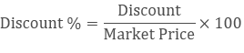
Example
If the price of one jean is 2500 Rs. and we are getting a discount of 500 Rs. then what is the sale price of the jeans? What is the discount percentage?
Solution
Market price = 2500 Rs.
Discount = 500 Rs.
Sale Price = 2500 – 500
= 2000 Rs.
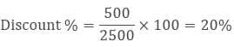

Estimation in Percentages
To understand the estimation let’s take an example
Example
If the price of a product in the mall is 498.80 and it is available at a discount of 15 % then how would you estimate the amount to be paid?
Solution
These are the steps to estimate the percentage-
a. Round off the value 498.80 to the nearest tens i.e. 500.
b. Calculate the 10% of 500.i.e.
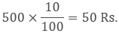
c. Find the half of it i.e. 1/2 × 50 = 25.
d. Add both the values 50 + 25 = 75.
Therefore the bill amount will be reduced by approximately 75 Rs and you may have to pay 425 Rs.

Prices Related to Buying and Selling (Profit and Loss)
When we buy or sell anything in the market then there are so many things included in it like the cost of the product, some overhead expenses to present it, some promotion etc.
Terms Related to Buying and Selling
Cost Price (CP)
Cost price is the actual amount which is paid by the manufacturer to produce it or to provide the service.
Selling Price (SP)
It is the amount at which the product is sold in the market by the retailer.

Profit
After selling a product if the seller has some financial gains then it is said to be a profit.
Profit = SP – CP
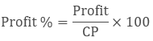

Loss
It is the financial negative revenue which a seller has to bear while selling the product.
Loss = CP – SP
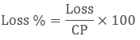
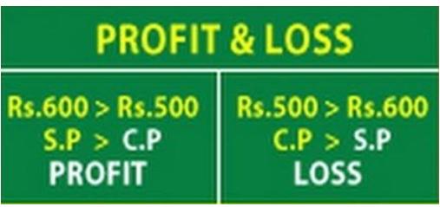

Remark: While buying an item if a shopkeeper made some additional expense then these expenses are called Overhead Expenses. It will be included in the cost price.
Example
If a shopkeeper bought 250 books for 75 each. He spent 500 Rs. on the binding of books. Then he sold it in 20000 Rs. Calculate the profit or loss percentage.
Solution:
Price of 250 books = 250 × 75 = 18750 Rs.
Cost price of books = 18750 + 500 = 19250 Rs.
Sale Price = 20000 Rs.
SP > CP so he made a profit.
Profit = SP – CP
= 20000 – 19250
= 750 Rs.
His profit on 19250 Rs. is 750 Rs.
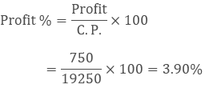

.
= 5
Thus,
3x – 12 = 5

Formation of Expressions
Statement | Expression
y subtracted from 12 | 12 - y
x multiplied by 6 | 6x
t Multiplied by 4, and then subtract 5 from the product. | 4t - 5



