Chapter- 11
CONSTRUCTIONS
STUDY NOTES
Determining a Point Dividing a given Line Segment, Internally in the given Ratio M : N
Let AB be the given line segment of length x cm. We are required to determine a point P dividing it internally in the ratio m : n.
Steps of Construction:

Draw a line segment AB = x cm.
Make an acute ∠BAX at the end A of AB.
Use a compass of any radius and mark off arcs. Take (m + n) points A₁, A₂, … A_{m}, A_{m+1}, …, A_{m+n} along AX such that AA₁ = A₁A₂ = … = A_{m+n-1} , A_{m+n}
Join A_{m+n}B.
Passing through A_{m}, draw a line A_{m}P || A_{m+n}B to intersect AB at P. The point P so obtained is the A required point which divides AB internally in the ratio m : n.
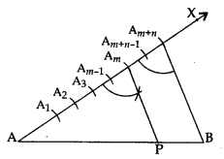

Construction of a Tangent at a Point on a Circle to the Circle when its Centre is Known
Steps of Construction:
- Draw a circle with centre O of the given radius.
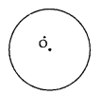
- Take a given point P on the circle.
- Join OP.
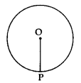
- Construct ∠OPT = 90°.
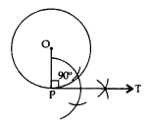

Produce TP to T’ to get TPT’ as the required tangent.
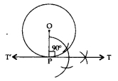

- Construction of a Tangent at a Point on a Circle to the Circle when its Centre is not Known
- If the centre of the circle is not known, then we first find the centre of the circle by drawing two non-parallel chords of the circle. The point of intersection of perpendicular bisectors of these chords gives the centre of the circle. Then we can proceed as above.
- Construction of a Tangents from an External Point to a Circle when its Centre is Known

: Steps of Construction
- Draw a circle with centre O.
- Join the centre O to the given external point P.
- Draw a right bisector of OP to intersect OP at Q.
- Taking Q as the centre and OQ = PQ as radius, draw a circle to intersect the given circle at T and T’.
- Join PT and PT’ to get the required tangents as PT and PT’.
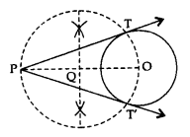
- Construction of a Tangents from an External Point to a Circle when its Centre is not Known
- If the centre of the circle is not known, then we first find the centre of the circle by drawing two non-parallel chords of a circle. The point of intersection of perpendicular bisectors of the chords gives the centre of the circle. Then we can proceed as above.
Let ΔABC be the given triangle. To construct a ΔA’B’C’ such that each of its sides is mn (m < n) of the corresponding sides of ΔABC.
Steps of Construction:
- Construct a triangle ABC by using the given data.
- Make an acute angle ∠BAX, below the base AB.
- Along AX, mark n points A₁, A₂ …, A_{n}, such that AA₁ = A₁A₂ = … = A_{m-1} A_{m} = … A_{n-1} A_{n}.
- Join A_{n}B.
- From A_{m}, draw A_{m}B’ parallel to AnB, meeting AB at B’.
- From B’, draw B’C’ parallel to BC, meeting AC at C’.
Triangle AB’C’ is the required triangle, each of whose sides is mn (m < n) of the corresponding sides of ΔABC.
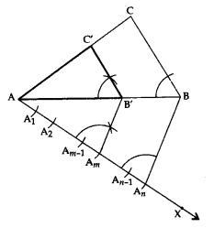
Construction of a Triangle Similar to a given Triangle as per given Scale Factor mn , m > n.
Let ΔABC be the given triangle and we want to construct a ΔAB’C’, such that each of its sides is mn (m > n) of the corresponding side of ΔABC.
Steps of Construction:
- Construct a ΔABC by using the given data.
- Make an acute angle ∠BAX, below the base AB. Extend AB to AY and AC to AZ.
- Along AX, mark m points A₁, A₂ …, A_{n}, ..A_{m}, such that AA₁ = A₁A₂ = A₂A₃ = … = A_{n-1} A_{n} = … = A_{m-1} A_{m}
- Join A_{n}B.
- From A_{m}, draw A_{m}B’ parallel to A_{n}B, meeting AY produced at B’.
- From B’, draw B’C’ parallel to BC, meeting AZ produced at C’.
- Triangle AB’C’ is the required triangle, each of whose sides is (mn) (m > n) of the corresponding sides of ΔABC.
