[CLASS-VI] | MATHEMATICS STUDY NOTES

RATIO
CHAPTER 12

Definition of Ratio
In certain situations, the comparison of two quantities by the method of division is very efficient. We can say that the comparison or simplified form of two quantities of the same kind is referred to as ratio. This relation gives us how many times one quantity is equal to the other quantity. In simple words, the ratio is the number which can be used to express one quantity as a fraction of the other ones.
The two numbers in a ratio can only be compared when they have the same unit. We make use of ratios to compare two things. The sign used to denote a ratio is ‘:’.
A ratio can be written as a fraction, say 2/5. We happen to see various comparisons or say ratios in our daily life.

If we compare two quantities using division then it is called ratio. It compares quantities in terms of ‘How many times’. The symbol to represent ratio is “:”.
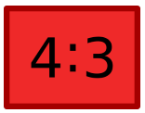
It reads as “4 is to 3”
It can also be written as 4/3.

The unit must be same to compare two quantities
If we have to compare two quantities with different units then we need to convert them in the same unit .then only they can be compared using ratio.

Key Points to Remember:
- The ratio should exist between the quantities of the same kind
- While comparing two things, the units should be similar
- There should be significant order of terms
- The comparison of two ratios can be performed, if the ratios are equivalent like the fractions

Difference between fractions and ratios
- A fraction describes a part of a whole and its denominator represents the total number of parts.
Example: 13 means one part out of 3 parts.
- A ratio is a comparison of two different quantities.
- Example: In a society, 10 people like driving, 20 people like swimming and the total number of people in society is 30.
- The ratio of the number of people liking driving to the total number of people = 10:30.
- The ratio of the number of people liking swimming to the number of people liking driving is 20:10.

Equivalent Ratios
If we multiply or divide both the numerator and denominator by the same number then we get the equivalent ratio. There could be so many equivalent ratios of the same ratio.
In the case of equivalent ratios only their value changes but they represent the same portion of the quantity.
Example
Find two equivalent ratios of 2/4.
Solution
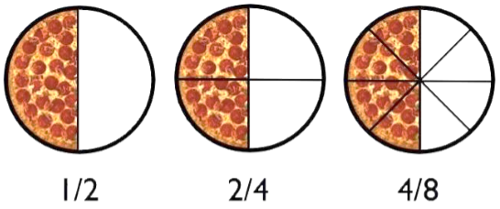

The Lowest form of the Ratio
If there is no common factor of numerator and denominator except one then it is the lowest form of the ratio.
Example
Find the lowest form of the ratio 25: 100.
Solution
The common factor of 25 and 100 is 25, so divide both the numerator and denominator with 25.
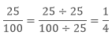
Hence the lowest ratio of 25: 100 is 1: 4.

Comparing quantities using ratios
- Quantities can be compared using ratios.
- Example: Joe worked for 8 hours and James worked for 2 hours. How many times Joe’s working hours
is of James’ working hours?
Solution: Working hours of Joe = 8 hours
⇒Working hours of Sheela = 2 hours
⇒The ratio of working hours of Joe to Sheela =82=4.
Therefore, Joe works four times more than James.

Equivalent Ratios
When the given ratios are equal, then these ratios are called as equivalent ratios.
- Equivalent ratios can be obtained by multiplying and dividing the numerator and denominator with the same number.
- Example: Ratios 10:30 (=1:3) and 11:33 (=1:3) are equivalent ratios.

ODM Educational Group Page

