
STRUGGLE FOR INDEPENDENCE
CIVIL DISOBEDIANCE AND DANDI MARCH-1930
SUBJECT : HISTORY
CHAPTER NUMBER:14
CHAPTER NAME :STRUGGLE FOR INDEPENDENCE
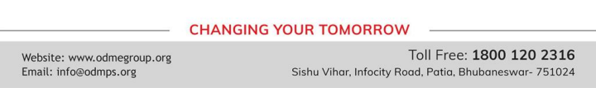
STRUGGLE FOR INDEPENDENCE
CIVIL DISOBEDIANCE AND DANDI MARCH session-3
Civil disobedience Movement was launched in 1930 under the leadership of Gandhiji. The March to Dandi:
(i) In 1930, Gandhiji started the march to break the Salt Law. According to this law, the state had a monopoly on the manufacture and sale of salt.
(ii) Gandhiji and his followers marched from Sabarmati Ashram(in Ahemdabad) to the coastal town of Dandi (in Surat) where they broke the Salt law by gathering natural salt found on the sea-shore are boiling sea water to Produce salt.
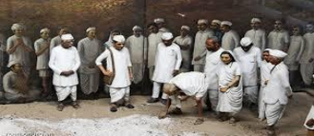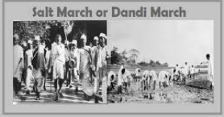
STRUGGLE FOR INDEPENDENCE
THE GANDHI-IRWIN PACT-1931
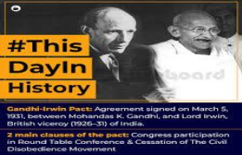
The Congress boycotted the First Round Table Conference. The British realized that without the participation of the Congress no decision could be taken on further Constitutional Reforms in India. In early 1931, an agreement was reached between viceroy of India Lord Irwin and Gandhi. The British govt agreed to release all political prisoners whom there was no charge of violence. In return the Congress suspended the Civil Disobedience Movement and agreed to participate in the Second Round Table Conference.
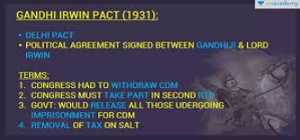
STRUGGLE FOR INDEPENDENCE
THE SECOND ROUND TABLE CONFERENCE
Gandhiji was deputed as the representative of Congress and Mohammad Ali Jinnah was deputed as the representative of Muslim League toattend the Second Round Table Conference.Gandhiji demanded for independence and immediate grant for dominion status to India. The British Govt refused and Gandhiji returned disillusioned and disappointed. He announced the revival of Civil Disobedience Movement. The govt now headed by Lord Wellington was determined to suppress the Congress. Gandhiji and other congress leaders were arrested and Congress was declared an illegal body.
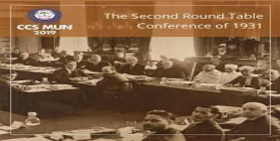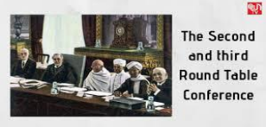
STRUGGLE FOR INDEPENDENCE
THE GOVERNMENT OF INDIA ACT OF 1935
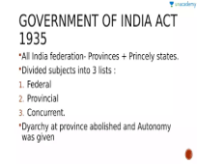
● After the Third Round Table Conference the British Government passed the Government of India Act of 1935.The combined struggles of the Indian people bore fruit when the Government of India Act of 1935 prescribed provincial autonomy and the government announced election to the provincial legislature in 1937.
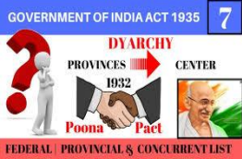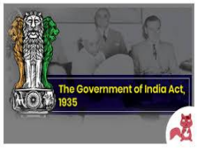
THANKING YOU
ODM EDUCATIONAL GROUP

