REVISION WORKSHEET-3
Date – 29.09.21
Class assignment-
Q1- Which number comes just before and after ?

_____ 34 _____ ____ 48 _____

_____ 28 _____ _____ 40 _____
Q2- Write and match the number with the number names that comes in between:
Forty
32 ____ 34
Thirty-three
24_____26

39_____ 41
Forty-seven
Twenty-five
46_____ 48
Q3- Circle the number that comes just before the given number:
18 20 19
21
48 50 49
49
35 34 33
34
28 26 27
28
ORAL
Q1- which number comes just before 20?
Q2- Which number comes just after20?
Q3- Which number comes in between 19 and 21?
Q4-What is the before number of 49?
Q5-Which number comes in between 39 and 41?
Q5- what is the before number of 30?
Q6- What is the after number of 30?
Q7- Which number comes in between 29 and 31
Q8- what is the after number of 48?
Q9- Which number comes in between 33 and 35?
Q10- What is the before number of 12?

Home assignment- Date-29.9.21
Q1-Fill in the numbers that comes just before:
31
30
29
28
45
44
46
43
12
15
14
13

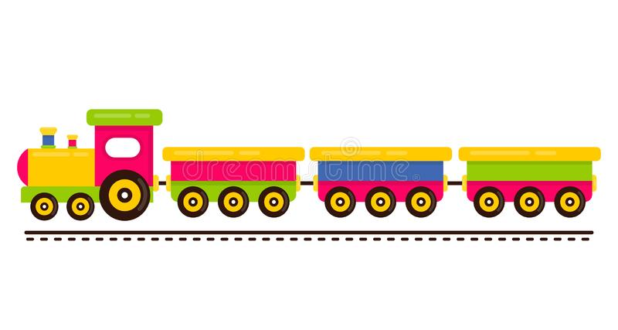
Q2- Fill in the numbers that comes just after-
41
43
42
40

38
37
36
35

21
22
20
19
35

Q3- Match and write the number that comes in between-
40 ___ 42 27
38 ___ 40 10
26 ___ 28 18
17 ____ 19 41
9 ____ 11 39
Q4- Circle the number that comes just after the given number-
10 11 12
10
46 47 48
47
37 38 39
38
17 18 19

17
5 6 7
6

