REVISION TEST
- Write all the parts of a nephron.

- What is phloem transport called? Which substances are carried through phloem?

- Explain the following activity with respect to the result obtained.

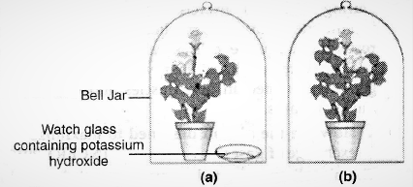

- Identify 1,2,3,4

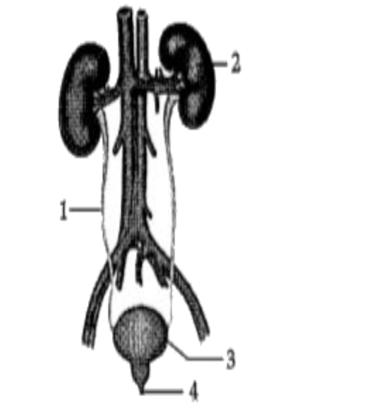

- Write functions of 1,2,3,4 of the above question.(2)
- Explain the process of ascent of sap during daytime.(2)
- Differentiate between artery and veins.(2)
- Differentiate between pulmonary and systemic circulation.(2)

