[REPRODUCTION IN HUMANS.]
| BIOLOGY | STUDY NOTES-1

Chapter-3
REPRODUCTION IN HUMANS.
Sub- Introduction, sex cells, Asexual Reproduction-Binary fission, Multiple fission, Budding, Regeneration
Introduction-
The reproductive system in animals is a network of organs in an organism, where the organs work together for the purpose of reproduction that is, giving birth to new organisms. The reproductive system in different vertebrates resembles each other with similar organs and functions.
There are two types of reproduction systems in animals:
- Asexual reproduction: A type of reproduction by which offspring arise from a single organism, and inherit the genes of that parent only.
  - For example, bacteria divide asexually via binary fission, viruses use host cells to produce more viruses and hydras reproduce by budding.
  - In other words, these organisms are asexual, that is they do not identify as male or female. This process does not involve the fusion of gametes and the number of chromosomes almost remain the same.
  - Therefore they are capable of cloning or splitting themselves into another organism.

Asexual Reproduction in animals:
Binary Fission:

- Most of the unicellular animals prefer this method for reproduction.
- These organisms reproduce by binary fission; especially when adequate amount of food and moisture are available.
- Binary fission is somewhat similar to mitosis.
- The mother cell divides into two daughter cells; and each daughter cell begins its life like a new individual. The parent generation ceases to exist, after binary fission.
- 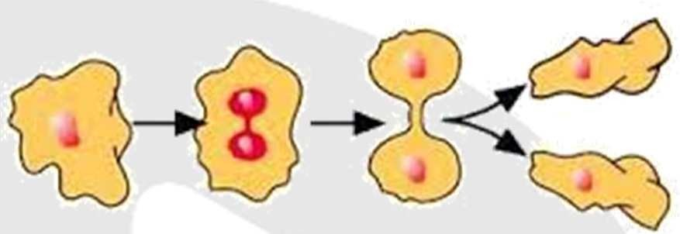Amoeba is a very good example of the organism which reproduces by binary fission.

Multiple Fission:
- When conditions become unfavourable, i.e. food, moisture, proper temperature, etc. are not available; this is the preferred mode of reproduction by unicellular organisms.
- The organism develops a thick coating around itself. This is called cyst.
- The cyst helps the organism to tide over the bad phase.
All metabolic activities stop in the organism, after cyst formation.
When favourable conditions return, the cyst dissolves or breaks down; releasing the daughter nuclei.
The daughter nuclei; in turn; grow into new individuals.
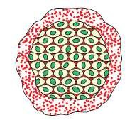Plasmodium and Entamoeba undergo cyst stage, when they are not in the body of their prime host, i.e. humans.

Budding in hydra-
- A bud grows anywhereon the main body of hydra.
- The bud grows to a certain size and gets detached from the mother hydra.
- This develops further to grow into a new individual.
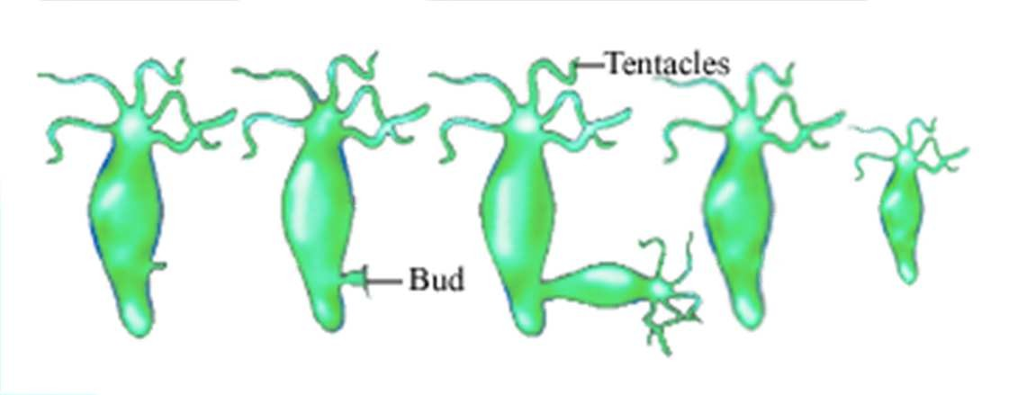

Regeneration in planaria.

- Some simple organisms can regenerate a new individual from a part which has been accidentally cut off.
- Planaria shows good example of reproduction by regeneration.
- If a planaria is cut into several pieces; each piece develops into a new individual.
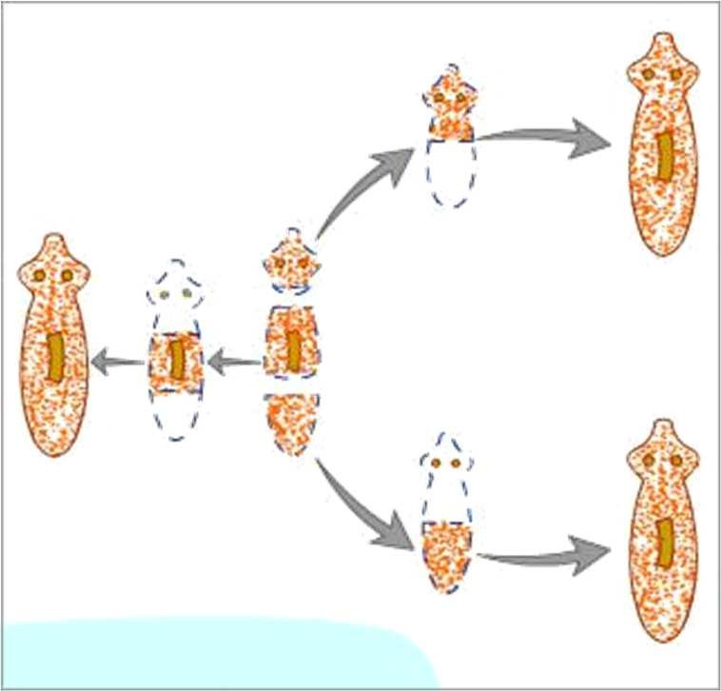

[REPRODUCTION IN HUMANS.]
| BIOLOGY | STUDY NOTES-2

Chapter-3
REPRODUCTION IN HUMANS.
Sub- sexual reproduction in Animals, sperm and ova, Human Reproductive system, female reproductive system
Sexual reproduction: Requires the interaction between two organisms (two parents) to produce an offspring. Reproduction occurs due to the union of morphologically distinct male and female gametes to form a zygote.

- Spermatogenesis: The process of production of sperms in the gonads of males.
- Oogenesis: The process of production of eggs in the gonads of females.
- Accessory reproductive parts: These include all the organs and body parts that are a part of the reproduction process and they help with the transfer, meeting of two kinds of sex cells, fertilisation, growth, and development of the egg and the birth of the baby.

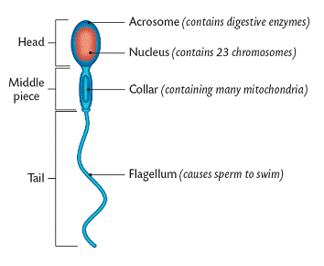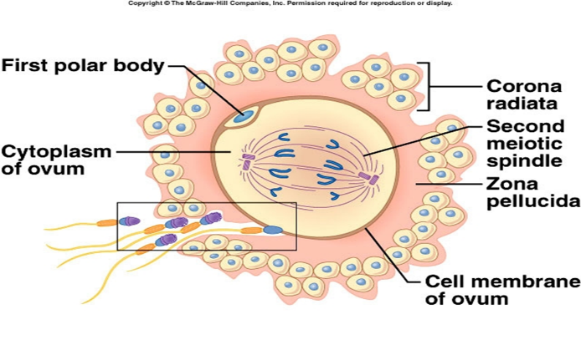

Reproduction in Human Beings

Female Reproductive System:
- The female reproductive system in human beings is composed of following parts:

a-Uterus:

- This is pear-shaped hollow muscular organ.
- Uterus is the place where the embryo gets implanted and develops into a new-born baby.
- The wall of the uterus provides safety and nutrition to the growing foetus.

b-Fallopian Tubes:

- One fallopian tube comes out from each side at the top of the uterus.
- The fallopian tubes end in finger-like structures; called fimbriae.
- Fertilization happens in the fallopian tube.

c-Ovary:

- There are two ovaries; one near each fallopian tube.
- Ovary produces the eggs or the female gametes.

d-Vagina:

- The cervix (mouth of the uterus) opens into the vagina.
- Vagina is a muscular tube-like organs; which serves as the passage for the sperms and also as the canal during the child birth.

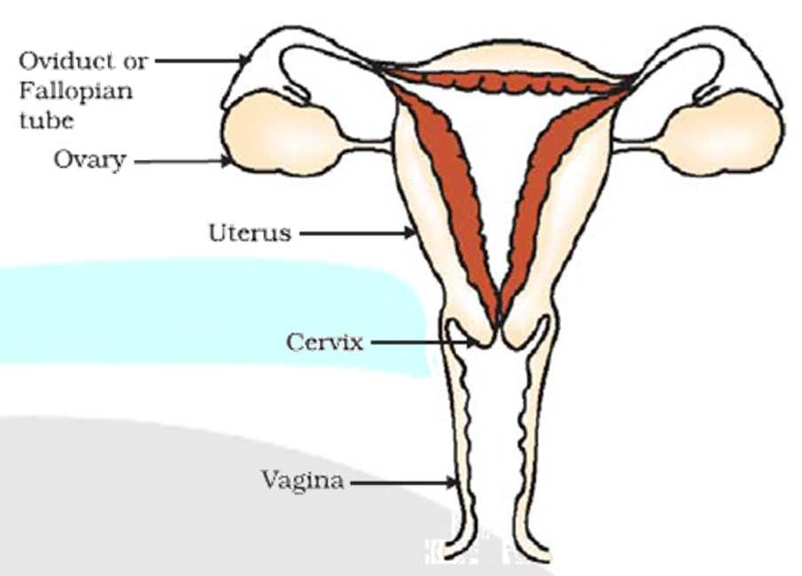

[REPRODUCTION IN HUMANS.]
| BIOLOGY | STUDY NOTES-3

Chapter-3
REPRODUCTION IN HUMANS.
Sub-. Human Male Reproductive system, Accessory glands

Male Reproductive System:
The male reproductive system in human beings is composed of following parts:

a-Testis:

- There is a pair of testes; which lie in a skin pouch; called scrotum.
- Scrotum is suspended outside the body; below the abdominal cavity.
- This helps in maintaining the temperature of testes below the body temperature.
- This is necessary for optimum sperm production.
- Sperms are the male gametes.
- Apart from that, testis also produces testosterone.
- Testosterone is also called the male hormone, as it is responsible for developing certain secondary sexual characters in boys.

b-Vas Deferens:

- Vas deferens is the tube which carries sperms to the seminal vesicle.

c-Seminal Vesicle:

- This is the place where sperms are stored.
- Secretions from the seminal vesicle and prostate gland add up to make the semen.

d-Penis:

- It is a muscular organ which serves the genitor-urinary functions.
- The urethra works as the common passage for urine as well as for sperms.

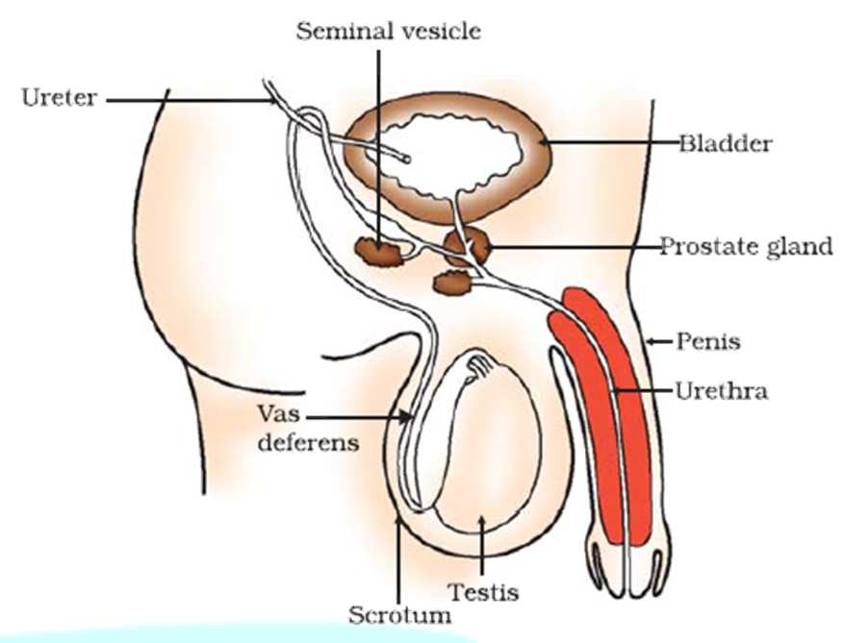

[REPRODUCTION IN HUMANS.]
| BIOLOGY | STUDY NOTES-4

Chapter-3
REPRODUCTION IN HUMANS.
Sub- Fertilisation, Implantation, Growth,Birth.
Fertilisation: The union of a male gamete with a female gamete to form the zygote is called fertilisation.
Implantation: The process by which the fertilised egg fixes itself to the wall of the uterus within 5-7 days after ovulation is called implantation.
Blastocyst: The small, hollow ball of numerous cells formed by the division of the zygote is called blastocyst.
Embryo: An organism that is in the early stages of growth and differentiation. In humans, the embryo stage is from fertilisation to the beginning of the third month of pregnancy.
Foetus: The unborn young of a viviparous vertebrate having a basic structural resemblance to the adult animal.
Process of Fertilisation
Fertilisation is the most important part of sexual reproduction where the male gamete or the sperm penetrates the female gamete or the ovum to form a zygote.

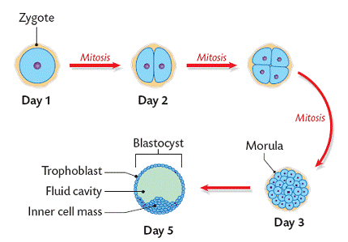

- In humans, the sperm is motile and the ovum is non-motile, hence for fertilisation to occur the two gametes must be brought together. This happens with insemination when a male releases sperm into the female’s vaginal canal.
- Only the healthy and strong sperms are able to swim up and reach the oviducts while the rest die on the way.
- If there is an egg in the oviduct, the sperm penetrates it. The sperm and egg nucleus fuse to form a diploid zygote.

- After fertilisation, the zygote divides to form a several-celled embryo which is implanted in the uterus and eventually develops into the foetus.
- Fertilisation occurs in the fallopian tube and then the fertilised egg travels down to the uterus. It is wrongly believed that fertilisation takes place in the uterus.
- Even though sperms remain alive in the female genital passage for a few days, their fertilising power does not extend beyond a day or two.
- Millions of sperms may be released into the vagina, but only one sperm can fertilise the egg. The ovum creates a protective layer after fertilisation to prevent the entry of other sperms.
- Once fertilisation occurs, the other sperms die and disintegrate.
- The period immediately after ovulation is the most favourable period for conception to occur.
- The zygote undergoes a series of mitotic cell divisions called cleavage.
- The stages of development are:
Fertilized ovum (zygote)
2-cell stage
4-cell stage
8-cell stage
Morula
Blastula Gastrula

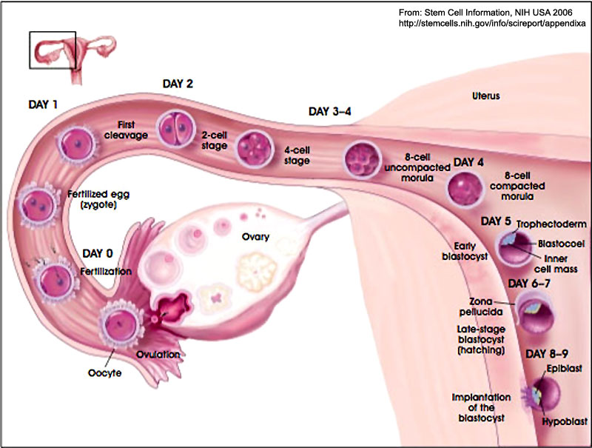

Implantation: The zygote undergoes mitotic division and forms a blastocyst which in turn forms a pit in the endometrial wall and gets fixed to it in about 5-7 days after ovulation. This process is called implantation and results in pregnancy.

Placenta: A flattened circular organ in the uterus of pregnant eutherian mammals that nourishes and maintains foetus through the umbilical cord.
- It is composed of blood capillaries, villi, connecting tissue and endocrinal cells.
- It is formed by the union of endometrial tissue, chorion, and allantois which is the embryonic tissue.
Gestation: The process or period of development of the embryo inside the womb between conception and birth. It is approximately 280 days for humans.

