[REPRODUCTION IN PLANTS.]
| BIOLOGY | STUDY NOTES-1

Chapter-2
REPRODUCTION IN PLANTS.
Sub- Introduction, modes of reproduction in plants, asexual reproduction, Binary fission, Budding, Fragmentation, Spore formation, Vegetative reproduction.

INTRODUCTION-
Reproduction is an integral feature of all living beings. The process by which a living being produces its own like is called reproduction.
IMPORTANCE OF REPRODUCTION:
Reproduction is important for each species, because this is the only way for a living being to continue its lineage. Apart from being important for a particular individual, reproduction is also important for the whole ecosystem. Reproduction helps in maintaining a proper balance among various biotic constituents of the ecosystem. Moreover, reproduction also facilitates evolution because variations come through reproduction; over several generations.

TYPES OF REPRODUCTION:

There are two main types, viz. asexual and sexual reproduction.

Asexual Reproduction: When a single parent is involved and no gamete formation takes place; the method is called asexual reproduction. No meiosis happens during asexual reproduction
Asexual reproduction occurs through,
- Budding
- Binary fission
- Fragmentation.
- Spore formation
- Vegetative Propagation

Modes of Asexual Reproduction-

1-Budding: Seen in Yeast (a fungus). The parent yeast cell develops a protrusion or an outgrowth at its upper end. The nucleus of the parent cell divides and one of them moves into the outgrowth which grows bigger and finally separates from the parent cell to lead an independent existence. Very often if the conditions are highly favorable, a chain of buds is formed.
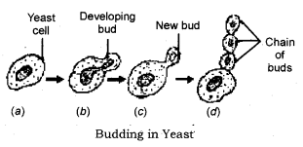

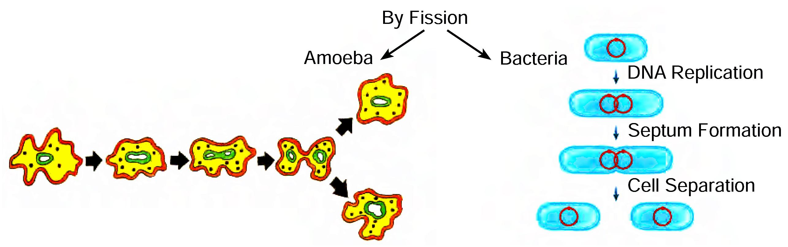
2- Binary Fission: Seen in bacteria, protozoa like Amoeba, Paramecium. (In these first pseudopodia withdrawn (karyokinesis) the nucleus of the parent cell divides and then the cytoplasm divides (cytokinesis) resulting in the formation of two daughter cells).

Multiple Fission: Seen in Plasmodium, (a malarial parasite). In this during unfavourable conditions, the parent cell develops a thick resistant wall around itself forming a cyst. Within the wall, the cytoplasm divides many times to form many plasmodia.

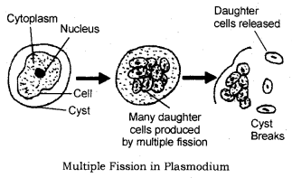

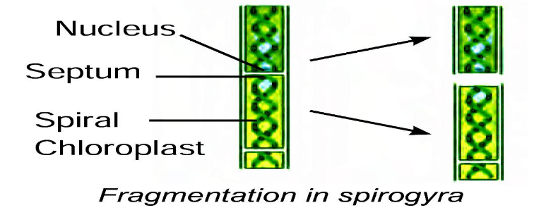
3- Fragmentation -Spirogyra breaks into smaller pieces on maturation and each fragment grows into a new individual.

4-Spore formation:
In plants like ferns, spores are formed on the underside of the leaves. These are capable of developing into new plants when they are carried by the wind to other places with suitable conditions for growth
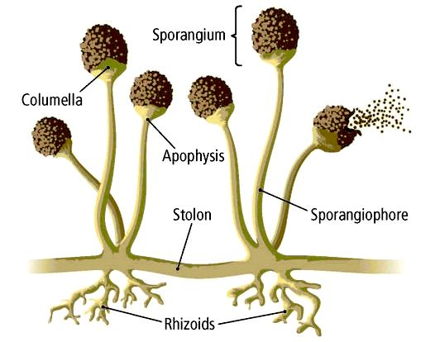

5-Vegetative Propagation- The roots, stems and leaves are called vegetative parts of a plant. When any of these give rise to new plants, it is called vegetative reproduction.

Vegetative reproduction
Vegetative propagation is the ability of plants to reproduce by bringing forth new plants from existing vegetative structures without sexual reproduction.
When sweet potatoes, asparagus, carrot are buried in the soil, they give rise to new plants.

[REPRODUCTION IN PLANTS.]
| BIOLOGY | STUDY NOTES-2

Chapter-2
REPRODUCTION IN PLANTS.
Sub- Reproduction by stem, Reproduction by Leaf, Reproduction by Root, Advantages of vegetative reproduction, Disadvantages of vegetative reproduction.
Vegetative reproduction by roots -Carrot and sweet potato are examples of modifications of roots; for food storage. These roots can give rise to new plants; when kept under the soil.
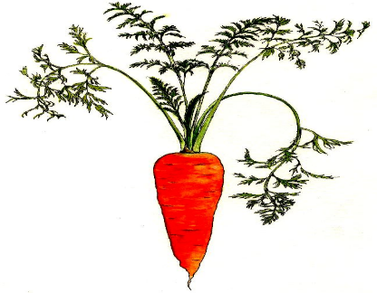

-

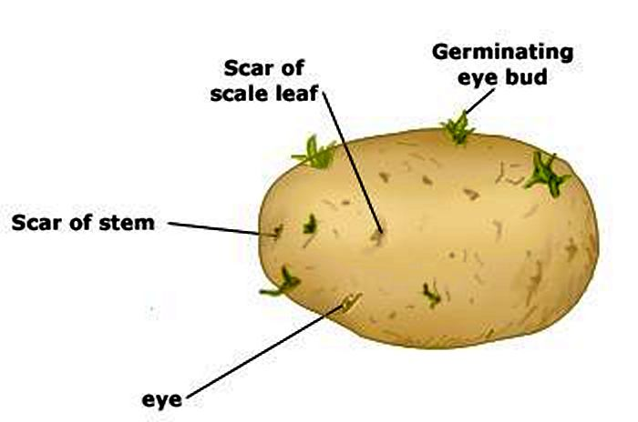
Vegetative reproduction by stems

Example: Potato, The ‘eyes’ are actually buds which give rise to new plants. If a piece of potato without the ‘eye’ portion is planted, it cannot develop into a new plant.
Rhizome:
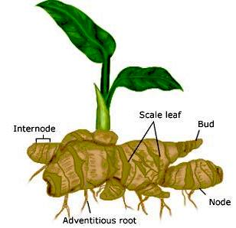
Example: Ginger also gives rise to new plants from buds on the stem. It has nodes and internodes and thin dry papery scaly leaves.

Bulbs of onion:
This has a thick short stem in the form of a condensed disc covered by scale leaves. The disc has buds which can grow into new plants. 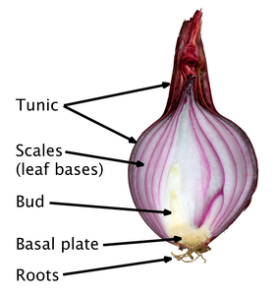
Some plants have horizontal stems. Roots and shoots develop at the nodes to form new plants.
Example: Mint, grass.
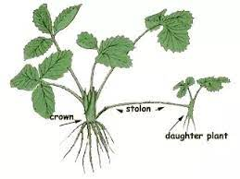
Vegetative reproduction by leaves
Bryophyllum bears buds on its leaf margins. When these fall on the ground, they develop into new plants.

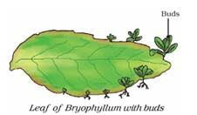

Advantages of vegetative reproduction or vegetative propagation
- Useful to grow seedless varieties.
- Faster and easier than the natural process.
- The only method of reproduction for plants which do not produce seeds Example: Banana and rose
- Offspring resemble the parent exactly.

Disadvantages of vegetative reproduction or vegetative propagation
- Being identical in all respects, these plants may be prone to disease at the same time.
- Dispersal cannot occur naturally so there tends to be overcrowding.

[REPRODUCTION IN PLANTS.]
| BIOLOGY | STUDY NOTES-3

Chapter-2
REPRODUCTION IN PLANTS.
Sub- Artificial vegetative propagation- Cutting, Layering, Grafting, Micro-propagation.

Artificial Vegetative Propagation

Cutting
Cutting is removing a part of the stem and planting it into the soil to allow the growth of roots and buds.
Example: Sugarcane, rose, china rose, pears. 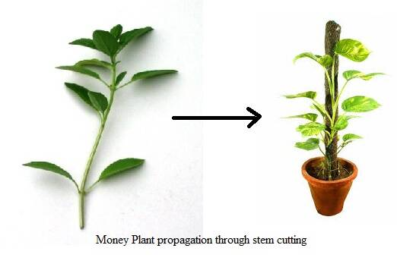
Layering:
The lower branch of a plant is selected and a ring of the bark is removed from the stem. The portion where the bark is removed is bent and covered with soil. The branch is kept covered with the soil for a few days during which new roots start to develop on the branch. The branch is then cut off from the parent plant and allowed to grow as an individual plant.Example: Hibiscus, jasmine, rose, bougainvillea.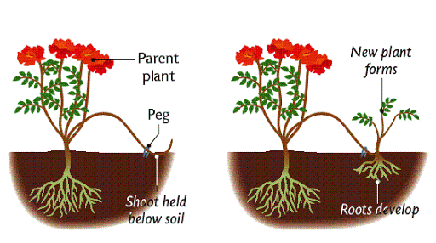
Grafting:
A small branch is cut from the plant to be grown with a wedge-shaped end. This is called scion. Now a V-shaped cut is made in the stem of a rooted called stock. The scion is now fitted into the stock and they are taped together. Soon the graft becomes part of the rooted plant.

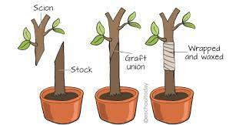

Tissue Culture:
Tissue culture is one of the ways of cloning plants. It works with small pieces of plants, called explants
The technique of developing new plants from a cell or tissue in a nutrient medium under aseptic conditions. The cell or tissue is placed in a nutrient medium where it forms a mass of cells called callus. This callus is then transferred to another nutrient medium where it differentiates and forms a new plant.

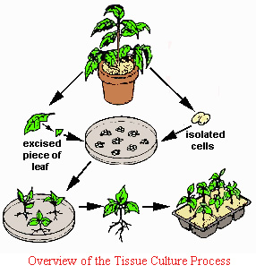
Benefits of plant tissue culture technique.

- The new plantlets can be grown in a short amount of time.
- Only a small amount of initial plant tissue is required.
- The new plantlets and plants are more likely to be free of viruses and diseases.
- The process is not dependant on the seasons and can be done throughout the year.

Limitations of tissue culture-
- It requires a lot of scientific expertise
- It can not be applied to all cases
- It is not easily applicable in remote agricultural areas

[REPRODUCTION IN PLANTS.]
| BIOLOGY | STUDY NOTES-4

Chapter-2
REPRODUCTION IN PLANTS.
Sub- Sexual reproduction in plants - Calyx, Corolla, Androecium, Gynoecium, Ovules.

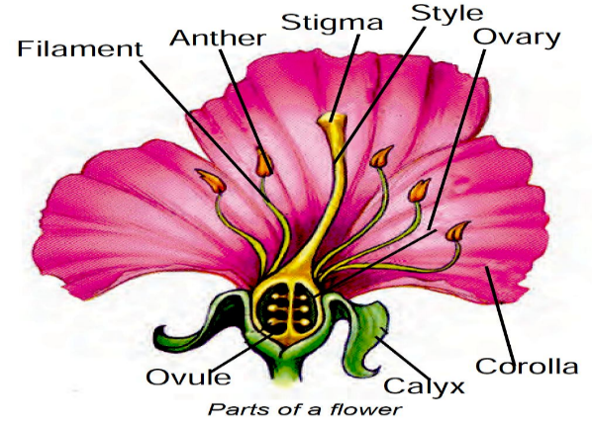
Sexual reproduction in flowering plants
PARTS OF A TYPICAL FLOWER
A flower is a modified shoot with a limited growth. Flowers vary in size, shape,structure and colour. The main parts of a flower are,
1. Calyx
2. Corolla
3. Androecium and
4. Gynoecium.
- The parts of the flower are sepals, petals, stamens and carpels.
- Sepals-Sepals are green structures that protect the inner parts when the flower is in bud stage.
- Petals-Petals are colourful and attract the insects for pollination.
- Stamens-Stamens are male reproductive parts and produce pollen grains that contain male gametes. Each stamen has two parts—
- Filament i.e. stalk and Anther i.e. swollen top part which has large number of pollen grains.
Carpel-The carpel is the female reproductive part and produces ovules that contain female gametes. It has three parts—Stigma which is top sticky part and receives pollen grains during pollination. Style which is the middle long part and ovary which is the swollen part and contains ovules. Each ovule has an egg cell i.e. female gamete.
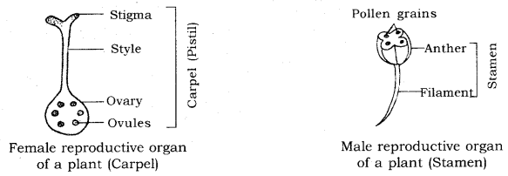
Bisexual- The flowers may be bisexual i.e. having both stamens and carpels for example; Mustard China Rose (Hibiscus).
unisexual-The flower may be unisexual i.e. paving either stamens or carpels for example; Papaya, Watermelon.

[REPRODUCTION IN PLANTS.]
| BIOLOGY | STUDY NOTES-5

Chapter-2
REPRODUCTION IN PLANTS.
Sub- Pollination, Self-pollination, Cross pollination, Agents of pollination. Characteristics of insect, wind and water pollinated flowers, Artificial pollination fertilization doublefertilisation.

The sexual reproduction in flowering plants involves
1. Pollination 2. Fertilization

1. POLLINATION
Transfer of pollen grains from the anther to the stigma is called pollination. Pollen grains are transferred mainly by wind, water and insects. They are called as pollinating agents. Pollination is the first and important event in the development of the fruit and seed. Pollination is followed by fertilization.

TYPES OF POLLINATION Pollination is of two types. They are
1. Self pollination 2. Cross pollination

SELF POLLINATION
Self pollination is also known as autogamy. The transfer of pollen grains from the anther of a flower to the stigma of the same flower or another flower of the same plant is known as self pollination.

CROSS POLLINATION (ALLOGAMY)
The transfer of pollen grains of a flower to the stigma of another flower of a different plant of the same species is called cross pollination or allogamy.

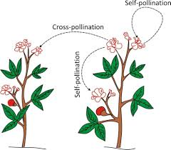
ADVANTAGES OF SELF POLLINATION
Self pollination is certain in bisexual flowers.
Flowers need not depend on agents of pollination.
There is no wastage of pollen grains
DISADVANTAGES OF SELF POLLINATION

The seeds are less in number.
Endosperm is minute. Therefore, the seeds produce weak plants.
New varieties of plants cannot be produced resulting in the degradation of the plant.

ADVANTAGES OF CROSS POLLINATION
The seeds produced as a result of cross pollination develop, germinate properly and grow into better plants, i.e., cross pollination leads to the production of new varieties.

More viable seeds are produced.

AGENTS OF POLLINATION
It generally takes place with the help of some agents like -
- Insects: Insects like bees, butterflies, moths visit flowers to collect nectar. When they alight on a flower, their bodies get dusted with pollen. When the insect visits another flower, this pollen gets transferred to the stigma. Insect-pollinated flowers are usually coloured, showy and scented with sticky pollen grains and large amounts of nectar.
- Wind: Some plants produce light, dry pollen which gets carried by the wind. When they happen to fall on the stigma of a flower of the same kind, pollination occurs. Example: Maize, wheat, pine. These produce a large amount of pollen because of a high incidence of wastage. Wind-pollinated flowers are usually small, dull coloured but with long feathery anthers to enable pollen to be blown off easily.
- Water: Male flowers get detached from the parent plant and are carried by water to other places. When they come in contact with a female flower, pollination occurs. Example: Vallisneria.
- Animals: Brightly coloured and tasty fruits contain seeds with indigestible coats so that the seeds pass through the animal’s digestive system undamaged. Examples: Tomato, plum, raspberry, grape.

FERTILIZATION
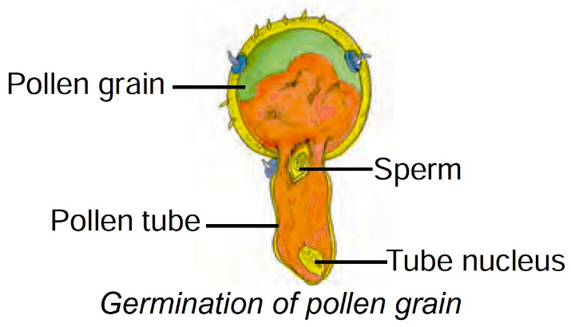
Pollination is the transfer of pollen grains from the anther to the stigma. Each pollen grain has protective walls called exine and intine. The outer wall exine is thick and it has small pores called germination pores. The inner wall is thin and elastic.

GERMINATION OF POLLEN GRAIN
If pollen grain falls on a suitable stigma, it starts germinating. A mature pollen consists of two cells. The larger one is vegetative cell and the smaller one is generative cell. The vegetative cell starts growing and emerges through the germination pore. It develops through the style as a long tube known as pollen tube. The generative cell gets into the tube and divides into two male gametes (sperms).

PROCESS OF FERTILIZATION
The pollen tube enters into the embryo sac through micropyle. At this time, the pollen tube bursts open, gametes released from the pollen tube and enter into the embryosac. One of the gametes fuses with the egg, and the other fuses with the secondary nucleus. The fusion of a male gamete with egg is known as fertilization. The fertilized egg is known as zygote which develops into embryo.

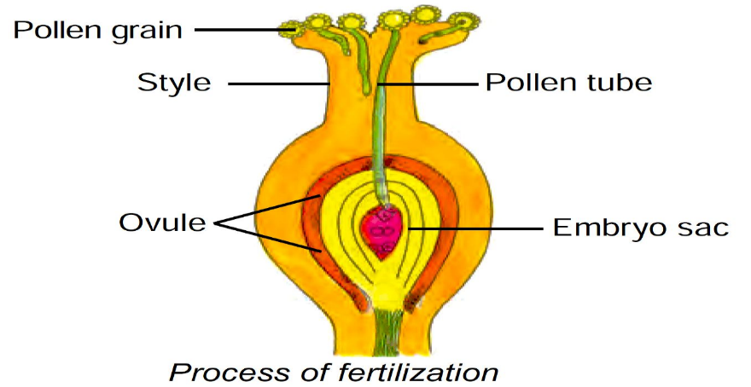

DOUBLE FERTILIZATION
The other male gamete fuses with the secondary nucleus. The secondary nucleus is diploid in nature.

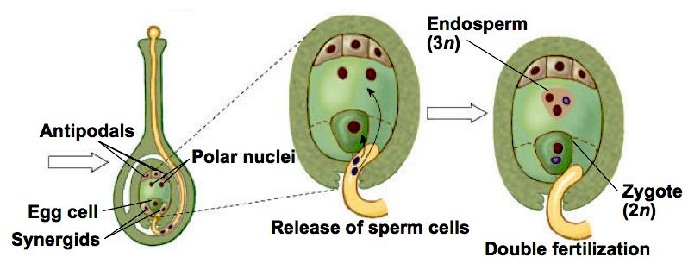

The fusion of this nucleus with the second male gamete is known as triple fusion. The triple fusion nucleus is called endosperm nucleus because it develops into endosperm.

Endosperm is a nutritive tissue meant for the development of the embryo. The process of fusion of a male gamete with egg and the other gamete with secondary nucleus is known as double fertilization.

Post fertilization events-
The ovule develops into seed.
The integuments of the ovule develop into seed coats.
The ovary enlarges and develops into fruit.

Artificial pollination- Artificial pollination is the type of pollination carried out by humans. It is a mechanical technique used to pollinate plants when natural pollination is insufficient or undesirable. It does not require the help of insects or weather.

