
THE STRUGGLE FOR INDEPENDENCE
THE QUIT INDIA MOVEMENT
SUBJECT : HISTORY
CHAPTER NUMBER: 14
CHAPTER NAME :THE STRUGGLE FOR INDEPENDENCE
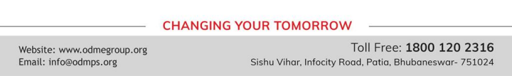
THE STRUGGLE FOR INDEPENDENCE
THE QUIT INDIA MOVEMENT session-5
Disillusioned by the failure of the Cripps Mission the Congress decided to take active steps to compel the British to grant complete independence to India. The All India Congress Committee met in Bombay on 8th August 1942 and passed the historic Quit India Resolution. Mahatma Gandhi decided to initiate a new phase of movement against the British in the middle of the Second World War which was Quit India Movement.
In the early hours of 9th August 1942, Gandhiji and all members of the Congress Working Committee were arrested. As a protest all over the country there were demonstrations and strikes. The govt resorted to firings, lathi charges and large scale arrests. Against Gandhi’s will, the Quit India Movement took a violent turn. In all corners of the country the people had expressed an intense desire for complete freedom from British rule.
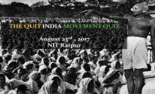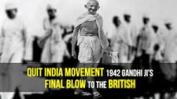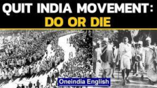
THE STRUGGLE FOR INDEPENDENCE
The Simla Conference
Lord Wavell, the new viceroy held the Simla Conference in 1945.He planned to give representative Indian leaders all the portfolios in his council except that of commander-in –chief. The Conference failed owing to the lack of agreement between the Congress and the Muslim League.
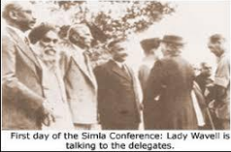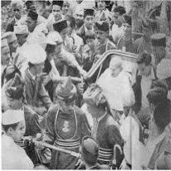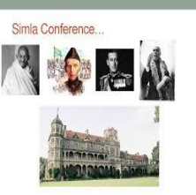
THE STRUGGLE FOR INDEPENDENCE
The Cabinet Mission
● After the second world war in Britain Labour Party under Clement Atlee came to power. He was in favours of Indian Independence.Atlee sent a Cabinet Mission consisting of Lord Pethick-Lawerence, Sir Stafford Cripps and A.V Alexander to India in March 1946, to negotiate the terms of the transfer of power with the Indian leaders. The Cabinet Mission proposed that India be federation consisting of the provinces of British India and the princely states, with the Federal centre controlling only defence, foreign affairs and communications. Both the Congress and Muslim League accepted this plan.
● In the elections to the Constituent Assembly that were held in July 1946, the Congress won an overwhelming majority of seats. Alarmed by this, the Muslim League decided to boycott the assembly and instead observed 16 August 1946 as Direct Action Day.
THE STRUGGLE FOR INDEPENDENCE
The Cabinet Mission
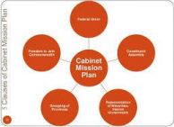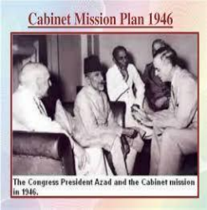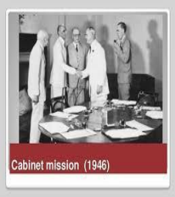
THANKING YOU
ODM EDUCATIONAL GROUP

