p
[NERVOUS SYSTEM]
| BIOLOGY | STUDY NOTES-1

Chapter-7

NERVOUS SYSTEM
Sub- Tissue, Nervous tissue, Coordination, Nervous coordination, Chemical coordination

Introduction to control & coordination

- Organisms move in response to various kinds of stimuli like light, heat, nutrients/food, etc.
- All the activities in animals are controlled and coordinated by the nervous and endocrine system.
- Hormones are chemical messengers, which assist the nervous system in carrying out various functions. They are secreted by endocrine glands.

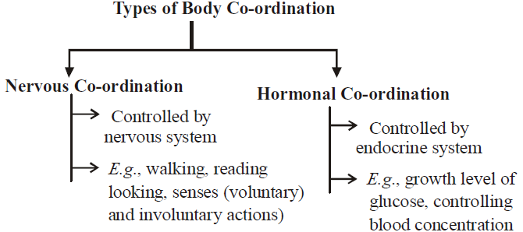

[NERVOUS SYSTEM]
| BIOLOGY | STUDY NOTES-2

Chapter-7

NERVOUS SYSTEM
Sub- Structural and Functional unit of the Nervous system
Neuron
Neuron is the structural and functional unit of the nervous system.

- Each neuron has three main parts: dendrites, cyton/soma/cell body and axon.
- Dendrites receive impulses from other neurons.
- Cyton/soma processes the impulse.
- Axon transmits the impulse, either to another neuron or to muscles/glands, etc.
- Axon may be myelinated or non-myelinated.
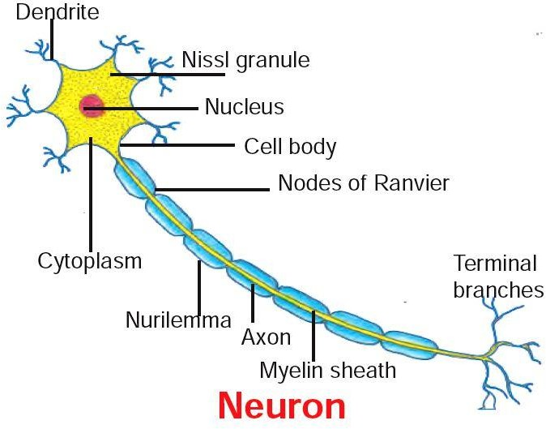
- The impulse transmission is faster in myelinated neurons.

CELL BODY
It is the cell structure irregular in shape or polyhedral structure, it is also called as cyton. Cell body contains cytoplasm with typical cell organelles and certain granular bodies are called Nissl granules

DENDRITES
Dendrites or Dendrons are shorter fibres which branch repeatedly and project out of the cell body. Dendrites transmit electrical impulses towards the cyton.

AXON
Transmission of nerve impulse: Nerve impulses travel in the following manner from one neutron to the
next :
Dendrites → cell body → axon → nerve endings at the tip of axon → synapse → dendrite of next neuron. Chemical released from axon tip of one neuron, cross the synapse or neuromuscular junction to reach the next cell.

FUNCTIONS OF THE NERVOUS SYSTEM:
- Keeps us informed.
- Enables us to remember, think and reason.
- Controls and harmonises all voluntary mascular activities .
- Regulates involuntary activities.

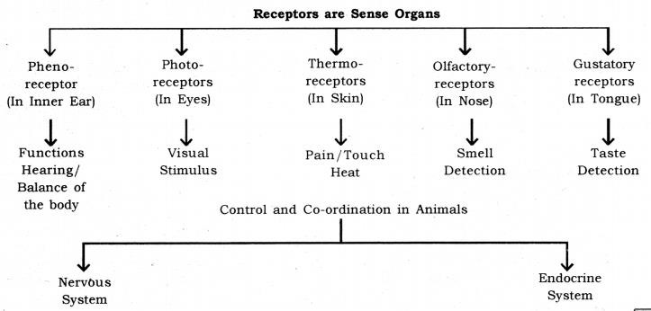

[NERVOUS SYSTEM]
| BIOLOGY | STUDY NOTES-3

Chapter-7

NERVOUS SYSTEM
Sub- Nerve, Human nervous system

NERVE: A nerve is formed of a bundle of axons enclosed in a tubular medullary sheath.
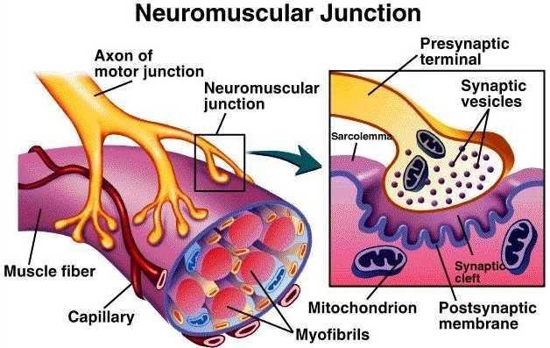

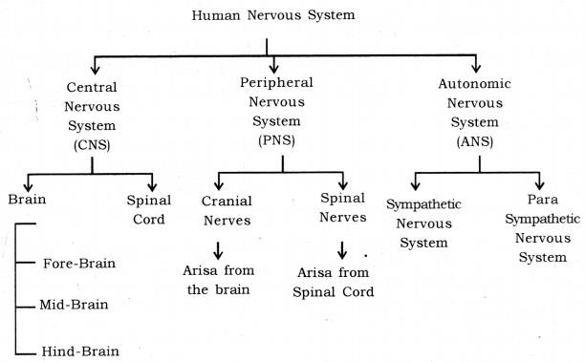

Human Nervous System: The nervous system in humans can be divided into three main parts
- Central Nervous System: The central nervous system is composed of the brain and the spinal cord. The brain controls all the functions in the human body. The spinal cord works as the relay channel for signals between the brain and the peripheral nervous system.

- Peripheral Nervous System: The peripheral nervous system is composed of the cranial nerves and spinal nerves. There are 12 pairs of cranial nerves. The cranial nerves come our of the brain and go to the organs in the head region. There are 31 pairs of spinal nerves. The spinal nerves come out of the spinal cord and go to the organs which are below the head region.

- Autonomous Nervous System: The autonomous nervous system is composed of a chain of nerve ganglion which runs along the spinal cord. It controls all the involuntary actions in the human body. The autonomous nervous system can be divided into two parts :

  - Sympathetic nervous system.
  - Parasympathetic nervous system.

Sympathetic Nervous System: This part of the autonomous nervous system heightens the activity of an organ as per the need. For example, during running, there is an increased demand for oxygen by the body. This is fulfilled by an increased breathing rate and increased heart rate. The sympathetic nervous system works to increase the breathing rate the heart rate, in this case.

Parasympathetic Nervous System: This part of the autonomous nervous system slows the down the activity of an organ and thus has a calming effect. During sleep, the breathing rate slows down and so does the heart rate. This is facilitated by the parasympathetic nervous system. It can be said that the parasympathetic nervous system helps in the conservation of energy.

[NERVOUS SYSTEM]
| BIOLOGY | STUDY NOTES-4

Chapter-7

NERVOUS SYSTEM
Sub- Central nervous system- The brain and the spinal cord.
Human Brain: Human brain is a highly complex organ, which is mainly composed of nervous tissue. The tissues are highly folded to accommodate a large surface area in less space. The brain is covered by a three- layered system of membranes, called meninges. Cerebrospinal fluid is filled between the meninges. The CSF providers cushion the brain against mechanical shocks. Furthermore, protection. The human brain can be divided into three regions, viz. forebrain, midbrain and hindbrain.

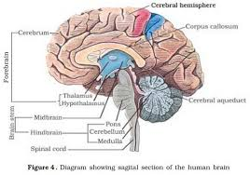

Parts of Human Brain :

  - Fore-brain: It is composed of the cerebrum.
  - Mid-brain: It is composed of the hypothalamus.
  - Hind-brain: It is composed of the cerebellum, pons, medulla, oblongata.

Some main structures of the human brain are explained below :
Cerebrum: The cerebrum is the largest part in the human brains. It is divided into two hemispheres called cerebral hemispheres.

Functions of cerebrum

- The cerebrum controls voluntary motor actions.
- It is the site of sensory perceptions, like tactile and auditory perceptions.
- It is the seat of learning and memory.

Hypothalamus: The hypothalamus lies at the base of the cerebrum. It controls sleep and wake cycle (circadian rhythm) of the body. It also controls the urges for eating and drinking.

Cerebellum: Cerebellum lies below the cerebrum and at the back of the whole structure. It coordinates the motor functions. When you are riding your bicycle, the perfect coordination between your pedalling and steering control is achieved by the cerebellum.

- It controls posture and balance.
- It controls the precision of voluntary action.

Medulla: Medulla forms the brain stem, along with the pons. It lies at the base of the brain and continues into the spinal cord. The medulla controls various involuntary functions, like hear beat respiration, etc.
It controls involuntary actions.
Example: Blood pressure, salivation, vomiting.

Pons: It relays impulses between the lower cerebellum and spinal cord, and higher parts of the brain like
the cerebrum and midbrain, also regulates respiration

THE SPINAL CORD:

- The spinal cord is a long bundle of nerves and cells that extends from the lower portion of the brain to the lower back.
- It carries signals between the brain and the rest of the body.
- This article covers the key anatomy of the spinal cord and its functions.
- It also provides some information about spinal cord injuries.
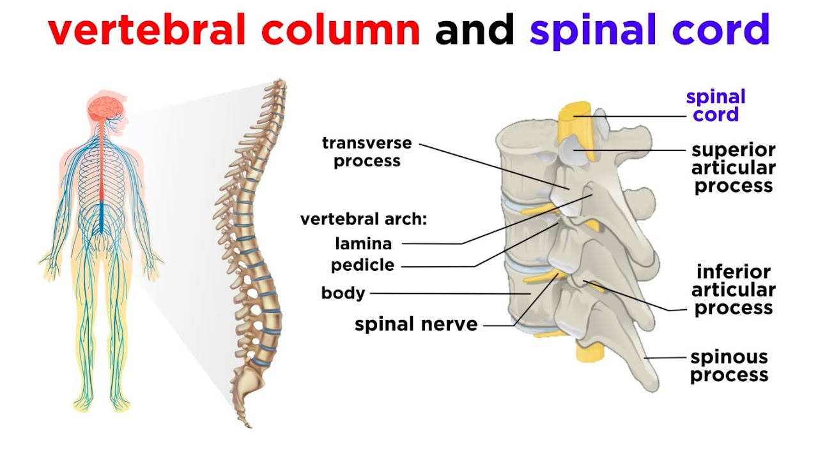

[NERVOUS SYSTEM]
| BIOLOGY | STUDY NOTES-5

Chapter-7

NERVOUS SYSTEM
Sub- Peripheral Nervous system, somatic nervous system, Autonomic Nervous system. Reflex action, Reflex arc, Types of Reflexes, Review questions

Peripheral Nervous System:
- The peripheral nervous system is composed of the cranial nerves and spinal nerves.
- There are 12 pairs of cranial nerves. The cranial nerves come our of the brain and go to the organs in the head region.
- There are 31 pairs of spinal nerves. The spinal nerves come out of the spinal cord and go to the organs which are below the head region.
Cranial Nerve.

The cranial nerves are a set of twelve nerves that originate in the brain. Each has a different function for sense or movement.

The functions of the cranial nerves are sensory, motor, or both:
- Sensory cranial nerves help a person to see, smell, and hear.
- Motor cranial nerves help control muscle movements in the head and neck.

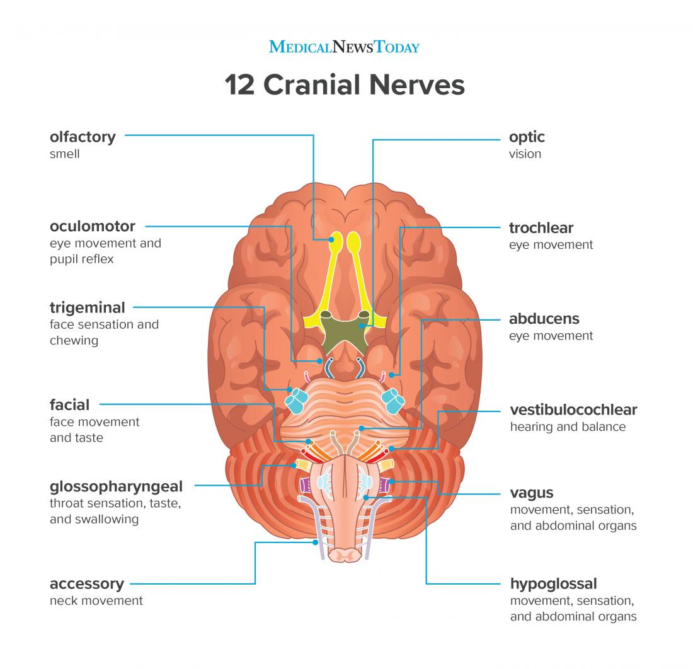

Spinal nerves.

- A spinal nerve is a mixed nerve, which carries motor, sensory, and autonomic signals between the spinal cord and the body.
- In the human body there are 31 pairs of spinal nerves, one on each side of the vertebral column. These are grouped into the corresponding cervical, thoracic, lumbar, sacral and coccygeal regions of the spine.
- There are eight pairs of cervical nerves, twelve pairs of thoracic nerves, five pairs of lumbar nerves, five pairs of sacral nerves, and one pair of coccygeal nerves.
- The spinal nerves are part of the peripheral nervous system.

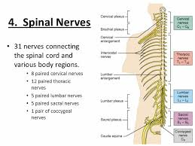

Autonomic nervous system:
- The autonomic nervous system is a component of the peripheral nervous system that regulates involuntary physiologic processes including heart rate, blood pressure, respiration, digestion, and sexual arousal.
- It contains three anatomically distinct divisions: sympathetic, parasympathetic, and enteric.

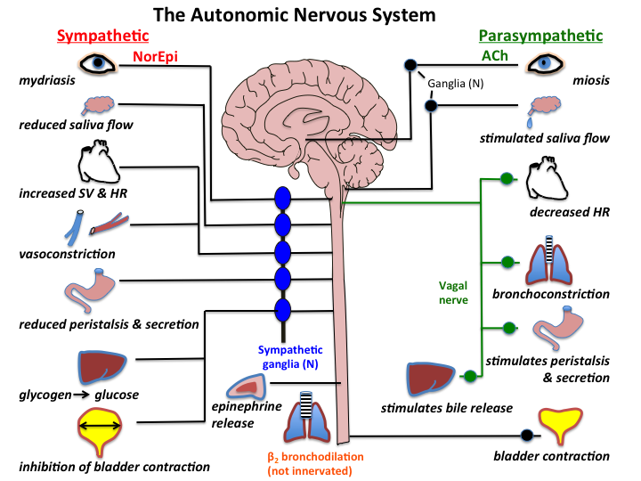

REFLEX ACTION

Reflex action is a special case of involuntary movement in voluntary organs. When a voluntary organ is in the vicinity of a sudden danger, it is immediately pulled away from the danger to save itself. For example; when your hand touches a very hot electric iron, you move away your hand in a jerk. All of this happens in flash and your hand is saved from the imminent injury. This is an example of reflex action.

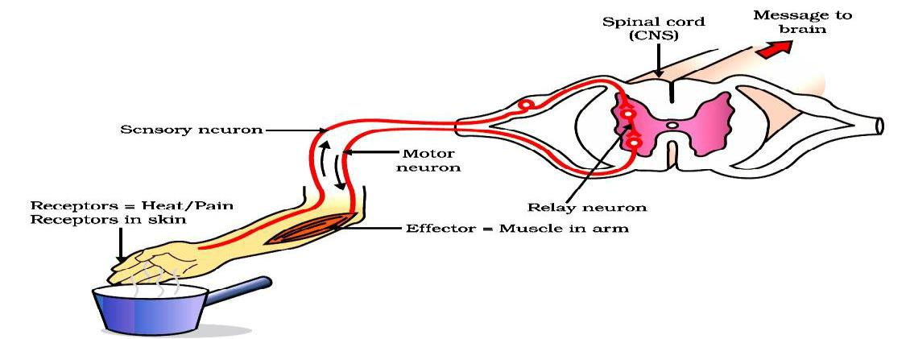

Reflex Arc: The path through which nerves signals; involved in a reflex action; travel is called the reflex arc. The following flow chart shows the flow of signal in a reflex arc.

