HALF YEARLY ASSESSMENT(2021-22)
CLASS-UKG
SUBJECT- MATHS
CONCEPTUAL SKILLS
Q1.Do as per the instruction.
a.Draw the biggest object.
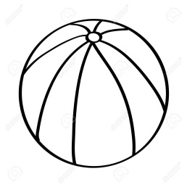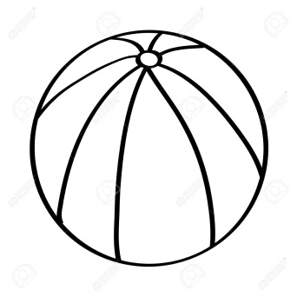
b. Colour the taller one.
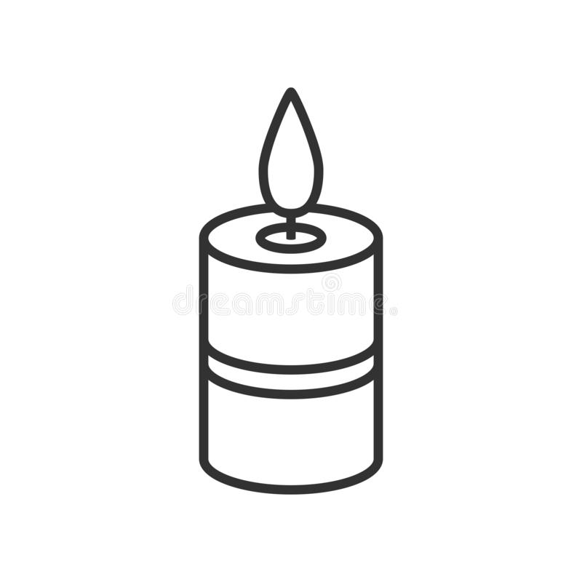

Q2. Circle the smallest number.
38, 27, 40, 92

86, 74, 51, 92

Q3. Tick  the biggest number.
75, 53, 87, 29

63, 41, 38, 17

Q4. Compare the numbers & put the correct symbol ( < or > )
a. 78 23 b. 56 65

c. 54 54 d. 97 80
COUNTING
Q5. Count forward and write the next 2 numbers.
65, _______, _______
51, _______, _______
79, _______, _______
32, _______, _______
89, _______, _______
Q6. Count and write the correct number.
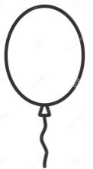


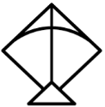

CLASSIFY AND SORT THE OBJECTS.
Q7. Encircle the different object.
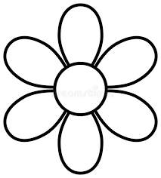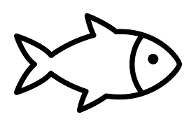
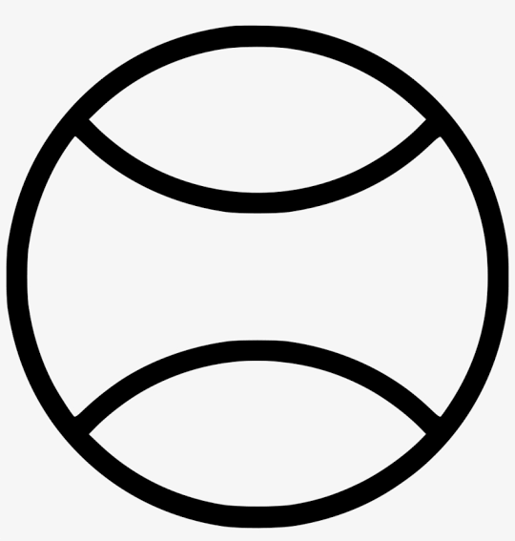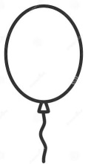
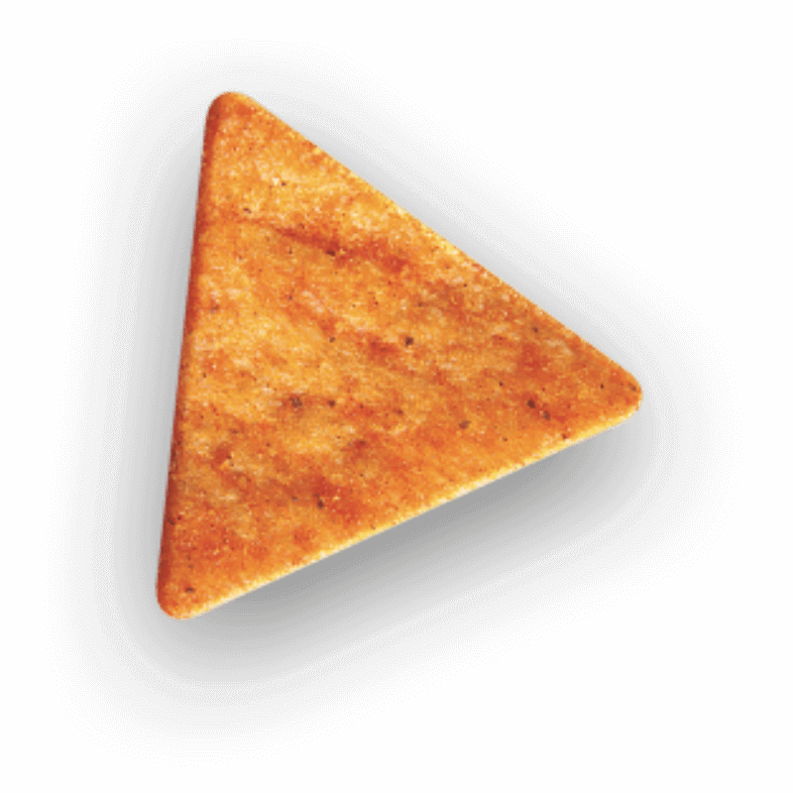
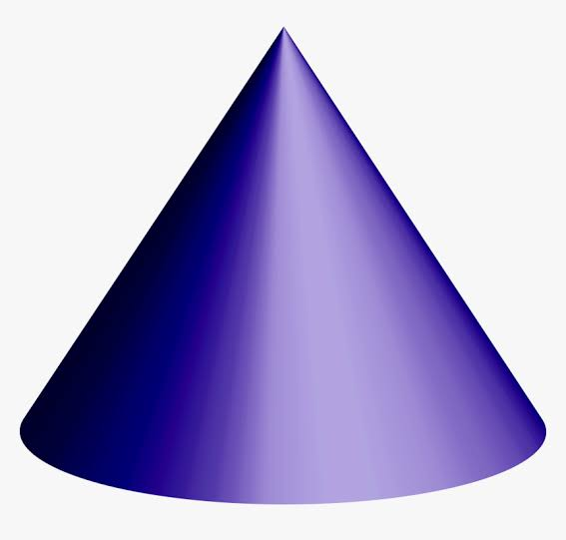
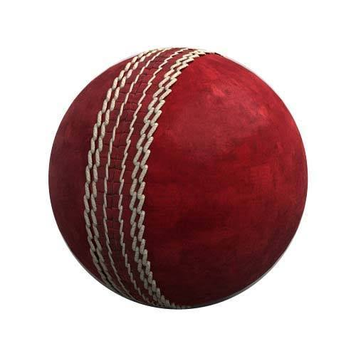

Q8. Observe the pictures and answer the following.

1 st
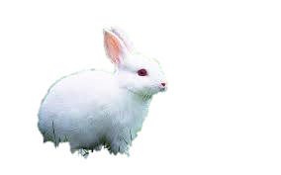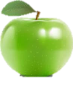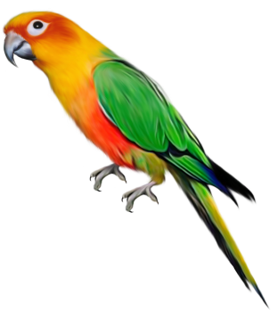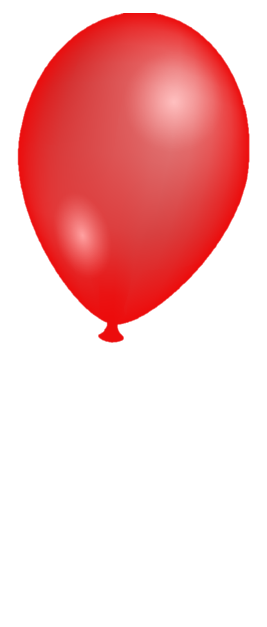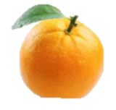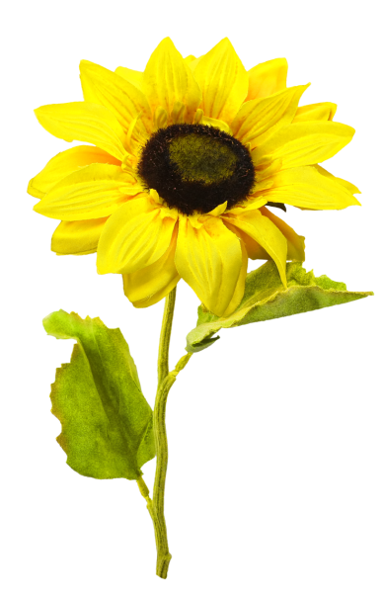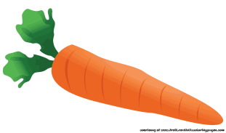
Write the position of the following objects.

NUMBER WRITING
Q9.Count backward and fill in the blanks.
76 |  | 74 | 73 |  | 71 |  |  | 68 | 67 |  | 65

Q10. Circle the correct number that comes -
After 49 - 70 50 34
Before 79 - 80 42 78
Between 44 & 46 - 67 32 45
After 69 - 70 32 68
Before 54 - 53 66 13
ORAL
Answer any 5 questions-
- Who is the tallest member in your family?
- Say the number names- 19 & 49.
- Count 5 numbers backward from 40.
- Which number comes just after 33 and just before 35 ?
- Which sign will you put if two numbers are same ?
- Say any 2 objects that are triangular in shape.
- Which one is the biggest number from the given sets-
60 70 50
35 23 46

- Count 10 forward numbers from 71.

- What is the meaning of HTO while we are writing the numbers in the
notebook ?

ALL THE BEST FOR THE ASSESSMENT

