[OUR ENVIRONMENT]
| BIOLOGY| STUDYNOTES

Chapter- 15.

Our Environment

Environment: Our surrounding is called environment.

Living organisms live in different surroundings. Some plants and animals completely live in water and some others live on land.
Man also leads life in different surroundings. Some live in cities, some in towns and some in villages.
Plants, animals, human beings survive with the interaction between them and the non-living things like air, water and land.
Human beings depend on the resources of nature. These resources include soil, water, coal, electricity, oil, gas, etc. These resources improve the lifestyle of human beings.

Environmental science can be defined as the study of organisms in relation to their surroundings.

Human activities related to livelihood and welfare generate waste. All wastes are pollutants and they create pollution in one way or another. Air, land and water surroundings are affected due to improper disposal of wastes which create an imbalance in the environment.

Pollution: Any undesirable change in the physical, chemical or biological characteristics of air, land and water that affect human life adversely is called pollution.

Pollutant: A substance released into the environment due to natural or human activity which affects adversely the environment is called pollutant. e.g. Sulphur- di-oxide, carbon-monoxide, lead, mercury, etc.

CLASSIFICATION OF WASTES
- Bio–degradable wastes
- Non–bio-degradable wastes

Substances that are broken down by biological process of biological or microbial

action are called bio-degradable waste. e.g. wood, paper and leather. Substances that are not broken down by biological or microbial action are called non-bio- degradable wastes. e.g. Plastic substances and mineral wastes.

ECO-SYSTEM — WHAT ARE ITS COMPONENTS?

A community of organisms that interact with one another and with the environment is called an ecosystem.

An ecosystem has two types of components, viz. biotic component and abiotic component.
Producers, consumers and decomposers are biotic factors.

ABIOTIC COMPONENT

All the non-living things make the abiotic component of an ecosystem. Air, water and soil are the abiotic components.
Air provides oxygen (for respiration), carbon dioxide (for photosynthesis) and other gases for various needs of the living beings.
Water is essential for all living beings because all the metabolic activities happen in the presence of water.
Soil is the reservoir of various nutrients which are utilized by plants. Through plants, these nutrients reach other living beings.

BIOTIC COMPONENT
All living beings make the biotic component of an ecosystem.
Green plants play the role of producers, because they prepare the food by photosynthesis.
Animals and other living beings play the role of consumers, because they take food (directly or indirectly) from plants.
Bacteria and fungi play the role of decomposers as they decompose dead remains of plants and animals so that raw materials of organisms can be channelized back to the environment.
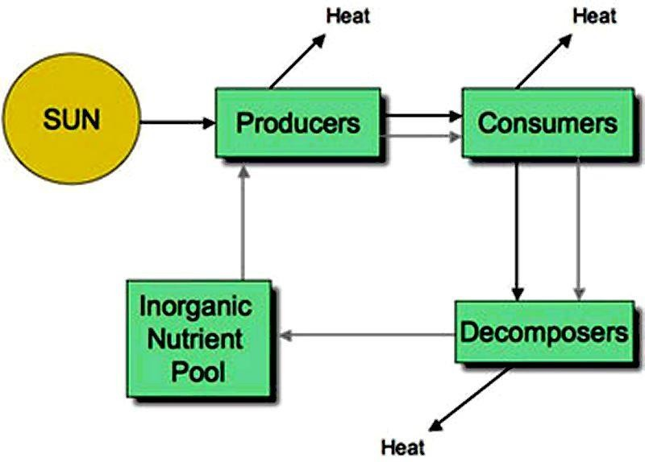 Fig. Flow of energy in an ecosystem

BALANCE IN ECO-SYSTEM
A balanced ecosystem is an ecological community together with its environment and functioning as a complex unit. An ecosystem is maintained by the balance in nature such as the balance between hawks and mice, if hawk population is larger than the mice population, then it is not balanced. They are balanced between resources like a banana tree and monkeys. If the banana trees stop growing, the monkeys won’t get bananas.

An ecosystem maintains the balance between the number of resources and the number of users or the balance between prey and predators.

FOOD CHAIN AND FOOD WEB
The ultimate source of this energy is the sun. Producers like green plants trap solar energy and convert it into the chemical energy of food. When a primary consumer eats the producer, a part of this energy is passed on to it.

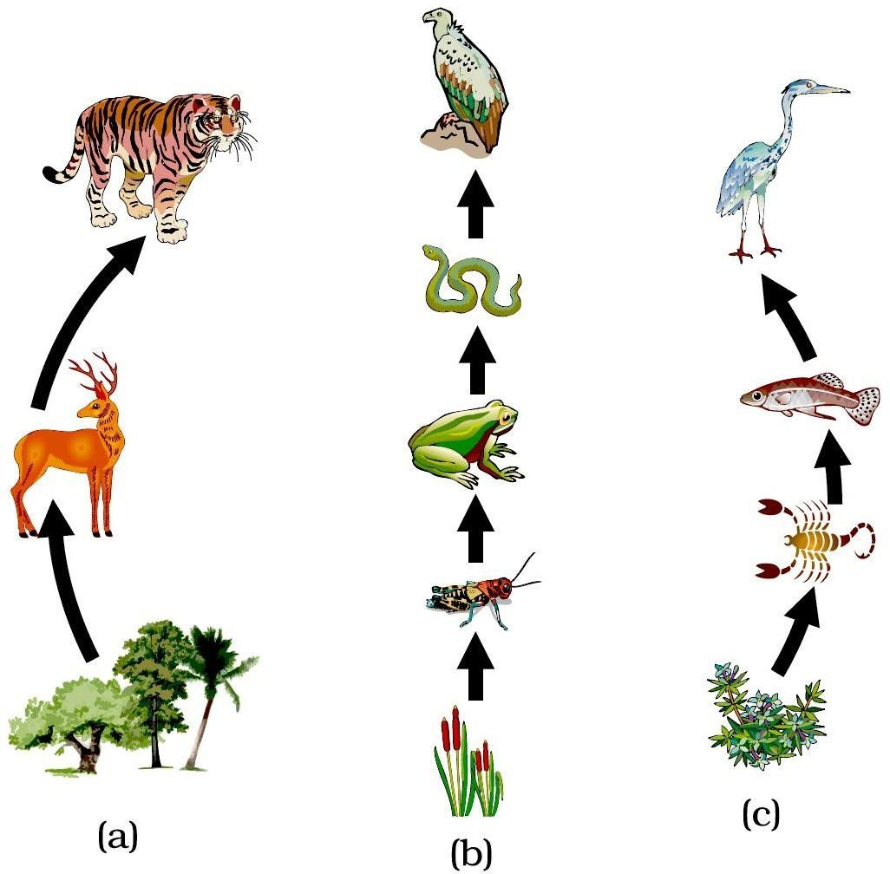

The primary consumer is then eaten by a secondary consumer. And the secondary consumer may be eaten by a tertiary consumer, and so on. In this way energy gets transferred from one consumer to the next higher level of consumer. A series of
organisms through which food energy flows in an ecosystem is called a food chain. It may also be defined as follows.

“A food chain in an ecosystem is a series of organisms in which each organism feeds on the one below it in the series.”

In a forest ecosystem, grass is eaten by a deer, which in turn is eaten by a tiger. The grass, deer and tiger form a food chain. In this food chain, energy flows from the grass (producer) to the deer (primary consumer) to the tiger (secondary consumer)

A food chain in a grassland ecosystem may consist of grasses and other plants, grasshoppers, frogs, snakes and hawks [see figure (b)].

In a freshwater aquatic ecosystem like a pond, the organisms in the food chain include algae, small animals, insects and their larvae, small fish, big fish and a fish- eating bird or animal

A food chain always begins with producers. Herbivores (plant-eaters) come next in the chain. They are consumed by carnivores (flesh-eaters). A few food chains can be long and may extend to the fourth, fifth or even sixth order of consumers

Some common food chains are mentioned below:
Plants → Deer → Lion
Plants → Worm→ Bird → Cat
Plants→ Grasshopper→ Frog→ Snake→ Hawk
Algae→ Small→ animal → Small fish → Big fish —> Bird

FOOD WEB
A food web is a graphical depiction of feeding connections among species of an ecological community. Food web consists of food chains of a particular ecosystem. The food web is a illustration of various methods of feeding that links the ecosystem. The food web also defines the energy flow through species of a community as a result of their feeding relationships. All the food chains are interconnected and overlapping within an ecosystem and they make up a food web. It increases the stability of ecosystem. It provides other source of food and allows the endangered species to grow.

TROPHIC LEVELS OF FOOD CHAINS
The levels of a food chain (food pyramid) is called Trophic levels. The trophic level of an organism is the level it holds in a food pyramid.

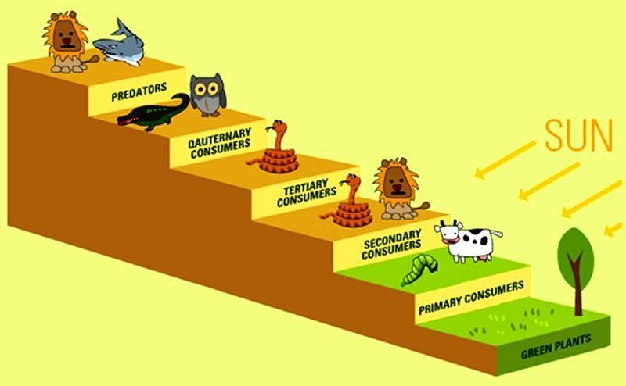

he sun is the source of all the energy in food chains. Green plants, usually the first level of any food chain, absorb some of the Sun’s light energy to make their own food by photosynthesis. Green plants (autotrophs) are therefore known as
‘Producers’ in a food chain.

The second level of the food chains is called the Primary Consumer. These consume the green plants. Animals in this group are usually herbivores. Examples include insects, sheep, caterpillars and even cows.

The third in the chain are Secondary Consumers. These usually eat up the primary consumers and other animal matter. They are commonly called carnivores and examples include lions, snakes and cats.

The fourth level is called Tertiary Consumers. These are animals that eat secondary consumers.

Quaternary Consumers eat tertiary consumers.

At the top of the levels are Predators. They are animals that have little or no natural enemies. They are the ‘bosses’ of their ecosystems. Predators feed on preys. A prey is an animal that predators hunt to kill and feed on. Predators include owls, snakes, wild cats, crocodiles and sharks. Humans can also be called predators.
When any organism dies, detrivores (like vultures, worms and crabs) eat them up. The rest are broken down by decomposers (mostly bacteria and fungi), and the exchange of energy continues. Decomposers start the cycle again.

ENERGY FLOW IS UNIDIRECTIONAL AND REQUIRES CONTINUOUS INPUTS.

Ecosystem energy processes conform to the thermodynamic laws.
- Energy cannot be made or destroyed
- Energy transformations are not perfect and energy is lost in each transformation in the form of heat.

The flow of energy in the ecosystem is unidirectional. The energy enters the plants (from the sun) through photosynthesis during the making of food. This energy is then passed on from one organism to another in a food chain.

Energy given out by the organisms as heat is lost to the environment, it does not return to be used by the plants again. This makes the flow of energy in ecosystem 'unidirectional'. Thus, the flow of energy in the ecosystem is said to be
unidirectional because the energy lost as heat from the living organisms of a food chain cannot be reused by plants in photosynthesis.

During the transfer of energy through successive trophic levels in an ecosystem, there is a loss of energy all along the path. No transfer of energy is 100 per cent. The energy available at each successive trophic level is 10 per cent of the previous level. Thus, there is a progressive decline (gradual reduction) in the amount of energy available as we go from producer level to the higher trophic levels of organisms.

The nutrient movement is a cyclic movement where the nutrients revolve round with an ecosystem, hence cyclic. Nutrients pass from abiotic nutrient stores, such as the soil and the atmosphere, into biotic, plant and animal stores (the biomass). The nutrients are then recycled, within the ecosystem, following death and decomposition.

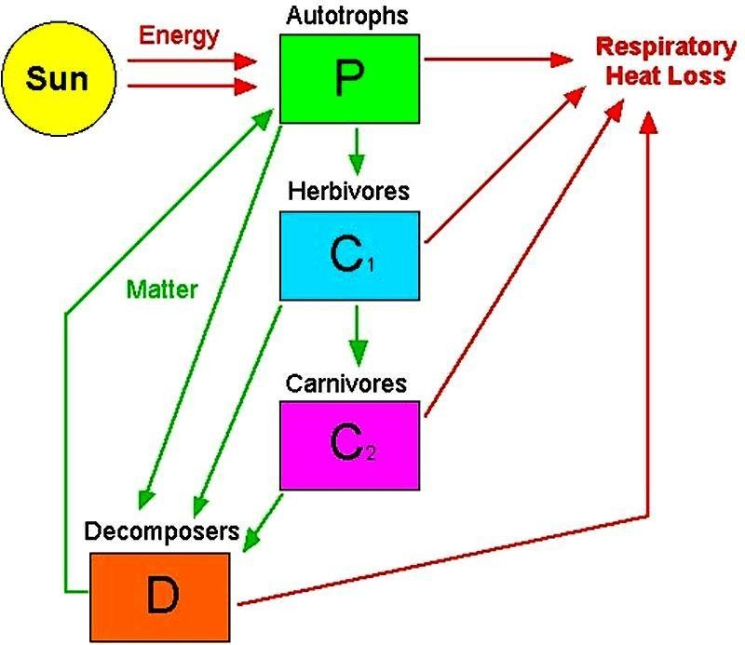

OZONE LAYER DEPLETION

Ozone (O₃) is a molecule formed by three atoms of oxygen. While O₂, which we normally refer to as oxygen, is essential for all aerobic forms of life. Ozone, is a deadly poison. However, at the higher levels of the atmosphere, ozone performs an essential function. It shields the surface of the earth from ultraviolet (UV) radiation from the Sun. This radiation is highly damaging to organisms, for example, it is known to cause skin cancer in human beings.

Ozone at the higher levels of the atmosphere is a product of UV radiation acting on oxygen (O₂) molecule. The higher energy UV radiations split apart some moleculer oxygen (O₂) into free oxygen (O) atoms. These atoms then combine with the molecular oxygen to form ozone as shown—
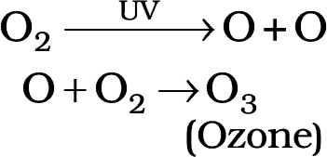

The amount of ozone in the atmosphere began to drop sharply in the 1980s. This decrease has been linked to synthetic chemicals like chlorofluorocarbons (CFCs) which are used as refrigerants and in fire extinguishers. In 1987, the United Nations Environment Programme (UNEP) succeeded in forging an agreement to freeze CFC production at 1986 levels.

HOW TO PROTECT US FROM THESE HAZARDOUS WASTES ?
The following methods are adopted for the disposal of harmful waste materials.

Land Fills
There are permanent storage facilities in secured lands for military related liquid and radioactive waste materials. High level radioactive wastes are stored in deep underground storage.

Deep well injection
It involves drilling a well into dry porous material below ground water. Hazardous waste liquids are pumped into the well. They are soaked into the porous material and made to remain isolated indefinitely.

Incineration
The burning of materials is called incineration. Hazardous bio-medical wastes are usually disposed off by means of incineration. Human anatomical wastes, discarded medicines, toxic drugs, blood, pus, animal wastes, microbiological and bio-technological wastes etc., are called bio-medical wastes.

MANAGEMENT OF NON-HAZARDOUS WASTES – SOLID
WASTE MANAGEMENT

Reuse and recycling technique

The separating out of materials such as rubber, glass, paper and scrap metal from refuse and reprocessing them for reuse is named as reclamation of waste or recycling.

Paper

(54% recovery) Can be repulped and reprocessed into recycled paper, cardboard and other products.

Glass
(20% recovery) Can be crushed, remelted and made into new containers or crushes used as a substitute for gravel or sand in construction materials such as concrete and asphalt, Food waste and yard wastes (leaves, grass etc.,) can be composted to produce humus soil

ODM Educational Group

Page

