[LIFE PROCESSES]
| BIOLOGY | STUDY NOTES-1

Chapter-6
Life processes

Introduction

Life
Earth happens to be the only known planet having a life. There are beings wh0 live, die and become part of nature again. The living organism can be differentiated from the inanimate entities on various parameters of life processes.

Life Process
- Maintenance of living organism is essential even if they are moving, resting or even sleeping.
- The processes which together perform the function of maintenance of ‘life’ are called as life processes.
- Nutrition, respiration, circulation, excretion are examples of essential life processes.
- In unicellular organisms, all these processes are carried out by that single cell.
- In multicellular organisms, well-developed systems are present to carry out the processes.

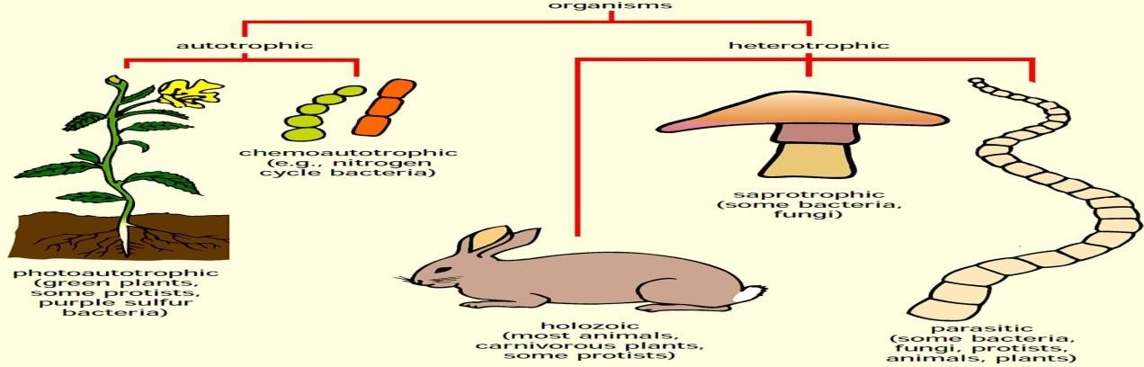

[LIFE PROCESSES]
| BIOLOGY | STUDY NOTES -2

Chapter-6
Life processes.
Nutrition-The process of obtaining energy through consumption of food is called as nutrition.

Autotrophic Nutrition: The mode of nutrition in which an organism prepares its own food is calledautotrophic nutrition. Green plants and blue- green algae follow the autotrophic mode ofnutrition
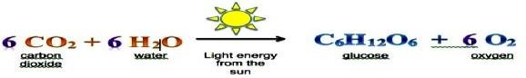

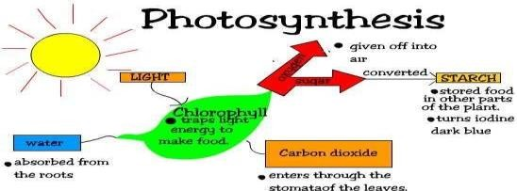

- Absorption of light energy by chlorophyll.
- Conversion of light energy to chemical energy and splitting of water molecules into hydrogen and oxygen
- Reduction of carbon dioxide into carbohydrates.

ACTIVITY 6.1 – Chlorophyll is necessary for photosynthesis.
ACTIVITY 6.2 –Carbon dioxide is necessary for photosynthesis.
Opening and closing of stomata -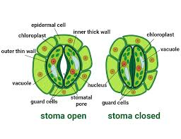

Heterotrophic Nutrition: The mode of nutrition in which an organism takes food from another organism is called heterotrophic nutrition.
Saprophytic Nutrition: In saprophytic nutrition; the organism secretes the digestive juices on the food.
Holozoic Nutrition: In holozoic nutrition; the digestion happens inside the body of the organism, i.e. after the food is ingested. Most of the animals follow this mode of nutrition.
Steps of Holozoic Nutrition-
1-Ingestion: The process of taking in the food is called ingestion.
2- Digestion: The process of breaking complex food substances into simple
molecules is called digestion. Simple molecules; thus obtained; can be absorbed by the body.
3- Absorption: The process of absorption of digested food is called absorption.
4 -Assimilation: The process of utilization of digested food; for energy and for growth and repair is called assimilation.
5- Egestion:-The process of removing undigested food from the body is called egestion.
HOW DO ORGANISMS OBTAIN THEIR NUTRITION?

Nutrition in an Amoeba occurs through a process called phagocytosis where the entire organism pretty much engulfs the food it plans on eating up. The mode of nutrition in amoeba is known as holozoic nutrition. It involves the ingestion, digestion , absorption,assimilation,and egestion of food material.
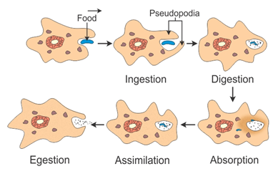

[LIFE PROCESSES]
| BIOLOGY | STUDY NOTES -3

Chapter-6
Life processes.
Nutrition in Human Beings.
The human digestive system comprises of the alimentary canal and associated digestive glands.
- Alimentary Canal: It comprises of mouth, oesophagus, stomach, small intestine and large intestine.
- Associated Glands: Main associated glands are
  - Salivary gland
  - Gastric Glands
  - Liver
  - Pancreas
Mouth or Buccal Cavity:
- The mouth has teeth and tongue. Salivary glands are also present in the mouth.
- The tongue has gustatory receptors which perceive the sense of taste.
- The tongue helps in turning over the food so that saliva can be properly mixed in it.
- Teeth help in breaking down the food into smaller particles so that, swallowing of food becomes easier.
- There are four types of teeth in human beings. The incisor teeth are used for cutting the food.
- The canine teeth are used for tearing the food and for cracking hard substances.
- The premolars are used for the coarse grinding of food. The molars are used for fine grinding of food.

Dental caries-Dental caries causes gradual softening of enamel and dentine.
It begins when bacteria acting on sugars produce acids that softens or demineralizes the enamel.
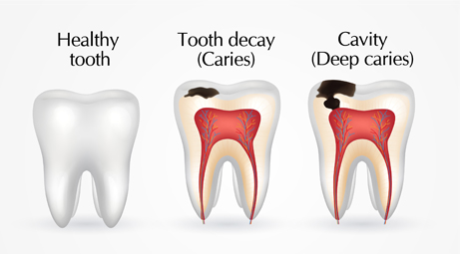
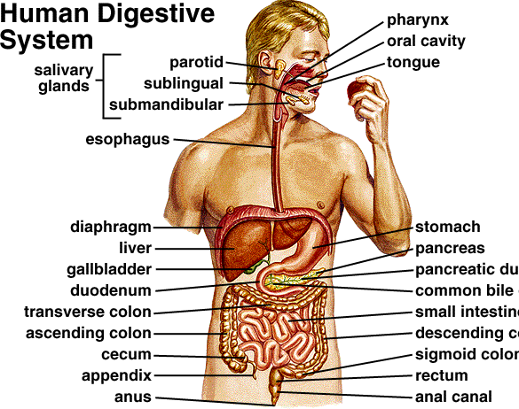

Salivary glands secrete saliva: Saliva makes the food slippery which makes it easy to swallow the food. Saliva also contains the enzyme salivary amylase or ptyalin. Salivary amylase digests starch and converts it into sucrose, (maltose).
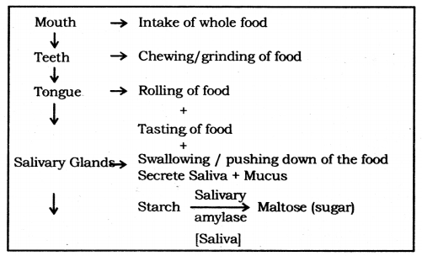

oesophagus: Taking food from mouth to stomach by Peristaltic movement.
Peristaltic movement: Rhythmic contraction of muscles of the lining of the alimentary canal to push the food forward.
Stomach
- Stomach is a bag-like organ. Highly muscular walls of the stomach help in churning the food.
- The walls of the stomach secrete hydrochloric acid. Hydrochloric acid kills the germs which may be present in food.
- Moreover, it makes the medium inside the stomach as acidic. The acidic medium is necessary for gastric enzymes to work.
- The enzyme pepsin, secreted in the stomach, does partial digestion of protein.
- The mucus, secreted by the walls of the stomach saves the inner lining of the stomach from getting damaged from hydrochloric acid.
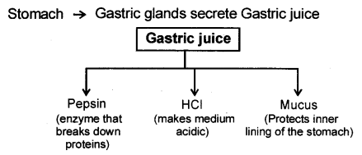
Small Intestine: It is a highly coiled tube-like structure. The small intestine is longer than the large intestine but its lumen is smaller than that of the large intestine. The small intestine is divided into three parts, like duodenum, jejunum and ileum.
Liver: Liver is the largest organ in the human body. The liver manufactures bile, which gets stored in the gall bladder. From the gall bladder, bile is released as and when required.
Pancreas: Pancreas is situated below the stomach. It secretes pancreatic juice which contains many digestive enzymes.
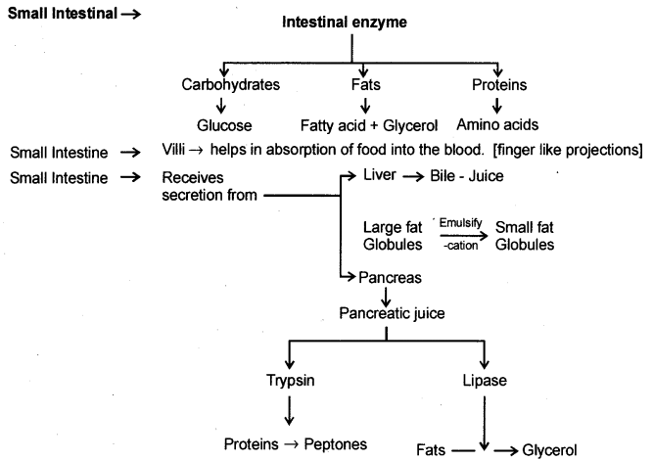

Bile and pancreatic juice go to the duodenum through a hepatopancreatic duct. Bile breaks down fat into smaller particles. This process is called emulsification of fat. After that, the enzyme lipase digests fat into fatty acids and glycerol.
Trypsin and chymotrypsin are enzymes which digest protein into amino acids.
Complex carbohydrates are digested into glucose. The major part of digestion takes place in the duodenum

Large Intestine:
- Large intestine is smaller than the small intestine.
- Undigested food goes into the large intestine.
- Some water and salt are absorbed by the walls of the large intestine. After that, the undigested food goes to the rectum, from where it is expelled out through the anus.
- Large Intestine absorb excess of water. The rest of the material is removed from the body via the anus. (Egestion).

[LIFE PROCESSES]
| BIOLOGY | STUDY NOTES -4

Chapter-6
Life processes.

Respiration-The process by which a living being utilizes the food to get energy is called respiration. Respiration is an oxidation reaction in which carbohydrate is oxidized to produce energy.
Mitochondrion is the site of respiration and the energy released is stored in the form of ATP (Adenosine triphosphate).
ATP is stored in mitochondria and is released as per need.

Types of Respiration
There are two types of respiration:

Aerobic respiration
It is a type of cellular respiration that takes place in the presence of oxygen to produce energy. It is a continuous process that takes place within the cells of animals and plants. This process can be explained with the help of the chemical equation:
Glucose(C₆H₁₂O₆) + Oxygen(6O₂) → Carbon dioxide(6CO₂) + Water(6H₂O)+ Energy (ATP)

Anaerobic respiration
It is a type of cellular respiration that takes place in the absence of oxygen to produce energy. The chemical equation for anaerobic respiration is
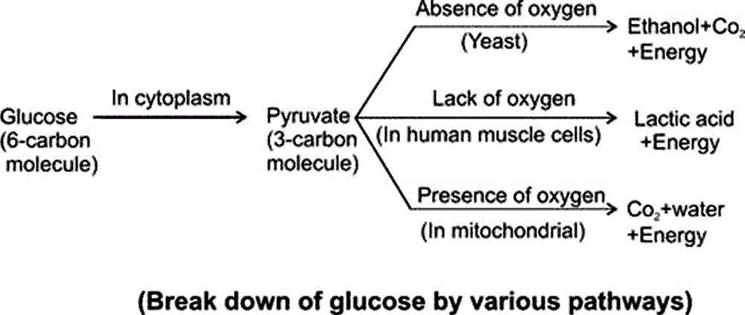
Glucose(C₆H₁₂O₆) → Alcohol 2(C₂H₅O H) + Carbon dioxide 2(CO₂) + Energy (ATP )

[LIFE PROCESSES]
| BIOLOGY | STUDY NOTES-5

Chapter-6
Life processes.
SUBTOPICS-
Human Respiratory system- Following are the main structures in the human respiratory system:
- Nostrils: There are two nostrils which converge to form a nasal passage. The inner lining of the nostrils is lined by hair and remains wet due to mucus secretion. The mucus and the hair help in filtering the dust particles out from inhaled air. Further, air is warmed up when it enters the nasal passage.
- Pharynx: It is a tube-like structure which continues after the nasal passage.
- Larynx: This part comes after the pharynx. This is also called voice box.
- Trachea: This is composed of rings of cartilage. Cartilaginous rings prevent the collapse of trachea in the absence of air.
- Bronchi: A pair of bronchi comes out from the trachea, with one bronchus going to each lung.
- Bronchioles: A bronchus divides into branches and sub-branches inside the lung.
- Alveoli: These are air sacs at the end of bronchioles. The alveolus is composed of a very thin membrane and is the place where blood capillaries open. This is alveolus, where the oxygen mixes with the blood and carbon dioxide exits from the blood. The exchange of gases, in alveoli, takes place due to the pressure differential.
passage of air through the respiratory system in human beings:
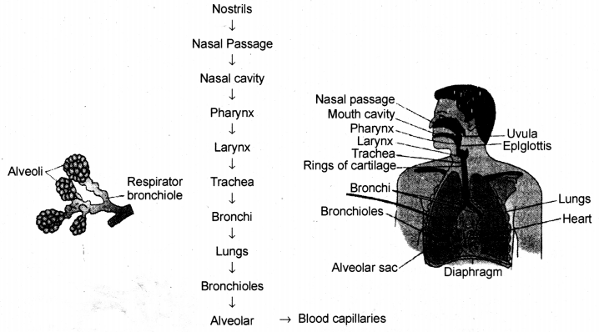
Mechanism of Respiration:
Breathing Mechanism
- The breathing mechanism of lungs is controlled by the diaphragm and the intercostalis muscles.
- The diaphragm is a membrane which separates the thoracic chamber from the abdominal cavity.
- When the diaphragm moves down, the lungs expand and the air is inhaled.
- When the diaphragm moves up, the lungs contract and air are exhaled.
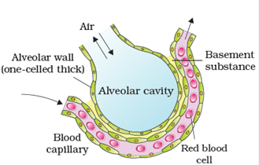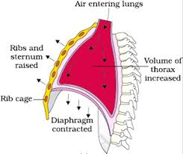
- exchange gases through stomata.
- The large inter-cellular spaces ensure that all the cells are in contact with air.
- Carbon dioxide and oxygen are exchanged in and out of the cells by the process of
- Diffusion is directed by environmental conditions and the requirements of the plants.
- During night, in the absence of sunlight photosynthesis do not take place and hence carbon dioxide is released but not used up by the plants.
- During the day, there is no carbon dioxide release because the released carbon dioxide is used up by the plants for photosynthesis.
- Oxygen is released instead of carbon dioxide during the day.
- Respiration in Lower Animals
- Lower animals lack a sophisticated respiratory system like lungs, alveoli etc.
- Respiration in them takes place by simple exchange mechanisms.
- Animals like earthworms take in gases through their skin.
- Fishes have gills for gaseous exchange.
- Insects have a tracheal system, which is a network of tubes, through which air circulates and gaseous exchange takes place.
- Frogs breathe through their skin when in water and through their lungs when on land.

Respiration in Plants
- Unlike animals and humans, plants do not have any specialized structures for gaseous exchange
- They have stomata (present in leaves) and lenticels (present in stems) which are involved in the exchange of gases.
- Compared to animals, plant roots, stems, and leaves respire at a very lower rate.

[LIFE PROCESSES]
| BIOLOGY | STUDY NOTES-6

Chapter-6
Life processes.
Transportation
- All living organisms need a few necessary components like air, water, and food for their survival.
- On our regular basis, animals ensure these elements by breathing, drinking and eating.
- The required elements are transported to their body cells and tissues by a transportation system.
- In plants, the vascular tissue is responsible for transporting the substances.

Transportation in Human beings
- Transportation in humans is done by the circulatory system.
- The circulatory system in humans mainly consists of blood, blood vessels and heart.
- It is responsible for the supply of oxygen, nutrients, removal of carbon dioxide and other excretory products.
It also helps to fight the infections
Blood Vessels
- Blood vessels carry blood throughout the body.
- There three types of blood vessels; arteries, veins and blood capillaries.
- Arteries carry oxygenated blood and veins carry deoxygenated blood.
- Gaseous exchange takes place between blood and cells at capillaries.
Difference between Arteries and Veins
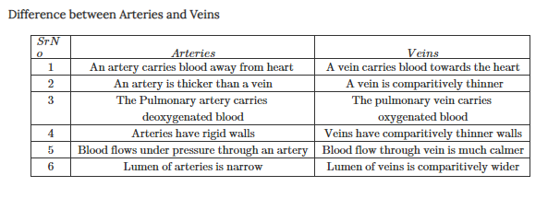
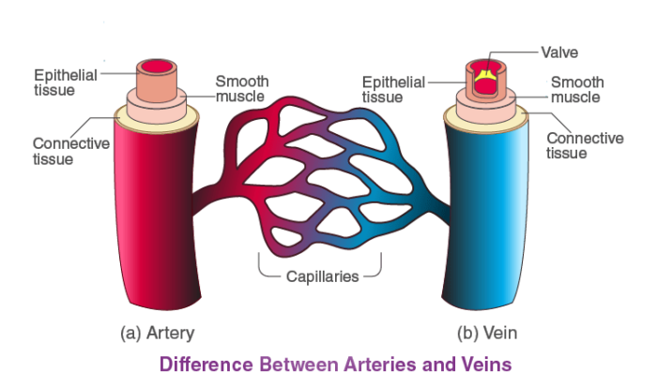Bleeding
- Bleeding occurs when the blood vessels rupture.
- Bleeding is stopped by the platelets that help in the clotting of blood at the site of the injury.
- Blood Clotting is the process of forming a clot in order to prevent excess loss of blood from the body.
- It is a gel-like mass which is formed by the platelets and a fibre-like protein in the blood.
Blood Pressure
The pressure exerted by the blood when it flows through the blood vessels is called blood pressure.
- There are two different variants of blood pressure; the systolic and the diastolic blood pressure.
- The pressure exerted on the walls of arteries when the heart is filling with blood is called diastolic pressure. It constitutes the minimum pressure on arteries.
- The normal range of diastolic blood pressure should be 60 – 80 mm Hg.
- The pressure exerted on the walls of arteries when the heart is pumping the blood is called systolic pressure. It constitutes the maximum pressure applied on the arteries.
- The normal range of systolic blood pressure should be 90 – 120 mm Hg.

[LIFE PROCESSES]
| BIOLOGY | STUDY NOTES-7

Chapter-6
Life processes.
Heart
- The muscular organ which is located near the chest slightly towards the left in the thoracic region.
- The heart is the main pumping organ of the body.
- The human heart is divided into four chambers which are involved in the transportation of oxygenated and deoxygenated blood.
- The upper two chambers are called atria whereas the lower two chambers are called as ventricles.
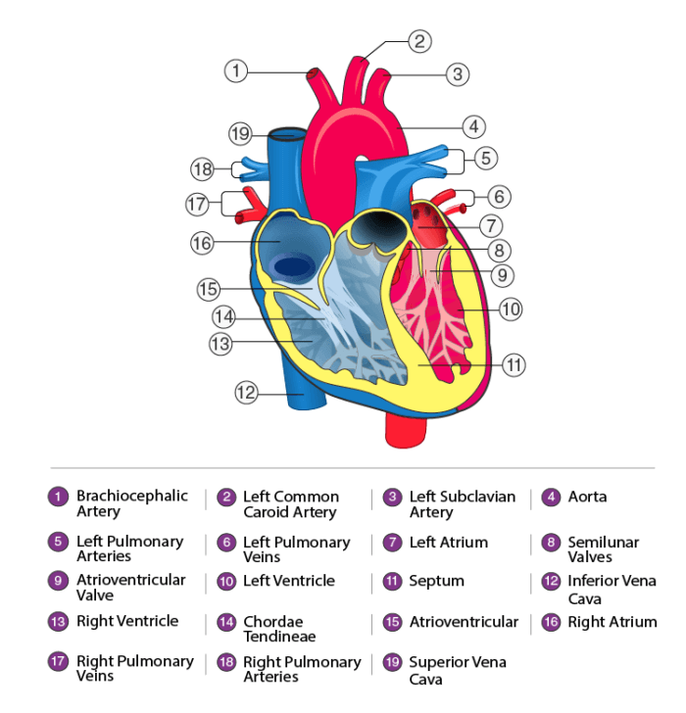 Double Circulation
- In the human body, blood circulates through the heart twice.
- Once it goes through the heart during pulmonary circulation and second time during systemic circulation.
- Hence, circulation in human beings is called double circulation.
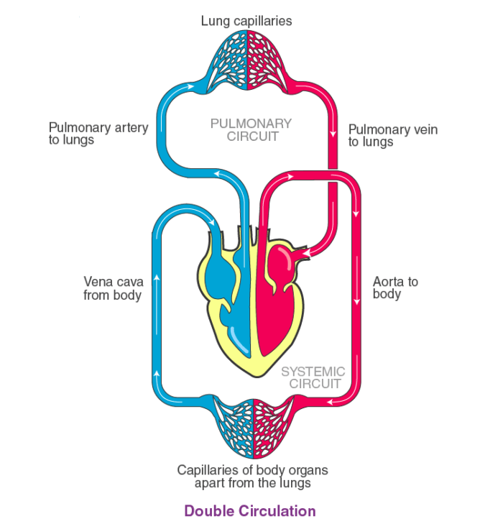

[LIFE PROCESSES]
| BIOLOGY | STUDY NOTES-8

Chapter-6
Life processes.
Lymph:
- Lymph is similar to blood but RBCs are absent in lymph.
- Lymph is formed from the fluid which leaks from blood capillaries and goes to the intercellular space in the tissues. This fluid is collected through lymph vessels and finally return to the blood capillaries.
- Lymph also plays an important role in the immune system.
- Lymph a yellowish fluids escape from the blood capillaries into the intercellular spaces contain less proteins than blood.
- Lymph flows from the tissues to the heart assisting in transportation and destroying germs.

[LIFE PROCESSES]
| BIOLOGY | STUDY NOTES-9

Chapter-6
Life processes.
SUBTOPICS-

Transportation in Plants
- Transportation is a vital process in plants.
- The process involves the transportation of water and necessary nutrients to all parts of the plant for its survival.
- Food and water transportation takes place separately in plants.
- Xylem transports water and phloem transports food.
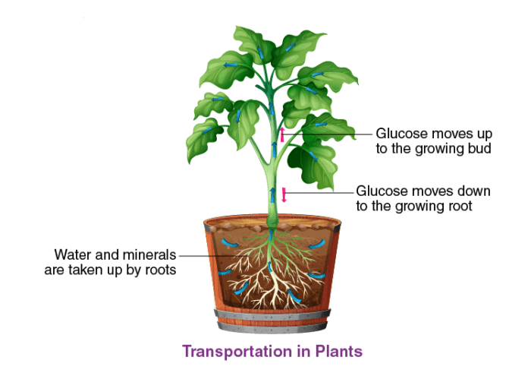Phloem
- The phloem is responsible for translocation of nutrients and sugar like carbohydrates, produced by the leaves to areas of the plant that are metabolically active.
- Sieve tubes, companion cells, phloem fibres, and phloem parenchyma cells are the components of this tissue
- The flow of material through phloem is bidirectional.
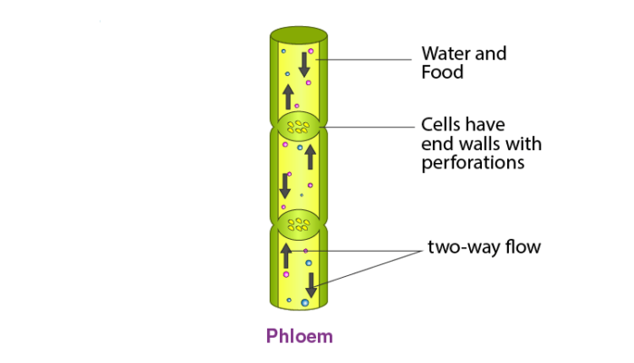

Translocation
- Transport of food in the plant through phloem via a process such as mass flow is called as translocation.
- Photosynthates i.e. sugars and organic molecules such as amino acids, organic acids, proteins and inorganic solutes like potassium, magnesium, nitrate, calcium, sulfur and iron from source tissues (mature leaves) to the sink cells (areas of growth and storage) are transported through the phloem.
- Material like sucrose is loaded from leaves to phloem using the energy of ATP.
- Such a transfer increases the osmotic pressure causing movement of water from nearby cells into in phloem tissue and the material gets transported through the phloem.
- The same pressure is also responsible for the transfer of substances from phloem to tissues where food is required.
- Thus the bulk flow of material through phloem takes place in response to an osmotically generated pressure difference.
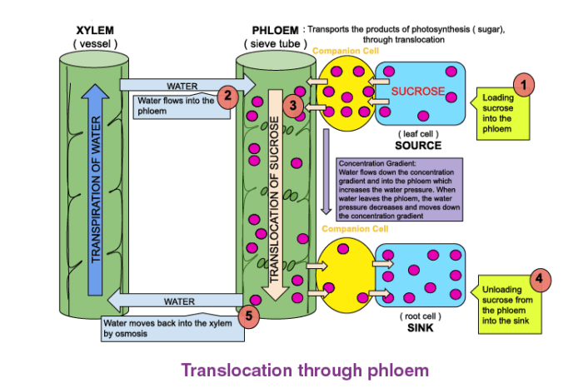Xylem
- Xylem tissue transports water in plants from root to all other parts of the plant.
- Xylem tissue is made up tracheids, vessels, xylem fibres and xylem parenchyma.
- The flow of water and minerals through xylem is always unidirectional.
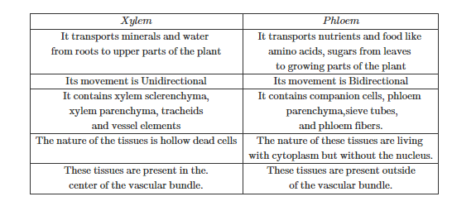
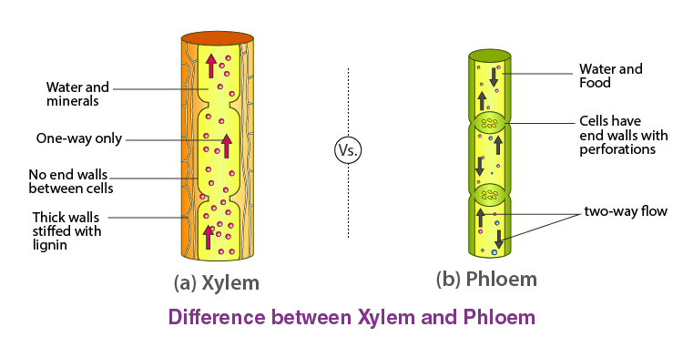

Root Pressure
- Conduction of water through the xylem, from roots to upper parts of plants, is due to many forces acting together.
- One of the forces responsible for this is root pressure.
- Root pressure is osmotic pressure within the cells of a root system that causes sap to rise through a plant stem to the leaves.
- Root pressure helps in the initial transport of water up the roots.

Transport of Water
- Water is absorbed by the roots and is transported by xylem to the upper parts of the plant.
Imbibition, osmosis, root pressure and transpiration are the forces that contribute towards the upward movement of water, even in the tallest plants.
- Imbibition is a process in which water is absorbed by the solids. E.g. seeds take up water when soaked.
- Osmosis is a process where water moves from the area of its lower concentration to the area of its higher concentration.
- At the roots, the cells take up ions by an active process and this results in the difference of concentration of these ions.
- It leads to movement of water, in the root cells, by osmosis.
- This creates a continuous column of water that gets pushed upwards. This is root pressure.
- Transpiration contributes to the upward movement of water by creating a staw effect.
- It pulls the water column upwards as there is a continuous loss of water from leaves.
All these forces act together for water transport through the xylem

Ascent of sap: The upward movement of water and minerals from roots to different plant parts is called ascent of sap. Many factors are at play in ascent of sap and it takes place in many steps. They are explained as follows :
- Root pressure: The walls of cells of root hairs are very thin. Water from soil enters the root hairs because of osmosis. Root pressure is responsible for movement of water up to the base of the stem.
- Capillary action: A very fine tube is called capillaiy, water, or any liquid, rises in the capillary because of physical forces and this phenomenon is called capillary action. Water, in stem, rises up to some height because of capillaiy action.
- Adhesion-cohesion of water molecules: Water molecules make a continuous column in the xylem because of forces of adhesion and cohesion among the molecules.
- Transpiration pull: Loss of water vapour through stomata and lenticels, in plants, is called transpiration. Transpiration through stomata creates vacuum which creates a suction, called transpiration pull. The transpiration pull sucks the water column from the xylem tubes and thus, water is able to rise to great heights in even the tallest plants.
- Transport of food: Transport of food in plants happens because of utilization of energy. Thus, unlike the transport through xylem, it is a form of active transport. Moreover, the flow of substances through phloem takes place in both directions, i.e., it is a two-way traffic in phloem.
Transpiration is the process of loss of water as vapour from aerial parts of the plant.
Functions
- Absorption and upward movement of water and minerals by creating pull.
- Helps in temperature regulation in plant.
Transport of food from leaves (food factory) to different parts of the plant is called Translocation.

[LIFE PROCESSES]
| BIOLOGY | STUDY NOTES-10

Chapter-6
Life processes.
SUBTOPICS-
Excretion
Excretion is the process of removal of metabolic waste material and other non-useful substances.
- Organisms like animals have an advanced and specialized system for excretion.
- But plants lack a well-developed excretory system like that in animals.
- They do not have special organs for excretion and thus excretion in plants is not so complex.

Excretory System of Humans
- The excretory system in humans includes
  - a pair of kidneys,
  - a pair of ureters,
  - a urinary bladder and
  - urethra.
- It produces urine as a waste product.
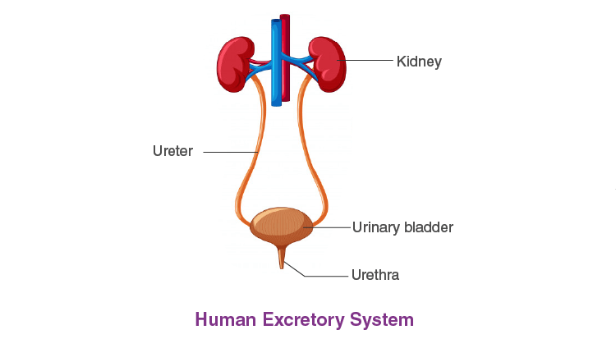Kidneys
- Paired kidneys are the main excretory organs of the body.
- They are basically the filtration units of the human body.
- Each kidney is made up many tiny filtration units called nephrons.
- Kidneys perform crucial functions like:
- Filtering waste materials, medications, and toxic substances from the blood.
- Regulation of osmolarity i.e. fluid balance of the body.
- Regulation of ion concentration in the body.
- Regulation of pH.
- Regulation of extracellular fluid volume.
- Secreting hormones that help produce red blood cells, promote bone health, and regulate blood pressure
[LIFE PROCESSES]
| BIOLOGY | STUDY NOTES-11

Chapter-6
Life processes
Nephron
Nephrons are the structural and functional unit of kidney.
- Each kidney has millions of nephrons and it forms the basic structural and functional unit of the kidney.
- Each nephron has two parts: Malpighian body and renal tubule.
- Malpighian body is made up of cup-like structure called Bowman’s capsule which encloses a bunch of capillaries called glomerulus.
- They together filter waste materials along with many useful substances.
- Renal tubule has regions called proximal convoluted tubule, Loop of Henle and distal convoluted tubule.
- These regions absorb back useful substances into the blood and also filter remaining waste substances.
- The output from nephrons is called urine.
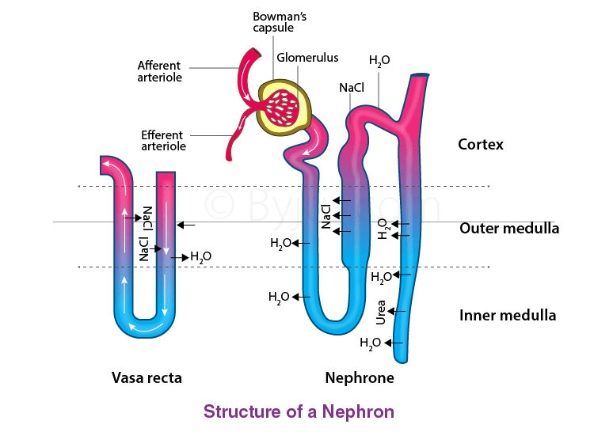

Haemodialysis

  - When the kidneys fail, it results in a lot of complications and to compensate this situation a technology called dialysis has been developed.
  - It uses a machine filter called a dialyzer or artificial kidney.
  - This is to remove excess water and salt, to balance other electrolytes in the body and remove waste products of metabolism.
  - Blood from the body is removed and flowed through a series of tubes made up of a semipermeable membrane.

  - A dialysate flows on the other side of the membrane, which draws impurities through the membrane.

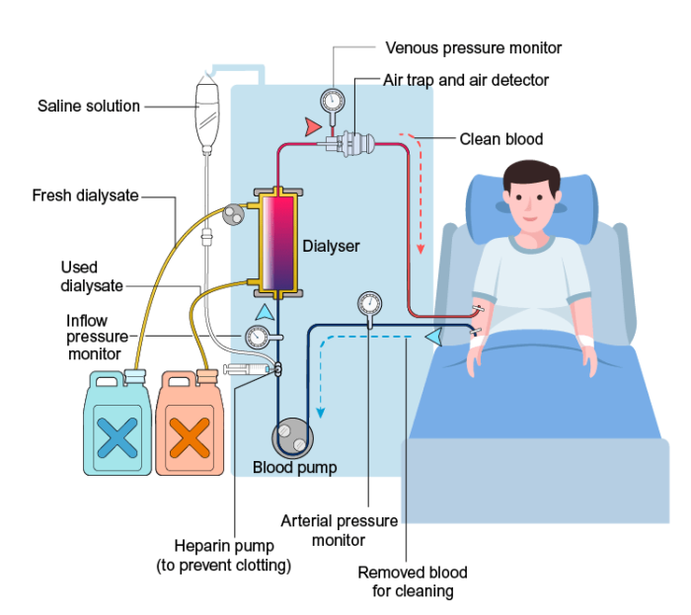

[LIFE PROCESSES]
| BIOLOGY | STUDY NOTES-12

Chapter-6
Life processes.

Excretion in Plants
- The cellular respiration, photosynthesis, and other metabolic reactions produce a lot of excretory products in plants.
- Carbon dioxide, excess water produced during respiration and nitrogenous compounds produced during protein metabolism are the major excretory products in plants.
- Plants produce two gaseous waste products i.e. oxygen during photosynthesis and carbon dioxide during respiration.
- Excretion of gaseous waste in plants takes place through stomatal pores on leaves.
- Oxygen released during photosynthesis is used for respiration while carbon dioxide released during respiration is used for photosynthesis.
- Excess water is excreted by transpiration.
- Organic by-products generated by the plant are stored in different forms in different parts.
- The gums, oils, latex, resins, etc. are some waste products stored in plant parts like barks, stems, leaves, etc.
- Eventually, plants shed off these parts.
- Few examples of the excretory products of plants are oil produced from orange, eucalyptus, jasmine, latex from the rubber tree, papaya tree, and gums from acacia.
- Sometimes plants even excrete into the soil.

