CLASS: IX
SUBJECT:BIOLOGY
LESSON-DIVERSITY IN LIVING ORGANISMS

Date: 18/01/2022
HOMEWORK

Answer the following questions in detail (each question carries 5 marks)

1. (a) In the human body what is the role of-
(i) seminal vesicles, and (ii) prostate gland?
(b) List two functions performed by testis in human beings.

2. (a) Name the parts labelled A, B, C, D and E.
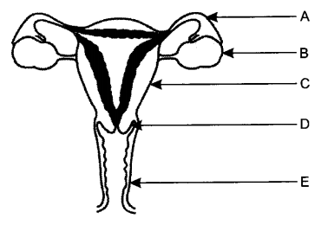

(b) Where do the following functions occur?
(i) Production of an egg (ii) Fertilisation (iii) Implantation of zygote.
(c) What happens to the lining of uterus:
(i) before release of a fertilised egg? (ii) if no fertilisation occurs?

3. (a) List any four reasons for adopting contraceptive methods.
(b) If a woman is using Copper-T, will it help in protecting her from sexually transmitted diseases? Why?

4. Explain the following methods of contraception giving one example of each:
(i) Barrier method (ii) Hormonal imbalance method (iii) Surgical method.

5. (a) State in brief the changes that take place in a fertilised egg (zygote) till birth of the child in the human female reproductive system.
(b) What happens to the egg when it is not fertilised?
