
HOMEWORK
L-6 NERVOUS SYSTEM
CLASS: VII BIOLOGY
The nervous system or the neural system is a complex network of neurons specialized to carry messages.
The complexity of the nervous system increases as we move towards higher animals.
In the human body, the neural system integrates the activities of organs based on the stimuli, which the neurons detect and transmit.
They transmit messages in the form of electrical impulses and convey messages to and from the sense organs. Thus, the nervous coordination involves the participation of the sense organs, nerves, spinal cord, and brain.
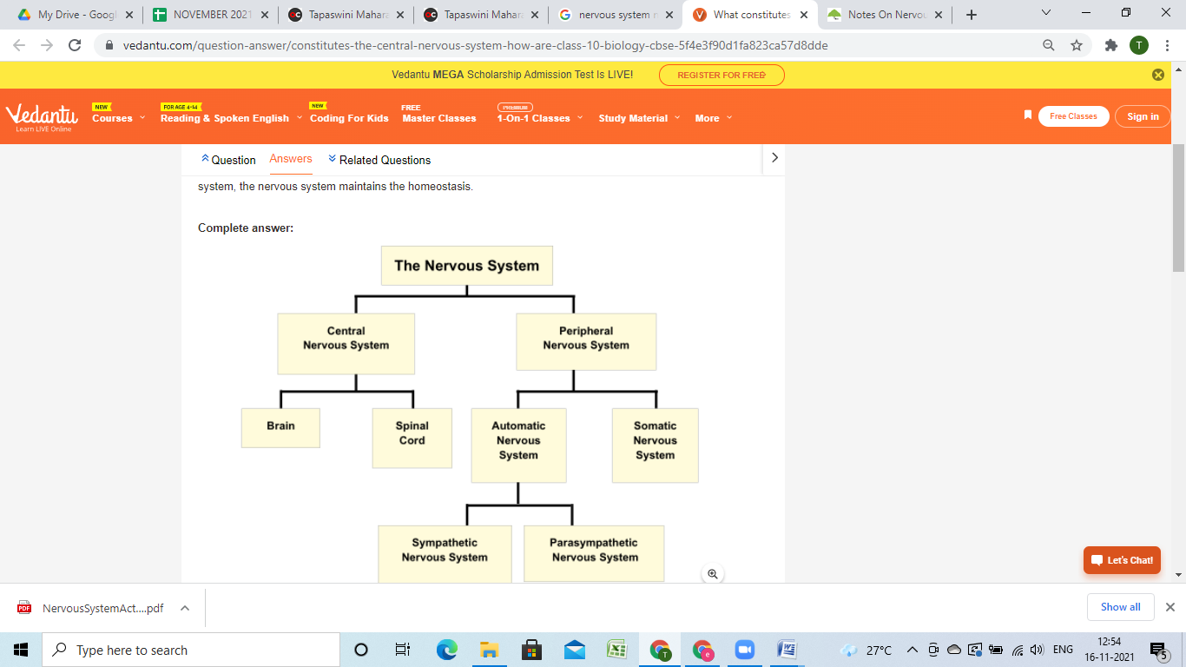
The human nervous system consists of two parts, namely:
- Central Nervous System (brain and spinal cord)
- Peripheral Nervous System (all the nerves of the body)
Central Nervous System (CNS) is often called the central processing unit of the body. It consists of the brain and the spinal cord.
Brain
The brain is one of the important, largest and central organ of the human nervous system. It is the control unit of the nervous system, which helps us in discovering new things, remembering and understanding, making decisions, and a lot more. It is enclosed within the skull, which provides frontal, lateral and dorsal protection. The human brain is composed of three major parts:
- Forebrain: The anterior part of the brain, consists of Cerebrum, Hypothalamus and Thalamus.
- Midbrain: The smaller and central part of the brainstem.
- Hindbrain: The central region of the brain, composed of Cerebellum, Medulla and Pons.
Spinal Cord- It is enclosed in a bony cage called vertebral column and surrounded by membranes called meninges. The spinal cord is concerned with spinal reflex actions and the conduction of nerve impulses to and from the brain.
Peripheral Nervous System (PNS) is the lateral part of the nervous system that develops from the central nervous system which connects different parts of the body with the CNS. We carry out both voluntary and involuntary actions with the help of peripheral nerves.
PNS includes two types of nerve fibers:
- Afferent nerve fibers – These are responsible for transmitting messages from tissues and organs to CNS.
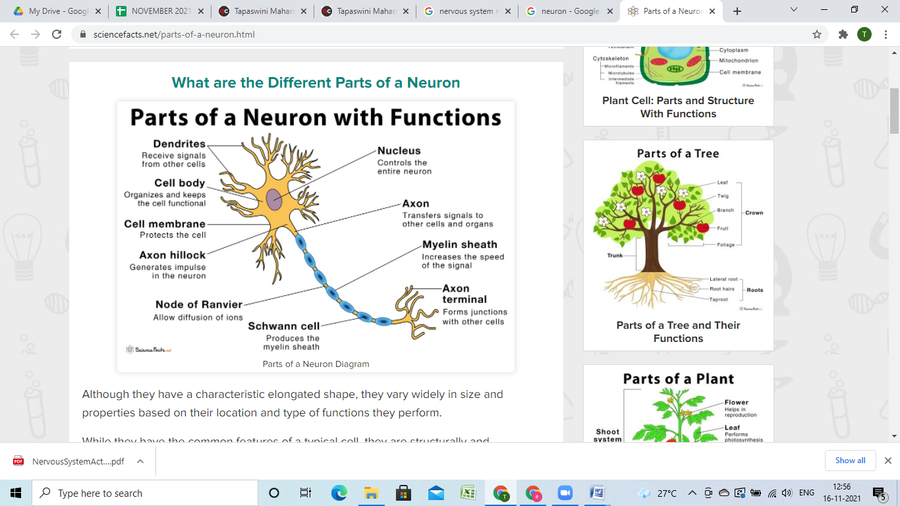
- Efferent nerve-fibers – These are responsible for conveying messages from CNS to the corresponding peripheral organ.
A Neuron is a structured and functional unit of the nervous system that conduct electrochemical signals.
- Dendrite stretches out from the cell body of a neuron, and it is the shortest fibre in the cell body.
- Axon is the longest thread on the cell body of a neuron and has an insulating and protective sheath of myelin around it.
- Cell body consists of cytoplasm and nucleus.
- Synapse is the microscopic gap between a pair of adjacent neurons over which nerve impulses pass, when moving from one neuron to the other.

Nerves are thread-like structures that emerge from the brain and spinal cord. It is responsible for carrying messages to all the parts of the body. There are three types of nerves.
- Sensory nerves send messages from all the senses to the brain.
- Motor nerves carry messages from the brain to all the muscles.
- Mixed nerves carry both sensory and motor nerves.
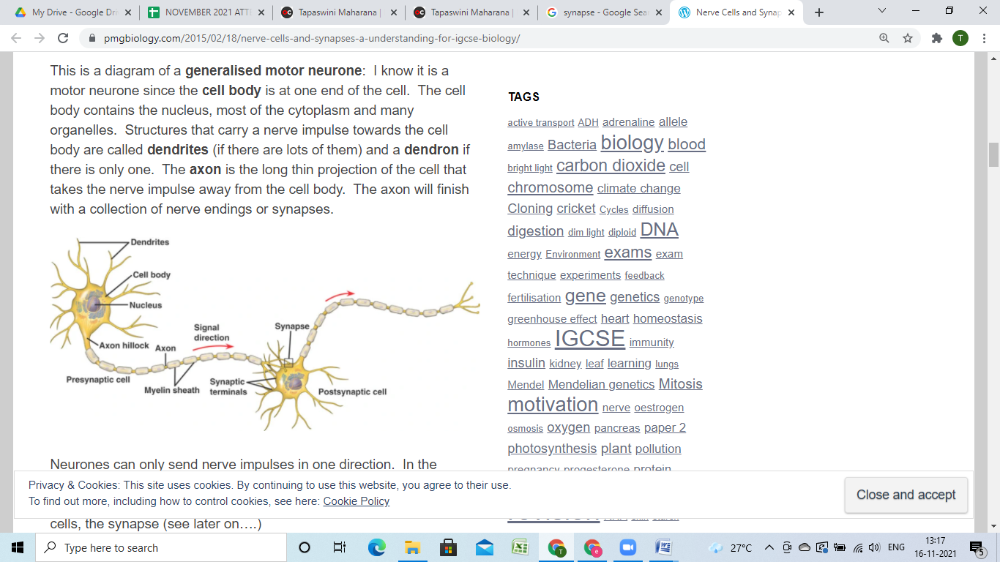
SYNAPSE:
Synapse or synaptic Knob is the small space or gap between two adjacent neurons. It is formed between the axon terminal of one neuron and the dendrites of the next neurons.
Functions
Synaptic knob of one neuron for conducting nerve impulse to the adjacent connected neuron.

1. The term central nervous system refers to the:
A) brain and spinal cord B) brain, spinal cord, and cranial nerves
C) brain and cranial nerves D) spinal cord and spinal nerves

2. The peripheral nervous system consists of:
A) spinal nerves only B) the spinal and cranial nerves
C) cranial nerves only D) the brain and spinal cord

3. The Schwann cells form a myelin sheath around the:
A) dendrites B) cell body
C) nucleus D) axon

4. The neuron processes that normally receives incoming stimuli are called:
A) axons B) dendrites

C) neurolemmas D) Schwann cells

5.Impulse conduction is fastest in neurons that are:
A) myelinated B) unmyelinated
C) sensory D) motor

