[FOOD PRODUCTION]
| BIOLOGY | STUDY NOTES-1

Chapter-9
FOOD PRODUCTION.

Microorganism
The living organisms that cannot be seen with unaided eye are called microorganisms.
The study of microorganisms is called microbiology.
They are cosmopolitan in distribution and found everywhere around us. All the tiny organisms around us like in air and soil do not fall into the category of microbes.
Antony Van Leewanhoek observed bacteria for the first time using his self built microscope.
Microorganisms are classified into four major groups- bacteria, fungi, protozoa and some algae.

Shapes of bacteria:

Bacteria are of different shapes. They can be classified in four groups based on their shape.
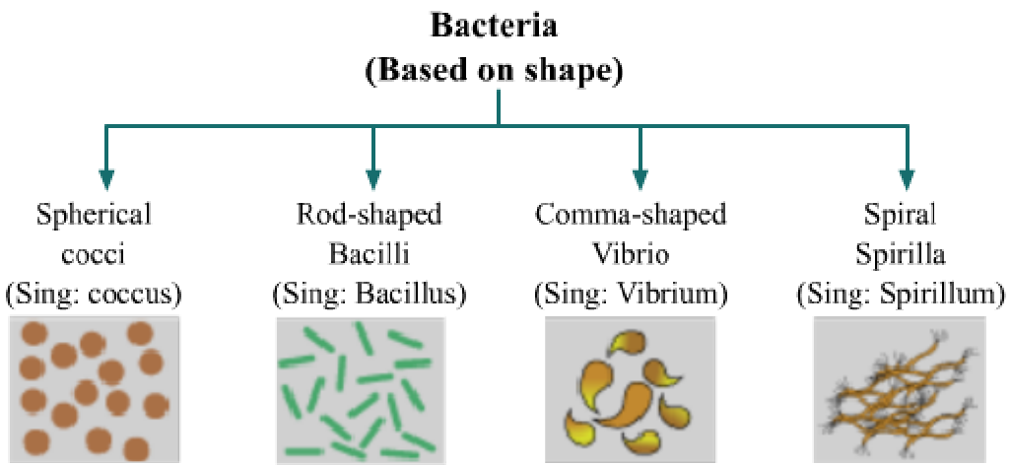

Important Scientists

Robert Koch ((1843-1910)

Robert Koch developed the germ theory of disease that established the microbial cause of disease.
He identified anthrax disease.
He developed agar growth medium.
Louis Pasteur (1822-1895)
He disapproved the theory of spontaneous generation of life. He proved this by his famous experiment known as swan neck flask experiment.
He developed the method of pasteurization.
He also contributed to the development of vaccines.

Importance of microorganisms In food industry
Lactobacillus bacteria promote the conversion of milk into curd. Yeast is used in preparation of breads, pastries and cakes.

In beverage industry
Yeast is used for commercial production of alcohol, wine and vinegar (acetic acid).
Yeast acts on sugar and converts it into alcohol by the process of fermentation. Louis Pasteur discovered fermentation.
Edible mushrooms are fleshy, non-poisonous fruit bodies of mushrooms that have desirable taste and aroma.
Commonly cultivated species of mushrooms: Agaricus bisporous (white button mushroom) Volvariella (paddy straw mushroom) Pleurotus (oyster mushroom)
They are the excellent source of minerals and vitamins, such as niacin, pantathonic acid and biotin.
Steps involved in mushroom cultivation: Composting
Spawning Casing
Cropping and harvesting Preservation

In increasing soil fertility
Blue green algae and Rhizobium bacteria are called biological nitrogen fixers.
They fix free atmospheric nitrogen to enhance soil fertility.

In cleaning the environment

Microorganisms (decomposers) help in converting dead waste of plants and animals into simpler substances by the process of decomposition.

Nitrogen cycle: It involves circulation of nitrogen through living and non- living components of nature.
Nitrogen gas comprises 78% of the atmosphere.
First process of nitrogen cycle is fixation of nitrogen gas into nitrogenous compounds caused by bacterium Rhizobium and lightning.
Nitrogen compounds in soil are taken up by the plants through roots and used up in synthesis of plant proteins. Animals obtain nitrogen by feeding on plants.
Waste of plants and animals are converted to nitrogenous compounds by the action of bacteria and fungi in the soil.
Some bacteria convert nitrogenous compounds back to nitrogen to maintain atmospheric levels of nitrogen.

Types of plants
Plants are usually grouped into herbs, shrubs, and trees.
Herbs are plants with green and tender stems. They are usually short. E.g. Wheat, rice.
Shrubs are plants with hard but not very thick stems. Their stem branches near the base. E.g. Rose plant
Trees are very tall plants with hard and thick brown stem. E.g. Mango, Apple.

Classification of plants depending upon the time required to complete their life cycle

Annuals - They complete their life cycle in one growing season. e.g., paddy, wheat, maize, etc.

Biennials - They complete their life cycle in two years e.g., cabbage, turnip, etc.
Perennials - They complete their life cycle in several years. e.g., mango

Crop: Same kind of plants grown for food on a large-scale are known as

crops.
On the basis of the growing season, crops are of two types- Kharif crops and Rabi crops.

Kharif crops – Crops that are grown in the rainy season (June to September). Example – soyabean, paddy and maize.
Soil requirement: Alluvial loam with a subsoil of clay
Cultivation methods: Seeds for Kharif crops can be sown through broadcasting, dibbling, drilling, or transplantation
Rabi crops – Crops that are grown in the winter season (October to March). Example – wheat, gram and pea.
Soil requirement: Clay loamy soil or black soil
Cultivation methods: Seeds for Rabi crops can be sown through broadcasting, dibbling, or drilling. The seeds are generally sown soon after the rainy season.
Green Revolution: It is a programme started in the 1960's to increase the agricultural productivity by the use of improved seeds and advanced agricultural technologies.
Organic Farming: It is the practice of cultivating crops without the use chemical fertilisers, weedicides or pesticides.

Animal Husbandry - It deals with the scientific management of livestock. These include cattle farming, poultry farming, fish culture, and bee culture.

Cattle farming- It is done to obtain milk and draught labour cattle's for
agricultural purposes. This can be achieved by producing hybrid breeds and by providing proper shelter and cleaning facilities to animals. Hybrid cattle breeds are produced by crossing the two superior breeds, in which both the
characteristics (milk pro
Poultry farming- It is undertaken to obtain egg production and meat. objectives of poultry farming is to improve following traits- Number and quality of chicks,tolerance to high temperatures,dwarf broiler parent for commercial chick production
duction and diseases resistance) are available.
Fish Farming-Fish is a cheap source of animal protein for our food. Therefore, fish culture is an important part of animal husbandry. The two ways of obtaining fish are - Capture fishing and Culture fishery. Farming can be done in both fresh water (such as rivers, ponds etc.) and marine ecosystems.
Apiculture- It is the practice of bee keeping. Bee farms are also known as apiaries.The quality of honey produced does not depend upon the variety of bees used. The quality of honey is greatly affected by both the quantity and quality of the available flowers, from which bees collect nectar and pollen.
Local varieties of bees used commonly for honey production are Apis cerana, Apis dorsata, A. florae.

An Italian bee variety A. mellifera is used for commercial production of honey.

Animals and their Products

Milk and Flesh Yielding Animals - cattle goat, poultry, pig, sheep, etc. Draught Animals – horse, donkey, mule, etc.
Fibre, Hide and Skin Yielding Animals - sheep, goat, cattle, camel, etc.

Some important animals

Cattle – we obtain milk, cow dung (for gobar gas and manure) from them. Also used to plough fields.

Sheep and goat – provide meat, wool and hide Pig – provides pork and hide
Poultry – provide meat and eggs Fishes – act as nutritious food.
Freshwater fishes – Catla, Rohu Marine fishes – Hilsa, salmon

Honeybees – Reared to obtain honey and beeswax. Queen bee lays eggs which are fertilized by drones. The worker bee looks after larvae and collects nectar from the flowers to produce honey. Rearing honeybees on commercial scale is called apiculture.
Silk moth – provides silk. Larvae develop into cocoon whose body is covered with silk threads. The commercial rearing of silk moths is called sericulture.

Food from animals

Milk obtained from cow, buffalo, goat, and camel Meat obtained from chicken, goat, and sheep Eggs obtained from chicken and ducks

Some common diseases of useful animals

Cattle
Diarrhoea smallpox Necrosis anthrax
haemorrhagic septicaemia pinkeye
Mad cow disease Poultry
fowl pox cholera
tuberculosis diarrhoea

