ENGLISH- (Practice Sample Paper) –
Identification
Q.1) Identify and match with correct rhyming words.
swing boat
roam ring
wing foam
goat wrench
bench string
Q.2) Read and circle the odd one
Nut Nine Newspaper Tree

Frog Fox Toad Fill

Bucket Stove Neck Shelf

Classroom Library Bedroom Playground

Chair Hook Foot Stood

Grammer
Q.3) Fill in the blanks with in/on/under/near
a) The fish is ___________ the pot. 
b) The ball is ___________ the box. 
c) The cat is ____________ the tree. 
d) The girl is sitting ___________ the window. 

Q.4) Fill in the blanks with this/these
- ___________ is a bicycle.  
- _______ are toys. 
- _______ are apples. 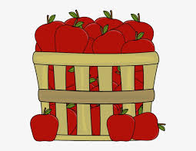
- _______ is an ant. 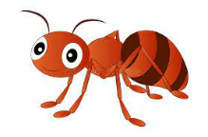
- _______ are chairs. 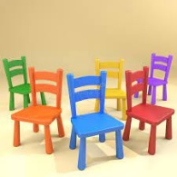

Spelling
Q.5) Fill in the blank with appropriate letter to make a meaningful word-
- Cup_oard
- _tove
- Fin_er
- Mo_th
- L_brary

Q.6) Rearrange the jumbled letters – spelling
- grof- _________
- seon- _________
- gisn- ___________
- dotos- ___________
- tahwc- ___________
Q.7) Write two (2) words with the following sounds-
‘oa’- ________ __________
‘ch’- __________ __________
‘oo’- __________ ___________
Reading Comprehension
Q.8) Read the passage. Circle and write the ‘oo’ sound words below.
Every day, Grandfather and Grandmother come to the
park with Vineet. They look at the children play. Vineet
plays with his friends, Varun and Nisha.
Then, Grandfather reads a book. Nisha sings for Grandmother. "Good!" says Grandmother.

___________________________________________

Q.9) Handwriting-( Write 2 lines properly)
I love my country.

