[ENDOCRINE SYSTEM AND ADOLESCENCE]
| BIOLOGY | STUDY NOTES-1

Chapter-5
ENDOCRINE SYSTEM AND ADOLESCENCE
Sub- Gland, Exocrine gland, Endocrine gland, Heterocrine gland.

GLAND
- An organ that makes one or more substances, such as hormones, digestive juices, sweat, tears, saliva, or milk.
- Exocrine glands release the substances into a duct or opening to the inside or outside of the body.
- Endocrine glands release the substances directly into the bloodstream.

EXOCRINE GLAND

- A gland that makes substances such as sweat, tears, saliva, milk, and digestive juices, and releases them through a duct or opening to a body surface.
- Examples of exocrine glands include sweat glands, lacrimal glands, salivary glands, mammary glands, and digestive glands in the stomach, and intestines.

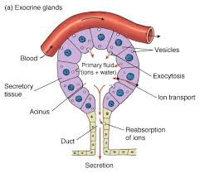

ENDOCRINE GLAND

- The endocrine system is composed of several endocrine glands.
- A ductless gland is called endocrine gland.
- Endocrine gland secretes its product directly into the bloodstream.
- Hormones are produced in the endocrine glands.
- Hormone is mainly composed of protein.
- Hormones assist the nervous system in control and coordination.
- Nerves do not reach to every nook and corner of the body and hence hormones are needed to affect control and coordination in those parts.
- Moreover, unlike nervous control; hormonal control is somewhat slower.
- Different types of endocrine glands present in our body are the pituitary gland, the pineal gland, the hypothalamus, the thyroid, the parathyroid, the thymus, the adrenal gland, the pancreas, the testes and the ovary.

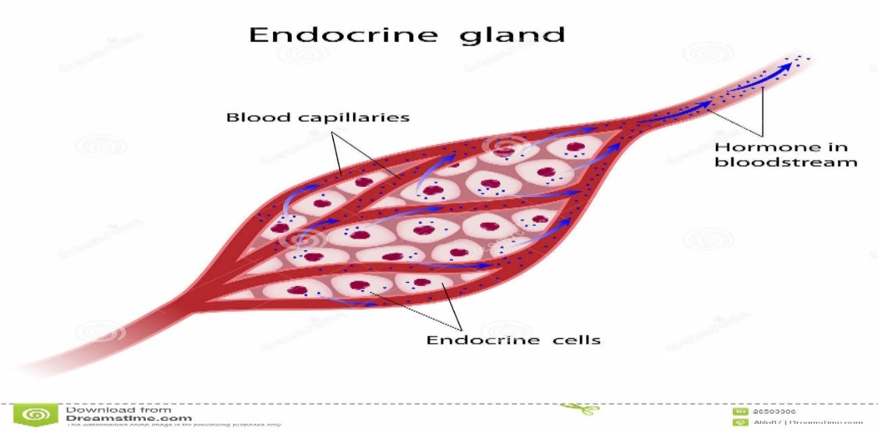

[ ENDOCRINE SYSTEM AND ADOLESCENCE]
| BIOLOGY | STUDY NOTES-2

Chapter-5
ENDOCRINE SYSTEM AND ADOLESCENCE
Sub- Hormone, Thyroid gland, Adrenal gland

HORMONES
- Hormone is a chemical substance secreted by an endocrine gland, which is directly poured into the blood stream and acts on a target organ or cell
- The term hormone was introduced byBaylissandStarling.
- There are various endocrine glands in humans are hypothalamus, pineal gland, pituitary gland, thyroid gland, parathyroid glands, thymus, pancreas, adrenal glands, ovary (in female) and testis (in males).

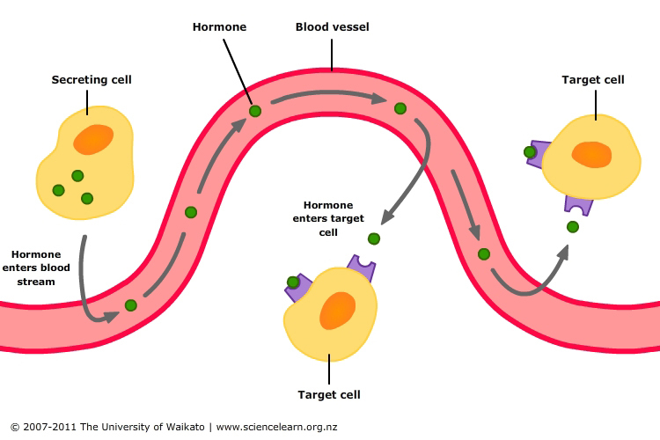

TARGET AND NON-TARGET CELL

- Target cell-any cell that has a specific receptor for an antigen or antibody or hormone or drug, or is the focus of contact by a virus or phagocyte or nerve fiber etc.

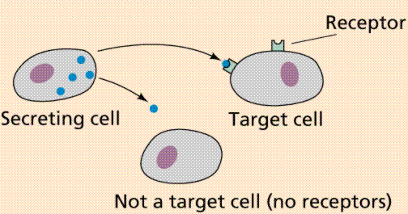

The thyroid gland:

- It is located in the neck, ventral to the larynx.
- It is the one of the largest endocrine glands.
- The principal hormones produced by this gland are triiodothyronine and thyroxine.
- Thyroxine is a hormone that regulates the metabolism of carbohydrates, proteins and fats in the body.
- Hyposecretion of thyroxine leads to cretinin in children, and myxoedema in adults.
- Hypersecretion of thyroxine leads to exopthalmic goitre in adults.
- Goitre is caused due to deficiency of iodine in food. Iodine is essential for the synthesis of thyroxine.

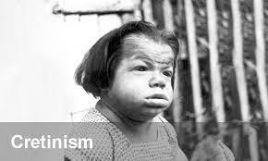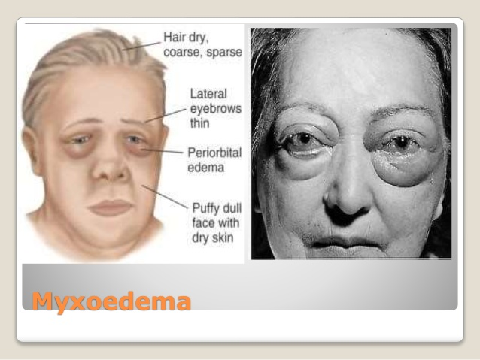

The adrenal glands:

- These are located above the kidneys and hence are called as suprarenal glands.
- Two regions of the adrenal gland are adrenal cortex and adrenal medulla.
- Adrenal cortex secretes the hormones like cortisol, aldosterone and androgens.
- Adrenal medulla secretes the hormones like adrenaline and noradrenaline.
- Adrenaline is also called the “hormone of fight or flight,” or the emergency hormone. It prepares the body to face an emergency condition of physical stress, like danger, anger and excitement.

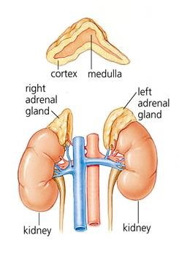

[ ENDOCRINE SYSTEM AND ADOLESCENCE]
| BIOLOGY | STUDY NOTES-3

Chapter-5
ENDOCRINE SYSTEM AND ADOLESCENCE
SUB-Pancreas, Pituitary gland.

Pancreas
- The pancreas is an organ that serves two vital purposes: to aid food digestion and to produce hormones that mainly serve to control levels of energy in the blood.

Where is the pancreas?
- The pancreas is a large gland that lies alongside the stomach and the small bowel.
- It is about six inches (approximately 15 cm) long and is divided into the head, body and tail.

What does the pancreas do?
The pancreas carries out two important roles:
- It makes digestive juices, which consist of powerful enzymes. These are released into the small bowel after meals to break down and digest food.
- It makes hormones that control blood glucose levels.
- The pancreas produces hormones in its 'endocrine' cells.
- These cells are gathered in clusters known as islets of Langerhans and monitor what is happening in the blood.
- They then can release hormones directly into the blood when necessary. In particular, they sense when sugar (glucose) levels in the blood rise, and as soon as this happens the cells produce hormones, particularly insulin.
Insulin
- Insulin then helps the body to lower blood glucose levels and 'store' the sugar away in fat muscle, liver and other body tissues where it can be used for energy when required.
Glucagon
Stimulates the break down of glycogen in the liver to glucose. Thus, it raises the sugar level in the blood

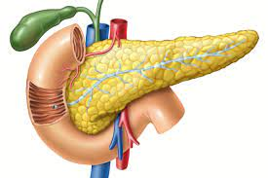

What is the pituitary gland?
- Your pituitary (hypophysis) is a pea-sized endocrine gland at the base of your brain, behind the bridge of your nose and directly below your hypothalamus
- The pituitary is often referred to as the “master gland” because it not only secretes its own hormones, it tells other glands to produce hormones.

What does the pituitary gland do?
- Glands are organs that secrete hormones — the “chemical messengers” of the body — that travel through your bloodstream to different cells, telling them what to do. The major hormones produced by the pituitary gland are:
- ACTH: Adrenocorticotrophic hormone. Stimulates the production of cortisol, a “stress hormone” that maintains blood pressure and blood sugar levels.
- FSH: Follicle-stimulating hormone. Promotes sperm production and stimulates the ovaries to produce estrogen.
- LH: Luteinizing hormone. Stimulates ovulation in women and testosterone production in men.
- GH: Growth hormone. Helps maintain healthy muscles and bones and manage fat distribution.
- PRL: Prolactin. Causes breast milk to be produced after childbirth. It also affects hormones that control the ovaries and testes, which can affect menstrual periods, sexual functions and fertility.
- TSH: Thyroid-stimulating hormone. Stimulates the thyroid gland, which regulates metabolism, energy and the nervous system.
- Oxytocin: Helps labor to progress, causes breast milk to flow, affects labor, breastfeeding, behavior and social interaction and the bonding between a mother and child.
- ADH: Anti-diuretic hormone, or vasopressin. Regulates water balance and sodium levels.

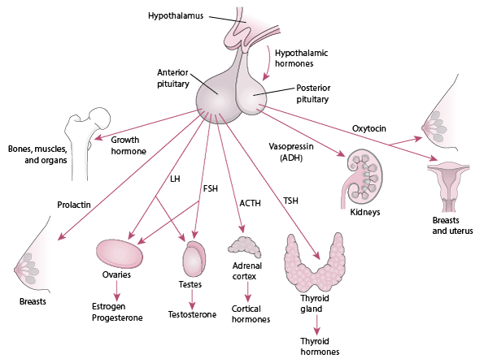

[ ENDOCRINE SYSTEM AND ADOLESCENCE]
| BIOLOGY | STUDY NOTES-4

Chapter-5
ENDOCRINE SYSTEM AND ADOLESCENCE
SUB-Adolescence, Physical changes during adolescence
Adolescence
- Adolescence, transitional phase of growth and development between childhood and adulthood. The World Health Organization (WHO) defines an adolescent as any person between ages 10 and 19.
- Children who are entering adolescence are going through many changes (physical, intellectual, personality and social developmental). Adolescence begins at puberty, which now occurs earlier, on average, than in the past.

Physical changes during adolescence
- Increase in height-
on average, the steady growth of middle childhood results in an increase in height of a little over 2 inches a year in both boys and girls. Weight gain averages about 6.5 pounds a year.

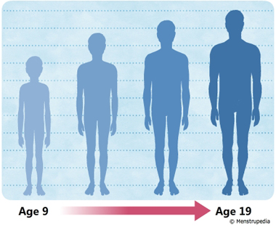

- Changes in body shape
- Most children have a slimmer appearance during middle childhood than they did during the preschool years This is due to shifts in the accumulation and location of body fat.
- As a child's entire body size increases, the amount of body fat stays relatively stable, giving her a thinner look. Also, during this stage of life, a child's legs are longer in proportion to the body than they were before

- changes in voice
- As you go through puberty, the larynx gets bigger and the vocal cords lengthen and thicken, so your voice gets deeper.
- As your body adjusts to this changing equipment, your voice may "crack" or "break." But this process lasts only a few months.

- Increased activity of sweat and sebaceous gland

- The increase in various hormones during puberty makes the body’s sweat glands more active and they produce more sweat.
- While sweat is actually odorless, the body odor associated with sweat results from bacteria on the skin multiplying in sweaty areas like armpits and breaking down the sweat into amino acids
- Acne is a very common skin condition that causes different types of bumps. Many teens and pre-teens get acne because of the hormonal changes that occur with puberty. causing acne to appear on the back, upper chest, neck, shoulders and most commonly, the face.

[ ENDOCRINE SYSTEM AND ADOLESCENCE]
| BIOLOGY | STUDY NOTES-5

Chapter-5
ENDOCRINE SYSTEM AND ADOLESCENCE
SUB-Development of Sexual and secondary sexual characters during Adolescence.

Secondary sexual characteristics
- Secondary characteristics are the result of hormonal changes in the body during puberty.
- These changes are faster in girls than in boys. Some changes are common in both boys and girls while others are specific to each gender. This is due to the different hormones released by them.
- Growth of pubic hair, facial hair and under the armpit, increase in height, sweating, etc. are some of the secondary sexual characteristics.
- Change in height: Most prominent change that occurs in adolescents is the change in their heights. Growth hormone secretion and bone growth are much higher during this time.
- Sweat and Sebaceous glands: The pimples and acne in adolescents are mostly due to the increased activities of sweat and sebaceous glands
- Hair growth: Another observable change is rapid hair growth under the armpit and pubic area.

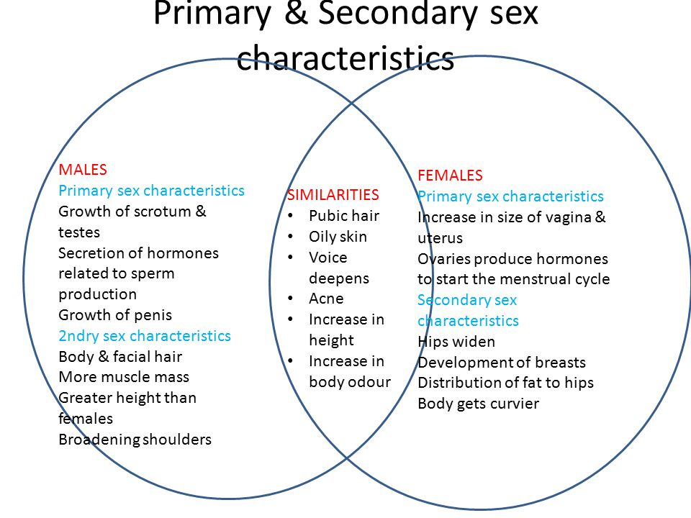

Secondary sexual characteristics in boys:
- Testosterone, the hormone responsible for the secondary sexual characteristics that develop in the male during adolescence, stimulates spermatogenesis.
- These secondary sex characteristics include a deepening of the voice, the growth of facial, axillary, and pubic hair, and the beginnings of the sex drive.

- Boys develop the heavier muscular body, wide shoulders, and narrow hips.
- Enlargement of the voice box leads to a much deeper voice.
- Maturation of testis and starts to produce sperms.
- The growth of hairs on the chest.
- Enlargement of Adam’s apple.
- More pronounced body hair characteristics (beard, chest, etc.) and usually more coarse
- Angular features (i.e. square jaw, triangular mid region)
- Narrow hips
- Muscular pectorals (chest)
- Less fat tissue overall
- Deeper voice
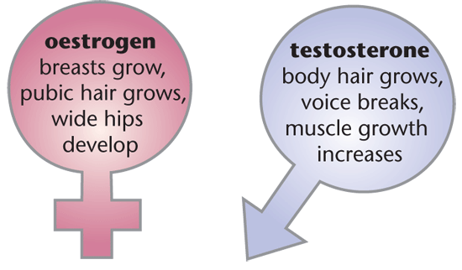

Secondary sexual characteristics in girls:
- Estrogen also induces growth of the uterus, proliferation of the endometrium, and menstruation. Female secondary sex characteristics include:
- Rounded hips and breast development.
- Matured ovaries start to release a mature ovum.
- Ovulation and menstruation initiate.
- Mammary gland enlargement.

[ ENDOCRINE SYSTEM AND ADOLESCENCE]
| BIOLOGY | STUDY NOTES-6

Chapter-5
ENDOCRINE SYSTEM AND ADOLESCENCE
SUB-Adolescence and the related psychological changes, Importance of personal hygiene. Stress, how to manage Stress

Adolescence and the related psychological change

- The most important psychological and psychosocial changes in puberty and early adolescence are the emergence of abstract thinking, the growing ability of absorbing the perspectives or viewpoints of others, an increased ability of introspection, the development of personal and sexual identity,
Social changes:
- searching for identity: young people are busy working out who they are and where they fit in the world. This search can be influenced by gender, peer group, cultural background, media, school and family expectations
- seeking more independence: this is likely to influence the decisions your child makes and the relationships your child has with family and friends
- seeking more responsibility, both at home and at school
- looking for new experiences: the nature of teenage brain development means that teenagers are likely to seek out new experiences and engage in more risk-taking behaviour. But they’re still developing control over their impulses
- thinking more about “right” and “wrong”: your child will start developing a stronger individual set of values and morals. Teenagers also learn that they’re responsible for their own actions, decisions and consequences. They question more things. Your words and actions shape your child’s sense of ‘‘right’’ and “wrong”
- influenced more by friends, especially when it comes to behaviour, sense of self and self-esteem
- starting to develop and explore a sexual identity: your child might start to have romantic relationships or go on “dates”. These are not necessarily intimate relationships. For some young people, intimate or sexual relationships don’t occur until later on in life
- communicating in different ways: the internet, cell phones and social media can significantly influence how your child communicates with friends and learns about the world.
- Emotional changes
shows strong feelings and intense emotions at different times. Moods might seem unpredictable.
- These emotional ups and downs can lead to increased conflict. Your child’s brain is still learning how to control and express emotions in a grown-up way
- is more sensitive to your emotions: young people get better at reading and processing other people’s emotions as they get older. While they’re developing these skills, they can sometimes misread facial expressions or body language
- is more self-conscious, especially about physical appearance and changes. Teenage self-esteem is often affected by appearance - or by how teenagers think they look. As they develop, teens might compare their bodies with those of friends and peers
- goes through a “invincible” stage of thinking and acting as if nothing bad could happen to him. Your child’s decision-making skills are still developing, and your child is still learning about the consequences of actions.
- Changes in relationships
wants to spend less time with family and more time with friends
- has more arguments with you: some conflict between parents and children during the teenage years is normal as teens seek more independence. It actually shows that your child is maturing. Conflict tends to peak in early adolescence. If you feel like you’re arguing with your child all the time, it might help to know that this isn’t likely to affect your long-term relationship with your child
- sees things differently from you: this isn’t because your child wants to upset you. It’s because your child is beginning to think more abstractly and to question different points of view. At the same time, some teens find it hard to understand the effects of their behaviour and comments on other people. These skills will develop with time.

Importance of personal hygiene

- Proper and safe food
- Proper life style
- Cleanliness
- Physical exercise

Stress

Stress can be defined as any type of change that causes physical, emotional, or psychological strain. Stress is your body's response to anything that requires attention or action.

Stress can be short-term or long-term. Both can lead to a variety of symptoms, but chronic stress can take a serious toll on the body over time and have long-lasting health effects.
Some common signs of stress include:¹﻿
- Changes in mood
- Clammy or sweaty palms
- Decreased sex drive
- Diarrhea
- Difficulty sleeping
- Digestive problems
- Dizziness
- Feeling anxious
- Frequent sickness
- Grinding teeth
- Headaches
- Low energy
- Muscle tension, especially in the neck and shoulders
- Physical aches and pains
- Racing heartbeat
- Trembling
How to manage stress
- Yoga
- Deep breathing exercises.
- Meditation.
- Mindfulness meditation.
- Progressive muscle relaxation.
- Mental imagery relaxation.
- Relaxation to music.
- Biofeedback (explained below).

