[ECOSYSTEMS]
| BIOLOGY | STUDY NOTES-1

Chapter-4
ECOSYSTEMS
Sub- What is an ecosystem? Types of ecosystems, Autotrophs, consumers
Ecosystem
- An ecosystem is a system which include all the living organism (plants, animals, micro-organism) of an area and physical environment (soil, water and air) in which they live.
- In an ecosystem, the various living organism interact among themselves and also with the physical environment in which they live.

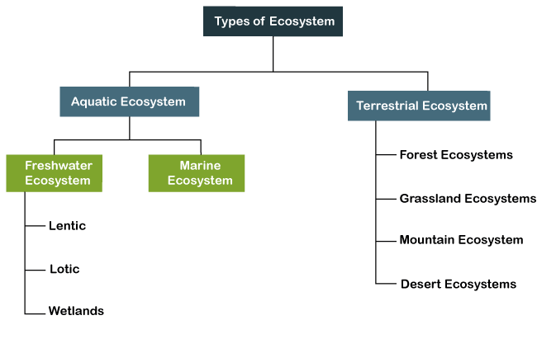
Forest ecosystem:
- A forest ecosystem is a dynamic complex of plant, animal and micro-organism communities and their abiotic environment interacting as a functional unit, where trees are a key component of the system.
- Humans, with their cultural, economic and environmental needs, are an integral part of many forest ecosystems.

[ECOSYSTEMS]
| BIOLOGY | STUDY NOTES-2

Chapter-4
ECOSYSTEMS
Sub- components of ecosystem, trophic level

Components of Ecosystem:
- Every ecosystem has two components, namely, biotic components and abiotic components.
- Biotic components refer to all living organisms in an ecology while abiotically refers to the non-living things.
- These biotic and abiotic interactions maintain the equilibrium in the environment.
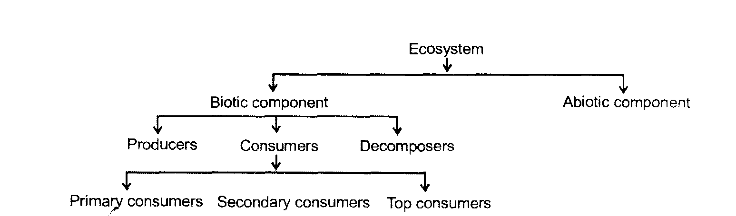
Biotic component:
- All living beings make the biotic component of an ecosystem.
- Green plants play the role of producers; because they prepare the food by photosynthesis.
 
 
- Animals and other living beings play the role of consumers; because they take food
(Directly or indirectly) from plants.
- Bacteria and fungi play the role of decomposers; as they decompose dead remains of plants and animals so that raw materials of organisms can be channelized back to the environment.
 

Abiotic components

- Abiotic factors refer to non-living physical and chemical elements in the ecosystem.
- Abiotic resources are usually obtained from the lithosphere, atmosphere, and hydrosphere.
- Examples of abiotic factors are water, air, soil, sunlight, and minerals.
- Examples Water, light, wind, soil, humidity, minerals, gases.

Trophic level

- The trophic level is the step or level included in a food chain.
- It denotes the number of steps the organism is from the start of the chain.
- There are 4 trophic levels it includes producers, herbivores (primary consumers), carnivores (secondary consumers), predators (tertiary consumers)
- The sun is the source of all the energy in food chains. Green plants, usually the first level of any food chain, absorb some of the Sun’s light energy to make their own food by photosynthesis. Green plants (autotrophs) are therefore known as ‘Producers’ in a food chain.
- The second level of the food chains is called the Primary Consumer. These consume the green plants. Animals in this group are usually herbivores. Examples include insects, sheep, caterpillars and even cows.
 
- The third in the chain are Secondary Consumers. These usually eat up the primary consumers and other animal matter. They are commonly called carnivores and examples include lions, snakes and cats.
 
- The fourth level is called Tertiary Consumers. These are animals that eat secondary consumers.
 
- Quaternary Consumers eat tertiary consumers.
 
- At the top of the levels are Predators. They are animals that have little or no natural enemies. They are the ‘bosses’ of their ecosystems. Predators feed on preys. A prey is an animal that predators hunt to kill and feed on. Predators include owls, snakes, wild cats, crocodiles and sharks. Humans can also be called predators.
 
- When any organism dies, detrivores (like vultures, worms and crabs) eat them up. The rest are broken down by decomposers (mostly bacteria and fungi), and the exchange of energy continues. Decomposers start the cycle again.
 

[ECOSYSTEMS]
| BIOLOGY | STUDY NOTES-3

Chapter-4
ECOSYSTEMS
Sub- Food chains, Food webs, Food pyramids, Symbiosis, Parasitism and Predation. Flora and Fauna of Forest Ecosystem, Risks to Ecosystem
Food chains

- A food chain explains which organism eats another organism in the environment.
- The food chain is a linear sequence of organisms where nutrients and energy is transferred from one organism to the other.

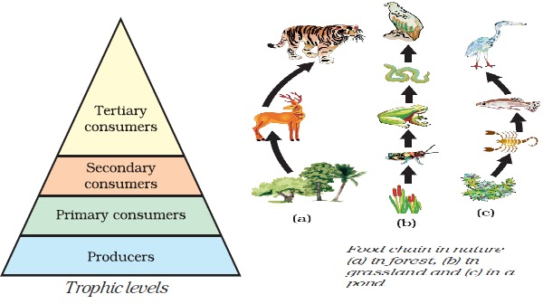
Food webs
- Food web is a network of food chains where all the chains are naturally interconnected.
- Flow of energy in a food chain is unidirectional, once it reaches the next tropic level it does not come back again.
- For example- energy which passes to the herbivores does not come back again to autotrophs.
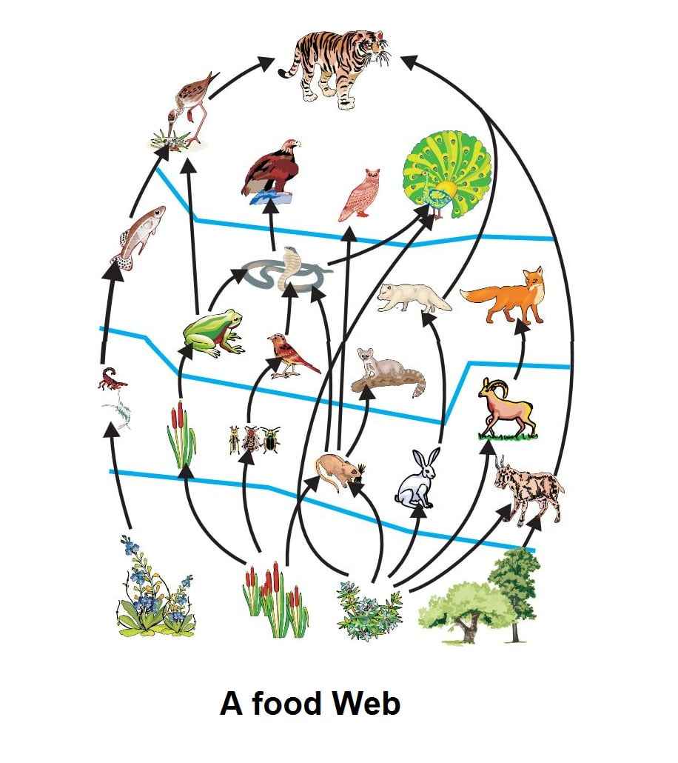

Advantages of food web

- Permit alternative foods.
- Ensures a better chance of survival of an organism
- Provides more stability to an ecosystem than a food chain.

Food pyramids

- A graphical representation of various trophic levels of a food chain in an ecosystem is called an ecological pyramid or a food pyramid.
- Role of food pyramid in the functioning of ecosystems
- The trophic levels in a food chain can be explained with the help of a food pyramid

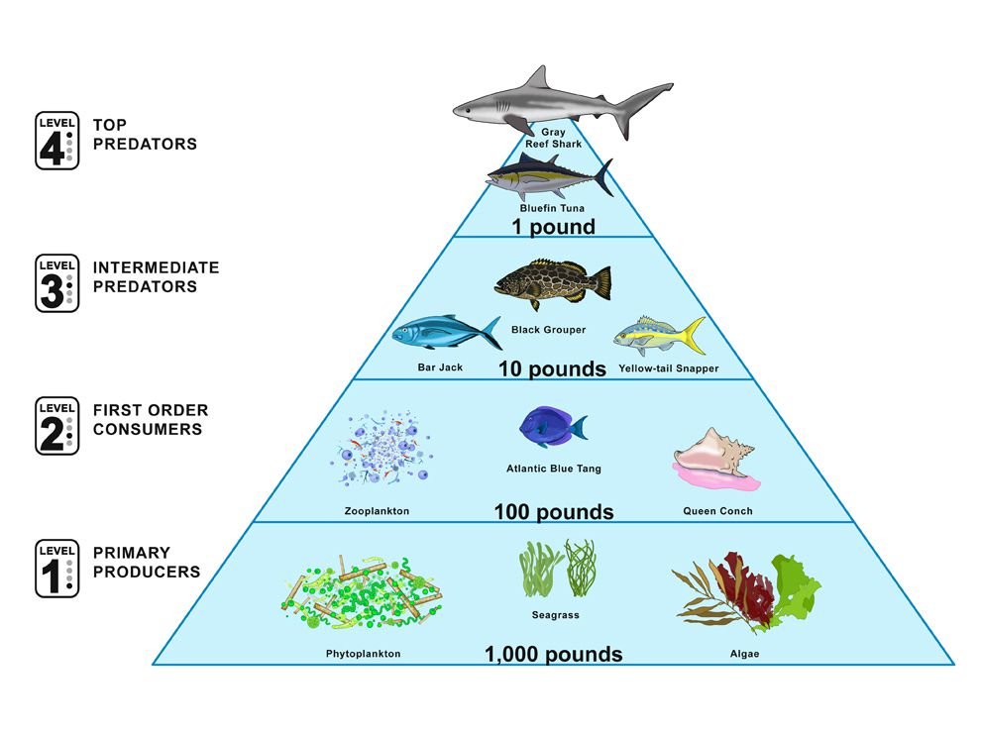
Pyramid numbers
- A pyramid of numbers is constructed on the basis of number of individuals that occupy a particular trophic level in a given area at a given time.
- A large number of shrubs and grasses provide food and energy to the deer in grasslands.
- They are the producers and form the base of the pyramid.
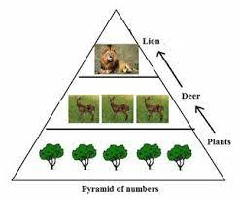

Pyramid of Biomass

- A biomass pyramid is the representation of total living biomass or organic matter present at different trophic levels in an ecosystem.
- In a biomass pyramid, producers (1st trophic level) are at the base, followed by herbivores (primary consumers) and then carnivores (secondary and tertiary consumers) at the top.

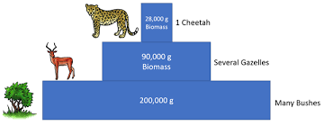
symbiosis
- Symbiosis is the combination of two Greek words 'Sym' means 'with' and 'biosis' means 'living', which means living together. In symbiosis or mutualism two different types of organisms live and work together for their mutual benefit from each other.
Parasitism
- Parasitism, relationship between two species of plants or animals in which one benefits at the expense of the other, sometimes without killing the host organism.
Predation
- Predation is a biological interaction where one organism, the predator, kills and eats another organism, its prey.
Flora and fauna

- The word "flora" refers to the plants occurring within a given region as well as to the publication of scientific descriptions of those plants.
- Animals, especially the animals in a particular area, can be referred to as fauna.
Tropical rain forest
- Tropical rainforests are found near the equator, with high average temperatures and humidity, while temperate rainforests lie mostly in coastal, mountainous areas within the mid-latitudes.
- A rainforest is typically made up of four key layers: emergent, upper canopy, understory, and forest floor.
- Flora-evergreen trees, bamboos, ferns, shrubs.
- Fauna- jungle cats, leopards, monkeys, flying squirrels , snakes, centipeds, millipedes, many insects, snails etc.
Temperate Deciduous Forest

- A temperate deciduous forest is a biome that has many deciduous trees which drop their leaves in the fall.
- These forests are also known as broad-leaf forests because the trees have wide, flat leaves. Temperate deciduous forests lie in the mid-latitude areas of the Earth, between the Arctic poles and the tropics.

- Flora- teak, sandalwood, sal
- Fauna-moths, beetles, deer, wolves, foxes
Coniferous forest
- Coniferous forests consist mostly of conifers, which are trees that grow needles instead of leaves and cones instead of flowers.
- Conifers tend to be evergreen—they bear needles all year long. These adaptations help conifers survive in areas that are very cold or dry.

- Flora-fir and pine trees
- Fauna-squirrel,deer,goat,wolves, robin ,sparrow

Gir forests

- Flora-peepal, acacia,neem
- Fauna- crows, kites, cat, rat, dog, vultures

Jim Corbet National Park

- Flora- pine
- Fauna- tiger
Jaladpara Sanctuary

- Flora-banyan trees
- Fauna- rhinoceros.

Risks to ecosystem

- burning of fossil fuels.
- deforestation.
- hunting of animals,poaching,etc.
- wastage of water.

Ecosystem conservation

- Forest should be reserved and more and trees should be planted across the region especially in those areas where deforestation takes place.
- Wildlife must be protected by enacting laws and creating awareness among people.
- Starting various projects to save endangered species of plants and wildlife

