[CONTROL AND COORDINATION.]
| BIOLOGY | STUDY NOTES-1

Chapter-7-Control and coordination.
Subtopic- What is coordination, what is stimuli, what is animal nervous system. Structural and functional unit of nervous system., Transmission of nerve impulse

Introduction to control & coordination
- Organisms move in response to various kinds of stimuli like light, heat, nutrients/food, etc.
- All the activities in animals are controlled and coordinated by the nervous and endocrine system.
- Hormones are chemical messengers, which assist the nervous system in carrying out various functions. They are secreted by endocrine glands.

- Hormones in plants coordinate the movements.

Movement and locomotion.
- The ability of organisms to move certain body parts is movement.
- When they move from one place to another, it is called locomotion.

THE NERVOUS SYSTEM

Neuron
Neuron is the structural and functional unit of the nervous system.
- Each neuron has three main parts: dendrites, cyton/soma/cell body and axon.
- Dendrites receive impulses from other neurons.
- Cyton/soma processes the impulse.
- Axon transmits the impulse, either to another neuron or to muscles/glands, etc.
- Axon may be myelinated or non-myelinated.
- The impulse transmission is faster in myelinated neurons.
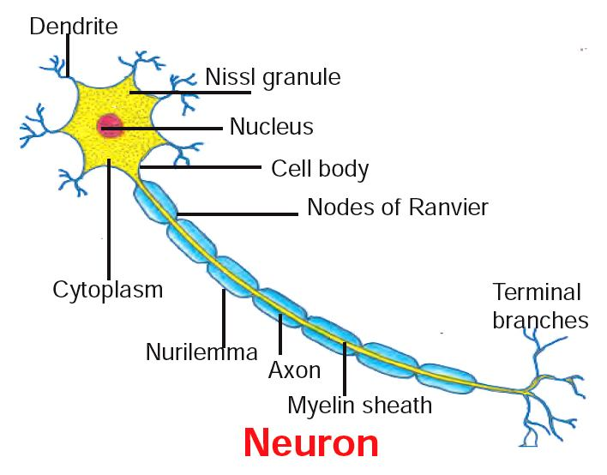
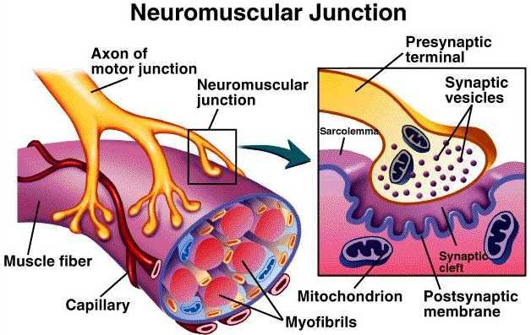

CELL BODY
It is the cell structure irregular in shape or polyhedral structure, it is also called as cyton. Cell body contains cytoplasm with typical cell organelles and certain granular bodies are called Nissl granules

DENDRITES
Dendrites or Dendrons are shorter fibres which branch repeatedly and project out of the cell body. Dendrites transmit electrical impulses towards the cyton.

AXON
One of the fibres arising from the cell body is very long with a branched distal end and it is called as Axon.

NERVE IMPULSE
The conduction of stimuli by the nerve cells is called nerve impulse. The dendrites will receive the stimuli from the receptor (sense organ) and conduct the same as electrical impulse to the axon through the cyton. At the synapse, the synaptic knobs release out chemical substances called neuro transmitters which convert the electrical impulse into chemical impulse and pass it to the neighbouring neuron.

Transmission of nerve impulse: Nerve impulses travel in the following manner from one neutron to the next :
Dendrites → cell body → axon → nerve endings at the tip of axon → synapse → dendrite of next neuron.
Chemical released from axon tip of one neuron, cross the synapse or neuromuscular junction to reach the next cell.

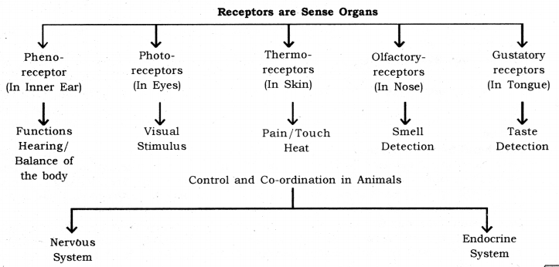

[CONTROL AND COORDINATION]
| BIOLOGY | STUDY NOTES -2

Chapter-7Control and coordination.

Subtopic- Spinal cord, Reflex Action, Reflex arc

REFLEX ACTION
Reflex action is a special case of involuntary movement in voluntary organs. When a voluntary organ is in the vicinity of a sudden danger, it is immediately pulled away from the danger to save itself. For example; when your hand touches a very hot electric iron, you move away your hand in a jerk. All of this happens in flash and your hand is saved from the imminent injury. This is an example of reflex action.
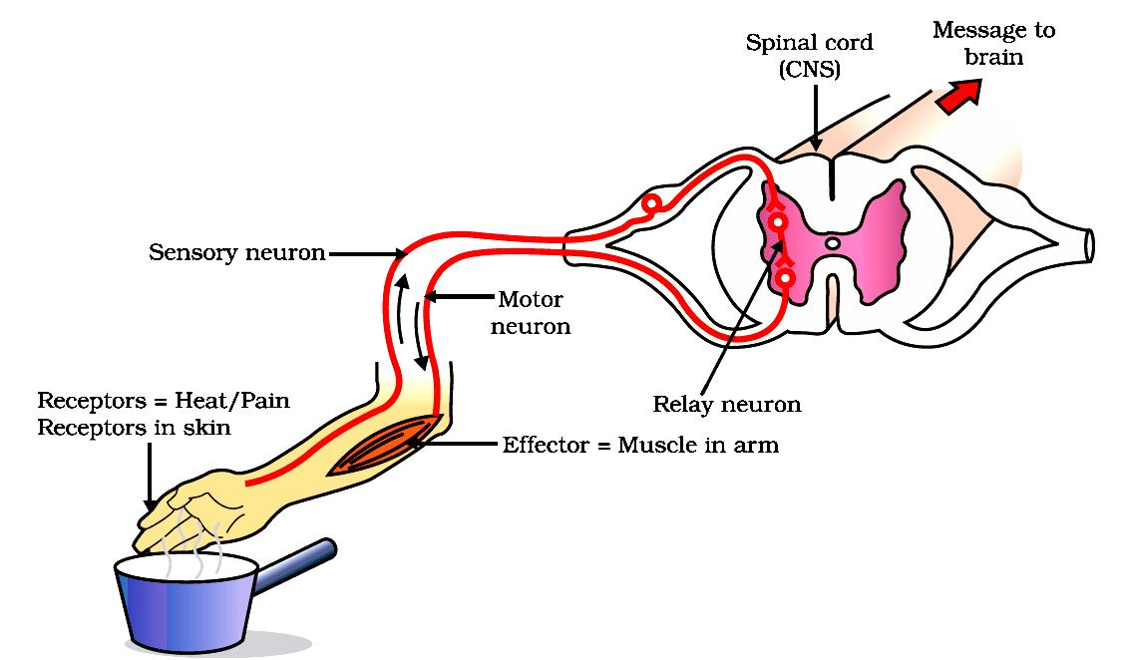

Reflex Arc: The path through which nerves signals; involved in a reflex action; travel is called the reflex arc. The following flow chart shows the flow of signal in a reflex arc.
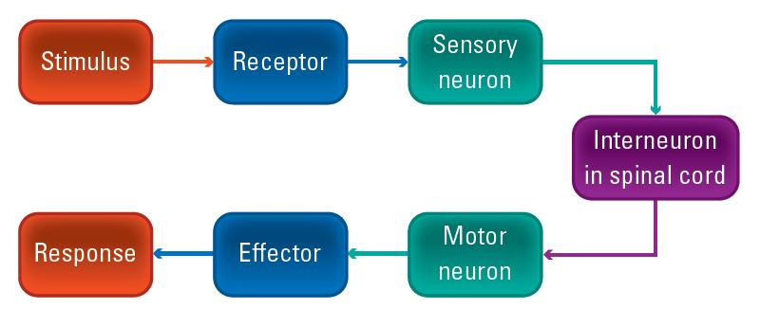

The receptor is the organ which comes in the danger zone. The sensory neurons pick signals from the receptor and send them to the relay neuron. The relay neuron is present in the spinal cord. The spinal cord sends signals to the effector via the motor neuron. The effector comes in action moves the receptor away from the danger.
Spinal cord: Spinal cord controls the reflex actions and conducts massages between different parts of the body and brain.

[CVONTROL AND COORDINATION]
| BIOLOGY | STUDY NOTES -3

Chapter-7 -Control and coordination.

Subtopic- Human Nervous System, Protection of brain and spinal cord, Brain structure, Forebrain and its function Brain and its function, Hind Brain and its function

Human Nervous System: The nervous system in humans can be divided into three main parts
1. Central Nervous System: The central nervous system is composed of the brain and the spinal cord. The brain controls all the functions in the human body. The spinal cord works as the relay channel for signals between the brain and the peripheral nervous system.
2. Peripheral Nervous System: The peripheral nervous system is composed of the cranial nerves and spinal nerves. There are 12 pairs of cranial nerves. The cranial nerves come our of the brain and go to the organs in the head region. There are 31 pairs of spinal nerves. The spinal nerves come out of the spinal cord and go to the organs which are below the head region.
3. Autonomous Nervous System: The autonomous nervous system is composed of a chain of nerve ganglion which runs along the spinal cord. It controls all the involuntary actions in the human body. The autonomous nervous system can be divided into two parts :
- Sympathetic nervous system.
- Parasympathetic nervous system.
Sympathetic Nervous System: This part of the autonomous nervous system heightens the activity of an organ as per the need. For example, during running, there is an increased demand for oxygen by the body. This is fulfilled by an increased breathing rate and increased heart rate. The sympathetic nervous system works to increase the breathing rate the heart rate, in this case.
Parasympathetic Nervous System: This part of the autonomous nervous system slows the down the activity of an organ and thus has a calming effect. During sleep, the breathing rate slows down and so does the heart rate. This is facilitated by the parasympathetic nervous system. It can be said that the parasympathetic nervous system helps in the conservation of energy.

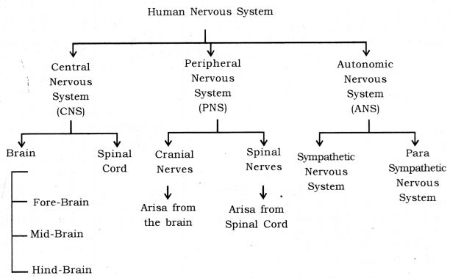

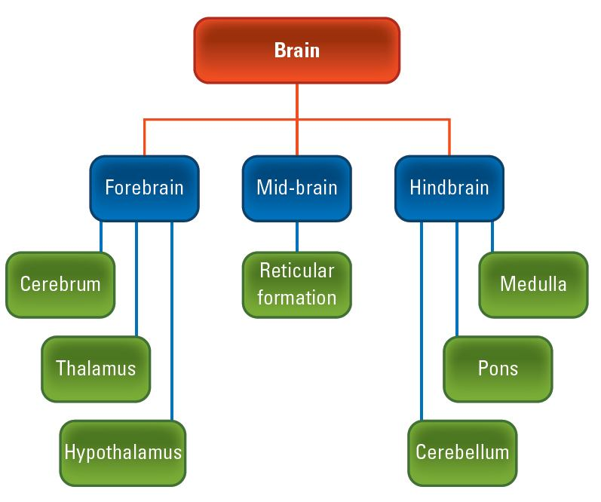
Human Brain: Human brain is a highly complex organ, which is mainly composed of nervous tissue. The tissues are highly folded to accommodate a large surface area in less space. The brain is covered by a three-layered system of membranes, called meninges. Cerebrospinal fluid is filled between the meninges. The CSF providers cushion the brain against mechanical shocks. Furthermore, protection. The human brain can be divided into three regions, viz. forebrain, midbrain and hindbrain.
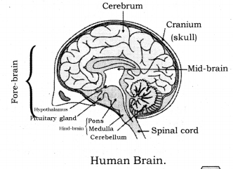
Parts of Human Brain :
- Fore-brain: It is composed of the cerebrum.
- Mid-brain: It is composed of the hypothalamus.
- Hind-brain: It is composed of the cerebellum, pons, medulla, oblongata.
Some main structures of the human brain are explained below :
Cerebrum: The cerebrum is the largest part in the human brains. It is divided into two hemispheres called cerebral hemispheres.
Functions of cerebrum
- The cerebrum controls voluntary motor actions.
- It is the site of sensory perceptions, like tactile and auditory perceptions.
- It is the seat of learning and memory.
Hypothalamus: The hypothalamus lies at the base of the cerebrum. It controls sleep and wake cycle (circadian rhythm) of the body. It also controls the urges for eating and drinking.
Cerebellum: Cerebellum lies below the cerebrum and at the back of the whole structure. It coordinates the motor functions. When you are riding your bicycle, the perfect coordination between your pedalling and steering control is achieved by the cerebellum.
- It controls posture and balance.
- It controls the precision of voluntary action.
Medulla: Medulla forms the brain stem, along with the pons. It lies at the base of the brain and continues into the spinal cord. The medulla controls various involuntary functions, like hear beat respiration, etc.
It controls involuntary actions.
Example: Blood pressure, salivation, vomiting.
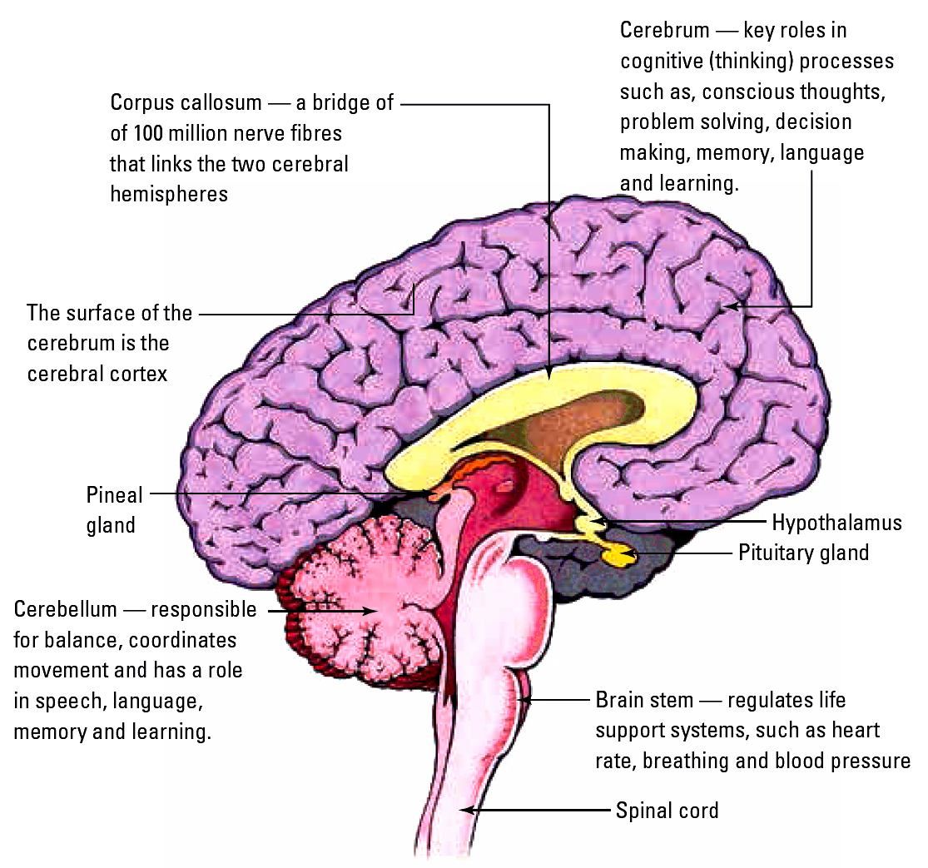
Pons: It relays impulses between the lower cerebellum and spinal cord, and higher parts of the brain like the cerebrum and midbrain, also regulates respiration.

[CONTROL AND COORDINATION.]
| BIOLOGY | STUDY NOTES-4

Chapter-7-Control and coordination.

Subtopic- Coordination in plants-Immediate Response to Stimulus, Nastic movement, Photonastic movement, Thermonastic movement, Seismonastic movement,Nyctinastic movements

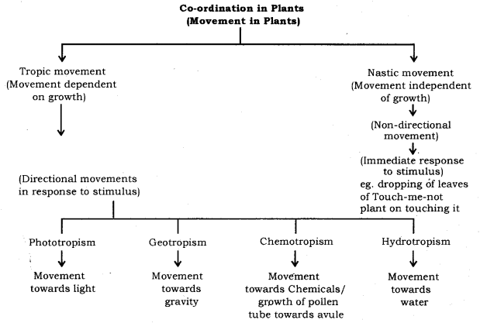

Control and Co-ordination in Plants: Movements in plants and plant harmones.
Co-ordination in Plants: Unlike animals, plants do not have a nervous system. Plants use chemical means for control and co-ordination. Many plant hormones are responsible for various kinds of movements in plants. Movements in plants can be divided into two main types :
1-Nastic movement
2-Tropic movement
1. Nastic Movement: The movement which do not depend on the direction from the stimulus acts are called nastic movement. For example, when someone touches the leaves of mimosa, the leaves droop. The drooping is independent of the direction from which the leaves are touched. Such movements usually happen because of changing water balance in the cells. When leaves of mimosa are touched, the cells in the leaves lose- water and become flaccid, resulting in drooping of leaves.

[CONTROL AND COORDINATION.]
| BIOLOGY | STUDY NOTES-5

Chapter-7-Control and coordination.

Subtopic- Coordination in plants-Movement Due to Growth, Phototropism, Geotropism, Chemotr opism, Hydrotropism, Phytohormone, Auxins, Gibberellins, Cytokinins, Abscisic acid,Ethene

Growth-related movements in plants
The movements which are growth related are called tropic movements. These movements occur in response to environmental stimuli and the direction of the response is dependent on the direction of the stimulus.
Examples:
- Phototropic movement (light dependent)
- Geotropic movement (gravity dependent)
- Chemotropic movement (chemical dependent)
- Hydrotropic movement (water dependent)
- Thigmotropic movement (touch dependent)

Geotropism
Movement of plant parts in response to earth’s gravitational force is known as geotropism/gravitropism.
- Towards gravity – positive geotropism
- Away from gravity – negative geotropism
- Root grows towards gravity and shoot grows away from gravity

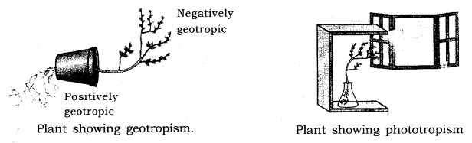

Phototropism
Movement of plant parts in response to light is known as phototropism.
- Towards light – positive phototropism
- Away from light – negative phototropism
- Stems move towards light and roots move away from light

Hydrotropism
Movement of plant parts in response to water or moisture.
- Towards water – positive hydrotropism
- Away from water – negative hydrotropism
- Again, root movement in search of water is positive hydrotropism

Chemotropism
Movement of plant parts in response to chemical stimuli is known as chemotropism.
- Towards chemical – positive chemotropism
- Away from chemical – negative chemotropism
- The growth of pollen tube towards the ovule is positive chemotropism

Thigmotropism
Movement of plant parts in response to touch is called as thigmotropism.
- Towards touch – Positive thigmotropism
- Away from touch – negative thigmotropism
- Movement of tendrils around the support is positive thigmotropism

Plant hormones: Plant hormones are chemical which help to co-ordinate growth, development and responses to the environment.
Type of plant hormones: Main plant hormones are
- Auxin: (Synthesized at shoot tip).
Function: Helps in growth.
Phototropism: more growth of cells towards the light.
- Gibberellin: Helps in the growth of the stem.
- Cytokinins: Promotes cell division.
- Abscisic acid: Inhibits growth, cause wilting of leaves. (Stress hormone)

[CONTROL AND COORDINATION.]
| BIOLOGY | STUDY NOTES-6

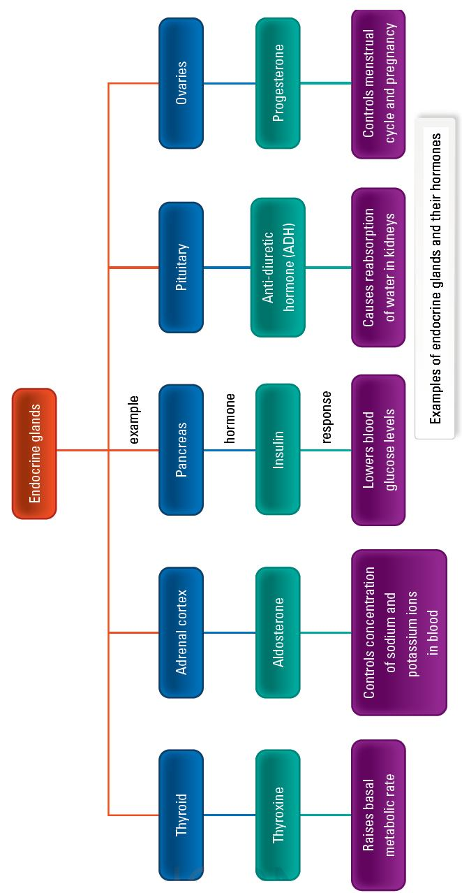
Chapter-7-Control and coordination.
Subtopic- Anterior pituitary- GH,PRLH,TSH,ACTH,FSH,LH,Posterior
pituitary -VP OR ADH, OT, intermediate pituitary-MSH,Feedback Mechanism, Explain with the help of an example or define feedback mechanism

Hormones: These are the chemical messengers secreted in very small amounts by specialised tissues called ductless glands. They act on target tissues/organs usually away from their source. Endocrine System helps in control and coordination through chemical compounds called hormones.

The pituitary gland:
• It is a pea-shaped gland located at the base of the brain.
• It is considered to be master gland as it secretes many hormones to regulate the organs as well as the other glands.
• Different hormones secreted by this gland include Growth hormone, TSH, FSH, LH, ACTH, MSH, Vasopressin and Oxytocin.

The hypothalamus:
• It is a neuro-endocrine part of the brain.
• It links the nervous system and the endocrine system through the pituitary gland. • Different hormones secreted by this gland include TRH, GnRH, GHRH, CRH,
Stomatostatin, Dopamine.

The thyroid gland:
• It is located in the neck, ventral to the larynx. • It is the one of the largest endocrine glands.

The principal hormones produced by this gland are triiodothyronine and thyroxine.
• Thyroxine is a hormone that regulates the metabolism of carbohydrates, proteins and fats in the body.
Hyposecretion of thyroxine leads to cretinin in children, and myxoedema in adults. Hypersecretion of thyroxine leads to exopthalmic goitre in adults. Goitre is caused due to deficiency of iodine in food. Iodine is essential for the synthesis of thyroxine.
Parathyroid glands:
• These are two pairs of small, oval-shaped glands embedded on the dorsal surface of the thyroid gland present in the neck.
• They secrete parathormone. Parathormone helps in regulation of calcium and phosphate ions in the bones and blood.
• Hyposecretion leads to parathyroid tetany and hypersecretion causes osteoporosis.

The adrenal glands:
• These are located above the kidneys and hence are called as suprarenal glands. • Two regions of the adrenal gland are adrenal cortex and adrenal medulla.
• Adrenal cortex secretes the hormones like cortisol, aldosterone and androgens. • Adrenal medulla secretes the hormones like adrenaline and noradrenaline.
Adrenaline is also called the “hormone of fight or flight,” or the emergency hormone. It prepares the body to face an emergency condition of physical stress, like danger, anger and excitement.

The pancreas:
• It is located just below the stomach within the curve of the duodenum. It is both exocrine and endocrine in function.
• It secretes hormones such as insulin, glucagon, somatostatin and pancreatic polypeptide.
• Insulin regulates the sugar level in our blood. Insulin secreted in small amounts increases the sugar level in our blood which in turn causes a disease called diabetes mellitus.

Gonads:
Two types of gonads present in human beings are female gonads and male gonads.

Female gonads
• A pair of ovaries forms the gonads in female.
• Ovaries are the female sex organs that lie one on either side of the abdominal cavity. Ovaries produce two hormones, namely, oestrogen and progesterone.
• Oestrogen controls the changes that occur during puberty, like feminine voice, soft skin and development in mammary glands.
• Progesterone controls the uterine changes in the menstrual cycle, and helps in the maintenance of pregnancy.

Male gonads

• A pair of testes forms the gonads in males.

• A pair of testes is the male sex organ located in the scrotum, which is outside the abdomen.
• Testes produce the hormone testosterone.
• Testosterone controls the changes, which occur during puberty, like deeper voice, development of penis, facial and body hair

The pineal gland:
• It is located near the centre of the brain, dorsal to the diencephalon. • It produces the hormone melatonin.
• Melatonin affects reproductive development, modulation of wake and sleep patterns, and seasonal functions.

The thymus gland:
• It is located in front of the heart, in the upper part of the sternum. • It produces the hormone thymosine.
• It helps in the maturation of T-lymphocytes.

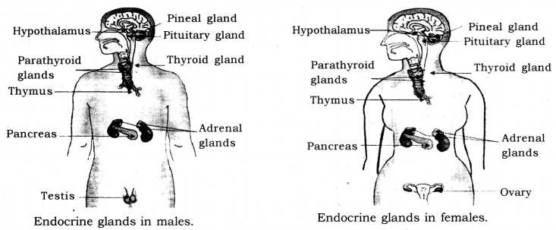

Feedback mechanism: A type of self-regulating mechanism in which the level of one substance in body influences the level of another.

