Chapter-8

Education and British Rule
STUDY NOTES

Introduction


Before the coming of the British, there were pathshalas and maktabas for elementary education in tols and madrasas for higher education. The elementary education schools made the students just literate enough to maintain accounts. In higher education they were taught Sanskrit, Arabic and Persian, law, religion, literature medicine and astronomy. Learning was based on old books; Education was neither organized nor supported by the state.

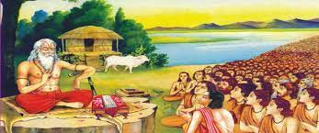

https://youtu.be/VRDsfv56_B4

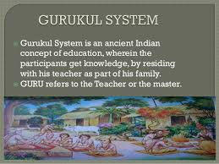

Modern System of Education

When British started ruling India, they realized that they needed educated Indians at some level to help them run the country. So, in 1781 Warren Hastings established The Calcutta Madrasa and in 1791 Jonathan Duncan started Banaras Sanskrit College.
The British appointed Lord Macaulay to decide whether they continue the existing system of education or English education
‘’ Lord Macaulay strongly believed that Oriental learning was completely inferior to European learning’s” he recommended the western system as it encouraged rational thinking and scientific research.

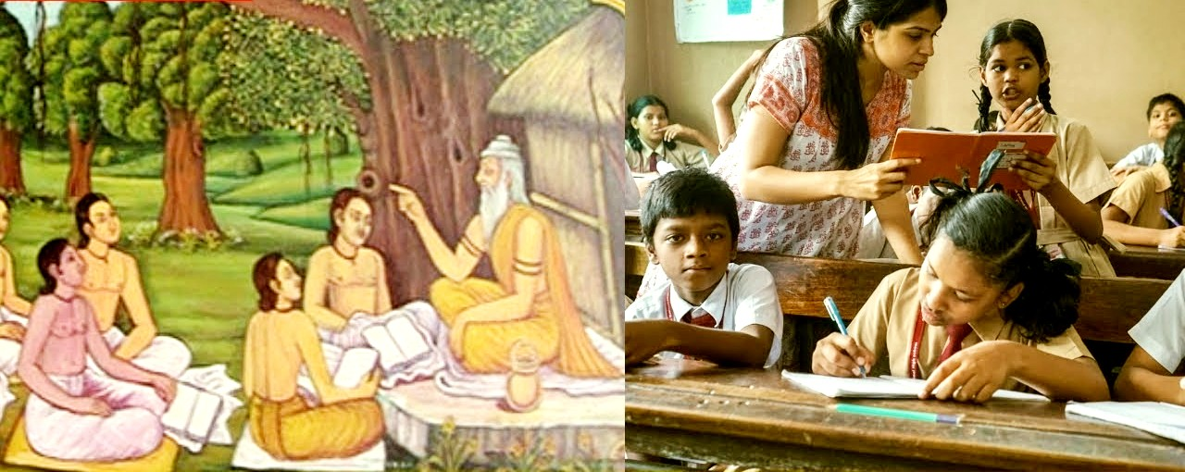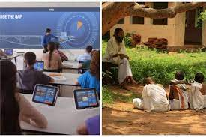

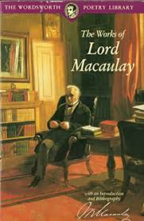

Wood’s Dispatch

Sir Charles Wood, the president of the Board of Control in England, sent a Dispatch to Governor – General Lord Dalhousie with his recommendations on the system of education to be followed in India came to be known as Wood’s Dispatch.

This Dispatch was to become the blueprint for Education in India for a long time to come

The important provisions of Wood’s Dispatch was

- A systematic method of education from the primary level to the university level.
- An education department was to be set up in all the provisions.
- Every district was to have one government school
- Grants –in –aid were to be given to private schools affiliated to the Government
- In Bombay, Madras, and Calcutta universities were to be opened along the lines of London Universities
- Indians were to be taught their mother tongue as well.
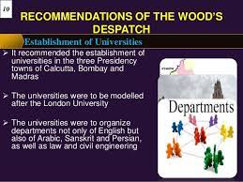 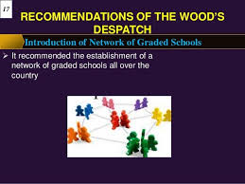y During the British Rule schools were opened to impart the Western System of Education on the Wood’s Dispatch model. Even Christian Missionaries teaching through Indian languages were made to switch over to English.

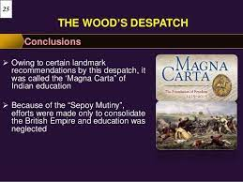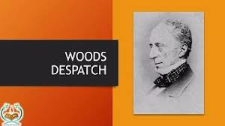

The Demerits of the modern system

- Though the middle schools which taught in English were opened, primary education was neglected. So was education for the poor.
- There was a decline in the indigenous system of Education. Indian language schools lost support and students, and were forced to close.
- No attention was paid to the education of women.
- Scientific and technical education was not taken care of.

The British invested money in Indian education only for the returns they would get in the form of an educated class of clerks. It was also less expensive than bringing in people from Britain.

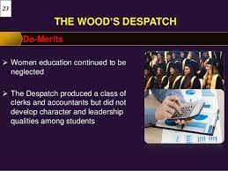

https://youtu.be/RbDqBLsYE0Q

NATIONAL EDUCATION

Under the new system of education, many Indians were educated in English medium schools and colleges. This brought them in touch with the happenings of the world and the great thinkers of that time who talked about the equality of humans and the freedom of nations. A nationalistic spirit grew in the minds of the educated Indians.

Soon the swadeshi and Boycott movements began to shake the British Empire. Indians stopped going to English – medium schools and colleges as a mark of protest.

Eminent men of Bengal, like Sarishchandra Mukherjee, Aurobindo Ghosh and Rabindranath
Tagore, met in 1905 and decided to form a National Council of Education to start a system of education on a national scale. Because they realized that the education policy of the British was not reaching the grassroots.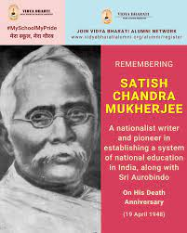 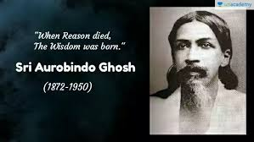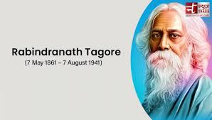

Funds were collected and many schools and colleges were opened based on the National Council of Education. Over the next 100 years, as modern education spread, Indian Universities produced outstanding scientists, like CV Raman, PC Ray, SN Bose, Meghnad Saah and DN Wadia.

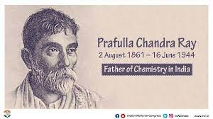

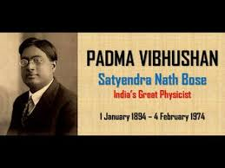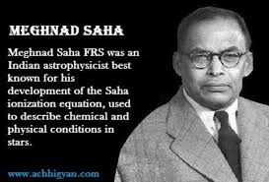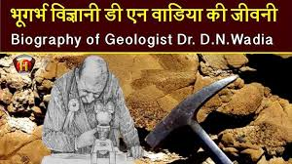

CASE STUDY--BARODA COLLEGE OF SCIENCE

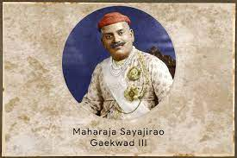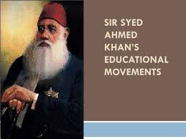
MOHAMMEDAN ANGLO-ORIENTAL COLLEGE

