[CHEMICAL REACTIONS AND EQUATIONS] CHEMISTRY CLASS-X WORKSHEET-6

SUBTOPIC - DISPLACEMENT AND DOUBLE DISPLACEMENT REACTIONS , CORROSION AND RANCIDITY

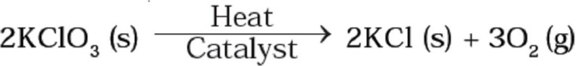
- The following reaction is used for the preparation of oxygen gas in the laboratory
Which of the following statement(s) is(are) correct about the reaction?
- It is a decomposition reaction and endothermic in nature
- It is a combination reaction
- It is a decomposition reaction and accompanied by release of heat
- It is a photochemical decomposition reaction and exothermic in nature
- Which of the following is(are) an endothermic process(es)?
- Dilution of sulphuric acid
- Sublimation of dry ice
- Condensation of water vapours
- Evaporation of water

- Which among the following is(are) double displacement reaction(s)?
- Pb + CuCl₂ → PbCl₂ + Cu
- Na₂SO₄ + BaCl₂ → BaSO₄ + 2NaCl
- C + O₂ → CO₂
- CH₄ + 2O₂ → CO₂ + 2H₂O
- (i) and (iv)
- (ii) only
- (i) and (ii)
- (iii) and (iv)
- Which of the following are combination reactions?
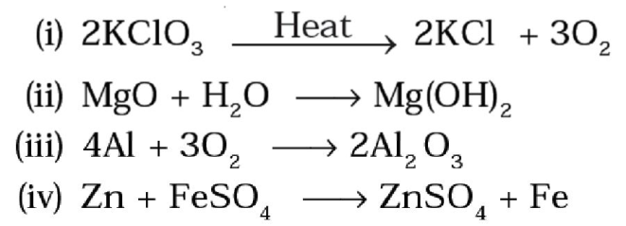
- (i) and (iii)
- (iii) and (iv)
- (ii) and (iv)
- (ii) and (iii)

