Chapter- 2
Maps
STUDY NOTES
Let’s Learn
The Globe and Maps
The Globe
The globe is a small model of the Earth. It is the most accurate way of looking at the size, shape and location of places on the Earth. It is the most accurate three - dimensional representation of the earth. Globe shows the continents and oceans accurately.
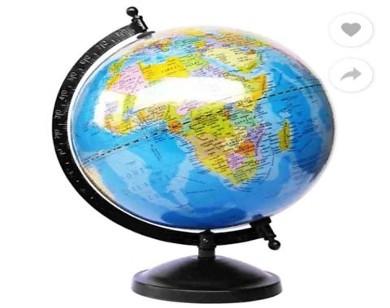
But it has some drawbacks. Like:-
- Only a part of the earth can be seen on a globe, at one glance.
- All details can not be marked on a globe.
- A globe is difficult to carry around.
To avoid these problems, we normally use maps instead of a globe.
What is a Map?
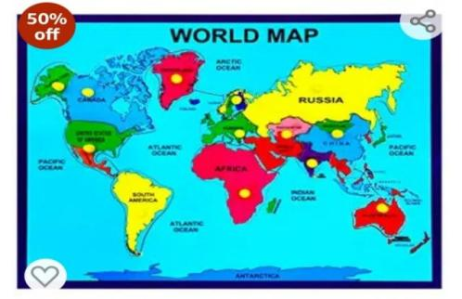
- The origin of the word ‘ map ‘ is from Latin word ‘ mappo ‘ which means a napkin.
- A map is a drawing of the Earth’s surface, or a part of it, on a flat surface, such as a sheet of paper.
- Maps are one of the oldest forms of non - verbal communication.
- Every culture in every part of the world makes and uses maps.
- All the information about one place can not be put in a single map.
- Different aspects of a place can be shown in different types of maps.
- The art and science of making maps is called cartography.
- A person who makes maps is called a cartographer.
Why use Maps?
People use to ‘ read ‘ maps for different reasons. For example :-
- We often use them when we are travelling to villages, towns or cities that we are not familiar with.
- News reporters use maps to tell us where things are happening in the world, pilots use them to navigate the skies and fisherman to navigate the seas.
Comparing globes and maps
Globes Maps
- A globe is spherical in shape and 1. A map is a representation of the Earth on a flat is a true model of the Earth. surface.
- A globe shows us the features of 2. A map often changes the shape of the
Earth as they really are. features and landmasses.
- A globe shows us only a part of the 3. A map can show us the entire surface of the Earth at a time. Earth at a glance.
- A globe is difficult to carry around. 4. A map is easy to carry around.
- A globe cannot show features of the 5. A map can show any number of details Earth in great details. depending on it’s scale.
Different types of Maps
Maps can be drawn to show the whole world, a single continent, a country, a city, your neighbourhood, and even your school. They can be drawn in any size. A book of maps is called an atlas. We can find different maps in it. Some of these are as follows:
- Political map
- Physical map
Political Map
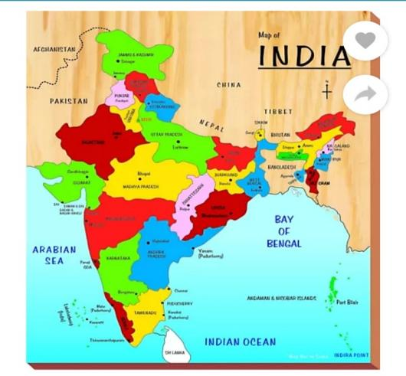
Political maps show the location and the boundaries of different countries. Some of them also show the states within countries.
Physical Map
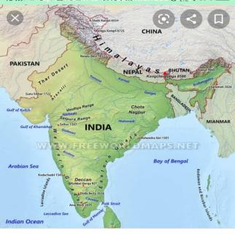
Physical maps show the land forms or physical features of an area, such as mountains, rivers, seas, plains, and deserts.

There are some other kinds of map like:-
Maps showing-
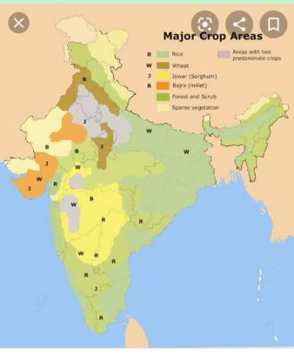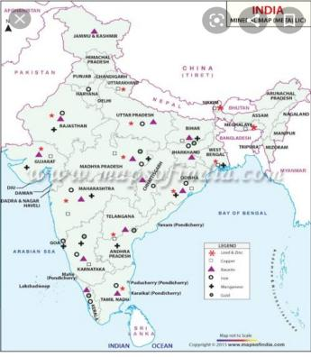
Crops grown in various places Minerals found in various places
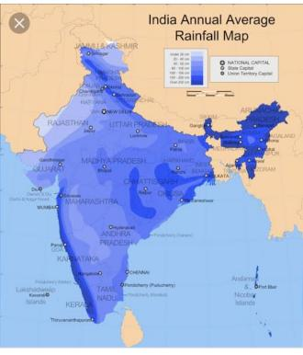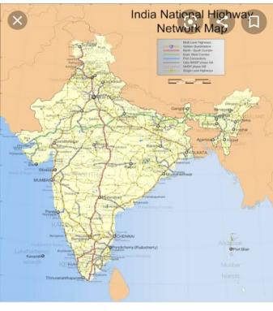
Rainfall in different areas India National Highways Network
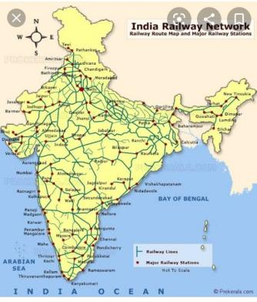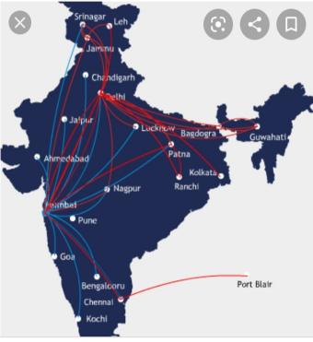
India Railway Network India Airline Network

Elements of a map
Every map has certain elements or features. By studying these elements, we are able to gather information about the area being shown in the map. Some of these elements are:
- Directions/ Orientation
- Scale
- Colour
- Symbols
Direction
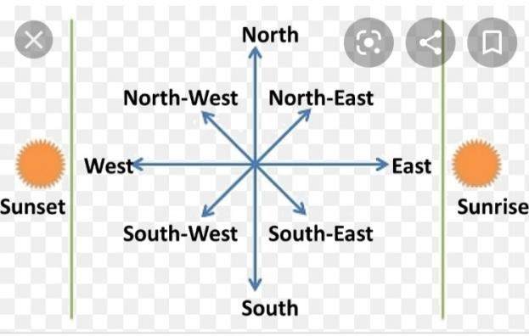
Directions tells you where the four cardinal directions are on the map i.e north, south, east and west. Most maps are drawn with north at the top. If you know where north lies, it is easy to find south, east and west.
Scale
A map rarely shows the actual distances between places. Distances are shrunk so that the area being mapped can be fitted on a piece of paper. To be able to do this accurately, maps are drawn to a scale. The scale of a map is the ratio between distance shown on the map and the actual distance on the ground. For example:-
- The actual distance between two cities may be 100 km.
- But on the map it may be shown as 1cm.
- Then the scale of the map is ‘1 cm:100 km’.
- The scale of a map is often shown as a line with distances marked on it.

- The scale of ‘1 cm:100 km’ is shown here in this way.
- This is called a linear scale.
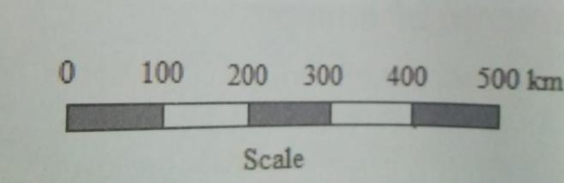
Each division in the bar is 1 cm (measured on the map) and indicates 100 km (as shown in numbers just above the bar) on the ground.
Colours
Certain standard colours are used in maps to show features such as oceans, seas, mountains, plains, deserts etc.
Water bodies
Water bodies are always shown in blue. Deep blue shows deep waters and light blue shows shallow waters.
Mountains and highlands
Mountains and highlands are shown in brown and yellow. Dark brown shows high mountains. Light brown shows lower mountains and hills. Yellow shows plateaus.
Plains
Plains and lowlands are shown in green.
Symbols
To make it easier to show features and places on a map, certain standard symbols are used in maps. A symbol is a shape or sign that is used to represent something. For example:-
- To show a church on a map we can just put a cross at that spot, instead of writing the word ‘church’ there.
- Symbols make it easier to read and understand maps.
- Once we are familiar with these, understanding a map becomes easier.
Standard symbols used in maps
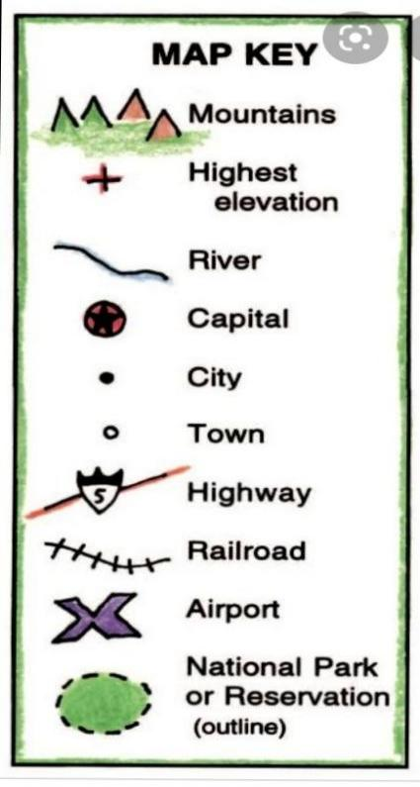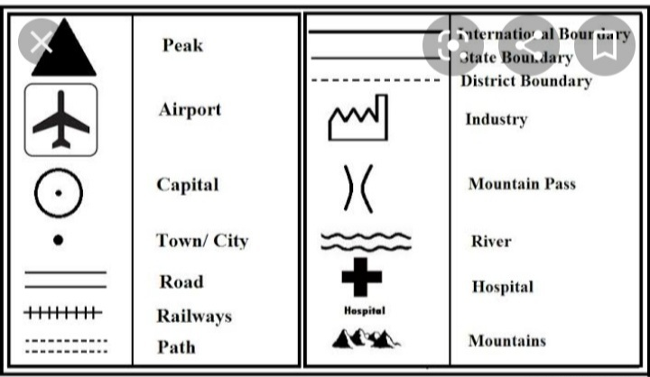
%3CmxGraphModel%3E%3Croot%3E%3CmxCell%20id%3D%220%22%2F%3E%3CmxCell%20id%3D%221%22%20parent%3D%220%22%2F%3E%3CmxCell%20id%3D%222%22%20value%3D%22%22%20style%3D%22edgeStyle%3DorthogonalEdgeStyle%3Brounded%3D0%3BorthogonalLoop%3D1%3BjettySize%3Dauto%3Bhtml%3D1%3B%22%20edge%3D%221%22%20source%3D%224%22%20target%3D%225%22%20parent%3D%221%22%3E%3CmxGeometry%20relative%3D%221%22%20as%3D%22geometry%22%2F%3E%3C%2FmxCell%3E%3CmxCell%20id%3D%223%22%20value%3D%22%22%20style%3D%22edgeStyle%3DorthogonalEdgeStyle%3Brounded%3D0%3BorthogonalLoop%3D1%3BjettySize%3Dauto%3Bhtml%3D1%3B%22%20edge%3D%221%22%20source%3D%224%22%20target%3D%228%22%20parent%3D%221%22%3E%3CmxGeometry%20relative%3D%221%22%20as%3D%22geometry%22%2F%3E%3C%2FmxCell%3E%3CmxCell%20id%3D%224%22%20value%3D%22MEMORY%20MAP%22%20style%3D%22shape%3Dhexagon%3Bperimeter%3DhexagonPerimeter2%3BwhiteSpace%3Dwrap%3Bhtml%3D1%3BfixedSize%3D1%3BfontStyle%3D1%22%20vertex%3D%221%22%20parent%3D%221%22%3E%3CmxGeometry%20x%3D%22380%22%20y%3D%2230%22%20width%3D%22120%22%20height%3D%2280%22%20as%3D%22geometry%22%2F%3E%3C%2FmxCell%3E%3CmxCell%20id%3D%225%22%20value%3D%22GLOBE%22%20style%3D%22shape%3Dtrapezoid%3Bperimeter%3DtrapezoidPerimeter%3BwhiteSpace%3Dwrap%3Bhtml%3D1%3BfixedSize%3D1%3BfontStyle%3D1%3B%22%20vertex%3D%221%22%20parent%3D%221%22%3E%3CmxGeometry%20x%3D%22140%22%20y%3D%22120%22%20width%3D%22120%22%20height%3D%2260%22%20as%3D%22geometry%22%2F%3E%3C%2FmxCell%3E%3CmxCell%20id%3D%226%22%20value%3D%22%22%20style%3D%22edgeStyle%3DorthogonalEdgeStyle%3Brounded%3D0%3BorthogonalLoop%3D1%3BjettySize%3Dauto%3Bhtml%3D1%3B%22%20edge%3D%221%22%20source%3D%228%22%20target%3D%2210%22%20parent%3D%221%22%3E%3CmxGeometry%20relative%3D%221%22%20as%3D%22geometry%22%2F%3E%3C%2FmxCell%3E%3CmxCell%20id%3D%227%22%20value%3D%22%22%20style%3D%22edgeStyle%3DorthogonalEdgeStyle%3Brounded%3D0%3BorthogonalLoop%3D1%3BjettySize%3Dauto%3Bhtml%3D1%3B%22%20edge%3D%221%22%20source%3D%228%22%20target%3D%2212%22%20parent%3D%221%22%3E%3CmxGeometry%20relative%3D%221%22%20as%3D%22geometry%22%2F%3E%3C%2FmxCell%3E%3CmxCell%20id%3D%228%22%20value%3D%22MAPS%22%20style%3D%22shape%3Dtrapezoid%3Bperimeter%3DtrapezoidPerimeter%3BwhiteSpace%3Dwrap%3Bhtml%3D1%3BfixedSize%3D1%3BfontStyle%3D1%3B%22%20vertex%3D%221%22%20parent%3D%221%22%3E%3CmxGeometry%20x%3D%22590%22%20y%3D%22120%22%20width%3D%22120%22%20height%3D%2260%22%20as%3D%22geometry%22%2F%3E%3C%2FmxCell%3E%3CmxCell%20id%3D%229%22%20value%3D%22%22%20style%3D%22edgeStyle%3DorthogonalEdgeStyle%3Brounded%3D0%3BorthogonalLoop%3D1%3BjettySize%3Dauto%3Bhtml%3D1%3B%22%20edge%3D%221%22%20source%3D%2210%22%20target%3D%2213%22%20parent%3D%221%22%3E%3CmxGeometry%20relative%3D%221%22%20as%3D%22geometry%22%2F%3E%3C%2FmxCell%3E%3CmxCell%20id%3D%2210%22%20value%3D%22DIFFERENT%20TYPES%20OF%20MAPS%22%20style%3D%22ellipse%3BwhiteSpace%3Dwrap%3Bhtml%3D1%3BfontStyle%3D1%3B%22%20vertex%3D%221%22%20parent%3D%221%22%3E%3CmxGeometry%20x%3D%22460%22%20y%3D%22210%22%20width%3D%22120%22%20height%3D%2280%22%20as%3D%22geometry%22%2F%3E%3C%2FmxCell%3E%3CmxCell%20id%3D%2211%22%20value%3D%22%22%20style%3D%22edgeStyle%3DorthogonalEdgeStyle%3Brounded%3D0%3BorthogonalLoop%3D1%3BjettySize%3Dauto%3Bhtml%3D1%3B%22%20edge%3D%221%22%20source%3D%2212%22%20target%3D%2214%22%20parent%3D%221%22%3E%3CmxGeometry%20relative%3D%221%22%20as%3D%22geometry%22%2F%3E%3C%2FmxCell%3E%3CmxCell%20id%3D%2212%22%20value%3D%22ELEMENTS%20OF%20A%20MAP%22%20style%3D%22ellipse%3BwhiteSpace%3Dwrap%3Bhtml%3D1%3BfontStyle%3D1%3B%22%20vertex%3D%221%22%20parent%3D%221%22%3E%3CmxGeometry%20x%3D%22730%22%20y%3D%22210%22%20width%3D%22120%22%20height%3D%2280%22%20as%3D%22geometry%22%2F%3E%3C%2FmxCell%3E%3CmxCell%20id%3D%2213%22%20value%3D%221.%20PHYSICAL%20MAP%26lt%3Bbr%26gt%3B2.%20POLITICAL%20MAP%26lt%3Bbr%26gt%3B3.%20THEMATIC%20MAP%22%20style%3D%22shape%3Dcube%3BwhiteSpace%3Dwrap%3Bhtml%3D1%3BboundedLbl%3D1%3BbackgroundOutline%3D1%3BdarkOpacity%3D0.05%3BdarkOpacity2%3D0.1%3BfontStyle%3D1%3B%22%20vertex%3D%221%22%20parent%3D%221%22%3E%3CmxGeometry%20x%3D%22460%22%20y%3D%22370%22%20width%3D%22140%22%20height%3D%22140%22%20as%3D%22geometry%22%2F%3E%3C%2FmxCell%3E%3CmxCell%20id%3D%2214%22%20value%3D%221.%20DIRECTIONS%26lt%3Bbr%26gt%3B2.%20SCALE%26lt%3Bbr%26gt%3B3.%20COLOURS%26lt%3Bbr%26gt%3B4.%20SYMBOLS%22%20style%3D%22shape%3Dcube%3BwhiteSpace%3Dwrap%3Bhtml%3D1%3BboundedLbl%3D1%3BbackgroundOutline%3D1%3BdarkOpacity%3D0.05%3BdarkOpacity2%3D0.1%3BfontStyle%3D1%3B%22%20vertex%3D%221%22%20parent%3D%221%22%3E%3CmxGeometry%20x%3D%22730%22%20y%3D%22370%22%20width%3D%22120%22%20height%3D%22130%22%20as%3D%22geometry%22%2F%3E%3C%2FmxCell%3E%3C%2Froot%3E%3C%2FmxGraphModel%3E%3CmxGraphModel%3E%3Croot%3E%3CmxCell%20id%3D%220%22%2F%3E%3CmxCell%20id%3D%221%22%20parent%3D%220%22%2F%3E%3CmxCell%20id%3D%222%22%20value%3D%22%22%20style%3D%22edgeStyle%3DorthogonalEdgeStyle%3Brounded%3D0%3BorthogonalLoop%3D1%3BjettySize%3Dauto%3Bhtml%3D1%3B%22%20edge%3D%221%22%20source%3D%224%22%20target%3D%225%22%20parent%3D%221%22%3E%3CmxGeometry%20relative%3D%221%22%20as%3D%22geometry%22%2F%3E%3C%2FmxCell%3E%3CmxCell%20id%3D%223%22%20value%3D%22%22%20style%3D%22edgeStyle%3DorthogonalEdgeStyle%3Brounded%3D0%3BorthogonalLoop%3D1%3BjettySize%3Dauto%3Bhtml%3D1%3B%22%20edge%3D%221%22%20source%3D%224%22%20target%3D%228%22%20parent%3D%221%22%3E%3CmxGeometry%20relative%3D%221%22%20as%3D%22geometry%22%2F%3E%3C%2FmxCell%3E%3CmxCell%20id%3D%224%22%20value%3D%22MEMORY%20MAP%22%20style%3D%22shape%3Dhexagon%3Bperimeter%3DhexagonPerimeter2%3BwhiteSpace%3Dwrap%3Bhtml%3D1%3BfixedSize%3D1%3BfontStyle%3D1%22%20vertex%3D%221%22%20parent%3D%221%22%3E%3CmxGeometry%20x%3D%22380%22%20y%3D%2230%22%20width%3D%22120%22%20height%3D%2280%22%20as%3D%22geometry%22%2F%3E%3C%2FmxCell%3E%3CmxCell%20id%3D%225%22%20value%3D%22GLOBE%22%20style%3D%22shape%3Dtrapezoid%3Bperimeter%3DtrapezoidPerimeter%3BwhiteSpace%3Dwrap%3Bhtml%3D1%3BfixedSize%3D1%3BfontStyle%3D1%3B%22%20vertex%3D%221%22%20parent%3D%221%22%3E%3CmxGeometry%20x%3D%22140%22%20y%3D%22120%22%20width%3D%22120%22%20height%3D%2260%22%20as%3D%22geometry%22%2F%3E%3C%2FmxCell%3E%3CmxCell%20id%3D%226%22%20value%3D%22%22%20style%3D%22edgeStyle%3DorthogonalEdgeStyle%3Brounded%3D0%3BorthogonalLoop%3D1%3BjettySize%3Dauto%3Bhtml%3D1%3B%22%20edge%3D%221%22%20source%3D%228%22%20target%3D%2210%22%20parent%3D%221%22%3E%3CmxGeometry%20relative%3D%221%22%20as%3D%22geometry%22%2F%3E%3C%2FmxCell%3E%3CmxCell%20id%3D%227%22%20value%3D%22%22%20style%3D%22edgeStyle%3DorthogonalEdgeStyle%3Brounded%3D0%3BorthogonalLoop%3D1%3BjettySize%3Dauto%3Bhtml%3D1%3B%22%20edge%3D%221%22%20source%3D%228%22%20target%3D%2212%22%20parent%3D%221%22%3E%3CmxGeometry%20relative%3D%221%22%20as%3D%22geometry%22%2F%3E%3C%2FmxCell%3E%3CmxCell%20id%3D%228%22%20value%3D%22MAPS%22%20style%3D%22shape%3Dtrapezoid%3Bperimeter%3DtrapezoidPerimeter%3BwhiteSpace%3Dwrap%3Bhtml%3D1%3BfixedSize%3D1%3BfontStyle%3D1%3B%22%20vertex%3D%221%22%20parent%3D%221%22%3E%3CmxGeometry%20x%3D%22590%22%20y%3D%22120%22%20width%3D%22120%22%20height%3D%2260%22%20as%3D%22geometry%22%2F%3E%3C%2FmxCell%3E%3CmxCell%20id%3D%229%22%20value%3D%22%22%20style%3D%22edgeStyle%3DorthogonalEdgeStyle%3Brounded%3D0%3BorthogonalLoop%3D1%3BjettySize%3Dauto%3Bhtml%3D1%3B%22%20edge%3D%221%22%20source%3D%2210%22%20target%3D%2213%22%20parent%3D%221%22%3E%3CmxGeometry%20relative%3D%221%22%20as%3D%22geometry%22%2F%3E%3C%2FmxCell%3E%3CmxCell%20id%3D%2210%22%20value%3D%22DIFFERENT%20TYPES%20OF%20MAPS%22%20style%3D%22ellipse%3BwhiteSpace%3Dwrap%3Bhtml%3D1%3BfontStyle%3D1%3B%22%20vertex%3D%221%22%20parent%3D%221%22%3E%3CmxGeometry%20x%3D%22460%22%20y%3D%22210%22%20width%3D%22120%22%20height%3D%2280%22%20as%3D%22geometry%22%2F%3E%3C%2FmxCell%3E%3CmxCell%20id%3D%2211%22%20value%3D%22%22%20style%3D%22edgeStyle%3DorthogonalEdgeStyle%3Brounded%3D0%3BorthogonalLoop%3D1%3BjettySize%3Dauto%3Bhtml%3D1%3B%22%20edge%3D%221%22%20source%3D%2212%22%20target%3D%2214%22%20parent%3D%221%22%3E%3CmxGeometry%20relative%3D%221%22%20as%3D%22geometry%22%2F%3E%3C%2FmxCell%3E%3CmxCell%20id%3D%2212%22%20value%3D%22ELEMENTS%20OF%20A%20MAP%22%20style%3D%22ellipse%3BwhiteSpace%3Dwrap%3Bhtml%3D1%3BfontStyle%3D1%3B%22%20vertex%3D%221%22%20parent%3D%221%22%3E%3CmxGeometry%20x%3D%22730%22%20y%3D%22210%22%20width%3D%22120%22%20height%3D%2280%22%20as%3D%22geometry%22%2F%3E%3C%2FmxCell%3E%3CmxCell%20id%3D%2213%22%20value%3D%221.%20PHYSICAL%20MAP%26lt%3Bbr%26gt%3B2.%20POLITICAL%20MAP%26lt%3Bbr%26gt%3B3.%20THEMATIC%20MAP%22%20style%3D%22shape%3Dcube%3BwhiteSpace%3Dwrap%3Bhtml%3D1%3BboundedLbl%3D1%3BbackgroundOutline%3D1%3BdarkOpacity%3D0.05%3BdarkOpacity2%3D0.1%3BfontStyle%3D1%3B%22%20vertex%3D%221%22%20parent%3D%221%22%3E%3CmxGeometry%20x%3D%22460%22%20y%3D%22370%22%20width%3D%22140%22%20height%3D%22140%22%20as%3D%22geometry%22%2F%3E%3C%2FmxCell%3E%3CmxCell%20id%3D%2214%22%20value%3D%221.%20DIRECTIONS%26lt%3Bbr%26gt%3B2.%20SCALE%26lt%3Bbr%26gt%3B3.%20COLOURS%26lt%3Bbr%26gt%3B4.%20SYMBOLS%22%20style%3D%22shape%3Dcube%3BwhiteSpace%3Dwrap%3Bhtml%3D1%3BboundedLbl%3D1%3BbackgroundOutline%3D1%3BdarkOpacity%3D0.05%3BdarkOpacity2%3D0.1%3BfontStyle%3D1%3B%22%20vertex%3D%221%22%20parent%3D%221%22%3E%3CmxGeometry%20x%3D%22730%22%20y%3D%22370%22%20width%3D%22120%22%20height%3D%22130%22%20as%3D%22geometry%22%2F%3E%3C%2FmxCell%3E%3C%2Froot%3E%3C%2FmxGraphMoVJBJHIHHHNNMKK
ELEMENTS OF MAP:-
- DIRECTIONS
- SCALE
- COLOUR
- SYMBOLS
DIFFERENT TYPES OF MAPS:-
- PHYSICAL MAP
- POLITICAL MAP
- THEMATIC MAP
MAPS
GLOBE
MEMORY MAP

Let’s know more
Fill in the blanks
- Digital maps tell us the best routes to reach our destination with the help of __________.
- A map which shows the climate of a country is a _______ map.
- The globe made by Martin Behaim was named ______.
- Some maps use colours as _______ to represent information.
- The _______ of a map tells us which area is covered by the map.
Let’s Do
- Fill in the blanks.
- An _______ is a book of maps.
- The ratio of distance on a map to actual distance is known as the ________ of the map.
- On a map, high mountains are shown in ___________.
- On a map, the use of the colour blue shows _________.
- Shapes or signs used to represent features on a map are called _________.
- On a map drawn to a scale of 1 cm : 100 kilometres, a distance of five centimetres on the map means an actual distance of ________.
- If north is at the top in a map, west is to the __________.

- Match the columns.
- Arrow marked N on map a. Green
- 1 centimetre : 1 Kilometre b. Bridge
- Plains c. North
- d.Map scale
- 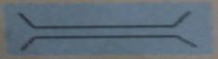 e. Boundary between two countries
Understand and Answer
- Answer the following questions.
- A globe is the most accurate way to represent the Earth. However, we generally use a map rather than a globe to study the Earth. Why is this?
- A map of the Earth will have errors in the shape and size of places shown on the map. Why is that so?
- How is direction usually shown in maps?
- What do you understand by the term ‘scale of a map’?
- Which standard colours are used in maps?
- What are symbols?
Teacher’s Note
Suppose the Earth was flat and not round. How would our lives have been different? Or would it have made no difference to our lives? Does the shape of the Earth matter at all?
Improve your G.K
- The science of making maps is called cartography.
- The oldest surviving globe was made by a German cartographer named Martin Behaim, in 1492.
- First ‘modern’ map printed over 500 years ago.
- The world’s best map collection is in Paris.
- Most expensive map was the first to name America.
ANSWER KEY
Let’s know more
Fill in the blanks.
- Thematic
- GPS ( Global Positioning System)
- Erdapfel
- Symbols
- Title
Let’s Do
- 1. Atlas
- Scale
- Dark brown
- Water bodies
- Symbol
- 500 Kilometer
- Left
B.1. c. North
- d. Map Scale
- a. Green
- e. Boundary between two countries
- b. Bridge

Understand and Answer
C.1. We generally use a map rather than a globe to study the Earth because -
- It is easy to carry a map around.
- A map can show the entire surface of the Earth at a glance.
- A map can show any number of details depending on it’s scale.
- A map of the Earth will have errors in the shape and size of places shown on the map because we cannot flatten out the Earth’s surface and show it accurately.
- Usually maps are drawn with north at the top. Most maps indicate North with an arrow marked N. If you know where north lies, it is easy to find south, east and west. If north is at the top, then south is at the bottom, east is to the right, and west to the left.
- Scale of a map shows the ratio between distances on a map to the actual distance on the ground.
- Standard colours used in maps are:- Blue, brown, yellow and green
- Deep blue shows deep waters.
- Light blue shows shallow waters.
- Dark brown shows high mountains.
- Light brown shows lower mountains and hills.
- Yellow shows plateaus.
- Green shows plains and lowlands.
- A symbol is a picture or sign used in a map to represent something from the real world. Colours are also used as symbols. The key or legend explains what each symbol stands for.

