Chapter- 21
Our Government
STUDY NOTES
Let’s Learn
Governmentt

What do you understand by this word?
Government
A government is a body that takes care of the needs of the people. It makes laws and ensures that people follow the rules of the land.
- The elected body which governs or rules a country or a state is called government.
- It also takes care of the needs of the people.
- It makes laws and ensures that people follow the rules of the land.

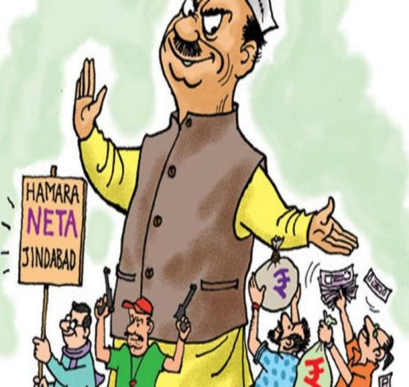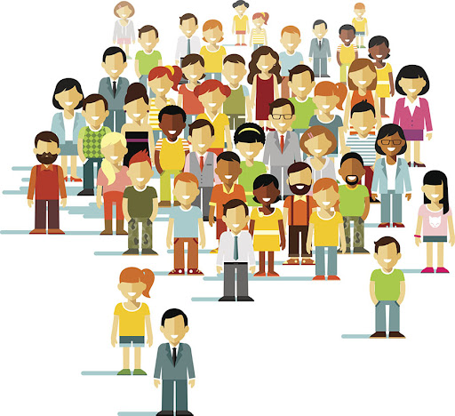

What is the role o the government in our lives?
Works performed by Government:
Governmentt

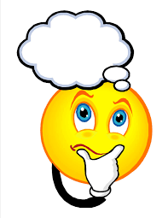
- Construction of roads
- Price regulation
- Supply of electricity
- Day to Day decisions.
- Takes action on social issue.

- Programme to help poor
- Child marriage
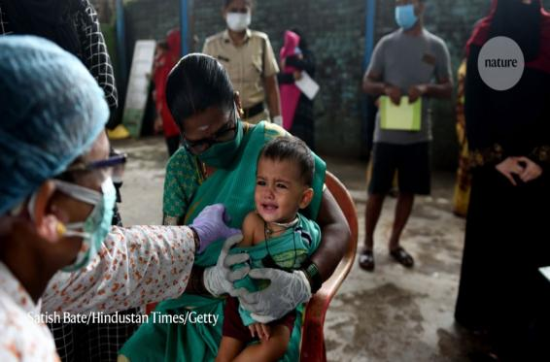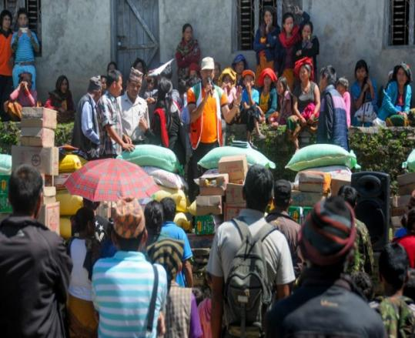

Levels of Government
Vast Country
India

How government manages to do all this?

Government works at different levels
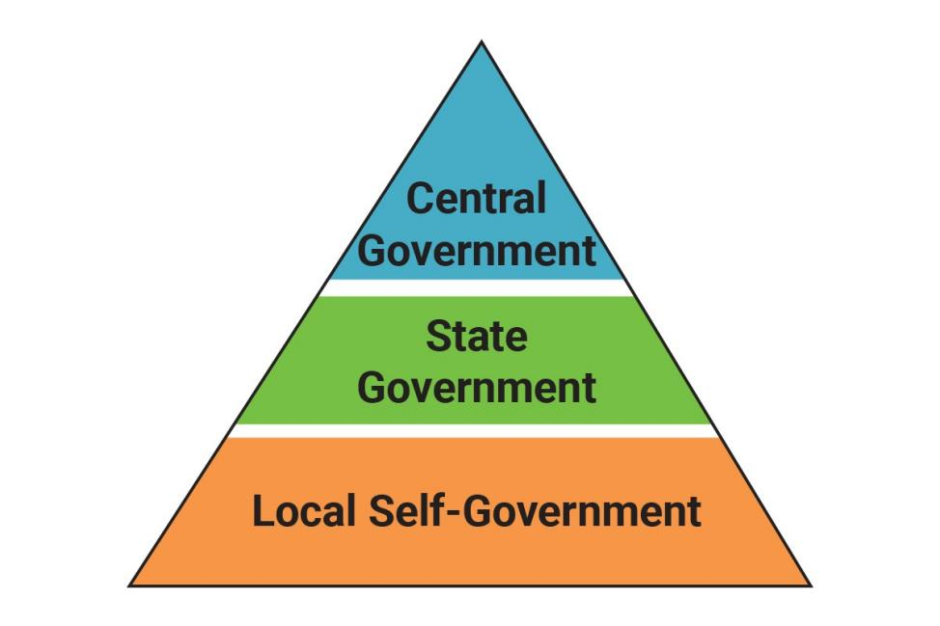
The local level means in your village, town or locality, the state level would mean that which covers an entire state like Odisha, Haryana or Assam and the national level relates to the entire country.

The Local Government
The Local Government governs the people in local level. It is of following types :
- Village Panchayat
- Municipal Committee
- Municipal Corporation

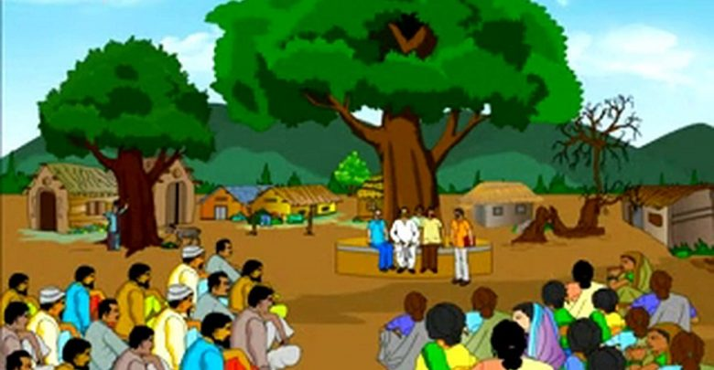

Village Panchayat
- The group of people that look after the welfare of the villagers is called a Panchayat.
- The Panchayat consists of five members called the panchas.
- The leader of the Village Panchayat is a Sarpanch, who is chosen by the adult villagers.

Function of the Panchayat
- They ensure that the medical facilities are provided to the villagers
- They make sure that the schools are provided to the children.
- They provide facilities to educate farmers about new methods of farming and usage of new machines and technologies.
- They also solve disputes among the villagers.
- They help the villagers in bringing wasteland under cultivation.

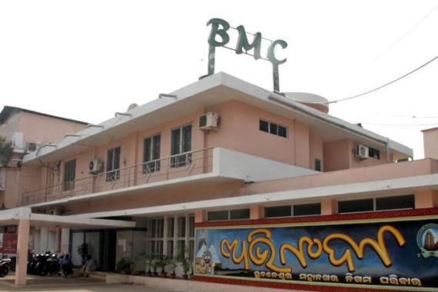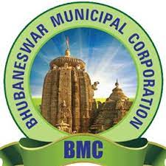

Municipal Committee
- The group that takes care of the people living in the towns is called the Municipal Committee.
- The head of the Municipal Committee is called the Chairperson.
- People living in towns elect the members of the Municipal Committee.
- A Municipal Committee is responsible for providing public services in its areas and looking after the welfare of its town.

Municipal Corporation
- A bigger group that take care of the people living in big cities is called a Municipal Corporation
- The head of the Municipal Corporation is called the Mayor.
- The members of the Municipal Corporation are called Councillors.

The State Government
The State Governments governs the states. The Central Government and the State Governments divide the responsibilities between themselves.
The head of the state is the Governor .The Governor is appointed by the President of India. There are usually two houses:

- The Vidhan Sabha
- The Vidhan Parishad

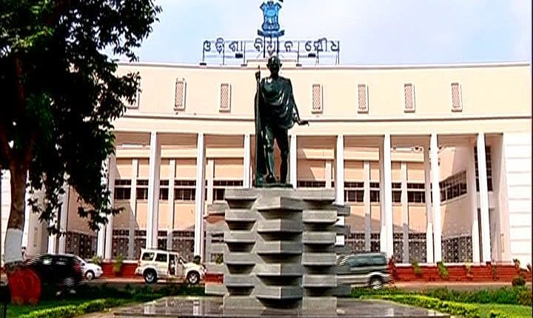

The Vidhan Sabha
- The Vidhan Sabha is also known as the State Legislative Assembly.
- It is the main law making body at the state level.
- The members of the Vidhan Sabha are directly elected by the people of the state.
- Election to the Vidhan Sabha are held every five years.
- The part which gets the most seats is called by the governor to form the new state Government.
- The leader of the party becomes the Chief Minister of the state
- The chief Minister chooses a group of people as ministers .Together they form the Council of Ministers.
- The head of the state government is the Chief Minister.

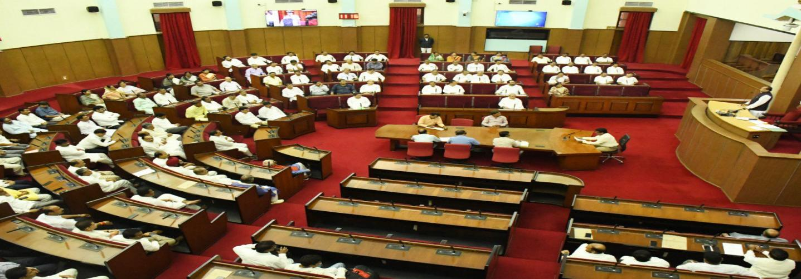

The Vidhan Parishad
The Vidhan Parishad is also known as the Legislative Council.

The Central Government
The main law-making body of the Central Government is the Parliament. The parliament consists of :
- the President of India
- the Lok Sabha
- the Rajya Sabha

The President of India
- The President is the head of our country.
- They are elected for a period of five years by the members of the Lok Sabha , the Rajya Sabha and the State Legislative Assemblies.

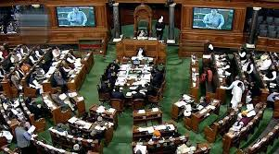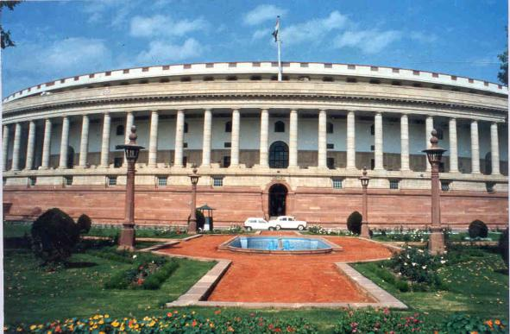

The Lok Sabha
- The Lok Sabha is the lower house of the Parliament.
- It can have a maximum of 552 members.
- As the members of this house are chosen directly by the people of the country, it is also called the House of Representatives.
- Every state sends a fixed number of representatives to the Lok Sabha.
- The members of the Lok Sabha are elected for a period of five years.
- The party which wins the most number of seats forms the new government.
- The president appoints the leader of that party as the Prime Minister.

- The Prime Minister is the head of the government.
- The Prime Minister chooses some people from their party as ministers.
- The Prime Minister and the ministers together form the Council of Ministers.

The Rajya Sabha
- The Rajya Sabha is the upper house of the Parliament.
- It can have a maximum of 250 members.
- The members of the Rajya Sabha are not elected but nominated by the members of the State Legislative Assemblies for six years.
- Every two years , one –third of the members retire .So in a way it is a permanent house.
- It is also called the Council of States.

Functions of the Central Government
Functions of the Central Government are to:
- make laws for the country
- protect it from its enemies
- take care of the welfare of the people
- ensure law and order is maintained in the country.

Constitution
- The constitution is a set of rules based on which a country is governed.
- The Constitution of India clearly lays down the powers and duties of the different levels of the government .
- The Supreme Court and the High Courts protect the Constitution.

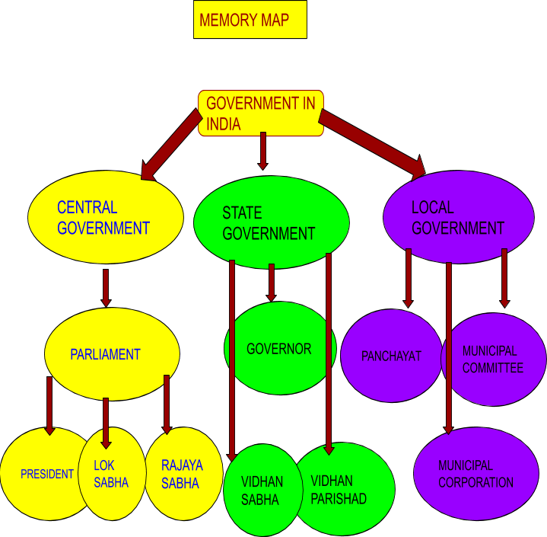

Let’s know more

Fill in the blanks.
- The Panchayat consists of members called the Panchas.
- The governor is appointed by the of the country.
- Group of people to help the Prime Minister to run the country is called the ___.
Let’s Do
- Who elects whom?
- People above 18 years of age elect members of the ________ in the Central Government.
- People above 18 years of age elect members of the state _________ in the states.
- Members of the State Legislative Assemblies elect members of the ________ in the Central Government.
- Members of the Lok Sabha, Rajya Sabha and State Legislative Assemblies elect the ________.
Understand and Answer
B.Answer the following questions.
- Name the three levels of government in India.
- Why do we have three levels of government in our country? Would it not be easier to have just the Central Government?
- Who is the head of: (a) our country, (b) the Central Government?
- List two responsibilities each of (a) the Central Government (b) the State Governments.
- What is the responsibility of the courts?
- Which is the highest court in the country?
Multiple choice questions.
- The Union Government is also known as the
- Lok Sabha b. Rajya Sabha c. Central Government d. Union Territory
- The defence of our country is the responsibility of the
- Central Government b. State Government c. Local Government d. All of these
- The set of rules according to which our country is run is called the
- Parliament b. Constitution c. Supreme Court d. Government
- The Lok Sabha is presided over by the
- President b. Prime Minister c. Speaker d. Vice President
- The number of constituencies India has been divided into is
- 543 b. 552 c. 553 d. 530
- The head of the Government of India is the
- Prime Minister b. President c. Speaker d. Vice President

Teacher’s Note
If Bangladesh attacks the eastern border of West Bengal, which government would be responsible for taking all decisions - the State Government of West Bengal or the Central Government of India?.
Improve Your GKs
- Mr Ram Nath Kobind is our President.
- Mr Narendra Modi is our prime minister
- Prof. Ganeshi Lal is our governor.
Answer key
Let’s Know More
- 5
- president
- the cabinet Ministers
Let’s Do
A.1. Lok Sabha
- Legislative Assemblies
- Rajya Sabha
- President
B.1. The three levels of government in India are:-
- The Central or Union Government
- The State Government
- The Local Government
- We have three levels of government in ou country because India is a big nation. It is not possible for a single government to look after the entire country properly. So, Constitution has divide the responsibilities between the Central, State and local level.
- a. The President is the head of the country.
- The Prime Minister is the head of the Central Government.

- a. The two responsibilities of the Central Government are-
- Making laws for the country & seeing that they are implemented is the main responsibility of the Central Government.
- The defence of our borders or relationship with other countries.
- Taking care of the relationship with other countries.
b.The two responsibilities of the State Government are-
- Educating the people.
- Looking after law and order in different states.
- The responsibility of the courts is to provide justice to the people and safeguard the fundamental rights of all the citizen of India.
- The Supreme Court at New Delhi is the highest court in the country.

