CHAPTER-04
MICROSOFT EXCEL 2016

Introduction
Excel is a spreadsheet program that allows you to store, organize, and analyze information. While you may believe Excel is only used by certain people to process complicated data, anyone can learn how to take advantage of the program's powerful features. Whether you're keeping a budget, organizing a training log, or creating an invoice, Excel makes it easy to work with different types of data.
Watch the video below to learn more about Excel.

Getting to know Excel
If you've previously used Excel 2010 or Excel 2013, then Excel 2016 should feel familiar. If you are new to Excel or have more experience with older versions, you should first take some time to become familiar with the Excel interface.

The Excel interface
When you open Excel 2016 for the first time, the Excel Start Screen will appear. From here, you'll be able to create a new workbook, choose a template, and access your recently edited workbooks.
- From the Excel Start Screen, locate and select Blank workbook to access the Excel interface.
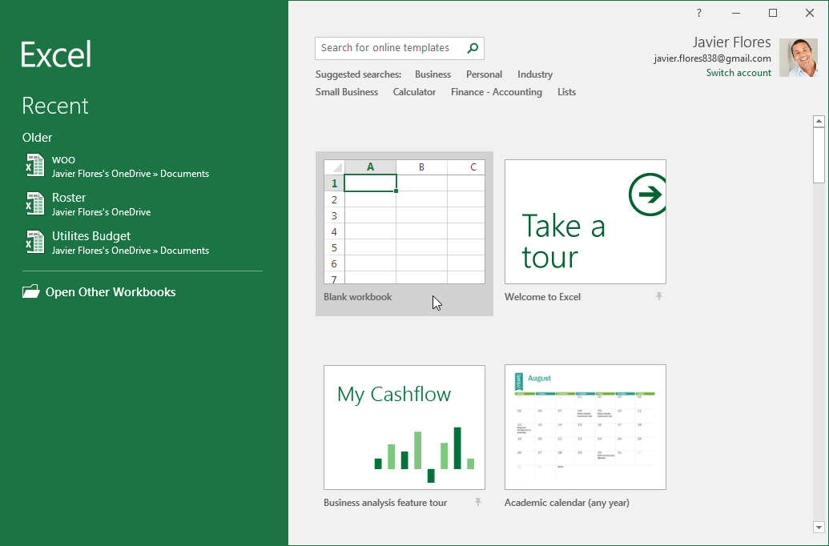
Click the buttons in the elow to become familiar with the Excel interface.
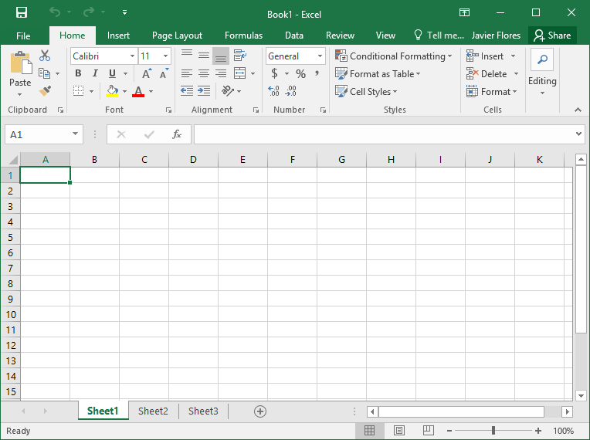

Working with the Excel environment
The Ribbon and Quick Access Toolbar are where you will find the commands to perform common tasks in Excel. The Backstage view gives you various options for saving, opening a file, printing, and sharing your document.

The Ribbon
Excel 2016 uses a tabbed Ribbon system instead of traditional menus. The Ribbon contains multiple tabs, each with several groups of commands. You will use these tabs to perform the most common tasks in Excel.
- Each tab will have one or more groups.
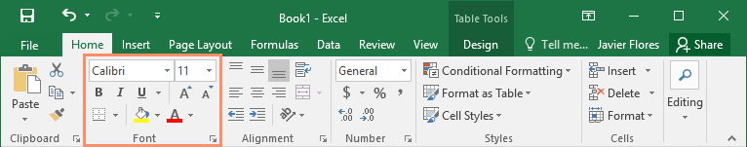
- Some groups will have an arrow you can click for more options.
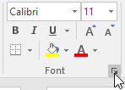
- Click a tab to see more commands.
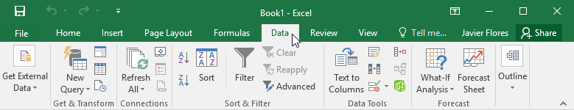
- You can adjust how the Ribbon is displayed with the Ribbon Display Options.
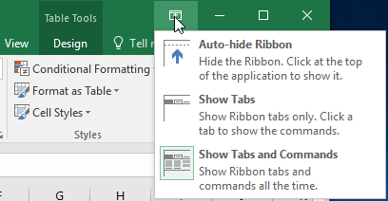
Certain programs, such as Adobe Acrobat Reader, may install additional tabs to the Ribbon. These tabs are called add-ins.

To change the Ribbon Display Options:
The Ribbon is designed to respond to your current task, but you can choose to minimize it if you find that it takes up too much screen space. Click the Ribbon Display Options arrow in the upper-right corner of the Ribbon to display the drop-down menu.
There are three modes in the Ribbon Display Options menu:
- Auto-hide Ribbon: Auto-hide displays your workbook in full-screen mode and completely hides the Ribbon. To show the Ribbon, click the Expand Ribbon command at the top of screen.
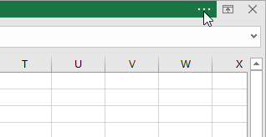
- Show Tabs: This option hides all command groups when they're not in use, but tabs will remain visible. To show the Ribbon, simply click a tab.
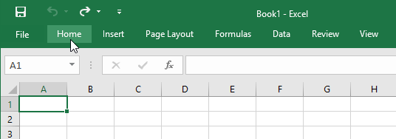
- Show Tabs and Commands: This option maximizes the Ribbon. All of the tabs and commands will be visible. This option is selected by default when you open Excel for the first time.

The Quick Access Toolbar
Located just above the Ribbon, the Quick Access Toolbar lets you access common commands no matter which tab is selected. By default, it includes the Save, Undo, and Repeat commands. You can add other commands depending on your preference.

To add commands to the Quick Access Toolbar:
- Click the drop-down arrow to the right of the Quick Access Toolbar.
- Select the command you want to add from the drop-down menu. To choose from more commands, select More Commands.
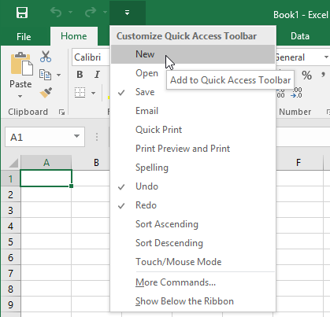
- The command will be added to the Quick Access Toolbar.
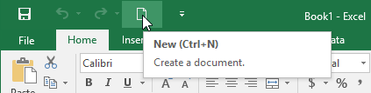

How to use Tell me:
The Tell me box works like a search bar to help you quickly find tools or commands you want to use.
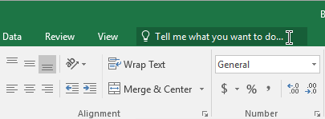
- Type in your own words what you want to do.
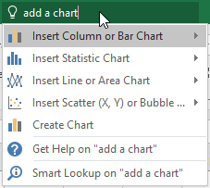
- The results will give you a few relevant options. To use one, click it like you would a command on the Ribbon.
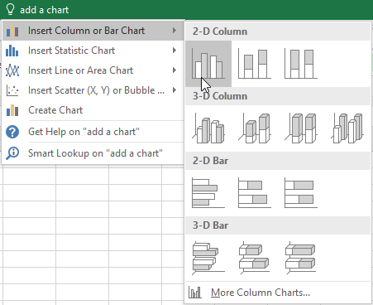

Worksheet views
Excel 2016 has a variety of viewing options that change how your workbook is displayed. These views can be useful for various tasks, especially if you're planning to print the spreadsheet. To change worksheet views, locate the commands in the bottom-right corner of the Excel window and select Normal view, Page Layout view, or Page Break view.
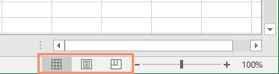
- Normal view is the default view for all worksheets in Excel.
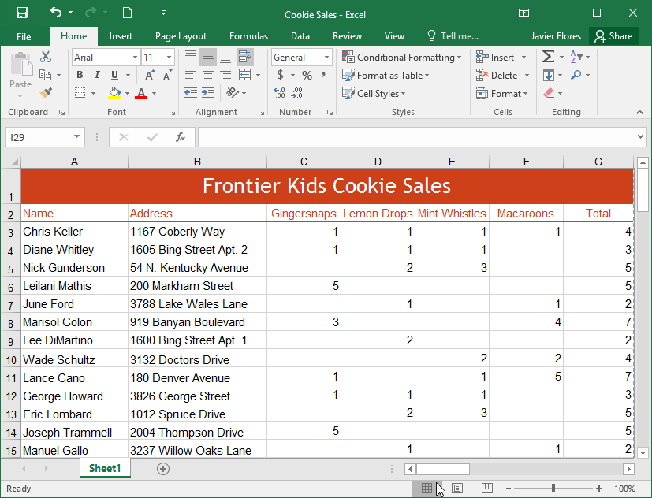
- Page Layout view displays how your worksheets will appear when printed. You can also add headers and footers in this view.
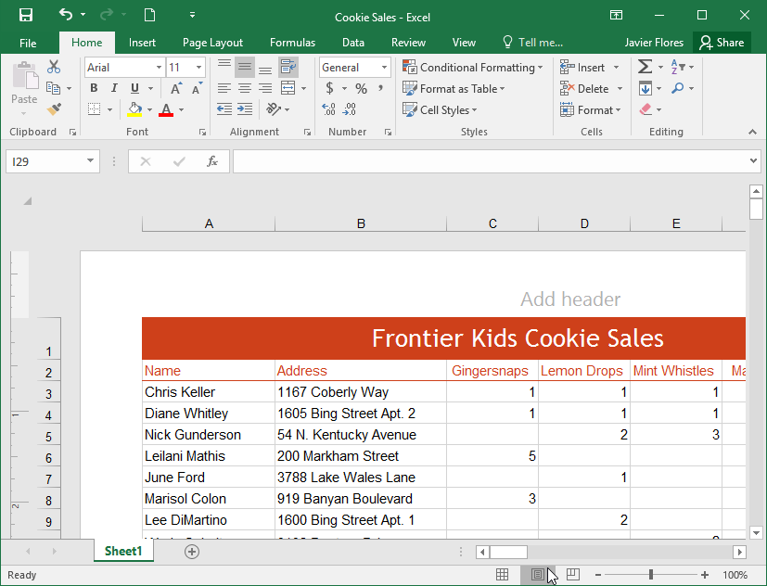
- Page Break view allows you to change the location of page breaks, which is especially helpful when printing a lot of data from Excel.
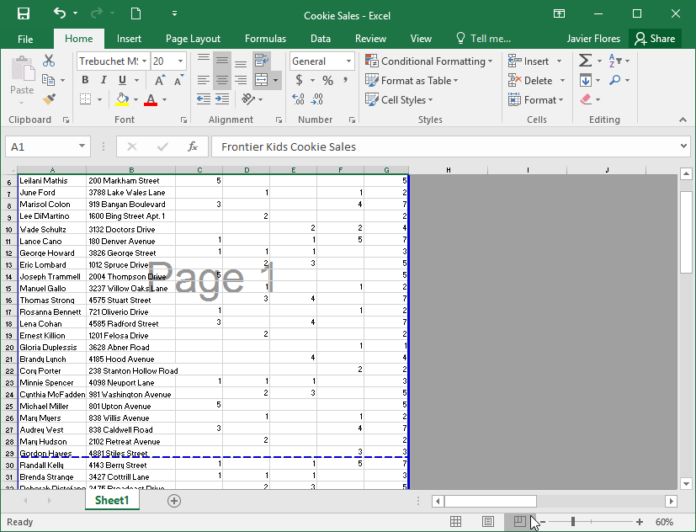

Backstage view
Backstage view gives you various options for saving, opening a file, printing, and sharing your workbooks.

To access Backstage view:
- Click the File tab on the Ribbon. Backstage view will appear.
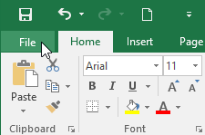
Click the buttons in the interactive below to learn more about using Backstage view.
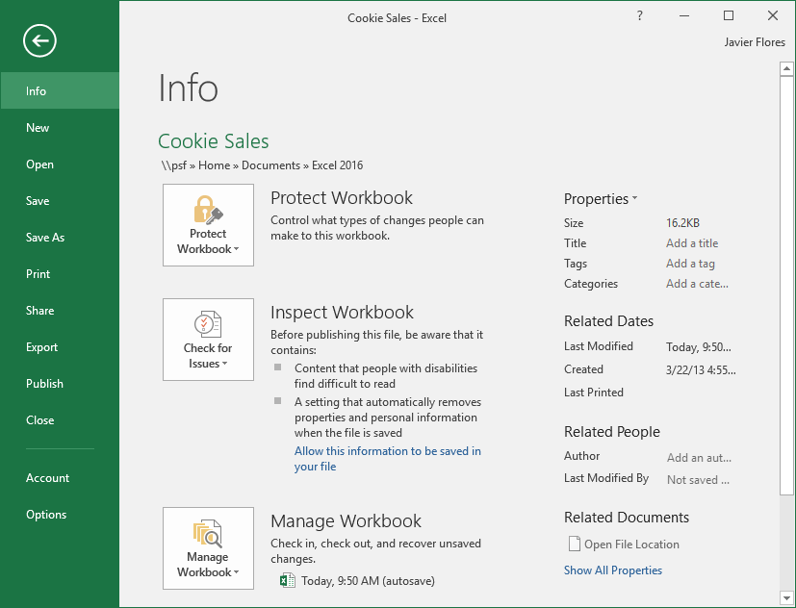

Understanding cells
Every worksheet is made up of thousands of rectangles, which are called cells. A cell is the intersection of a row and a column—in other words, where a row and column meet.
Columns are identified by letters (A, B, C), while rows are identified by numbers (1, 2, 3). Each cell has its own name—or cell address—based on its column and row. In the example below, the selected cell intersects column C and row 5, so the cell address is C5.
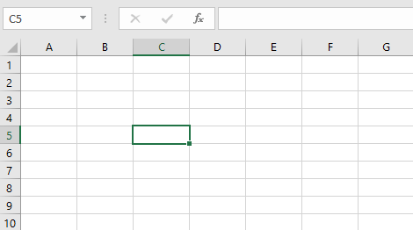
Note that the cell address also appears in the Name box in the top-left corner, and that a cell's column and row headings are highlighted when the cell is selected.
You can also select multiple cells at the same time. A group of cells is known as a cell range. Rather than a single cell address, you will refer to a cell range using the cell addresses of the first and last cells in the cell range, separated by a colon. For example, a cell range that included cells A1, A2, A3, A4, and A5 would be written as A1:A5. Take a look at the different cell ranges below:
- Cell range A1:A8
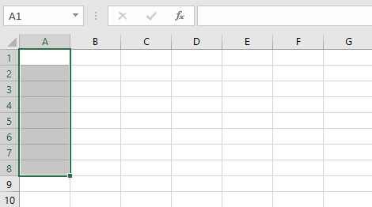
- Cell range A1:F1
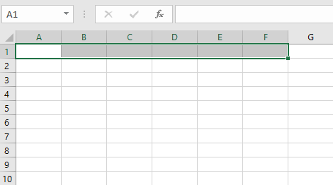
- Cell range A1:F8
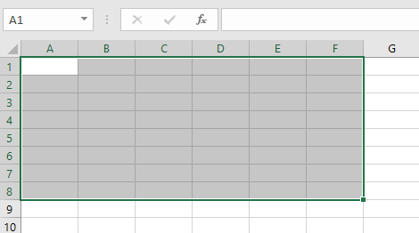
If the columns in your spreadsheet are labeled with numbers instead of letters, you'll need to change the default reference style for Excel. Review our Extra on What are Reference Styles? to learn how.

To select a cell:
To input or edit cell content, you'll first need to select the cell.
- Click a cell to select it. In our example, we'll select cell D9.
- A border will appear around the selected cell, and the column heading and row heading will be highlighted. The cell will remain selected until you click another cell in the worksheet.
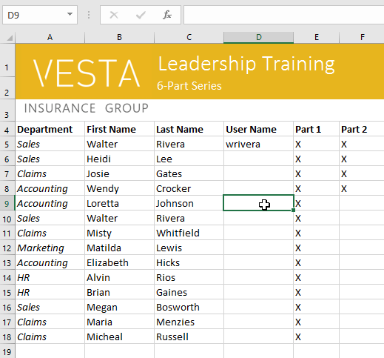
You can also select cells using the arrow keys on your keyboard.

To select a cell range:
Sometimes you may want to select a larger group of cells, or a cell range.
- Click and drag the mouse until all of the adjoining cells you want to select are highlighted. In our example, we'll select the cell range B5:C18.
- Release the mouse to select the desired cell range. The cells will remain selected until you click another cell in the worksheet.
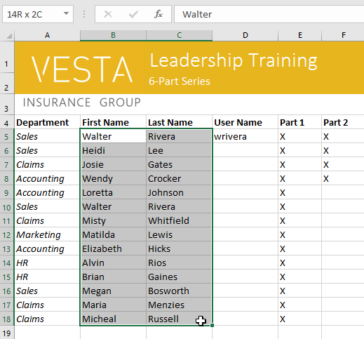

Cell content
Any information you enter into a spreadsheet will be stored in a cell. Each cell can contain different types of content, including text, formatting, formulas, and functions.
- Text: Cells can contain text, such as letters, numbers, and dates.
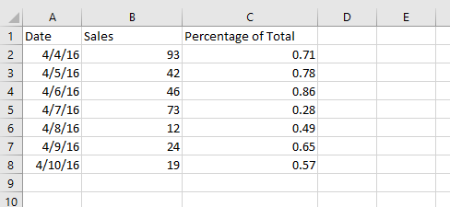
- Formatting attributes: Cells can contain formatting attributes that change the way letters, numbers, and dates are displayed. For example, percentages can appear as 0.15 or 15%. You can even change a cell's text or background color.
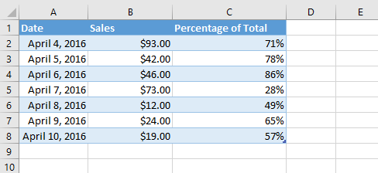
- Formulas and functions: Cells can contain formulas and functions that calculate cell values. In our example, SUM(B2:B8) adds the value of each cell in the cell range B2:B8 and displays the total in cell B9.
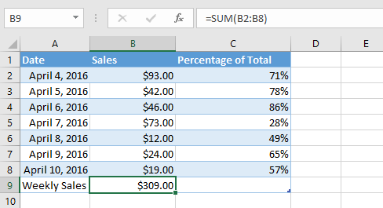

To insert content:
- Click a cell to select it. In our example, we'll select cell F9.
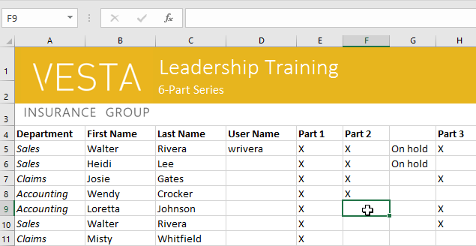
- Type something into the selected cell, then press Enter on your keyboard. The content will appear in the cell and the formula bar. You can also input and edit cell content in the formula bar.
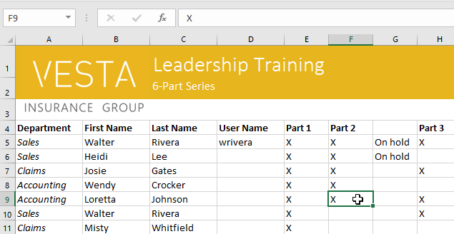

To delete (or clear) cell content:
- Select the cell(s) with content you want to delete. In our example, we'll select the cell range A10:H10.
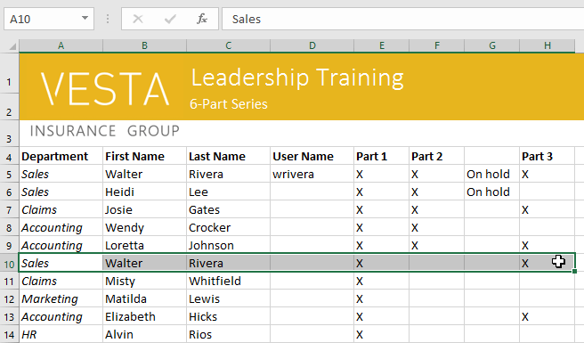
- Select the Clear command on the Home tab, then click Clear Contents.
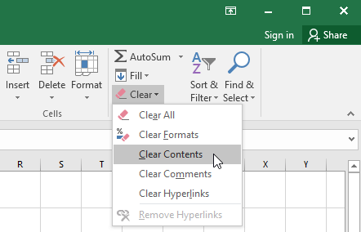
- The cell contents will be deleted.
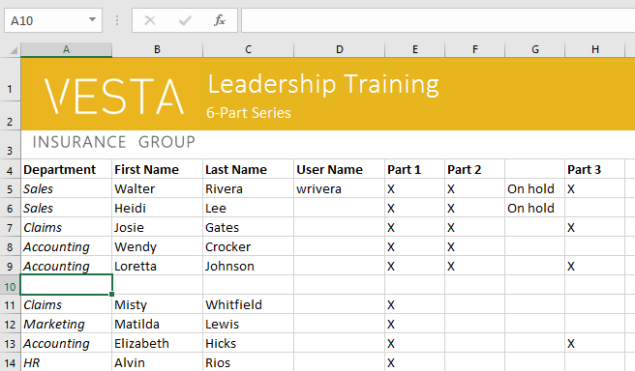
You can also use the Delete key on your keyboard to delete content from multiple cells at once. The Backspace key will only delete content from one cell at a time.

To delete cells:
There is an important difference between deleting the content of a cell and deleting the cell itself. If you delete the entire cell, the cells below it will shift to fill in the gaps and replace the deleted cells.
- Select the cell(s) you want to delete. In our example, we'll select A10:H10.
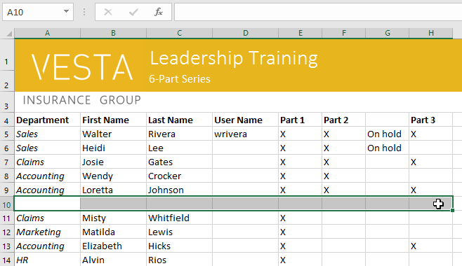
- Select the Delete command from the Home tab on the Ribbon.
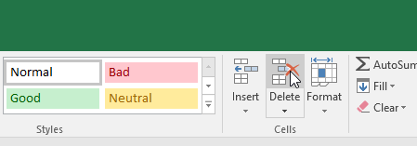
- The cells below will shift up and fill in the gaps.
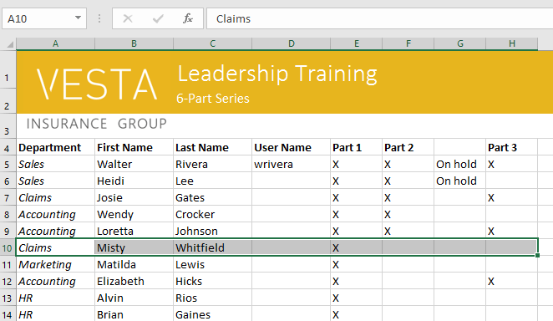

To copy and paste cell content:
Excel allows you to copy content that is already entered into your spreadsheet and paste that content to other cells, which can save you time and effort.
- Select the cell(s) you want to copy. In our example, we'll select F9.
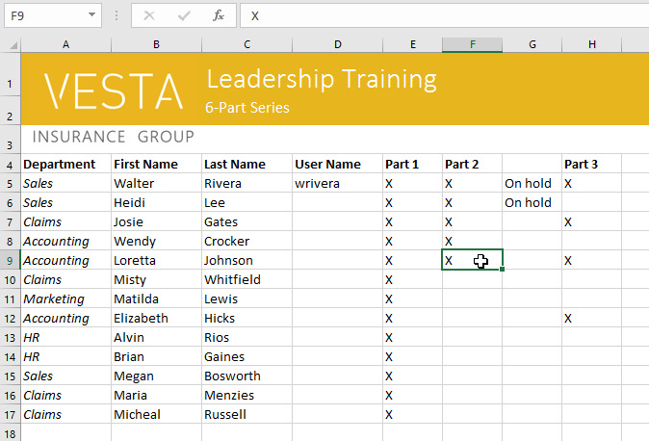
- Click the Copy command on the Home tab, or press Ctrl+C on your keyboard.
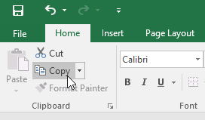
- Select the cell(s) where you want to paste the content. In our example, we'll select F12:F17. The copied cell(s) will have a dashed box around them.
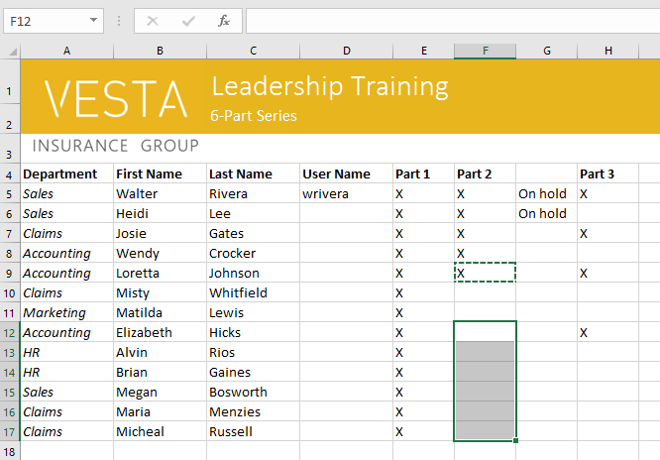
- Click the Paste command on the Home tab, or press Ctrl+V on your keyboard.
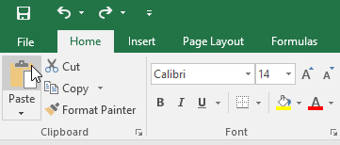
- The content will be pasted into the selected cells.
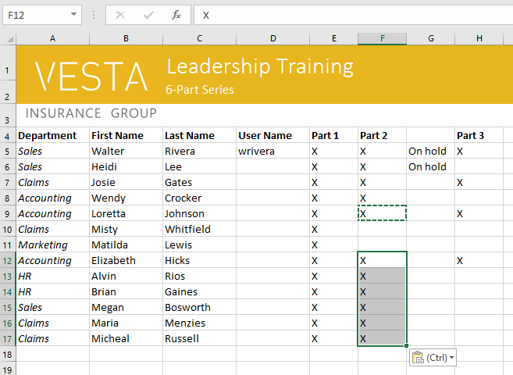

To access more paste options:
You can also access additional paste options, which are especially convenient when working with cells that contain formulas or formatting. Just click the drop-down arrow on the Paste command to see these options.
You can also AutoFit the width for several columns at the same time. Simply select the columns you want to AutoFit, then select the AutoFit Column Width command from the Format drop-down menu on the Home tab. This method can also be used for row height.
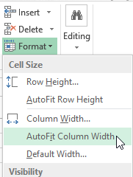

To modify row height:
- Position the cursor over the row line so the cursor becomes a double arrow.
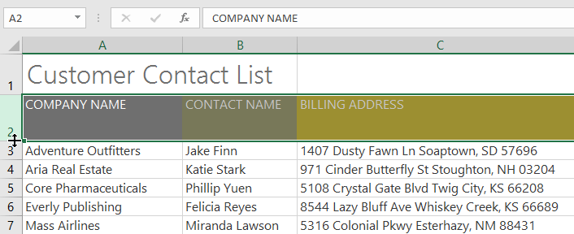
- Click and drag the mouse to increase or decrease the row height.
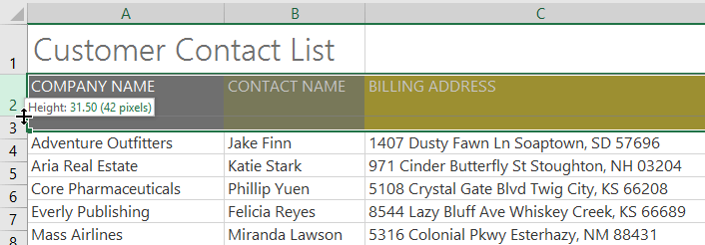
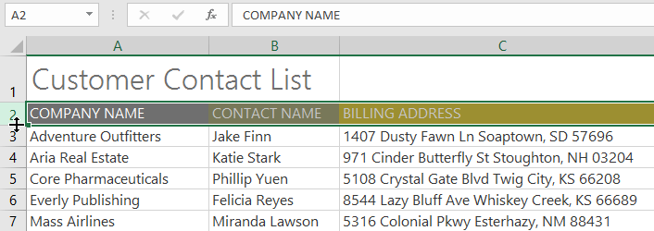
- Release the mouse. The height of the selected row will be changed.

To modify all rows or columns:
Instead of resizing rows and columns individually, you can modify the height and width of every row and column at the same time. This method allows you to set a uniform size for every row and column in your worksheet. In our example, we will set a uniform row height.
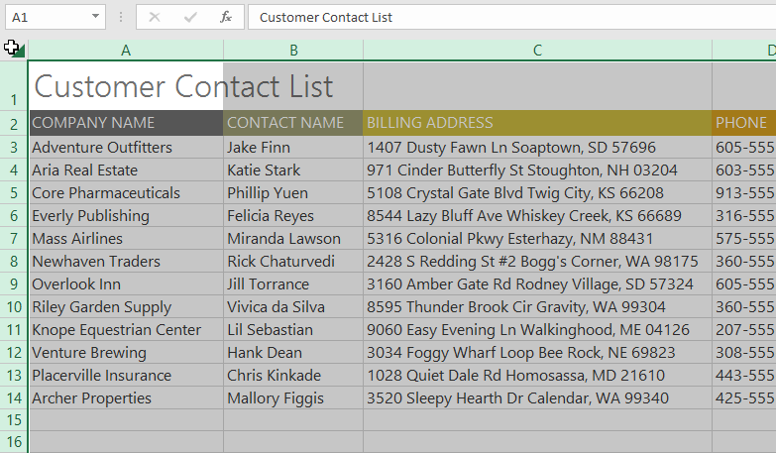
- Locate and click the Select All button just below the name box to select every cell in the worksheet.

- Position the mouse over a row line so the cursor becomes a double arrow.
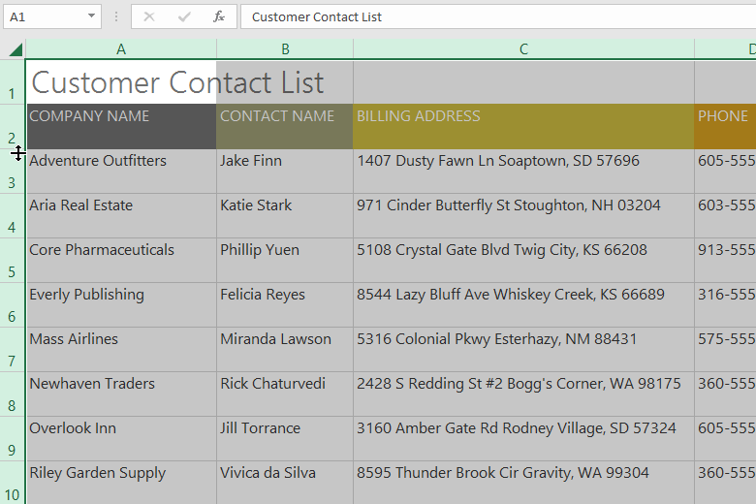
- Click and drag the mouse to increase or decrease the row height, then release the mouse when you are satisfied. The row height will be changed for the entire worksheet.

Inserting, deleting, moving, and hiding
After you've been working with a workbook for a while, you may find that you want to insert new columns or rows, delete certain rows or columns, move them to a different location in the worksheet, or even hide them.

To insert rows:
- Select the row heading below where you want the new row to appear. In this example, we want to insert a row between rows 4 and 5, so we'll select row 5.
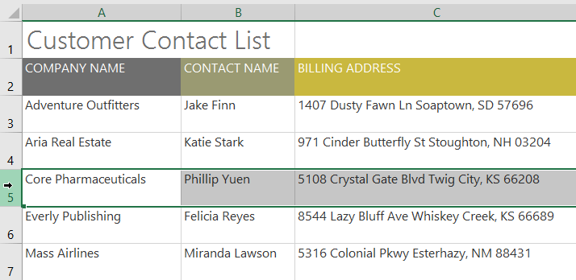
- Click the Insert command on the Home tab.
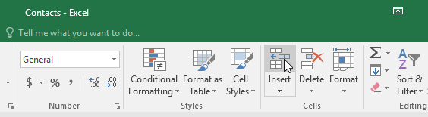
- The new row will appear above the selected row.
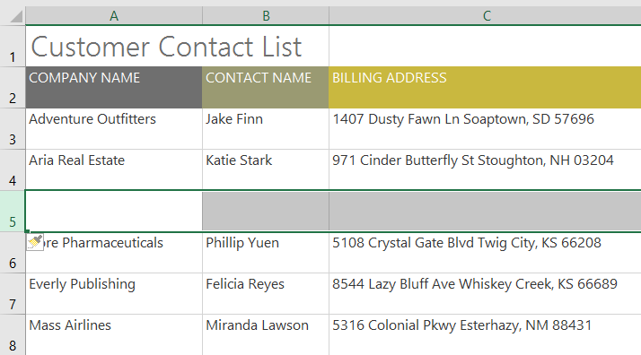
When inserting new rows, columns, or cells, you will see a paintbrush icon next to the inserted cells. This button allows you to choose how Excel formats these cells. By default, Excel formats inserted rows with the same formatting as the cells in the row above. To access more options, hover your mouse over the icon, then click the drop-down arrow.
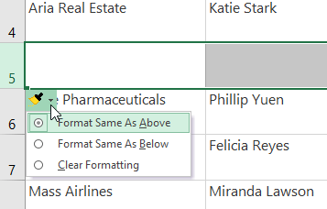

To insert columns:
- Select the column heading to the right of where you want the new column to appear. For example, if you want to insert a column between columns D and E, select column E.
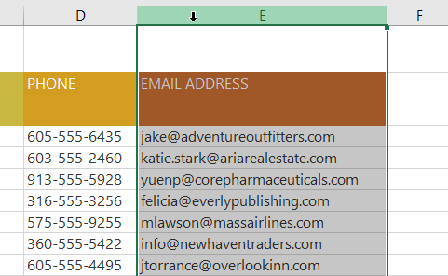
- Click the Insert command on the Home tab.
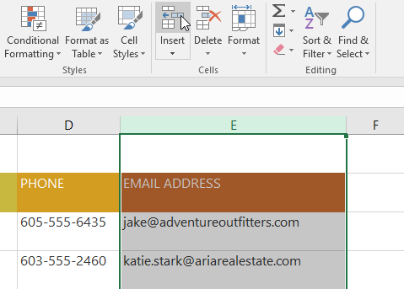
- The new column will appear to the left of the selected column.
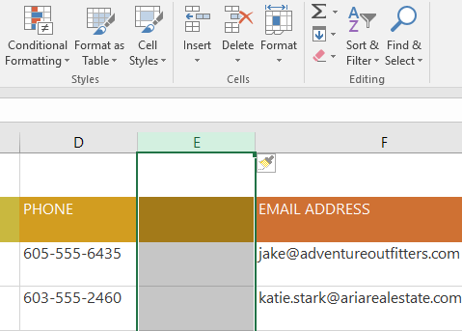
When inserting rows and columns, make sure you select the entire row or column by clicking the heading. If you select only a cell in the row or column, the Insert command will only insert a new cell.

To delete a row or column:
It's easy to delete a row or column that you no longer need. In our example we'll delete a row, but you can delete a column the same way.
- Select the row you want to delete. In our example, we'll select row 9.
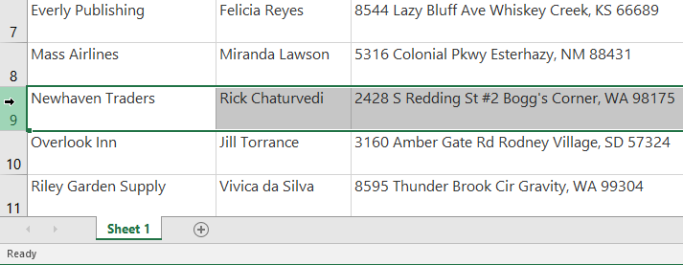
- Click the Delete command on the Home tab.
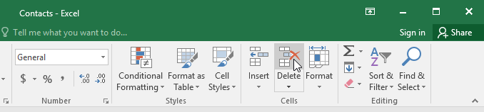
- The selected row will be deleted, and those around it will shift. In our example, row 10 has moved up, so it's now row 9.
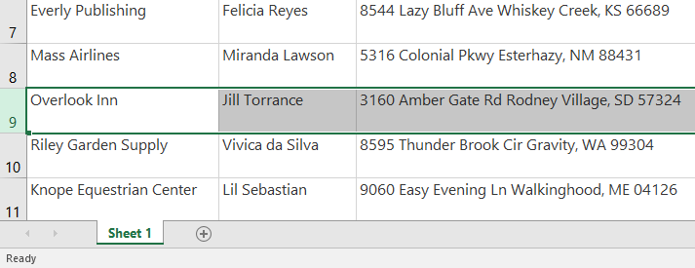
It's important to understand the difference between deleting a row or column and simply clearing its contents. If you want to remove the content from a row or column without causing others to shift, right-click a heading, then select Clear Contents from the drop-down menu.

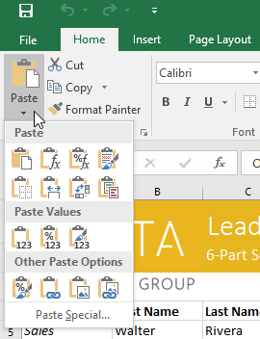
Instead of choosing commands from the Ribbon, you can access commands quickly by right-clicking. Simply select the cell(s) you want to format, then right-click the mouse. A drop-down menu will appear, where you'll find several commands that are also located on the Ribbon.
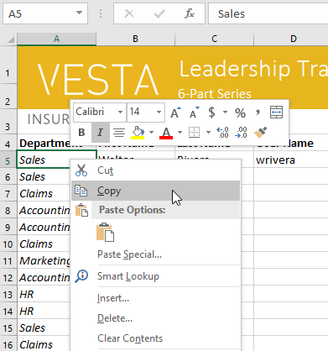

To cut and paste cell content:
Unlike copying and pasting, which duplicates cell content, cutting allows you to move content between cells.
- Select the cell(s) you want to cut. In our example, we'll select G5:G6.
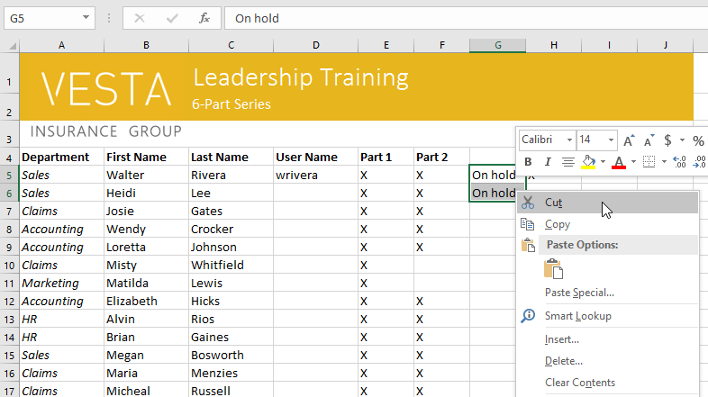
- Right-click the mouse and select the Cut command. Alternatively, you can use the command on the Home tab, or press Ctrl+X on your keyboard.

- Select the cells where you want to paste the content. In our example, we'll select F10:F11. The cut cells will now have a dashed box around them.
- Right-click the mouse and select the Paste command. Alternatively, you can use the command on the Home tab, or press Ctrl+V on your keyboard.
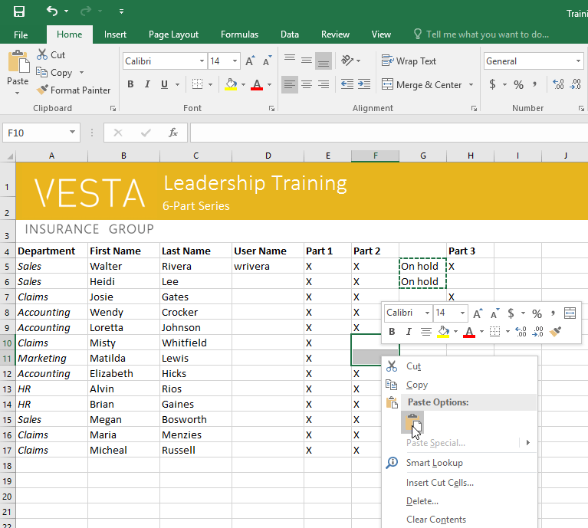
- The cut content will be removed from the original cells and pasted into the selected cells.
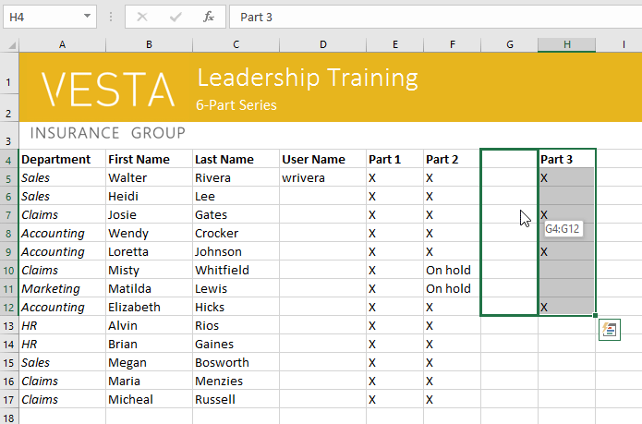
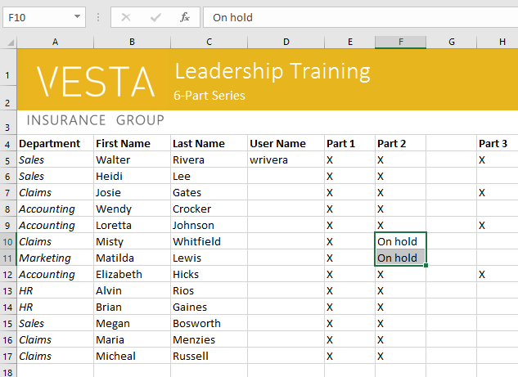

To drag and drop cells:
Instead of cutting, copying, and pasting, you can drag and drop cells to move their contents.
- Select the cell(s) you want to move. In our example, we'll select H4:H12.
- Hover the mouse over the border of the selected cell(s) until the mouse changes to a pointer with four arrows.
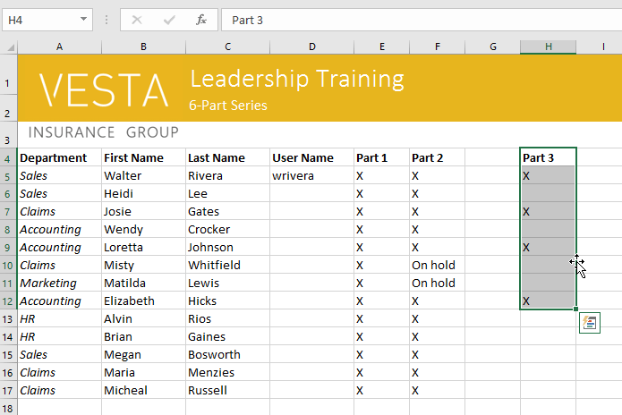
- Click and drag the cells to the desired location. In our example, we'll move them to G4:G12.

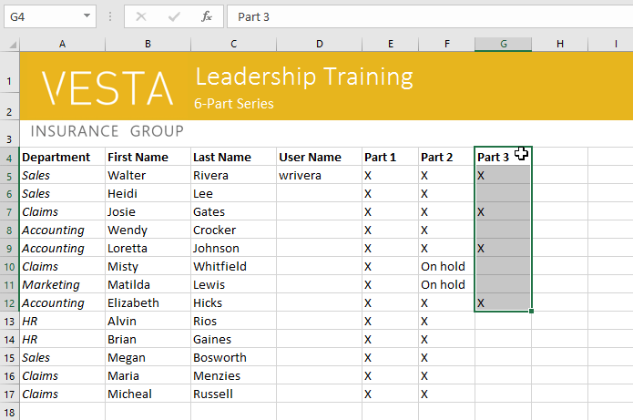
- Release the mouse. The cells will be dropped in the selected location.

To use the fill handle:
If you're copying cell content to adjacent cells in the same row or column, the fill handle is a good alternative to the copy and paste commands.
- Select the cell(s) containing the content you want to use, then hover the mouse over the lower-right corner of the cell so the fill handle appears.
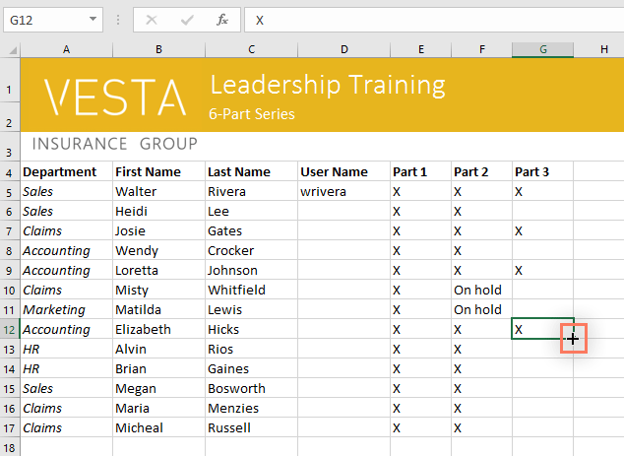
- Click and drag the fill handle until all of the cells you want to fill are selected. In our example, we'll select G13:G17.
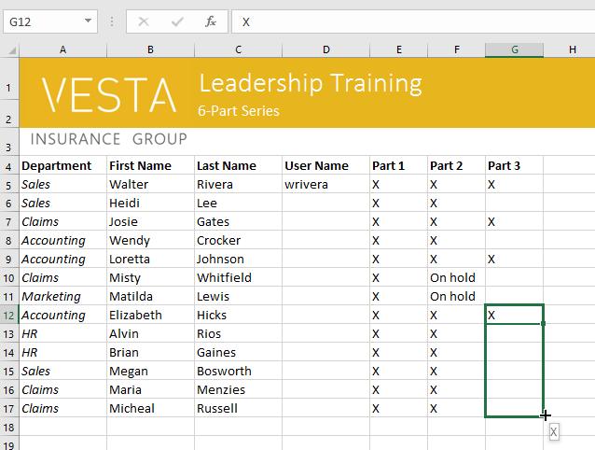
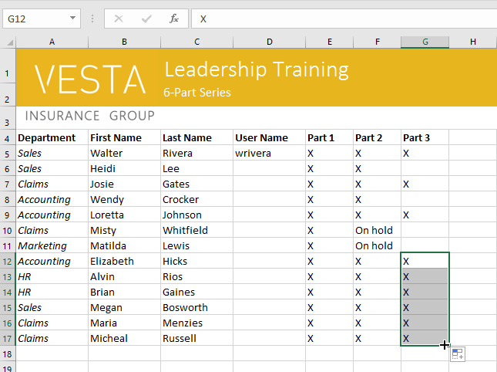
- Release the mouse to fill the selected cells.

To continue a series with the fill handle:
The fill handle can also be used to continue a series. Whenever the content of a row or column follows a sequential order, like numbers (1, 2, 3) or days (Monday, Tuesday, Wednesday), the fill handle can guess what should come next in the series. In most cases, you will need to select multiple cells before using the fill handle to help Excel determine the series order. Let's take a look at an example:
- Select the cell range that contains the series you want to continue. In our example, we'll select E4:G4.
- Click and drag the fill handle to continue the series.
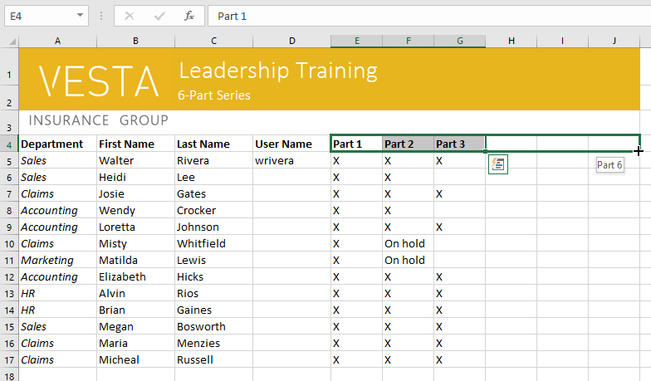
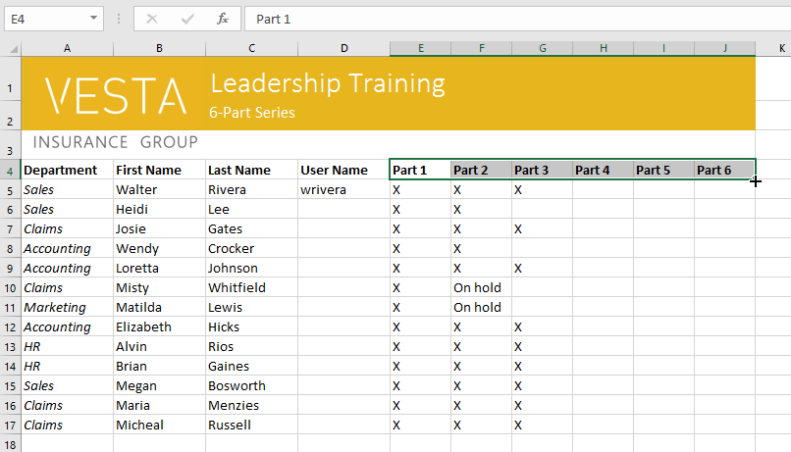
- Release the mouse. If Excel understood the series, it will be continued in the selected cells. In our example, Excel added Part 4, Part 5, and Part 6 to H4:J4.

You can also double-click the fill handle instead of clicking and dragging. This can be useful with larger spreadsheets, where clicking and dragging may be awkward.
Watch the video below to see an example of double-clicking the fill handle.

