WORKSHEET
DT:13.08.21
- Count the Shapes and write the numbers and color as per the instructions

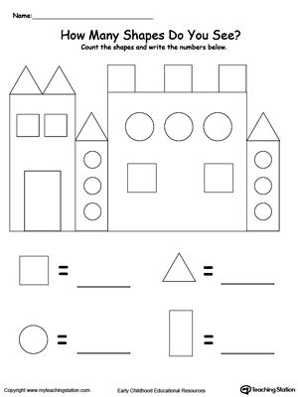
2.Write the Before Numbers
