
THE REVOLT OF 1857
SUBJECT : HISTORY CHAPTER
NUMBER:7
CHAPTER NAME : THE REVOLT OF 1857

Outbreak of the Revolt .
On 9th MAY In Meerut a refused to use the greased the cartridge. They were dismissed and
sentenced to imprisonment for 10 years. On hearing this other soldiers stationed at Meerut and revolted. ON 10TH May they realised the imprisoned soldiers, killed their Britishofficers and
marched to Delhi. There they proclaimed the old Mughal emperor Bahadur Shah Zafar as the
emperor of India.
Spread of the Revolt
The Revolt in Kanpur was led by Nana Saheb with the help of his commander Tantia Tope andAzimullah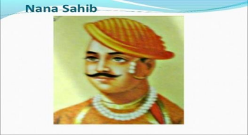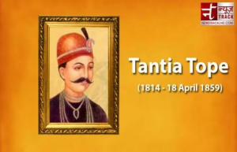
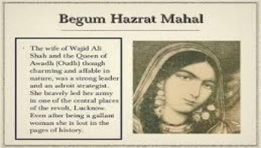
❖ In Lucknow the Revolt was led by Hazrat Mahal andMaulvi
Ahmadullah
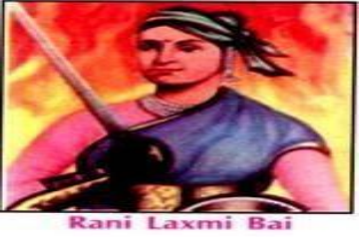
❖ In Jhansi the Revolt was led by RaniLakshmibai
❖ With the defeat of Rani Lakshmibai, theRevolt was
almost completely crushed by theBritish
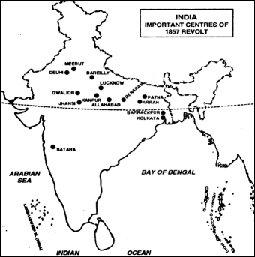
The end of the Mughal Empire
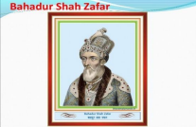
❖Under the command ofGeneral O’Neil, British troops
launched a massacre in Delhi
❖Bahadur Shah Zafar‘s sons were captured and killed. The
old emperor was exiled toRangoon
❖In Burma where he died. Thus the Mughal Empirecame
to anend.
Reasons for the failure of the Revolt
❖ Lack of Unity among Indians
The revolt did not involve the entire region or all the sections of the Indian society. Many of the Indian rulers and big zamindars refused to join the rebellion. Most of the educated, westernised Indian did not support the revolt.
❖ Lack of National Leader
There was no single leader who could unite the various groups for the revolt. The freedom fighters were not inspired by modern ideas of nationalism, Liberty, equality anddemocracy.
❖ Lack of resources
The rebels could not match the modern weapons and materials of war used by the British. Though the Indian soldiers were fearless and brave but they lacked organisation and discipline. TheBritish had the railways at their disposal and an excellent system of communication.
THANKING YOU
ODM EDUCATIONAL GROUP

