[ENGLISH]
REVISION WORKSHEET

REVISION-3
Date – 29.09.21

Q1. Circle the correct spelling

nurse norse narse

nast nest neist

hand haind hnad

bocket bucket backet

ring reng rung

Q2. Answer the following questions


What is this?

Ans - _______________________


What are these?

Ans - _______________________

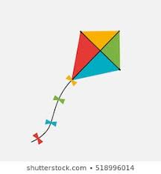
What is that ?

Ans - _______________________

Q3. Oral

Individual reading

Book page – 25

[ENGLISH]
REVISION WORKHEET

Home assignment

Find out ‘oa’ sound pictures from the worksheet and write their spelling in your note book and make sentences.

