Chapter- 8
ELECTROMAGNETIC WAVES

Introduction to EMW
- Static charge produces An electric field.
- Oersted, experimentally Predated: An electric current (moving charges) in a wire produces a magnetic field.
- Faraday, experimentally Predated: Time-varying magnetic field generates an electric field (Faraday-Lenz law).
- The question arises; The reverse is true?
“CAN A CHANGING ELECTRIC FIELD PRODUCE MAGNETIC FIELD? “
This answer was given by Clerk Maxwell, yes!
- Maxwell points out: Changing the electric field produces a magnetic field.
- That Ampere circuital law satisfied only in conduction current.
And there exists another type current in between two parallel plate capacitors which is called “DISPLACEMENT CURRENT’(where no conduction current is there).
A. Maxwell’s Experiments
- Maxwell proposed that the time-varying electric field can generate a magnetic field.
- According to Faraday Lenz law, an emf is induced in the circuit whenever the amount of magnetic flux linked with a circuit changes.
- As a result, the electric current gets generated in the circuit which has an electric field associated with it.
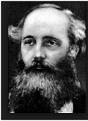
- According to Maxwell if Faraday’s law is true then the vice-versa should also be true, i.e. time-varying electric field should also be able to generate the amagnetic field.
- According to Ampere’s Circuital Law, the line integral of the magnetic field over the length element is equal to μ₀ times the total current passing through the surface ∫ B. dl = μ₀ I
- According to Maxwell, there was some inconsistency in Ampere’s circuital law.
- This means Ampere’s circuital law was correct for some cases but not correct for some.
- Maxwell took different scenarios i.e. he took a capacitor and tried to calculate the magnetic field at a specific point in a piece of a capacitor.
- Point P as shown in the figure is where he determined the value of B, assuming some current I is flowing through the circuit.
- He considered 3 different amperial loops as shown in the figs.
- Ampere’s circuital law should be the same for all the 3 setups.
Case 1: Considered a surface of radius r & dl is the circumference of the surface, then from Ampere’s circuital law
∫ B.dl = μ₀ I
or B(2πr) = μ₀ I
or B = μ₀ I / 2πr
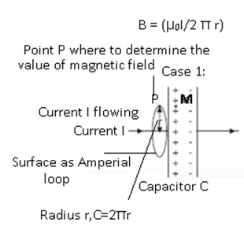
Case 2: Considering a surface like a box & its lid is open and applying the Ampere’s circuital law
∫ B.dl = μ₀ I
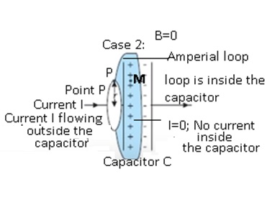
As there is no current flowing inside the capacitor, therefore I = 0
Or ∫ B.dl = 0
Case 3: Considering the surface between 2 plates of the capacitor, in this case also I=0, so B=0
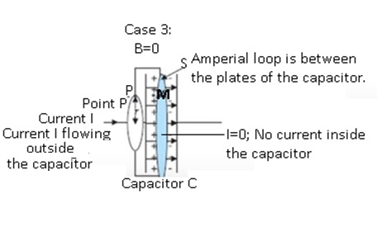
- At the same point but with different amperial surfaces, the value of the magnetic field is not the same. They are different for the same point.
- Maxwell suggested that there are some gaps in the Ampere’s circuital law.
- He corrected the Ampere’s circuital law. And he made Ampere’s circuital law consistent in all the scenarios.
Maxwell’s correction to Ampere’s law
- Ampere’s law states that “the line integral of the resultant magnetic field along a closed plane curve is equal to μ₀ time the total current crossing the area bounded by the closed curve provided the electric field inside the loop remains constant".
- Ampere’s law is true only for steady currents.
- Maxwell found the shortcoming in Ampere’s law and the modified Ampere’s law to include time-varying electric fields.
- For Ampere’s circuital law to be correct, Maxwell assumed that there has to be some current existing between the plates of the capacitor.
- Outside the capacitor, the current was due to the flow of electrons.
- There was no conduction of charges between the plates of the capacitor.
- According to Maxwell between the plates of the capacitor, there is an electric field that is directed from a positive plate to the negative plate.
- The magnitude of the electric field E =(V/d)
- Where V=potential difference between the plates, d = distance between the plates
- E = (Q/Cd)
    - where Q=charge on the plates of the capacitor, Capacitance of the capacitor=C
=>= (Q/ (Aε₀d/d))where A =area of the capacitor.
  - E=Q/(Aε₀)
  - The direction of the electric field will be perpendicular to the selected surface i.e. if considering the plate of the capacitor as surface.
- As E =0 outside the plates and E=(Q/(Aε₀)) between the plates.
  - There may be some electric field between the plates because of which some current is present between the plates of the capacitor.
  - Electric Flux through the surface=Φ_{E}= (EA) =(QA)/ (Aε₀) =(Q/ ε₀)
- Assuming Q (charge on capacitor i.e. charging or discharging of the capacitor) changes with time current will be get generated.
  - Therefore current I_{d} =(dQ/dt)
    - Where I_{d} =displacement current
  - =>DifferentiatingΦ_{E} =(Q/ ε₀) on both sides w.r.t time,
  - (dΦ_{E}/dt) =(1/ ε₀) (dQ/dt)
    - where (dQ/dt) =current
  - Therefore (dQ/dt) = ε₀ (d Φ_{E}/dt)
  - =>Current was generated because of change of electric flux with time.
  - Electric flux arose because of the presence of the electric field in the plates of the capacitor.
  - I_{d} = (dQ/dt) = Displacement current
  - Therefore Change in the electric field gave rise to Displacement current.
    - Current won’t be 0 it will be I_{d}.
    - There is some current between the plates of the capacitor and there is some current at the surface.
    - At certain points there is no displacement current there is only conduction current and vice-versa.
  - Maxwell corrected the Ampere’s circuital law by including displacement current.
  - He said that there is not only the current existed outside the capacitor but also current known as displacement current existed between the plates of the capacitor.
  - Displacement current exists due to the change in the electric field between the plates of the capacitor.
  - Conclusion:-Magnetic fields are produced both by conduction currents and by time-varying fields.
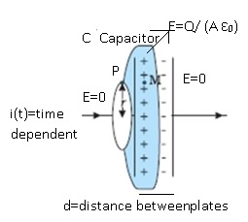

Modified Ampere-Maxwell Law
- As Maxwell was able to correct the shortcomings of Ampere’s circuital law therefore the law came to know as Ampere-Maxwell law.
- The current which is arising due to the flow of charges is known as conduction current.
  - It is denoted by I_{C}.
- The current which is arising due to change in the electric field is known as displacement current.
  - It is denoted by I_{d}.
- Therefore I = I_{c} + I_{d} where I = total current
- Ampere-Maxwell Law stated that
  - ∫B.dl = μ₀ (I_{c} + I_{d})
  - ∫B.dl = μ₀ I_{c} + μ₀ ε₀ (d ɸ_{E}/dt)
  - The above expression is known as Modified Maxwell Law
PROBLEMS
Problem: 1A parallel plate capacitor (Fig) made of circular plates each of radiusR = 6.0 cm has a capacitance C = 100 pF. The capacitor is connected toa 230 V ac supply with a (angular) frequency of 300 rad s^{–1}.
(a) What is the rms value of the conduction current?
(b) Is the conduction current equal to the displacement current?
(c) Determine the amplitude of B at a point 3.0 cm from the axis between the plates.
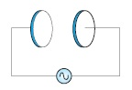
Answer:- Radius of each circular plate, R = 6.0 cm = 0.06 m
Capacitance of a parallel plate capacitor, C = 100 pF = 100 × 10⁻¹² F
Supply voltage, V = 230 V
Angular frequency, ω = 300 rad s⁻¹
(a) rms value of conduction current, I
Where,X_{C} = Capacitive reactance
=1/ (ωC)
Therefore, I = V × ωC
= 230 × 300 × 100 × 10⁻¹²
= 6.9 × 10⁻⁶ A
= 6.9 μA
Hence, the rms value of conduction current is 6.9 μA.
(b) Yes, conduction current is equal to displacement current.
(c) Magnetic field is given as:
B = (μ₀r)/ (2 R²) I₀ Where,
μ₀ = Free space permeability = 4x πx10⁻⁷NA⁻²
I₀ = Maximum value of current =√2 I
r = Distance between the plates from the axis = 3.0 cm = 0.03 m
Therefore B = (4xπ x10⁻⁷x0.03x√2x6.9x10⁻⁶)/ (2xπ x0.06)²
= 1.63 × 10⁻¹¹ T
Hence, the magnetic field at that point is 1.63 × 10⁻¹¹ T.
Problem:- 2 (CBSE)
The figure shows a capacitor made of two circular plates each of radius 12 cm and separated by 5.0 cm. The capacitor is being charged by an external source (not shown in the figure). The charging current is constant and equal to 0.15A. (a) Calculate the capacitance and the rate of charge of the potential difference between the plates.
(b) Obtain the displacement current across the plates.
(c) Is Kirchhoff’s first rule (junction rule) valid at each plate of the capacitor? Explain
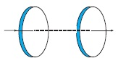
Answer:-
Radius of each circular plate, r = 12 cm = 0.12 m
Distance between the plates, d = 5 cm = 0.05 m
Charging current, I = 0.15 A
The permittivity of free spaceε₀, = 8.85 × 10⁻¹² C² N⁻¹ m⁻²
(a) Capacitance between the two plates is given by the relation,
C = (ε₀A)/ (d)
Where,
A = Area of each plate=πr²
C= (ε₀πr²)/ (d)
= (8.85x10⁻¹²πx0.12x0.12)/ (0.05)
=8.0032x10⁻¹²F
=80.032pF
Charge on each plate, q = CV
Where,
V = Potential difference across the plates
Differentiation on both sides with respect to time (t) gives:
(dq/dt)=C (dV/dt)
Bur (dq/dt) =current (I)
Therefore (dV/dt) = (I/C)
=> (0.15)/ (80.032x10⁻¹²) =1.87 ×10⁹ V/s
Therefore, the change in potential difference between the plates is 1.87 ×10⁹ V/s.
(b) The displacement current across the plates is the same as the conduction current. Hence, the displacement current, id is 0.15 A.
(c) Yes
Kirchhoff’s first rule is valid at each plate of the capacitor provided that we take the sum of conduction and displacement for current.
Problem3 (NCERT)
A parallel plate capacitor with circular plates of radius1 m has a capacitance of 1 nF. At t = 0, it is connected for charging in series with a resistor R = 1 MΩ across a 2V battery (Fig.). Calculate the magnetic field at a point P, halfway between the center and the periphery of the plates, after t = 10^{–3} s. (The charge on the capacitor at time t is q (t) = CV [1 – exp (–t/τ)], where the time constant τ is equal to CR.)
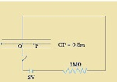
Answer:- The time constant of the CR circuit is τ = CR = 10^{–3} s. Then,we have
= q (t) = CV [1 – exp (–t/τ)]
= 2 × 10^{–9} [1– exp (–t/10^{–3})]
The electric field in between the plates at time t is
E= q (t)/ (ε₀A)
=q/ (πε₀); A = π (1)² m² = area of the plates.
Consider now a circular loop of the radius (1/2) m parallel to the plates passing through P. The magnetic field B at all points on the loop is along the loop and of the same value.
The flux Φ_{E} through this loop is
Φ_{E} = E × area of the loop
=Exπ x (1/2)²
= (π E/4)
= (q/4ε₀)
The displacement current
I_{d} =ε₀(dΦ_{E}/dt)
= (1/4) (dq/dt)
=0.5x10⁻⁶ exp (-1)
at t = 10^{–3}s. Now, applying Ampere-Maxwell law to the loop, we get
=B x 2π x (1/2)
=μ₀(I_{C}+I_{d})
=μ₀(0 +I_{d})
=0.5x10⁻⁶μ₀exp (-1)
or B = 0.74 × 10^{–13} T

Conclusion: -
- The value of B is the same in both cases.
- The total current should be the same.
- The time-varying electric field generates a magnetic field given by (Ampere-Maxwell law)
  - Consider 1st step up there is an electric field between the plates and this electric field is varying with time.
  - As a result, there is a displacement current and this displacement current gives rise to the magnetic field.
- The time-varying magnetic field generates an electric field given by (Faraday-Lenz law)
- Therefore if there is the electric field changing with time it generates a magnetic field and if there is a magnetic field changing with time it generates an electric field.
- Electromagnetic waves are based on the above conclusion.
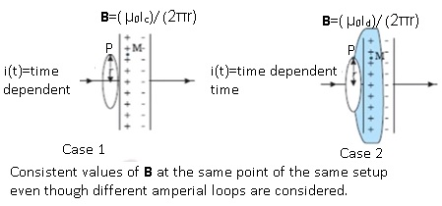
Maxwell’s Equations
- Maxwell gave a set of 4 equations which are known as Maxwell’s equations.
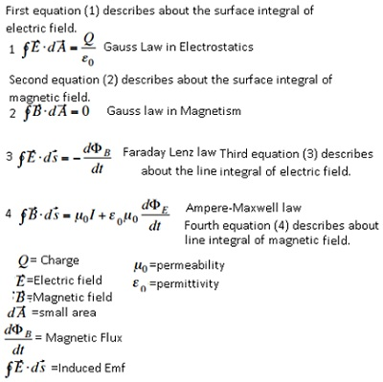

Electromagnetic waves

Electromagnetic (EM) waves are changing electric and magnetic fields, transporting energy and momentum through space.EM waves require no medium, they can travel through space. Electromagnetic waves are composed of oscillating electric and magnetic fields at right angles to each other and both are perpendicular to the direction of propagation of the wave. Electromagnetic waves differ in wavelength (or frequency). In an electronegative wave, the electric field E(vector) and the Magnetic field B(vector) oscillate perpendicular to each other and both are perpendicular to the direction of propagation of the wave.
Sources of Electromagnetic Waves (EM)
- EM waves are generated by electrically charged particle oscillates (accelerating charges).
- The electric field associated with the accelerating charge vibrates which generates the vibrating magnetic field.
- These both vibrating electric and magnetic fields give rise to EM waves.
- If the charge is at rest, the electric field associated with the charge will also be static.
  - There will be no generation of EM waves as the electric field is not varying with time.
- When the charge is moving with uniform velocity, then the acceleration is 0.
  - The change in an electric field with time is also constant as a result again there will be no electromagnetic waves generated.
- This shows that only accelerated charges alone can generate waves.
- For example:
  - Consider an oscillating charge particle, it will have an oscillating electric field and which give rise to the oscillating magnetic field.
  - This oscillating magnetic field, in turn, give rise to the oscillating electric field, and so on process continues.
  - The regeneration of electric and magnetic fields are the same as the propagation of the wave.
  - This wave is known as an electromagnetic wave.
  - The frequency of EM waves= the frequency of the oscillating particle.
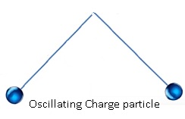
Nature of EM waves
- EM waves are transverse waves.
- The transverse waves are those in which direction of disturbance or displacement in the medium is perpendicular to that of the propagation of the wave.
- The particles of the medium are moving in a direction perpendicular to the direction of the propagation of the wave.
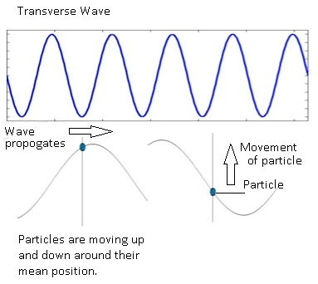
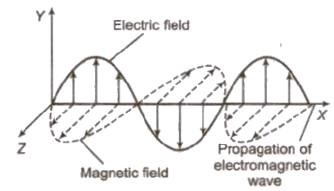
- In the case of EM waves, the propagation of wave takes place along the x-axis, electric and magnetic fields are perpendicular to the wave propagation.
- This means wave propagation --- x-axis , electric field ------> y-axis,magnetic field --à z-axis.
- Because of this EM waves are transverse in nature.
- The electric field of EM wave is represented as:
  - E_{y} = E₀ sin(kx–ωt)
    - Where Ey= electric field along the y-axis and x=direction of propagation of the wave.
    - Wavenumber k=(2π/λ)
  - The magnetic field of EM wave is represented as:
    - B_{z}=B₀sin(kx-ωt)
      - Where B_{Z} = electric field along the z-axis and x=direction of propagation of the wave.
The wavenumber is k = 2π/λ, where λ is the wavelength of the wave. The frequency f of the wave is f = ω/2π, ω is the angular frequency. The speed of any periodic wave is the product of its wavelength and frequency.
v = λf.
The energy of EM wave
- As the EM waves propagate they carry energy.
- Because of this property they have so many practical uses in our day-to-day life.
- The energy in the EM wave is partly carried by an electric field and partly by the magnetic field.
- Mathematically:
  - The total energy stored per unit volume in EM wave E_{T} =Energy stored per unit volume by electric field + Energy stored per unit volume stored in the magnetic field.
  - =(1/2)(E²ε₀) + (1/2)(B²μ₀)
  - Experimentally it has been found that the;
  - Speed of the EM wave =Speed of the light c=(E/B)
  - => B=(E/c)
  - E_{T} =(1/2)(E²ε₀) + (1/2)( E²/c²μ₀)
  - From Maxwell’s equations :- c=(1/√μ₀ε₀)
  - Therefore ,E_{T} =(1/2)(E²ε₀) + (1/2)( E²μ₀ε₀/μ₀)
  - =(1/2)(E²ε₀) + (1/2)(E²ε₀)
  - E_{T} = E²ε₀
This is the amount of energy carried per unit volume by the EM wave.
Properties of EM waves
- The velocity of EM waves in free space or vacuum is a fundamental constant.
- Experimentally it was found that the velocity of the EM wave is the same as the speed of light(c=3x10⁸m/s).
- The value of c is a fundamental constant.
- Therefore, c=(1/√μ₀ε₀)
- No material medium is necessary for EM waves. But they can propagate with ina medium as well.
- EM waves require time-varying electric and magnetic fields to propagate.
- If the medium is present then velocity v = (1/√με)
  - Whereμ =permeability of the medium and ε=permittivity of the medium.
- For example: -Spectacles. When light falls on the glass of the spectacle, light rays pass through glass. i.e. Light waves propagate through a medium which is glass here.

- EM waves carry energy and momentum.
- The total energy stored per unit volume in EM wave E_{T}= E²ε₀(partly carried by an electric field and partly by magnetic field).
- As EM waves carry energy and momentum, it becomes an important property for its practical purposes.
- EM waves are used for communication purposes, voice communication in mobile phones, telecommunication used in radio. 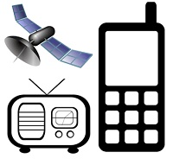
- EM waves exert pressure. As they carry energy and momentum, they exert pressure.
- The pressure exerted by EM waves is known as Radiation pressure.
- For example: -
  - The sunlight which we get from the sun is in the form of visible light rays.
  - These light rays are also part of EM waves.
  - If we keep our palm in the sun, after some time, the palm becomes warm and starts sweating.
  - This happens because sunlight is getting transferred in the form of EM waves and these EM waves carry energy.
  - Suppose total energy transferred to the hand =E.
  - Momentum = (E/c) as c is extremely high, therefore momentum is very small.
  - As momentum is very less, pressure experience is also very less.
  - This is the reason due to which the pressure exerted by the sun is not experienced by the hand.


Problem:-
Suppose that the electric field amplitude of an electromagnetic wave is E₀ = 120 N/C and that its frequency is ν = 50.0 MHz (a) Determine, B₀, ω, k, and λ. (b) Find expressions for E and B.
Answer:-
Electric field amplitude, E₀ = 120 N/C
Frequency of source, ν = 50.0 MHz = 50 × 10⁶ Hz
Speed of light, c = 3 × 10⁸ m/s
- Magnitude of magnetic field strength is given as:
B₀= (E₀/c)
=(120)/(3x10⁸)=4 x10⁻⁷ T=400 nT
Angular frequency of the source is given as:
ω = 2πν = 2π ×50 × 10⁶
= 3.14 × 10⁸rad/s
The propagation constant is given as:
k=(ω/c)
= (3.14 × 10⁸)/ (3x10⁸) =1.05rad/m
The wavelength of the wave is given as:
λ=(c/v) =(3x10⁸)/(50x10⁶) = 6.0m
(b) Suppose the wave is propagating in the positive x-direction. Then, the electric field vector will be in the positive y-direction and the magnetic field vector will be in the positive z-direction. This is because all three vectors are mutually perpendicular.
The equation of electric field vector is given as:
E=E₀ sin (kx –ωt)ˆj
=120 sin [1.05 x - 3.14x10⁸t] ˆj
And, magnetic field vector is given as:
B=B₀ sin (kx –ωt)ˆk
=4 x10⁻⁷) sin1.05 x - 3.14x10⁸t]ˆk
Problem:-
A plane electromagnetic wave of frequency25 MHz travels in free space along the x-direction. At a particular point in space and time, E = 6.3 ˆj V/m. What is B at this point?
Answer:-
Using Eq. B₀ = (E₀/c)the magnitude of B is
B= (E/c)
= (6.3 V)/ (3x10⁸m/s)
=2.1 x10⁻⁸ T
To find the direction, we note that E is along the y-direction and the wave propagates along the x-axis. Therefore, B should be in a direction perpendicular to both x- and y-axes. Using vector algebra, E × B should be along the x-direction. Since, (+ ˆj) × (+ ˆk) = ˆi, B is along the z-direction.
Thus, B = 2.1 × 10^{–8}ˆkT

Problem:-
The magnetic field in a plane electromagnetic wave is given by
B_{y} = 2 × 10^{–7} sin (0.5×10³x+1.5×10¹¹t) T.(a) What is the wavelength and frequency of the wave?
(b) Write an expression for the electric field.
Answer:-
(a) Comparing the given equation with
B_{y} = B₀ sin [2 π ((x/ λ) + (t/T))]
We get, λ = (2 π)/ (0.5x103) m =1.26cm and
(1/T) = ν = (1.5 x10¹¹)/ (2 π)
= 23.9 GHz
(b) E₀ = B₀c = 2×10^{–7} T × 3 × 10⁸ m/s = 6 × 10¹ V/m
The electric field component is perpendicular to the direction ofpropagation and the direction of magnetic field. Therefore, theelectric field component along the z-axis is obtained as
E_{z} = 60 sin (0.5 × 10³x + 1.5 × 10¹¹ t) V/m
Problem:-
Light with an energy flux of 18 W/cm² falls on a non-reflectingsurface at normal incidence. If the surface has an area of20 cm², find the average force exerted on the surface during a 30minute time span.
Answer:-
The total energy falling on the surface is
U = (18 W/cm²) × (20 cm²) × (30 × 60)
= 6.48 × 10⁵J
Therefore, the total momentum delivered (for complete absorption) is
p = (U/c) = (6.48 x 10⁵J)/ (3x10⁸m/s)
= 2.16 × 10^{–3} kg m/s
The average force exerted on the surface is
F = (p/t) = (2.16x10⁻³)/ (0.18x10⁴)
=1.2 x10⁻⁶ N
How will your result be modified if the surface is a perfect reflector?
.
Problem:- In a plane electromagnetic wave, the electric field oscillates sinusoidally at a frequency of 2.0 × 10¹⁰ Hz and amplitude 48 V m⁻¹.
(a) What is the wavelength of the wave?
(b) What is the amplitude of the oscillating magnetic field?
(c) Show that the average energy density of the E field equals the average energy density
of the B field. [c = 3 × 10⁸ m s⁻¹.]
Answer:-
Frequency of the electromagnetic wave, ν = 2.0 × 10¹⁰ Hz
Electric field amplitude, E₀ = 48 Vm⁻¹
Speed of light, c = 3 × 10⁸ m/s
(a) The wavelength of a wave is given as:
λ=(c/ν)
= (3 × 10⁸)/ (2.0 × 10¹⁰)
=0.015m
(b) Magnetic field strength is given as:
B₀ = (E₀/c)
= (48)/ (3 × 10⁸)
=1.6x10⁻⁷ T
(c) The energy density of the electric field is given as:
U_{E} = (1/2) (E²ε₀)
And, the energy density of the magnetic field is given as:
U_{B} =B²(1/2μ₀)
Where,
ε₀ = Permittivity of free space
μ₀ = Permeability of free space
We have the relation connecting E and B as:
E = cB ... (1)
Where,
c= (1/√μ₀ε₀) … (2)
Putting equation (2) in equation (1), we get
E= (1/√μ₀ε₀) B
Squaring both sides, we get
E²=1/ (μ₀ε₀) B²
ε₀E² = (B²/μ₀)
(1/2)ε₀E² = (1/2)μ ₀B²
=>U_{E}=U_{B}

Electromagnetic Spectrum
- The electromagnetic spectrum is the classification of EM waves according to their frequency or wavelength.
- Based on the wavelength EM waves are classified into different categories. This classification is known as the electromagnetic spectrum.
- Different categories of EM waves in decreasing order of their wavelength:-
  - Radio waves > 0.1m
  - Microwaves 0.1 m - 1mm
  - Infra-Red 1mm – 700 nm
  - Visible light 700nm – 400 nm
  - Ultraviolet 400nm- 1nm
  - X-rays 1nm – 10⁻³nm
  - Gamma rays <10⁻³nm
- These 7 waves together constitute the electromagnetic spectrum.
Tip:-
- To remember the order of the wavelength of each wave, we can just write the initial letter of all the waves and they are in the order of decreasing wavelength.
- R (max wavelength), M, I, V, U, X, and G (minimum wavelength).
- It can be remembered like this Red Man In Violet Uniform X Gun.
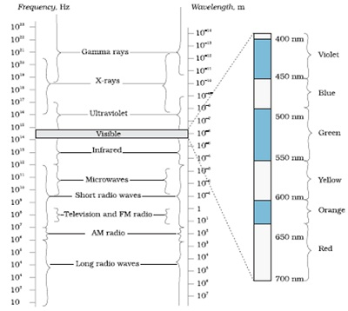
The electromagnetic spectrum, with common names for various parts of it. The various regions do not have sharply defined boundaries.
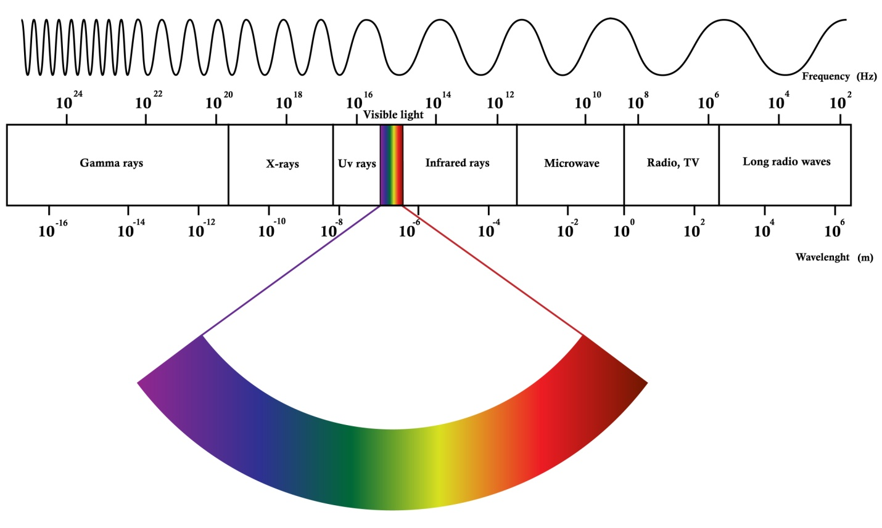
Problem:- A radio can tune in to any station in the 7.5 MHz to 12 MHz bands. What is the corresponding wavelength band?
Answer:- A radio can tune to minimum frequency, ν₁ = 7.5 MHz= 7.5 × 10⁶ Hz
Maximum frequency, ν₂ = 12 MHz = 12 × 10⁶ Hz
Speed of light, c = 3 × 10⁸ m/s
Corresponding wavelength for ν₁ can be calculated as:
λ₁ = (c/v₁) = (3x10⁸)/ (7.5x10⁶) = 40m
Corresponding wavelength for ν₂ can be calculated as:
λ₂ = (c/v₂) =(3x10⁸)/ (12x10⁶) =25m
Thus, the wavelength band of the radio is 40 m to 25 m.
Electromagnetic energy of each wave in Electromagnetic Spectrum
Electromagnetic waves energy can be described by frequency, wavelength, or energy.
- Frequency- Both micro and radio waves are described in terms of frequencies.
  - Frequency is a number of crests that pass a given point within one second.
  - Consider a wave that has 3 crests that pass a point in 1 second. Therefore frequency=3Hz.
- Wavelength-Infrared and visible waves are generally described in terms of wavelength.
  - Wavelength is the distance between consecutive crests or troughs.
  - The wavelength can vary from small value to a large value.
  - I unit: - meter.
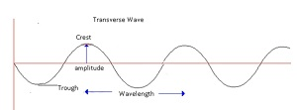
- Energy- X-rays and Gamma rays are described in terms of energies.
  - An EM wave can be described in terms of energy –in units of eV.
  - eV is the amount of kinetic energy needed to move 1 electron through a potential of 1 volt.
- Moving along the EM spectrum energy increases as the wavelength decreases.
The relation between Wavelength and Frequency
- c=νλ
  - Whereλ =wavelength and ν= frequency.
- =>λ = (c/ν)
- E=hν
- =(hc/λ)
- => E ∝ν and E ∝ (1/λ)
- Therefore from EM spectrum
  - Decreasing order of wavelength->R, M, I, V, U, X and G
  - In terms of increasing order of frequency -> G,X,U,V,I,M,R.
Problem:- The amplitude of the magnetic field part of a harmonic electromagnetic wave in vacuum is B₀ = 510 nT. What is the amplitude of the electric field part of the wave?
Answer:- Amplitude of the magnetic field of an electromagnetic wave in a vacuum,
B₀ = 510 nT = 510 × 10⁻⁹ T
Speed of light in a vacuum, c = 3 × 10⁸ m/s
The amplitude of the electric field of the electromagnetic wave is given by the relation,
E = cB₀ = 3 × 10⁸ × 510 × 10⁻⁹ = 153 N/C
Therefore, the electric field part of the wave is 153 N/C.
Problem:- A plane electromagnetic wave travels in a vacuum along the z-direction. What can you say about the directions of its electric and magnetic field vectors? If the frequency of the wave is 30 MHz, what is its wavelength?
Answer:- The electromagnetic wave travels in a vacuum along the z-direction. The electric field (E) and the magnetic field (H) are in the x-y plane. They are mutually perpendicular. Frequency of the wave, ν = 30 MHz = 30 × 10⁶s⁻¹
Speed of light in a vacuum, c = 3 × 10⁸ m/s Wavelength of a wave is given as:
λ =(c/ ν) = (3x10⁸)/ (30x10⁶)
λ =10m
Radio Waves
- Radio waves are produced by the accelerated motion of charges in conducting wires.
- An important application of radio waves is in:-
  - Radio and television communication systems.
  - Mobile phones for voice communication.
- In the electromagnetic spectrum, the wavelength (λ) of radio waves is >0.1m.
- Radio waves are further classified into different bands:-
  - (Amplitude Modulated)AM band 530 kHz to 1710 kHz (lowest frequency band).They are similar to FM channels.
  - Short wave band – up to 54MHz
  - TV waves band – 54MHz to 890MHz
  - (Frequency Modulated)FM band – 88MHz to 108MHz
  - UHF band- Ultra high frequency(used for voice communication over cell phones)

Micro Waves

- Microwaves are short-wavelength radio waves.
- They are produced by special vacuum tubes(klystrons/magnetrons/Gunn diodes).
- They are used in microwave ovens and a radar system in aircraft navigation.
  - RADAR Technology:-
- RADAR- Radio detection and ranging.
- Different applications of RADAR:-
- Air traffic control:-
  - For example: - To manage air traffic. The pilot should know any other airplane is present nearby or not.
  - The pilot should know the climatic conditions during take-off and landing.
  - Radar plays a very important role in aircraft navigation.
- Speed detection
  - The instruments which are used to detect the speed of the vehicles which move on the roads use radar technology.
- Military purposes
  - It helps to detect enemies and weapons.
- Satellite tracking
  - In order to track satellites, radar technology is used.
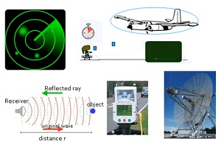
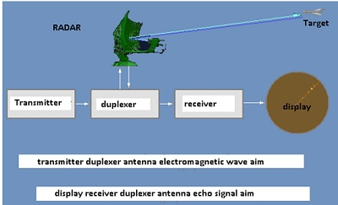

Why Radio waves use microwaves:-
- As they use short-wavelength waves which are the same as microwaves.
- They are invisible to humans. If we are able to see the waves which get transmitted it will be very irritating.
- Even the smallest presence of microwaves is easy to detect.
Working of Radar Set:-
It consists of:-
- Transmitter: - It transmits the microwaves.
- Receiver: - It receives the echo produced by the microwaves when they strike any object. When the receiver receives the reflected ray then it is possible to track the presence of other objects in the vicinity.
Microwave ovens
- The following are the properties because of which microwaves are very useful:-
- They have a smaller wavelength.
- They get absorbed by water, fats, and sugar.
Working of the microwave oven:-
- In order to heat anything uniformly, microwave ovens are used.
- Any food material will have water, sugar, and fats in it.
- When we heat any food material inside the microwave, the microwaves penetrate inside the food.
- So the microwaves get absorbed by the water and the fat molecules.
- The molecules of the food material will start moving randomly with some frequency.
- This is the same as providing some waves to the food material with the same frequency with which the molecules start vibrating.
- This shows that the frequency of microwave matches with the frequency of the molecules.
- As all the molecules are set in random motion, temperature increases, and food material gets heated uniformly throughout.
- The object can be heated by 2 ways:-
  - Conduction of heat: - It happens when anything is heated over the gas burner.
  - Exciting the molecules: - This technique is used in the microwave oven.
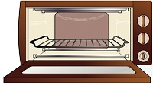
Infrared waves
- Infrared waves often known as heat waves as they are produced by hot bodies.
- Their wavelength is lesser than both radio and microwaves.
- They readily get absorbed by water.
Applications:- Infrared lamps/Infrared detector/LED in remote switches of electronic devices/Greenhouse effect.
For example:-
- Fire gives out both visible light waves and infrared waves. The light rays are visible to us but the infrared waves can not be seen by us.
- Humans also generate some infrared waves.
- There are some special glasses that have an infrared detector to view infrared waves.
- The infrared lamps are used to heat food materials and sometimes washrooms.
- When we switch on the TV with the help of a remote, there is an LED both on the TV and on the remote.
- The signal gets transferred from remote to the TV via infrared waves.

Greenhouse Effect:- Greenhouse effect is an atmospheric heating phenomenon that allows incoming solar radiation to pass through but blocks the heat radiated back from the Earth’s surface.
- Consider that the sun gives radiation in the form of visible light to the earth.
- When the visible light reaches the earth’s surface all the objects on the earth become hot.
- The visible light carries energy from the sun and that energy gets transferred to all the objects present on the earth.
- As a result of heat transfer, all the objects get heated up.
- These hot objects transmit infrared waves.
- The earth will reradiate the infrared waves.
- When these infrared waves try to go out of the atmosphere they get trapped by the greenhouse gases (CO₂, CH₄, water vapor).
- As a result, heat gets trapped inside the earth which results in an increase in temperature.
- The greenhouse effect makes the earth warm because of which the temperature of the earth is suitable for the survival of life on earth.
- Global warming is due to an increase in temperature of the environment, due to pollution.

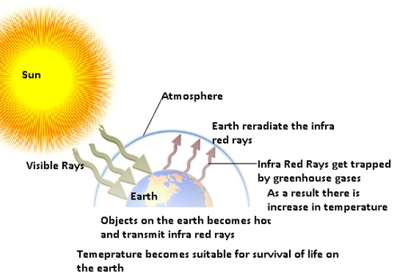
Visible or Light rays
- Light waves are the most common form of EM wave.
- Their wavelength range is 4x10¹⁴ Hz-7x10¹⁴
- We are able to see everything because of light rays.
- The radiation which we get from the sun is in the form of visible light.

- Most of the insects have compound eyes due to which they see not only the visible light but also the ultraviolet rays.
- Snakes can even see the infrared rays.
Problem:- About 5% of the power of a 100 W light bulb is converted to visible radiation. What is the average intensity of visible radiation:-
(a) at a distance of 1m from the bulb? at a distance of 10 m?
Answer:- Power rating of the bulb, P = 100 W
It is given that about 5% of its power is converted into visible radiation.
Power of visible radiation,
P’=(5/100)x100 =5W.
Hence, the power of visible radiation is 5W.
(a) Distance of a point from the bulb, d = 1 m
Hence, intensity of radiation at that point is given as:
I=(P’/4xπ xd²)
= (5)/ (4xπx1x1) =0.398W/m²
(b) Distance of a point from the bulb, d₁ = 10 m
Hence, intensity of radiation at that point is given as:
I= (P’)/ (4xπ x(d₁)²) =5/(4x x100x100)
=0.00398W/m²
Ultraviolet rays(UV rays)
It covers wavelengths ranging from about 4 × 10^{–7} m (400 nm) down to 6 × 10^{–10}m (0.6 nm).
- The UV rays are produced by special lamps and very hot bodies (sun).
- UV rays have harmful effects on humans.
- UV lamps are used to kill germs in water purifiers.
- For example:-
  - When UV rays fall on the skin of humans then it leads to the production of a pigment called melamine which causes tanning of the skin.
- In order to protect from UV rays, glasses are used, as they get absorbed by the glasses.
- UV rays help in LASER assisted eye surgery.
  - As UV rays have a very short wavelength so they can be focussed into a narrow beam of light.

- The ozone layer which is present outside the atmosphere protects us from the harmful UV rays.
- Ozone has a property of reflecting the harmful UV rays.
  - But due to the use of CFC (chlorofluorocarbon), the ozone layer is depleting.
  - So if the ozone layer gets depleted humans will get exposed to harmful UV rays coming from the sun.
X-Rays
- X-rays are produced by bombarding a metal target by high energy electrons.
- It is a very important diagnostic tool.
  - X-Rays have lesser wavelengths as compared to all other waves.
  - Because of this X-Rays can easily penetrate inside the skin (low-density material). It either gets reflected or absorbed by the high-density material (like bone).
  - In any X-Ray, bones look darker and lighter area is skin.
- It is also used for cancer treatment.
  - In cancer, there is the unwanted growth of the cells.
  - In order to treat cancer the abnormal growth of cells should be stopped.
  - The X-Rays have the ability to damage the living tissue.
This is how it helps in the treatment of cancer
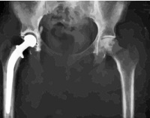
Gamma Rays
- Gamma rays are produced in the nuclear reactions and also emitted by radioactive nuclei.
- It is also used in the treatment of cancer.
- Gamma rays also have a very small wavelength. So they help to kill the growth of unwanted living cells which grow when the body is suffering from cancer.

