Chapter- 12
ATOMS

Introduction:
Atom is the fundamental building block of matter having a confined positively charged nucleus at the centre, surrounded by negatively charged electrons. Every inorganic, organic, or even synthetic object is made up of atoms.
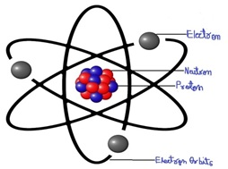
There were many atomic models given initially

Thomson Model of Atom:
- Atom is like a sphere where the positive charge has uniform distribution throughout
- Electrons are scattered inside in a way that most stable electrostatic arrangement is achieved, meaning that minimum possible energy of the system should is achieved
- Also known as watermelon model or plum pudding model
- It positively illustrated the net neutrality(equal positive and negative charges, so no net charge) of an atom
- It was inconsistent with the experiments conducted later and the discovery of neutron and proton.
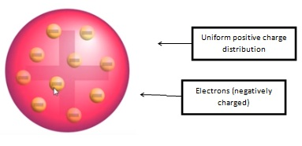

Thomson’s atomic model
Alpha- particle scattering experiment
- Geiger and Marsden carried out few experiments on the advice of Rutherford
- They directed a beam of 5.5 MeV α-particles emitted from a ²¹⁴Bi₈₃ radioactive source at a thin metallic foil (made of gold).
- The beam was allowed to fall on a thin foil of gold of thickness 2.1 × 10^{‒7} m.
- The scattered alpha-particles were observed through a rotatable detector consisting of a zinc sulphide screen and a microscope
- The scattered alpha-particles on striking the screen produced brief light flashes or scintillations. These flashes may be viewed through a microscope and the distribution of the number of scattered particles may be studied as a function of angle of scattering.

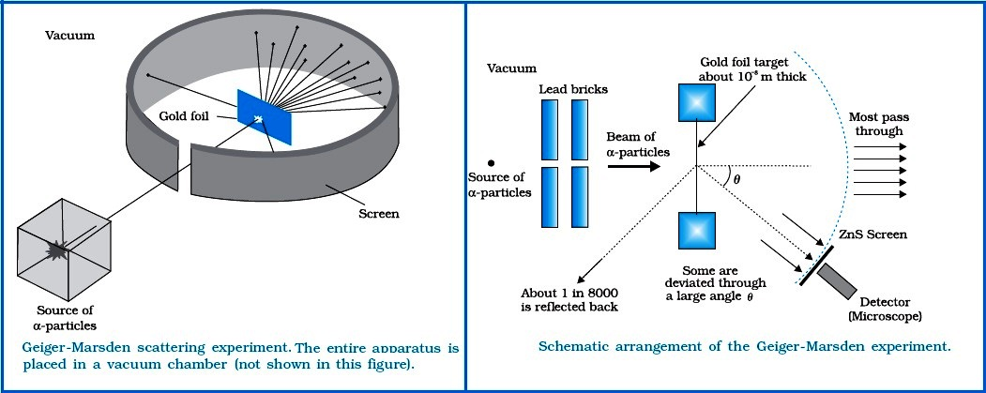
Results from Alpha- particle scattering experiment
- Scattered α-particles’ distribution as a function of scattering angle (θ) was analyzed and plotted as a graph
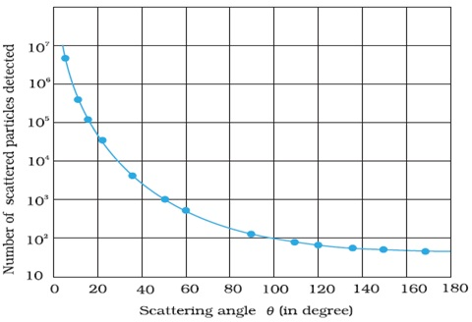
- As the scattering angle (θ) got higher, the count of scattered α-particles observed got lower, and vice versa.
- Many of the α-particles pass through the foil which means that they do not suffer any collisions.
- Approximately 0.14% of the incidents α-particles scatter by more than 1 º and about 1 in 8000 deflect by more than 90º.
- Some Important terms related to Alpha (α) Scattering Experiment
Impact Parameter
- It is the perpendicular distance of the velocity vector of the α particle from the central line of the nucleus when the particle is far away from the nucleus of the atom.
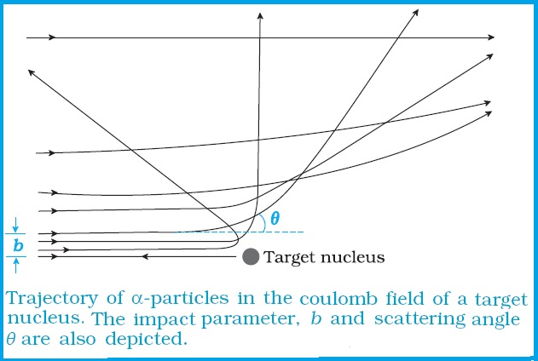
Angle of Scattering
It is the angle made by α particle when it gets deviated from its original path around the nucleus.
The conclusion from Alpha (α) Scattering Experiment
Based on α scattering experiment, Rutherford concluded the following important points.
According to him
- Scattering of alpha particles is due to Columbus force between the positive charge of α particle and positive charge of an atom.
- Rutherford’s experiments suggested the size of the nucleus to be about 10^{–15} m to 10^{–14} m.
- The electrons are present at a distance of about 10,000 to 100,000 times the size of the nucleus itself.
- Atom has a lot of space and the entire mass of the atom is confined to the very small central core also known as the nucleus.
- Almost all of the α-particles passed through the gold foil undeflected, and the infinitesimally small number of α-particles got deflected.

Rutherford’s Nuclear Model of Atom:

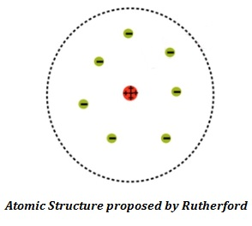
- Electrons and protons are bound together by electrostatic forces of attraction and atom, as a whole is electrically neutral
- Rutherford was the first to discover that atom has a nucleus and so his model was called as Rutherford’s nuclear model of an atom
Electron Orbit:
Since electrons orbiting around the nucleus and are held to the nucleus by the electrostatic force of attraction, ergo, centripetal force (F_{c}) is provided by the electrostatic force (F_{e}) to keep electrons in the orbit.
F_{c} = F_{e}
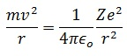
Here r=radius of orbit, v= velocity of orbiting electron, e= charge of an electron, m= mass of an electron, Z=atomic mass of an atom, Ɛ_{o}=permittivity of free space
On solving, we get:
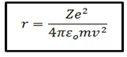
- Kinetic Energy(K): putting the value of mv²from eq.(1), we get:
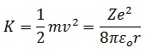
- Potential Energy(U): using the electrostatic potential between 2 charged body, we get:
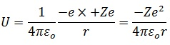
- Negative sign here shows that there is a force of attraction and energy has to be given to the system to overcome this force of attraction
- Total Energy(T):
T = U + K
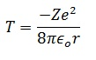
Some important things to note:
- Kinetic energy(K) = -(1/2)Potential energy(U)
- Kinetic energy(K) = -Total energy(T)
- Potential energy(U) = 2×Total energy(T)
Drawbacks of Rutherford’s Model:
- Accelerated charged particle produces electromagnetic waves (Maxwell Theory), so the orbital radius of the electron should go on decreasing and finally, the electron should fall into the nucleus. But atoms are stable and this stability of atoms could not be clarified by Rutherford’s model
- The model didn’t talk about the electronic structure of atoms, viz. electrons orientation, their orbital motion and relative energy of the electron in different orbits
- The dual character of electromagnetic radiation couldn’t be elaborated by the model
Problem: Hydrogen atom has ground state energy of -13.6eV. What are the kinetic and potential energies of atom at this state?
Solution: Given: Total energy= -13.6eV
We know from the above equations: Kinetic energy(K)= -Total energy(T)
∴ K = -(-13.6eV) = 13.6eV (ans)
Potential energy(U) = 2×Total energy(T)
∴ U = 2×(-13.6eV) = -27.2eV (ans)
Note: Here negative sign shows that there is a force of attraction between electron and nucleus.
Bohr’s Model of Hydrogen Atom:
- Drawbacks of Rutherford’s atomic model lead to the Bohr’s Model where he came up with 3 postulates:
- First Postulate: Atoms have some specific stable energy states (called stationary states) where electrons could orbit around the nucleus without emitting radiation
- Second Postulate: Orbiting of electrons occur only in the orbits (called stable orbits) where electrons’ angular momentum (L) is equal to the integral multiples of h/(2π), leading to the quantization of moving electron

L_{n} = mind = nh/(2π)
Here h= Planck’s constant = 6.6×10⁻³⁴Js
L_{n}= angular momentum of the electron in n^{th} orbit
v_{n}= velocity of the electron in n^{th} orbit
r_{n}= radius of an n^{th} orbit
n= permitted orbits on which electron revolve (called principal quantum number)
- Third Postulate: Electron while jumping from higher(initial) energy state to lower(final) energy state, emit a photon of energy equal to the energy difference between the 2 energy states, and its frequency is given by:
hv = E_{i} - E_{f}
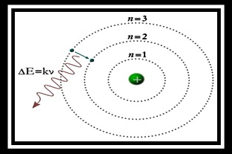
Bohr’s Radius: The radius on which electron moves around the nucleus in the orbit described by the Bohr’s model is known as Bohr’s radius.
Using the second postulate and Rutherford’s model(eq.1)
mvr = nh/(2π)
Using the value of υ²from both the equations, we get
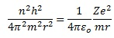
On solving (and putting Z=1 for hydrogen atom) we get:
r = n²h²Ɛ_{o}/(πme²)
For the radius of the innermost orbit, put n=1
The velocity of Electron in the Orbit:
v = e²/2nhƐ_{o}
The energy of Orbits:
The orbital energy of orbiting electron in the discrete energy levels in the Bohr’s model is called the energy of orbits.
We already know, from Rutherford’s Model that total energy(T) is given by
T = -Ze²/(8πƐ_{o}r)
Putting the value of Bohr’s radius, we get
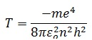
- Putting the values of electron mass(m), charge(e), permittivity of free space(Ɛ_{o}), Planck’s constant(h); we get
T = (-13.6/n²)eV
- For the energy of the innermost stationary orbit, put n=1

Drawbacks of Bohr’s Model:
- It was primarily for a hydrogen atom
- It couldn’t elaborate spectra of multi-electron atoms
- Wave nature of electron was not justified by the model (inconsistent with the de Broglie’s hypothesis of dual nature of matter)
- It didn’t illustrate molecules making the process of chemical reactions
- It violated Heisenberg’s Principal (Δx× Δp ≥nh/(2π)) which said that it was impossible to evaluate the precise position and momentum of an electron (and other microscopic particles) simultaneously. Only their probability could be estimated.
- Zeeman effect(spectral lines variation due to external magnetic field) and Stark Effect(spectral lines variation due to external electric field) couldn’t be described by the model
Problem: The energy gap between the 2 energy levels is 2.3eV. What is the frequency of radiation emitted when the atom makes a transition from higher to lower energy levels?
Solution: Given, ΔE = 2.3eV
Using Bohr’s 2nd postulate
ΔE = hv
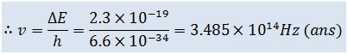
Problem: Use the Bohr’s model to calculate:
- Electron speed in the n=1, 2, and 3 levels of the hydrogen atom
- Bohr’s radius of the orbit in each of these levels.
Solution:
- The velocity of orbiting electron as per Bohr’s model is given by
v = e²/(2nhƐ_{o})
For n = 1, velocity is given by
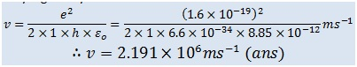
For n = 2, velocity is given by
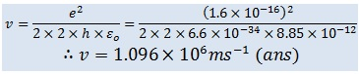
For n =3, velocity is given by
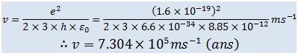
- Bohr’s radius of the orbit is given by
r = n²h²Ɛ_{o}/(πme²)
For n = 1, Bohr’s radius will be
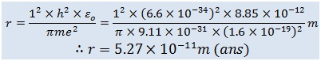
For n = 2, Bohr’s radius will be
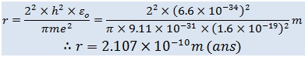
For n = 3, Bohr’s radius will be
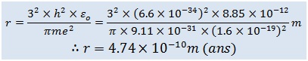
Problem: Using Bohr’s Model, find the quantum number associated with earth’s revolution around the sun in an orbit of radius 5×10¹¹m, orbital speed of3× 10⁴m/s, and
mass of earth=6×10²⁴kg
Solution:
Given, r_{n} =1.5×10¹¹m, v_{n} = 3×10⁴m/s, and m = 6×10²⁴kg
According to the Bohr’s second postulate:
mv_{n}r_{n} = nh/(2π)
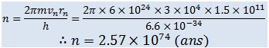

De-Broglie’s Hypothesis:
- De Broglie’s Hypothesis showed the wave-particle duality of matter
- It showed that, like photons, electrons must also have mass or momentum() and wavelength(λ), given by the equation (here c= speed of light in air, v=frequency)
p = mv = h/λ = h/(c/λ)
- It holds only for the subatomic (microscopic) particles like electron, proton etc. where mass is very small, so the wavelength is large enough to be experimentally observable
- It does not hold for the macroscopic particles since mass there is very large, making wavelength too small to be experimentally observable

De-Broglie’s Explanation of Bohr’s Second Postulate of Quantization:
- An electron orbiting in circular orbit can be considered as a particle-wave
- Only those waves propagate and survive which form nodes at a terminal point with an integer multiple of wavelength(resonant standing waves), thus covering the whole circumferential distance of the circular orbit
2πr_{n} = nλ
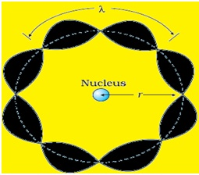
- From de Broglie’s hypothesis:λ = h/(mv)
- So, ultimately we get:mv_{n}r_{n} = nh/(2π)
- This proved that wave-particle duality is the cause of quantized energy states

Concept of Atomic Spectra:
- When an electron jumps amongst energy levels in an atom, energy is emitted or absorbed in the form of electromagnetic radiations and these radiations produce a spectral line of frequencies(or wavelength) associated with an atom, called atomic spectra
- Spectroscopy is the learning and examination emission and absorption spectra associated with an atom to determine its properties
- Spectral lines are the bright and dark line series that constitute the spectrum associated with an atom
- An atom has discrete spectra(where exist a fixed specific lines of energy transition of the electron with discrete energy gaps) also known as quantized spectra
- Another type is continuous spectra(where there are no specific lines of energy transition of electrons) which is the reverse of discrete spectra
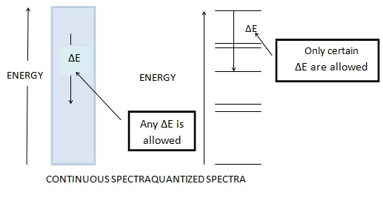
- There are 3 types of atomic spectra: a) emission spectra, b) absorption spectra, c) continuous spectra
Emission spectra:
- Radiation spectrum produced due to absorption of energy by a matter
- When an electron of an atom, molecules or ions get to a higher energy state than their ground (stable) state due to radiation absorption, they are said to be excited
- The emission spectrum is produced when energy is supplied to a sample (through heating or irradiation) and the wavelength or frequency of radiation emitted by the sample is observed as a function of energy
Absorption spectra:
- It is just the opposite of emission spectra
- Continuous radiation (energy) is directed through a sample which absorbs certain radiation of particular wavelengths and the remaining spectrum is recorded. Absorbed wavelengths correspond to the dark spaces in the spectrum
- Whatever absent(showed by dark lines) in the emission spectrum of an atom is present (showed by bright lines) in the absorption spectrum of that atom
Continuous spectra:
- Formed when a ray of white light is passed through a prism(or water droplets) causing a continuous spectrum of visible light of different wavelength
- There are no discrete lines (separation) between any 2 adjacent wavelengths
- Speed of light changes with respect to the medium through which it passes, so as the medium changes, light with the longest wavelength (red)deviates the least and the light with the shortest wavelength (violet) deviates the most

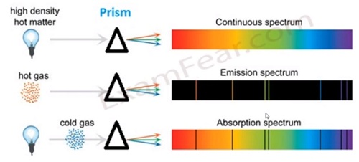

Spectral Series of Hydrogen atom
- On passing an electric discharge through hydrogen gas, hydrogen molecules would dissociate giving rise to excited (highly energetic) hydrogen atoms that emit radiation of certain specified frequency while returning to its ground state
- Hydrogen spectra are constituted of 5 series of spectrum named after their discoverer (Lyman, Balmer, Paschen, Bracket and Pfund series)
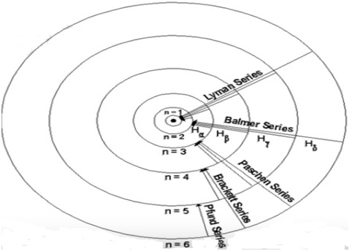

Types of Spectral Series:
Balmer Series:
- The first scientist to discover a spectral series of a hydrogen atom
- It consists of the visible radiation spectrum
- Experimentally, he found that these spectral lines could be expressed mathematically in the form of wavelength as:
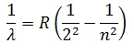
- Here R= Rhydberg constant = 109677cm⁻¹(found experimentally), n= 3, 4, 5…… (higher discrete energy state from which electron jumps to 2nd energy state thus emitting radiation)
λ = wavelength of emitted radiation in (cm)
- For maximum wavelength(λ_{max}) in the Balmer series, n=3 (has to be minimum):
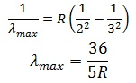
- For minimum wavelength (λ_{min}) in the Balmer series, n=∞ (has to be minimum):
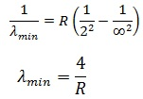
Lyman Series:
- Spectral series when radiation emitted is due to jumping off the electron from higher energy states to ground state
- Mathematically expressed as
- Here n= 2, 3, 4…
- For maximum wavelength in the Lyman series, n=2 (has to be minimum):
λ_{max} = 4/3R
- For minimum wavelength in the Lyman series, n=∞(has to be minimum):
λ_{min} = 1/R
Similarly, all other series could be expressed as:
Paschen Series:
- Mathematically expressed as
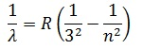
- Here n= 4, 5, 6…
Bracket Series:
- Mathematically expressed as
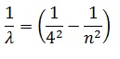
- Here n= 5, 6, 7…
Pfund Series:
- Mathematically expressed as
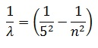
- Here n= 6, 7, 8…
- These energy levels of the hydrogen atom are represented in the energy level diagram given below.
- 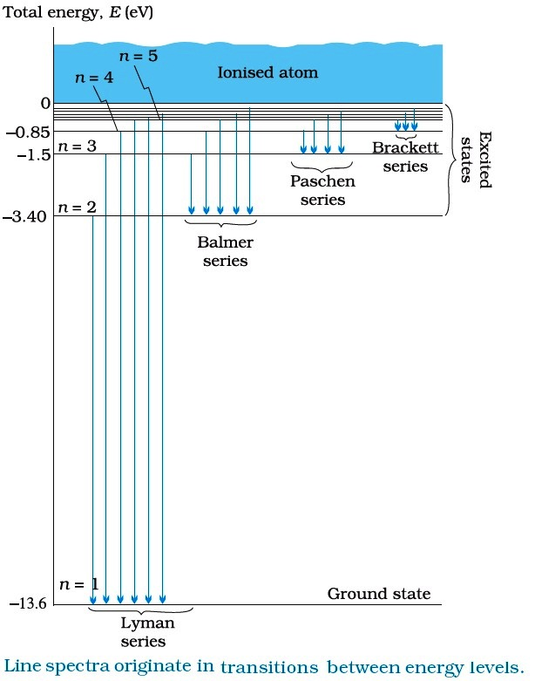
- Atomic spectra have a huge scope in the study of electronic structures of various atoms, molecules and ions
- Elements have their distinctive spectral series. So spectral series is used in the identification (even discovery) of unknown atoms
- Many elements were discovered by the spectroscopic methods, such as Rubidium (Ru), Caesium (Cs), Helium (He), Gallium (Ga), Thallium(Tl), Scandium (Sc).
Problem: Evaluate the shortest and the longest wavelength corresponding to the following series of spectral lines:
- Lyman series
- Paschen series
- Bracket series
Solution:
- For Lyman series: 1/λ = R(1/1² – 1/n²)
For shortest wavelength (λ_{min}), n has to be maximum
1/λ_{max} = R(1/1² – 1/∞²)
λ_{max} = 1/R = (1/109677)cm
= 9.118×10⁻⁶cm (Answer)
For longest wavelength (λ_{max}), n has to be minimum
1/λ_{max} = R(1/1² – 1/2²)
λ_{max} = 4/(3R) = 4/(3×109677) = 1.216×10⁻⁵cm
λ_{max} = 1.216×10⁻⁵cm (Answer)
- b) For Paschen series, similarly proceeding as above
For shortest wavelength , n has to be maximum
1/λ_{min} = R(1/3² – 1/∞²)
= 9/R = 9/109677 = 8.206×10⁻⁵cm (ans)
For longest wavelength , n has to be minimum
1/λ_{max} = R(1/3² – 1/4²)
λ_{max} = 16×9/7 =16×9/106977 = 1.876×10⁻⁴cm (Answer)

c) For Bracket series, similarly proceeding as above
1/λ_{min} = R(1/4² – 1/∞²)
= 16/R = 16/109677 =1.459×10⁻⁴cm
For longest wavelength (λ_{max}), n has to be minimum
∴1/λ_{max} = R(1/4² – 1/5²)
= 25×16/(9R) = 4.052×10⁻⁴cm (Answer)
ProblemA hydrogen atom on absorbing a photon, gets excited to the n = 4 level from its ground level. What is the wavelength and frequency of the photon?
Solution: Given, n =4
From Balmer series, we can write
= R(1/2² – 1/4²) = 109677(1/4 – 1/16)
λ = 16/(3×109677) = 4.86×10⁻⁵cm (ans)
For frequency(υ), we know that it is given by the formula
= 3×10⁸/(4.86×10⁻⁷) = 6.1×10¹⁴Hz (ans)

