Chapter- 2
Inverse Trigonometric Functions
Introduction:-
In the previous chapter, we have studied the existence of the inverse of a function. In this chapter, we shall study the restrictions on domains and ranges of trigonometric functions, which ensure the existence of their inverse and study their properties.
The inverse of Trigonometric Functions:-
We know that trigonometric functions are periodic functions and hence in general all trigonometric functions are not bijections, consequently, their inverse does not exist. However, if we restrict their domains and co-domains, they can be made bijections and we can obtain their inverses.
Domain and Range of Trigonometric functions:-
$$\begin{matrix}Function & Domain & Range \\ \sin{x} & R & \left[-1,1\right] \\ \cos{x} & R & \left[-1,1\right] \\ \tan{x} & R-\left\{x:x=\left(2n+1\right)\frac{π}{2},n∈z\right\} & R \\ \cot{x} & R-\left\{x:x=nπ,n∈z\right\} & R \\ \sec{x} & R-\left\{x:x=\left(2n+1\right)\frac{π}{2},n∈z\right\} & R-\left(-1,1\right) \\ \cos{e}cx & R-\left\{x:x=nπ,n∈z\right\} & R-\left(-1,1\right)\end{matrix}$$
Domain and Range of Inverse Trigonometric Functions:-
The range of trigonometric functions becomes the domain of inverse trigonometric functions and the restricted domain of trigonometric functions becomes the range or principal value branch of inverse trigonometric functions.
e.g let the function$f:R→R$ defined as $f\left(x\right)=\sin{x}$. Since the domain of sine function is a set of all real numbers and ranges $\left[-1,1\right]$, so it is a many-one function. If we restrict its domains to any one of the intervals $\left[-\frac{3π}{2},-\frac{π}{2}\right],\left[-\frac{π}{2},\frac{π}{2}\right],\left[\frac{π}{2},\frac{3π}{2}\right]$etc, then it becomes one-one and onto, and in each case the range is $\left[-1,1\right]$. Therefore, we can define the inverse of the sine function in each of these intervals and denoted by $\sin^{-1}{}$ (arc sine function). Thus $\sin^{-1}{}$ is a function whose domain is $\left[-1,1\right]$ and range may be any of the intervals $\left[\frac{-3π}{2},\frac{-π}{2}\right],\left[\frac{-π}{2},\frac{π}{2}\right],\left[\frac{π}{2},\frac{3π}{2}\right]$ and so on. Corresponding to each such interval we get a branch of the function $\sin^{-1}{}$. The branch with the range $\left[-\frac{π}{2},\frac{π}{2}\right]$ is called the principal value branch and the value belonging to it is called principal value. The function $\sin^{-1}{x}$ whose domain is $\left[-1,1\right]$ and range $\left[-\frac{π}{2},\frac{π}{2}\right]$ is written as.
$$\sin^{-1}{:}\left[-1,1\right]→\left[-\frac{π}{2},\frac{π}{2}\right]$$
Domain, Principal value branch (Range) of inverse trigonometric function:-
$$\begin{matrix}Function & Domain & \operatorname{Pr}{i}ncipalvalue\left(Range\right) \\ \left(i\right)y=\sin^{-1}{x} & \left[-1,1\right] & \left[-\frac{π}{2},\frac{π}{2}\right] \\ \left(ii\right)y=\cos^{-1}{x} & \left[-1,1\right] & \left[0,π\right] \\ \left(iii\right)y=\tan^{-1}{x} & R & \left(-\frac{π}{2},\frac{π}{2}\right) \\ \left(iv\right)y=\cot^{-1}{x} & R & \left(0,π\right) \\ \left(v\right)y=\sec^{-1}{x} & R-\left(-1,1\right) & \left[0,π\right]-\left\{\frac{π}{2}\right\} \\ \left(vi\right)y=\cos{e}c^{-1}x & R-\left(-1,1\right) & \left[-\frac{π}{2},\frac{π}{2}\right]-\left\{0\right\}\end{matrix}$$
Important Points:-
- $\sin^{-1}{x}≠{\left(\sin{x}\right)}^{-1}or\sin^{-1}{x}≠\frac{1}{\sin{x}}$. These relations also hold for other inverse trigonometric functions.
- Whenever no branch of an inverse trigonometric function is mentioned we consider the principal value branch of that function.
- If $\sin^{-1}{x}=y$, then x and y are the elements of domain and range of principal vale branch of $\sin^{-1}{x}$ respectively.
- If $\sin{y}=x$ then $\sin^{-1}{x}=y$.
- For example, $\sin{\frac{π}{6}}=\frac{1}{2}$ $⇒\sin^{-1}\left(\frac{1}{2}\right)=\frac{π}{6}$

Graphs of Inverse Trigonometric Functions:-
Graph of $\sin{x}and\sin^{-1}{x}$:-
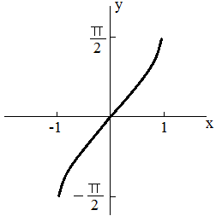
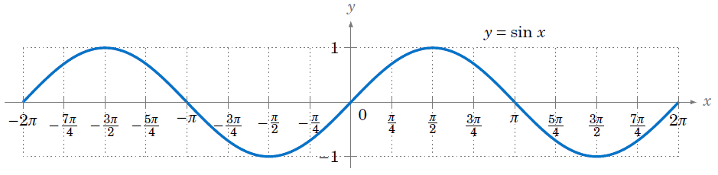

$y=\sin{x}$ $y=\sin^{-1}{x}$
Graph of $\cos{x}and\cos^{-1}{x}$:-
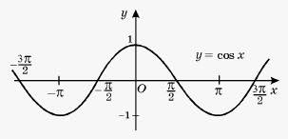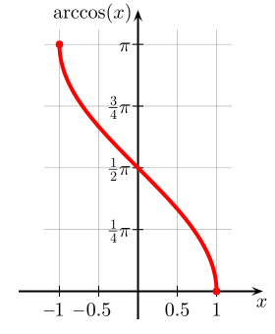
$y=\cos{x}$ $y=\cos^{-1}{x}$

Remember:
- The graphs of $y=\sin{x}andy=\sin^{-1}{x}$ are mirror images of each other in the line mirror y = x
- $\sin^{-1}{x}$ is an odd function
- $\cos^{-1}{x}$ is neither odd nor even function
- $\sin^{-1}{x}$ is an increasing function in its domain
- $\cos^{-1}{x}$ is a decreasing function in its domain.

Graph of $\tan{x}and\tan^{-1}{x}$:-

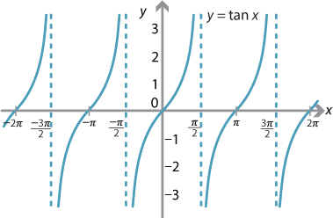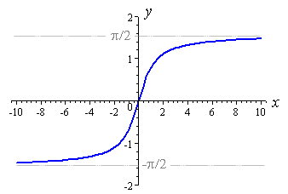
$y=\tan{x}$ $y=\tan^{-1}{x}$

Graph of $\cot{x}and\cot^{-1}{x}$:-
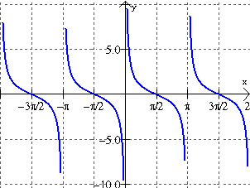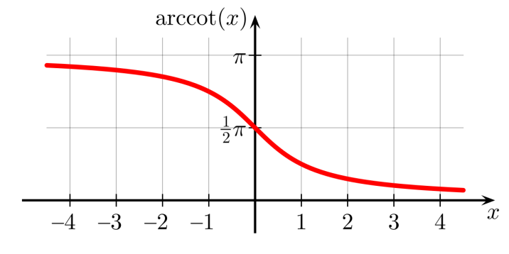
$y=\cot{x}$ $y=\cot^{-1}{x}$

Graph of $\sec{x}and\sec^{-1}{x}$:-
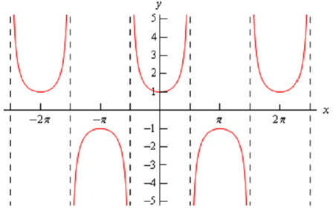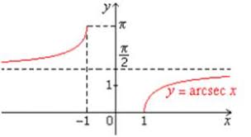
$y=\sec{x}$ $y=\sec^{-1}{x}$

Graph of $cosecx and {cosec}^{-1}x$:-
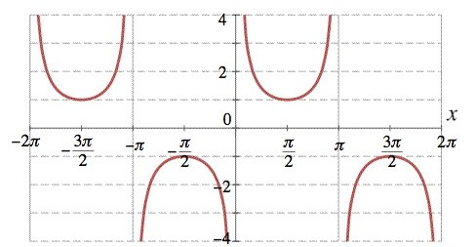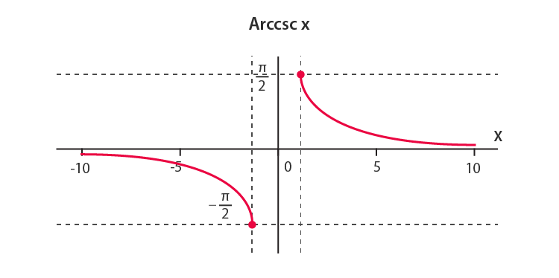
$y=cosecx$ $y={cosec}^{-1}x$
Note:-
The graph of an inverse trigonometric function can be obtained from the graph of the original function by interchanging the coordinate axes.
Example:-
1. The domain of $\sin^{-1}{2}x$ is
(a) $\left[0,1\right]$ (b) $\left[-1,1\right]$ (c) $\left[-\frac{1}{2},\frac{1}{2}\right]$ (d) $\left[-2,2\right]$
2. The domain of $\cos^{-1}\left(x^{2}-4\right)$ is
(a) $\left[3,5\right]$ (b) $\left[0,π\right]$
(c) $\left[-\sqrt{5},-\sqrt{3}\right]∩\left[-\sqrt{5},\sqrt{3}\right]$ (d) $\left[-\sqrt{5},-\sqrt{3}\right]∪\left[\sqrt{3},\sqrt{5}\right]$
3. The domain of the function $f\left(x\right)=\sin^{-1}{x}+\cos{x}$ is
(a) $\left[-1,1\right]$ (b) $\left[-1,π+1\right]$ (c) $\left(-∞,∞\right)$ (d) $ϕ$
4. Find the principal values of the following
(a) $\sin^{-1}\left(\frac{1}{\sqrt{2}}\right)$ (b) $\sin\left[\cos^{-1}\left(\frac{1}{2}\right)\right]$ (c) $\cot^{-1}\left(-\frac{1}{\sqrt{3}}\right)$

Elementary Properties of Inverse Trigonometric Functions:-
Property – 1
- $\sin^{-1}\left(\sin{θ}\right)=θ$ where $θ∈\left[-\frac{π}{2},\frac{π}{2}\right]$
- $\cos^{-1}\left(\cos{θ}\right)=θ$ where $θ∈\left[0,π\right]$
- $\tan^{-1}\left(\tan{θ}\right)=θ$ where $θ∈\left(-\frac{π}{2},\frac{π}{2}\right)$
- $\cot^{-1}\left(\cot{θ}\right)=θ$ where $θ∈\left(0,π\right)$
- $\sec^{-1}\left(\sec{θ}\right)=θ$ where $θ∈\left[0,π\right]-\left\{\frac{π}{2}\right\}$
- $\cos{e}c^{-1}\left(\cos{e}cθ\right)=θ$ where $θ∈\left[-\frac{π}{2},\frac{π}{2}\right]-\left\{0\right\}$
Example:-
Evaluate the following
(a) $\cos^{-1}\left(\cos{\frac{π}{3}}\right)=\frac{π}{3}$
(b) $\sin^{-1}\left(\sin{\frac{2π}{3}}\right)$ $=\sin^{-1}{\sin\left(π-\frac{π}{3}\right)}$ $=\sin^{-1}{\sin{\frac{π}{3}}}=\frac{π}{3}$
(c) $\tan^{-1}\left(\tan{\frac{5π}{4}}\right)=\tan^{-1}{\tan\left(π+\frac{π}{4}\right)}$ $=\tan^{-1}{\tan{\frac{π}{4}}}=\frac{π}{4}$
(d) $\sin^{-1}\left(\sin{3}\right)$ $\left[3^{c}≈171^{o}\right]$
$=\sin^{-1}{\sin\left(π-\left(π-3\right)\right)}$ $=\sin^{-1}{\sin\left(π-3\right)}=π-3$
(e) $\sin^{-1}\left(\sin{4}\right)$ $\left[4^{c}≈228^{o}\right]$
$=\sin^{-1}{\sin\left(π+\left(4-π\right)\right)}$ $=\sin^{-1}\left\{-\sin\left(4-π\right)\right\}$ $=\sin^{-1}{\sin\left(π-4\right)}=π-4$
Example:-
Express the following in the simplest form
(a) $\tan^{-1}\left(\frac{\cos{x}}{1+\sin{x}}\right)$ (b) $\sin^{-1}\left(\frac{x}{\sqrt{x^{2}+a^{2}}}\right)$

Property – 2
- $\sin\left(\sin^{-1}{x}\right)=x$ where $x∈\left[-1,1\right]$
- $\cos\left(\cos^{-1}{x}\right)=x$ where $x∈\left[-1,1\right]$
- $\tan\left(\tan^{-1}{x}\right)=x$ where $x∈R$
- $\cot\left(\cot^{-1}{x}\right)=x$ where $x∈R$
- $\sec\left(\sec^{-1}{x}\right)=x$ where $x∈R-\left(-1,1\right)$
- $\cos{e}c\left(\cos{e}c^{-1}x\right)=x$ where $x∈R-\left(-1,1\right)$
Example:-
Evaluate:-
(a) $\tan\left(\tan^{-1}{\frac{3}{4}}\right)$ (b) $\sin\left(\sin^{-1}{\frac{5}{13}}\right)$ (c) $\sin\left(\cos^{-1}{\frac{4}{5}}\right)$ (d) $\cos\left(\cot^{-1}{\frac{15}{8}}\right)$
Example:-
Prove that $\tan^{2}\left(\sec^{-1}{2}\right)+\cot^{2}\left(\cos{e}c^{-1}3\right)=11$
Example:-
Find the value of the expression $\sin\left[\cot^{-1}\left\{\cos\left(\tan^{-1}{1}\right)\right\}\right]$
Example:-
Solve $\cos\left(\tan^{-1}{x}\right)=\sin\left(\cot^{-1}{\frac{3}{4}}\right)$
Property - 3
- $\sin^{-1}\left(-x\right)=-\sin^{-1}{x},x∈\left[-1,1\right]$
- $\cos^{-1}\left(-x\right)=π-\cos^{-1}{x},x∈\left[-1,1\right]$
- $\tan^{-1}\left(-x\right)=-\tan^{-1}{x},x∈R$
- $\cos{e}c^{-1}\left(-x\right)=-\cos{e}c^{-1}x,x∈(-∞,-1]∪[1,∞)$
- $\sec^{-1}\left(-x\right)=π-\sec^{-1}{x},x∈(-∞,-1]∪[1,∞)$
- $\cot^{-1}\left(-x\right)=π-\cot^{-1}{x},x∈R$
Example:- Find the principal value of $\sin^{-1}\left(-\frac{1}{\sqrt{2}}\right)$
Example:- Find the principal value of $\cot^{-1}\left(-\sqrt{3}\right)$
Example:- Evaluate
(a) $\cos\left\{\sin^{-1}\left(-\frac{5}{13}\right)\right\}$ (b) $\cot\left\{\sec^{-1}\left(-\frac{13}{5}\right)\right\}$
Property - 4
- $\sin^{-1}\left(\frac{1}{x}\right)=\cos{e}c^{-1}x,x∈(-∞,-1]∪[1,∞)$
- $\cos^{-1}\left(\frac{1}{x}\right)=\sec^{-1}{x},x∈(-∞,-1]∪[1,∞)$
- $\tan^{-1}\left(\frac{1}{x}\right)=\left\{\begin{matrix}\cot^{-1}{x}, & x>0 \\ -π+\cot^{-1}{x}, & x<0\end{matrix}\right.$
Property - 5
- $\sin^{-1}{x}+\cos^{-1}{x}=\frac{π}{2},x∈\left[-1,1\right]$
- $\tan^{-1}{x}+\cot^{-1}{x}=\frac{π}{2},x∈R$
- $\sec^{-1}{x}+\cos{e}c^{-1}x=\frac{π}{2},x∈(-∞,-1]∪[1,∞)$
Example:-
If $-1≤x,y{≤}1$, such that $\sin^{-1}{x}+\sin^{-1}{y}=\frac{π}{2}$, find the value of $\cos^{-1}{x}+\cos^{-1}{y}$
Example:-
(a) If $\tan^{-1}{x}-\cot^{-1}{x}=\tan^{-1}{\frac{1}{\sqrt{3}}}$ find the value of x.
(b) If $\cos\left(\sin^{-1}{\frac{2}{5}}+\cos^{-1}{x}\right)=0$, find the value of x.
Example:-
Find the greatest and least values of ${\left(\sin^{-1}{x}\right)}^{2}+{\left(\cos^{-1}{x}\right)}^{2}$
Example:-
Solve: $4\sin^{-1}{x}=π-\cos^{-1}{x}$
Multiple Choice Questions (MCQ):-
1. If $\sin^{-1}{x}-\cos^{-1}{x}=\frac{π}{6}$, then $x=______$
(a) $\frac{1}{2}$ (b) $\frac{\sqrt{3}}{2}$ (c) $-\frac{1}{2}$ (d) None of these
2. If $4\cos^{-1}{x}+\sin^{-1}{x}=π$, then the value of x is
(a) $\frac{3}{2}$ (b) $\frac{1}{\sqrt{2}}$ (c) $\frac{\sqrt{3}}{2}$ (d) $\frac{2}{\sqrt{3}}$
3. The value of $\cos^{-1}\left(\cos{\frac{5π}{3}}\right)+\sin^{-1}\left(\sin{\frac{5π}{3}}\right)$ is
(a) $\frac{π}{2}$ (b) $\frac{5π}{3}$ (c) $\frac{10π}{3}$ (d) Zero
More Properties of Inverse Trigonometric Functions:-
Property - 6
- $\tan^{-1}{x}+\tan^{-1}{y}=\left\{\begin{matrix}\tan^{-1}\left(\frac{x+y}{1-xy}\right), & if xy<1 \\ π+\tan^{-1}\left(\frac{x+y}{1-xy}\right), & if x>0,y>0 and xy>1 \\ -π+\tan^{-1}\left(\frac{x+y}{1-xy}\right), & if x<0,y<0 and xy>1\end{matrix}\right.$
- $\tan^{-1}{x}-\tan^{-1}{y}=\left\{\begin{matrix}\tan^{-1}\left(\frac{x-y}{1+xy}\right), & if xy>-1 \\ π+\tan^{-1}\left(\frac{x-y}{1+xy}\right), & if x>0,y<0 and xy<-1 \\ -π+\tan^{-1}\left(\frac{x-y}{1+xy}\right), & if x<0,y>0 and xy<-1\end{matrix}\right.$
Example:-
Prove the following
(a) $\tan^{-1}{\frac{1}{7}}+\tan^{-1}{\frac{1}{13}}=\tan^{-1}{\frac{2}{9}}$ (b)$\cot^{-1}{7}+\cot^{-1}{8}+\cot^{-1}{1}8=\cot^{-1}{3}$
Example:-
Solve (a) $\tan^{-1}\left(\frac{x-1}{x+1}\right)+\tan^{-1}\left(\frac{2x-1}{2x+1}\right)=\tan^{-1}{\frac{23}{36}}$ (b) $\cot^{-1}{x}-\cot^{-1}\left(x+2\right)=\frac{π}{12}$
Property – 7
- $\sin^{-1}{x}+\sin^{-1}{y}=\sin^{-1}\left(x\sqrt{1-y^{2}}+y\sqrt{1-x^{2}}\right)$
- $\sin^{-1}{x}-\sin^{-1}{y}=\sin^{-1}\left(x\sqrt{1-y^{2}}-y\sqrt{1-x^{2}}\right)$
Example:-
Prove that
(a) $\sin^{-1}{\frac{3}{5}}+\sin^{-1}{\frac{8}{17}}=\sin^{-1}{\frac{77}{85}}$ (b) $\sin^{-1}{\frac{5}{13}}+\cos^{-1}{\frac{3}{5}}=\tan^{-1}{\frac{63}{16}}$
Example:-
Solve the following
(a) $\sin^{-1}{\frac{3x}{5}}+\sin^{-1}{\frac{4x}{5}}=\sin^{-1}{x}$ (b) $\cos^{-1}{x}+\sin^{-1}{\frac{x}{2}}-\frac{π}{6}=0$
Property - 8
- $\cos^{-1}{x}+\cos^{-1}{y}=\cos^{-1}\left(xy-\sqrt{\left(1-x^{2}\right)\left(1-y^{2}\right)}\right)$
- $\cos^{-1}{x}-\cos^{-1}{y}=\cos^{-1}\left(xy+\sqrt{\left(1-x^{2}\right)\left(1-y^{2}\right)}\right)$
Example:-
Prove that $\cos^{-1}{\frac{x}{2}}+\cos^{-1}{\frac{y}{3}}=θ$then prove that $9x^{2}-12xy\cos{θ}+4y^{2}{=}36\sin^{2}{θ}$
Property – 9
- $2\sin^{-1}{x}=\sin^{-1}\left(2x\sqrt{1-x^{2}}\right)if-\frac{1}{\sqrt{2}}≤x≤\frac{1}{\sqrt{2}}$
- $3\sin^{-1}{x}=\sin^{-1}\left(3x-4x^{3}\right)if-\frac{1}{2}≤x≤\frac{1}{2}$
Example:-
Evaluate $\sin\left(2\sin^{-1}{0}.6\right)$
Property - 10
(a) $2\cos^{-1}{x}=\cos^{-1}\left(2x^{2}-1\right)if0≤x≤1$
(b) $3\cos^{-1}{x}=\cos^{-1}\left(4x^{3}-3x\right)if\frac{1}{2}≤x≤1$
Property - 11
(a) $2\tan^{-1}{x}=\tan^{-1}\left(\frac{2x}{1-x^{2}}\right)if-1<x<1$
(b) $3\tan^{-1}{x}=\tan^{-1}\left(\frac{3x-x^{3}}{1-3x^{2}}\right)if-\frac{1}{\sqrt{3}}<x<\frac{1}{\sqrt{3}}$
(c) $2\tan^{-1}{x}=\sin^{-1}\left(\frac{2x}{1+x^{2}}\right)=\cos^{-1}\left(\frac{1-x^{2}}{1+x^{2}}\right)$
Example:-
Prove that
(a) $2\sin^{-1}{\frac{3}{5}}-\tan^{-1}{\frac{17}{31}}=\frac{π}{4}$ (b) $4\tan^{-1}{\frac{1}{5}}-\tan^{-1}{\frac{1}{239}}=\frac{π}{4}$
Example:-
If $\sin^{-1}{\frac{2a}{1+a^{2}}}-\cos^{-1}{\frac{1-b^{2}}{1+b^{2}}}=\tan^{-1}{\frac{2x}{1-x^{2}}}$ then prove that $x=\frac{a-b}{1+ab}$
Example:-
Prove that
$$2\tan^{-1}\left(\sqrt{\frac{a-b}{a+b}}\tan{\frac{θ}{2}}\right)=\cos^{-1}\left(\frac{a\cos{θ}+b}{a+b\cos{θ}}\right)$$
Property - 12
(a) $\sin^{-1}{x}=\cos^{-1}{\sqrt{1-x^{2}}}=\tan^{-1}\left(\frac{x}{\sqrt{1-x^{2}}}\right)=\cot^{-1}{\frac{\sqrt{1-x^{2}}}{x}}=\sec^{-1}\left(\frac{1}{\sqrt{1-x^{2}}}\right)=\cos{e}c^{-1}\left(\frac{1}{x}\right)$
(b)$\cos^{-1}{x}=\sin^{-1}{\sqrt{1-x^{2}}}=\tan^{-1}\left(\frac{\sqrt{1-x^{2}}}{x}\right)=\cot^{-1}\left(\frac{x}{\sqrt{1-x^{2}}}\right)=\sec^{-1}\left(\frac{1}{x}\right)=\cos{e}c^{-1}\left(\frac{1}{\sqrt{1-x^{2}}}\right)$
(c) $\tan^{-1}{x}=\sin^{-1}\left(\frac{x}{\sqrt{1+x^{2}}}\right)=\cos^{-1}\left(\frac{1}{\sqrt{1+x^{2}}}\right)=\cot^{-1}\left(\frac{1}{x}\right)=\sec^{-1}\left(\sqrt{1+x^{2}}\right)=\cos{e}c^{-1}\left(\frac{\sqrt{1+x^{2}}}{x}\right)$
Example:-
Evaluate
(a) $\cos\left(\tan^{-1}{\frac{24}{7}}\right)$ (b) $\sin\left(\sec^{-1}{\frac{17}{8}}\right)$
Example:-
Prove that $\tan\left(\sin^{-1}{\frac{5}{13}}+\cos^{-1}{\frac{3}{5}}\right)=\frac{63}{16}$
Example:-
Solve $\cos\left(\sin^{-1}{x}\right)=\frac{1}{6}$
Some Important Questions:-
1. Write the principal value of $\tan^{-1}\left(\sin\left(-\frac{π}{2}\right)\right)$
2. Evaluate $\cos\left(\cos{e}c^{-1}\frac{13}{12}\right)$
3. Find the value of $\cot\left(\frac{π}{2}-2\cot^{-1}{\sqrt{3}}\right)$
4. If $\sin\left(\sin^{-1}{\frac{1}{5}}+\cos^{-1}{x}\right)=1$, then find the value of x.
5. If $\tan^{-1}{\frac{x-1}{x-2}}+\tan^{-1}{\frac{x+1}{x+2}}=\frac{π}{4}$, then find the value of x.
6. $\tan^{-1}{\sqrt{3}}-\cot^{-1}\left(-\sqrt{3}\right)$ is equal to
(a) $π$ (b) $-\frac{π}{2}$ (c) Zero (d) $2\sqrt{3}$
7. $\sin\left(\tan^{-1}{x}\right),|x|<1$ is equal to
(a) $\frac{x}{\sqrt{1-x^{2}}}$ (b) $\frac{1}{\sqrt{1-x^{2}}}$ (c) $\frac{1}{\sqrt{1+x^{2}}}$ (d) $\frac{x}{\sqrt{1+x^{2}}}$
8. $\sin^{-1}\left(1-x\right)-2\sin^{-1}{x}=\frac{π}{2}$, then x is equal to
(a) $0,\frac{1}{2}$ (b) $1,\frac{1}{2}$ (c) Zero (d) $\frac{1}{2}$
9. Prove that:- $\sin^{-1}{\frac{3}{5}}-\sin^{-1}{\frac{8}{17}}=\cos^{-1}{\frac{84}{85}}$
10. Prove that $\tan^{-1}\left(\frac{\sqrt{1+x}-\sqrt{1-x}}{\sqrt{1+x}+\sqrt{1-x}}\right)=\frac{π}{4}-\frac{1}{2}\cos^{-1}{x}-\frac{1}{\sqrt{2}}≤x≤1$
11. Prove that $\tan^{-1}{\frac{1}{4}}+\tan^{-1}{\frac{2}{9}}=\frac{1}{2}\tan^{-1}{\frac{4}{3}}$
12. If $\tan^{-1}{x}+\tan^{-1}{y}=\frac{π}{4};xy<1$, then write the value of $x+y+xy$
13. Solve for x, $\cos\left(2\sin^{-1}{x}\right)=\frac{1}{9},x>0$
14. Simplify $\tan^{-1}{\sqrt{\frac{1-\cos{x}}{1+\cos{x}}}},x<π$
15. Solve for x, $\tan^{-1}\left(x+1\right)+\tan^{-1}\left(x-1\right)=\tan^{-1}{\frac{8}{31}},0<x<1$
16. Prove that $\cos^{-1}{\frac{12}{13}}+\sin^{-1}{\frac{3}{5}}=\sin^{-1}{\frac{56}{65}}$
17. Simplify $\tan^{-1}\left(\frac{a\cos{x}-b\sin{x}}{b\cos{x}+a\sin{x}}\right)$ if $\frac{a}{b}\tan{x}>-1$
18. Simplify $\tan^{-1}{2}x+\tan^{-1}{3}x=\frac{π}{4}$
19. Express $\tan^{-1}\left(\frac{\cos{x}}{1-\sin{x}}\right),\frac{-π}{2}<x<\frac{π}{2}$ in the simplest form
20. Express $\tan^{-1}{\frac{1}{\sqrt{x^{2}-1}}},|x|>1$ in the simplest form

