[COMMUNICATION SKILLS]
| SUBJECT NAME| IT #402 HOME ASSIGNMENT

Chapter- 1

COMMUNICATION SKILLS
SESSION 1
- What is communication?
- List the barriers to an effective communication?
- Multiple choice questions
Read the questions carefully and circle the letter (a), (b),(c) or (d) that best answers the question.
I. What is the purpose of communication?
- Inform (tell someone about something)
- Influence (get someone to do something you want)
- Share thoughts, ideas, feelings
- All of the above
II. Which of the following methods are used to receive information from the sender through a letter?
- Listening
- Speaking
- Reading
- Writing
III. How do you receive information on phone?
- Listening
- Speaking
- Reading
- Writing
- 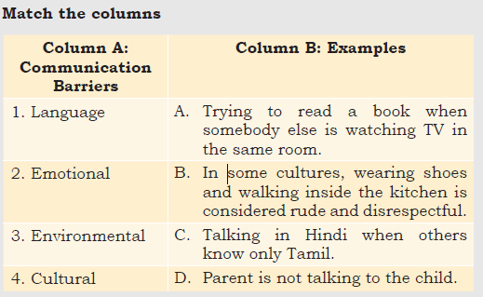

- Short answer question:
- Write down the seven factors affecting perspectives in communication.
Give an example of the following:
- Clear communication
- Complete communication

SESSION 2
- A. Multiple choice questions
Read the questions carefully and circle the letter (a), (b), (c) or (d) that best answers the question.
- Choose the correct example of oral communication.
- Reports
- Newspapers
- Face-to-face conversation
- Notes
- When we communicate verbally, we should use _______.
- difficult words | - simple words | - confusing words | - abbreviations
- Why do we send emails?
- To reach on time
- To share documents and files
- To talk to each other
- To meet each other
- Short answer question:
- Write down the different types of verbal communication. Give an example for each type.

SESSION 3
  - Multiple choice questions
Read the questions carefully and circle the letter (a), (b), (c) or (d) that best answers the question.
- Which of these is a positive (good) facial expression?
- Staring hard
- Nodding while listening
- Wrinkled forehead
- Looking away from the speaker
- What does an upright (straight) body posture convey/ show?
- Shyness
- Fear
- Confidence
- Intelligence
- Which of these is not an appropriate non-verbal communication at work?
- Putting arm around a coworker’s shoulder
- Shaking hands firmly
- Looking at the speaker with a smile
- Standing with an upright posture
- When you are preparing for a presentation, you should __________________.
- focus on the objectives of the presentation
- practice your speech in front of a mirror or friend
- do rehearsals to time your presentation of slides
- All of the above
  - Put a × mark against the actions below which are incorrect for demonstrating the use of non-verbal communication
- Laughing during formal communication
- Scratching head
- Smiling when speaking to a friend
- Nodding when you agree with something
- Standing straight
- Yawning while listening
- Sitting straight
- Maintaining eye contact while speaking
- Biting nails
- Firm handshake
- Clenching jaws
- Looking away when someone is speaking to you
- Intense stare
- Short answer question:
Give examples of any four common signs used for visual communication.

SESSION 4
- A. Multiple choice questions
Read the questions carefully and circle the letter (a), (b), (c) or (d) that best answers the question.
- What is a sentence?
- A group of ideas that form a complete paragraph.
- A group of words that communicate a complete thought.
- A set of rules that we must follow to write correctly.
- A set of words that contains all the basic punctuation marks

- Which of these sentences use uppercase letters correctly?
- I am Hungry.
- Divya and sunil are reading.
- The bucket is Full of water.
- She lives in Delhi.
3. Which of these sentences are punctuated correctly?
(a) Where are you going.
(b) I have a pen a notebook and a pencil.
(c) I am so happy to see you!
(d) This is Abdul’s house.
4. Underline the noun, pronoun, adjective, verb and adverb in these sentences.
(a) Sanjay plays football every day.
(b) Divya gave him new books.
(c) I opened the red box carefully.

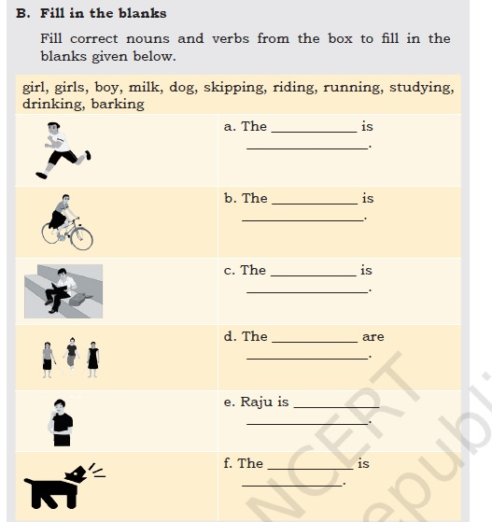

SESSION 5
- A. Multiple choice questions
Read the questions carefully and circle the letter (a), (b), (c) or (d) that best answers the question.
- Identify the subject in the sentence, “The children played football.”
- The children
- Children played
- Played
- Football
- Identify the object in the sentence, “The children played football.”
- The children
- Children played
- Played
- Football
- Which of these sentences has both indirect and direct objects?
- I am watching TV.
- She bought a blue pen.
- The girls played cricket.
- He wrote his sister a letter.
- Which of these sentences is in passive voice?
- They are watching a movie.
- The clock was repaired by Raju.
- He is sleeping in the room.
- My pet dog bit the postman.
B. Short answer questions
- Write one sentence of each type—statement, question, exclamatory and order.
- Which is your favourite festival? Write two paragraphs about your favourite festival. Each paragraph should have a minimum of four sentences. Make sure you follow all the rules about sentences and paragraphs you have learnt.
- Practice speaking correct sentences with your classmates. Try and find the parts of sentences which you use commonly.

