[COMMUNICATION SKILLS]
| SUBJECT NAME| IT #402 HOME ASSIGNMENT

Chapter- 1

COMMUNICATION SKILLS-II
SESSION 1
A. Multiple choice questions
Read the questions carefully and circle the letter(s) (a), (b), (c) or (d) that best answer(s) the question. (Note: There can be more than one correct choice)
1. Which of the following is NOT an element of communication within the communication process cycle?
(a) Channel
(b) Receiver
(c) Sender
(d) Time
2. You need to apply leave at work? Which method of communication will you use?
(a) e-mail
(b) Poster
(c) Newsletter
(d) Blog
3. By which action can senders send their messages?
(a) Gestures
(b) Speaking
(c) Reading
(d) Writing
B. Subjective question
1. Make a chart highlighting all the methods of communication. Use markers and colours to highlight differences amongst all.

SESSION 2
A. Multiple choice questions
Read the questions carefully and circle the letter (a), (b), (c) or (d) that best answers the questions.
1. Which of the following is an example of oral
communication?
(a) Newspapers
(b) Letters
(c) Phone call

(d) e-mail
2. What are the types of words we should use for
verbal communication?
(a) Acronyms
(b) Simple
(c) Technical
(d) Jargons
3. Why do we use e-mails?
(a) To communicate with many people at the same time.
(b) To share documents and files.
(c) To talk to each other in real-time.
(d) To keep a record of communication.
B. Subjective question
1. List the different types of verbal communication.
Include examples for each verbal communication type.

SESSION 3
A. Multiple choice questions
Read the questions carefully and circle the letter (a), (b), (c) or (d) that best answers the question.
1. Which of these is a positive (good) facial expression?
(a) Frowning while concentrating
(b) Maintaining eye contact
(c) Smiling continuously
(d) Rolling up your eyes
2. What does an upright (straight) body posture convey
or show?
(a) Pride
(b) Professionalism
(c) Confidence
(d) Humility
3. Which of these is NOT an appropriate non-verbal
communication at work?
(a) Keeping hands in pockets while talking
(b) Talking at moderate speed
(c) Sitting straight
(d) Tilting head a bit to listen
4. Which of the following statement is true about communication?
(a) 50% of our communication is non-verbal
(b) 20% communication is done using body movements, face, arms, etc.
(c) 5% communication is done using voice, tone, pauses, etc.
(d) 7% communication is done using words
5. Put a X mark against the actions below which are examples of bad non-verbal communication.
• Laughing during formal communication
• Scratching head
• Smiling when speaking to a friend
• Nodding when you agree with something
• Standing straight
• Yawning while listening
• Sitting straight
• Maintaining eye contact while speaking
• Biting nails
• Firm Handshake
• Clenching jaws
• Looking away when someone is speaking to you
• Intense stare
B. Subjective question
1. Draw any five common signs used for Visual Communication. Explain what each conveys and where did you see it?

SESSION 4
A. Multiple choice questions
Read the questions carefully and circle the letter (a), (b),(c) or (d) that best answers the question.
1. Which of these are examples of positive feedback?
(a) Excellent, your work has improved.
(b) I noticed your dedication towards the project.
(c) You are always doing it the wrong way.
(d) All of the above
2. Which of these are examples of negative feedback?
(a) I hate to tell you this but your drawing skills are poor.
(b) You can surely improve your drawing.
(c) This is a good drawing but you can do better.
(d) None of the above
3. Which of the following are effective components of a good
feedback?
(a) Detailed and time consuming
(b) Direct and honest
(c) Specific
(d) Opinion-based
B. Subjective question
1. What do you mean by feedback?

SESSION 5
- Multiple choice questions
- Read the questions carefully and circle the letter (a), (b), (c) or (d) that best answers the question.
- Which of these is NOT a common communication barrier?
- Linguistic barrier
- Interpersonal barrier
- Financial barrier
- Organisational barrier
- Which of these are ways to overcome communication barriers?
- Respecting each other’s differences
- Using a translator
- Not communicating at all
- Using your own language for comfort
- Subjective question
- Write down the common communication barriers you may come across when you move to a new city or country.

SESSION 6
- A. Multiple choice questions
Read the questions carefully and circle the letter (a), (b), (c) or (d) that best answers the question.
1. In which of the following, the underlined word is
an adjective?
(a) Radha has a red dress.
(b) I can speak French.
(c) The Girl on the Train is a best-seller.
(d) Abdul can swim fast.
2. Which of these sentences is capitalised correctly?
(a) Ravi and i are going to the movies.
(b) Salim is visiting India in july.
(c) The Tiger is a strong animal.
(d) She is arriving on Monday.
3. Which of these sentences are punctuated correctly?
(a) When is the party.
(b) I had bread omelette and a Banana for breakfast.
(c) I am so excited about my first foreign trip!
(d) This is Abdul’s notebook.
4. In which of these sentences can you find an adverb?
(a) Divya drinks milk every day.
(b) Sanjay gifted me a new pen.
(c) I opened the door lock.
(d) Sita is 5-feet tall.

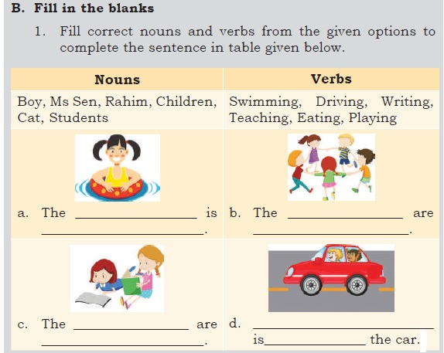
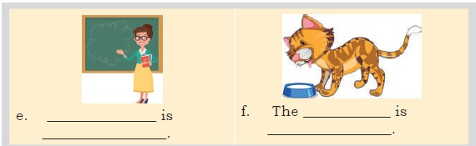
- . Subjective question
1. Identify the conjunctions and prepositions from the list
below and write these in the correct box.
Over, Because, Under, And, Since, In, At, Although, Or, Up,On, Beside
Conjunction | Preposition

SESSION 7
- A. Multiple choice questions
Read the questions carefully and circle the letter (a), (b), (c) or (d) that best answers the question.
- Identify the subject in the sentence, “The children played football.”
- The children
- Children played
- Played
- Football
- Identify the object in the sentence, “The children played football.”
- The children
- Children played
- Played
- Football
- Which of these sentences has both indirect and direct objects?
- I am watching TV.
- She bought a blue pen.
- The girls played cricket.
- He wrote his sister a letter.
- Which of these sentences is in passive voice?
- They are watching a movie.
- The clock was repaired by Raju.
- He is sleeping in the room.
- My pet dog bit the postman
- Identify the object, verb and subject in the sentence, ‘The car crashed into a tree.’
(a) Object: a tree; Verb: crashed; Subject: the car
(b) Object: The car; Verb: crashed; Subject: a tree
(c) Object: crashed; Verb: the tree; Subject: the car
(d) Object: crashed; Verb: the car; Subject: the tree
- Identify the indirect object in the sentence, ‘The band played music for the audience.’
(a) The band
(b) played
(c) music
(d) audience
B. Short answer questions
  - Write one sentence of each type—statement, question, exclamatory and order.
  - Which is your favourite festival? Write two paragraphs about your favourite festival. Each paragraph should have a minimum of four sentences. Make sure you follow all the rules about sentences and paragraphs you have learnt.
  - Practice speaking correct sentences with your classmates. Try and find the parts of sentences which you use commonly.
- Subjective questions
1. Write two sentences of each type of sentence — statement, question, exclamatory and order.
2. Which is your favourite food, dish or cuisine? Write two paragraphs about your favourite food, dish or cuisine. Each paragraph should have a minimum of five sentences. Make sure you follow all the rules about sentences and paragraphs you have learnt.
3. Practice speaking in active and passive voice with your classmates. Also, try to identify the different parts of sentences while you speak.

