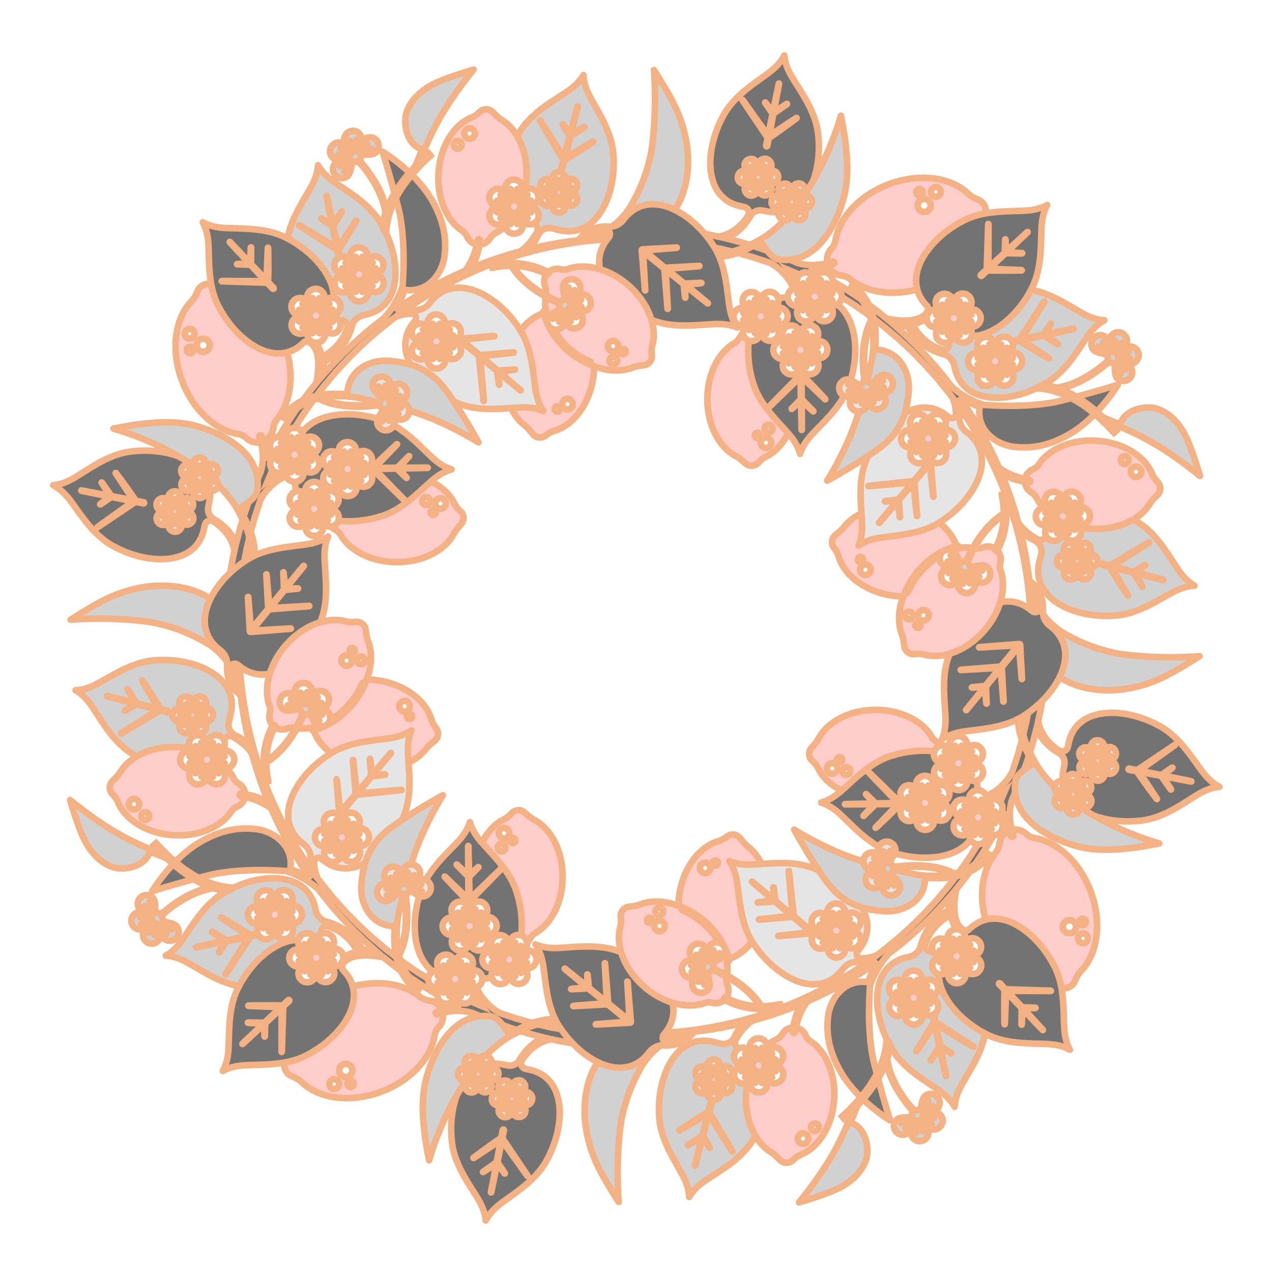

Write a character sketch of Albert Einstein as given in the chapter ‘A Truly Beautiful Mind’.

