DATE: -06/10/21 CLASS-X
HOME-WORK
GEOGRAPHY
MAP BASED QUESTIONS

- Major soil types (identification only)
- Dams: 1. Salal 2. Bhakra Nangal 3. Tehri 4. Rana Pratap Sagar 5. Sardar Sarovar 6. Hirakud 7. Nagarjuna Sagar 8. Tungabhadra

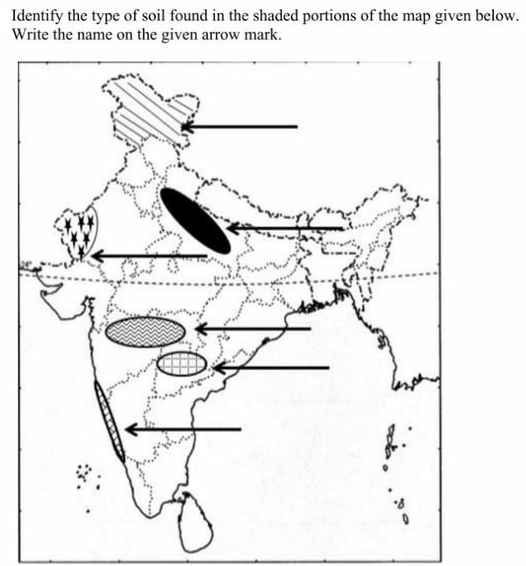

- Identify the soils marked in numbers: -

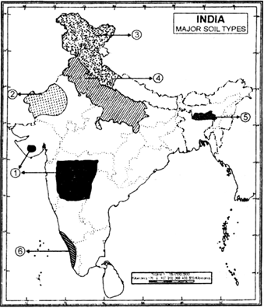

- Identify the soils: -
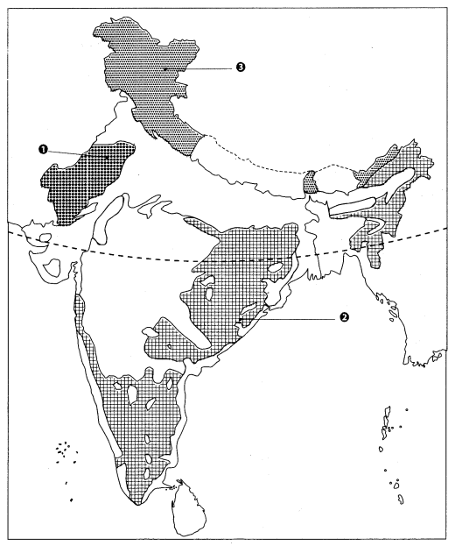

- Identify Dam located as (a) and (b)
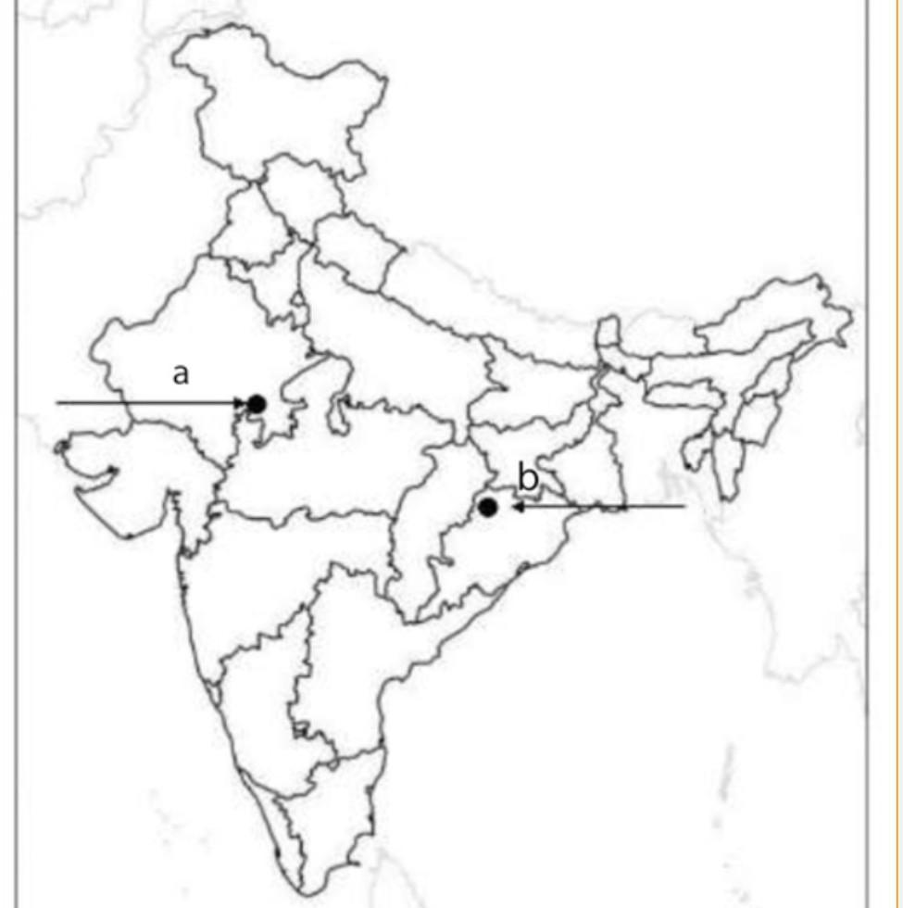

- Match COLUMN A with COLUMN B AND C from the following table: -
Name of the Dam (A) | Name of the River(B) | Name of the State(C )
HIRAKUD | CHENAB | HIMACHAL PRADESH
BHAKHRA NANGAL | KRISHNA | TELANGANA
NAGARJUNA SAGAR | SATLUJ | ODISHA
SALAL | MAHANADI | RAJASTHAN
SARDAR SAROVAR | TUNGABHADRA | JAMMU AND KASHMIR
TEHRI | CHAMBAL | KARNATAKA
RANAPRATAP SAGAR | NARMADA | UTTARAKHAND
TUNGABHADRA | BHAGIRATHI | GUJARAT

- Identify the dam:
- Built under Indus water treaty
- First hydropower plant of the state
- Run-of-the river hydropower project

- Identify the dam:
- Concrete gravity dam
- Dam forms the Gobinda sagar reservoir
- Third largest reservoir in terms of water quantity

- Identify the dam:
- Highest dam in India
- Rock-earth fill embankment dam
- On one of the headstream of the Ganga River.

- Identify the dam:
- Masonry dam across the Krishna River
- Border between Telangana and Andhra Pradesh
- Large infrastructure project under “Modern Temples”.

- Identify the dam:
- Multipurpose dam
- Across a tributary of the Krishna River
- Also known as Pampa Sagar

