DATE: -06/10/2021 CLASS-VIII
HOME-WORK
GEOGRAPHY
CH-4- MINERAL AND POWER RESOURCE
CH-5-AGRICULTURE

Q1. Write a short note Sedimentary Rocks with example. (3)

Q2. Give comparison between advantage and disadvantage of Wind Energy. (3)

Q3. Read the text: - (5)
Agriculture refers to the process of preparing the land for the cultivation of crops, and to the rearing of livestock. Agriculture (also cal1ed farming) is one of the oldest occupations known to humans. It is a primary activity. Nearly 50% of the people of the world are engaged in agriculture. In India, two-thirds of the people depend on agriculture directly or indirectly for their livelihood.

- Explain importance of Agriculture in day-today life? (2)
- Why agriculture is considered as a primary activity? (2)
- Name some festivals that celebrates agriculture in our country. (1)

Q4. Name important activities of a farmer with the help of the picture below: - (3)

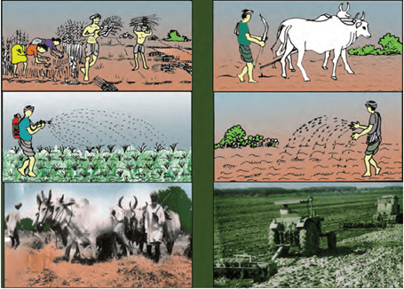

Q5. Read the extract: - (5)
In shifting cultivation, a small area of a forest is cleared by cutting down all the trees and the area is burned. The ashes are mixed with the soil to make it more fertile and this land is used for growing crops. After a couple of years, when the land becomes less fertile, it is abandoned.
Subsistence farming is carried out by farmers to satisfy the needs of their family alone. There is nothing left over for sale. They use simple methods and traditional tools in the field and do not use hired labour. Only the members of the household work on the field.
- Highlight routine of a farmer who is into shifting cultivation. (1)
- What values do you see in a farmer? (2)
- As per your opinion which method of farming is the best and why? (2)

