WORKSHEET
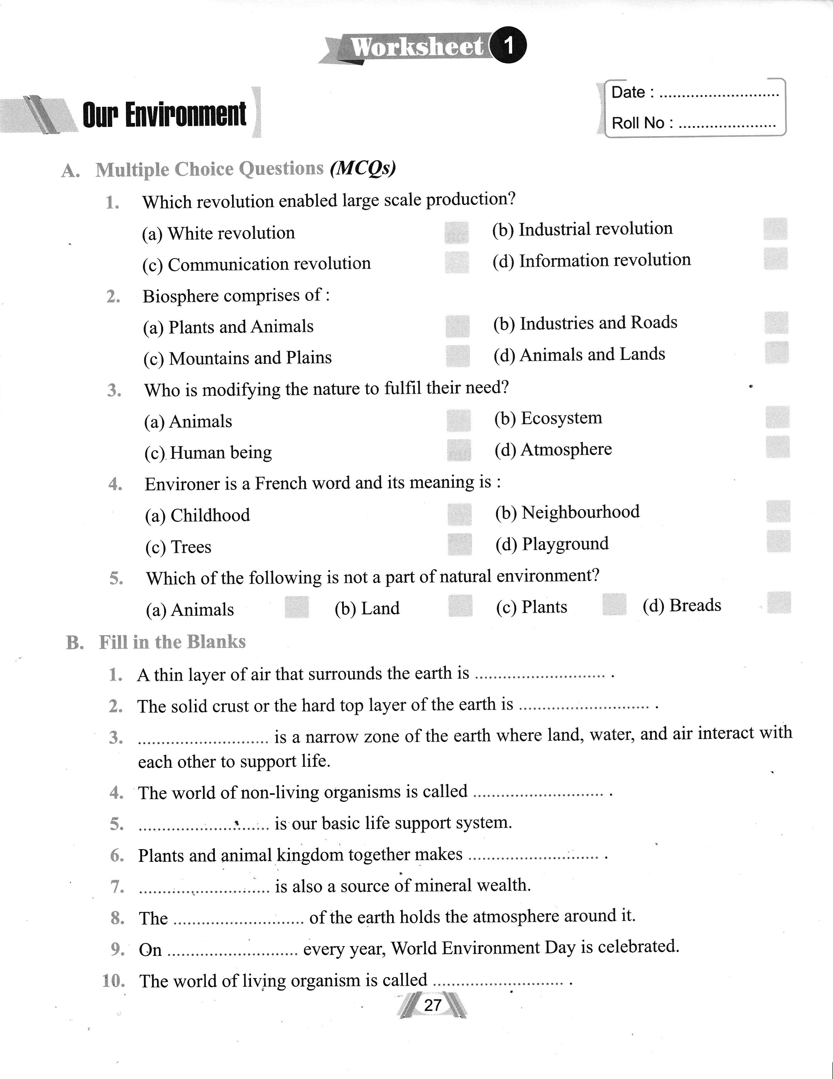
Chapter- 1
OUR ENVIRONMENT (1MARK EACH)

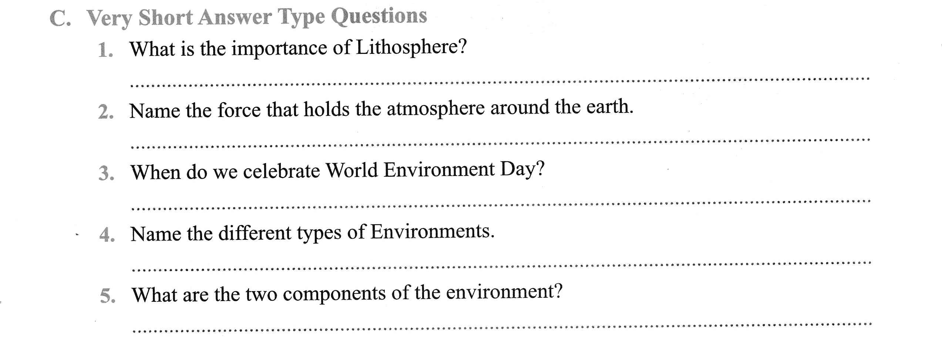
(2MARKS)

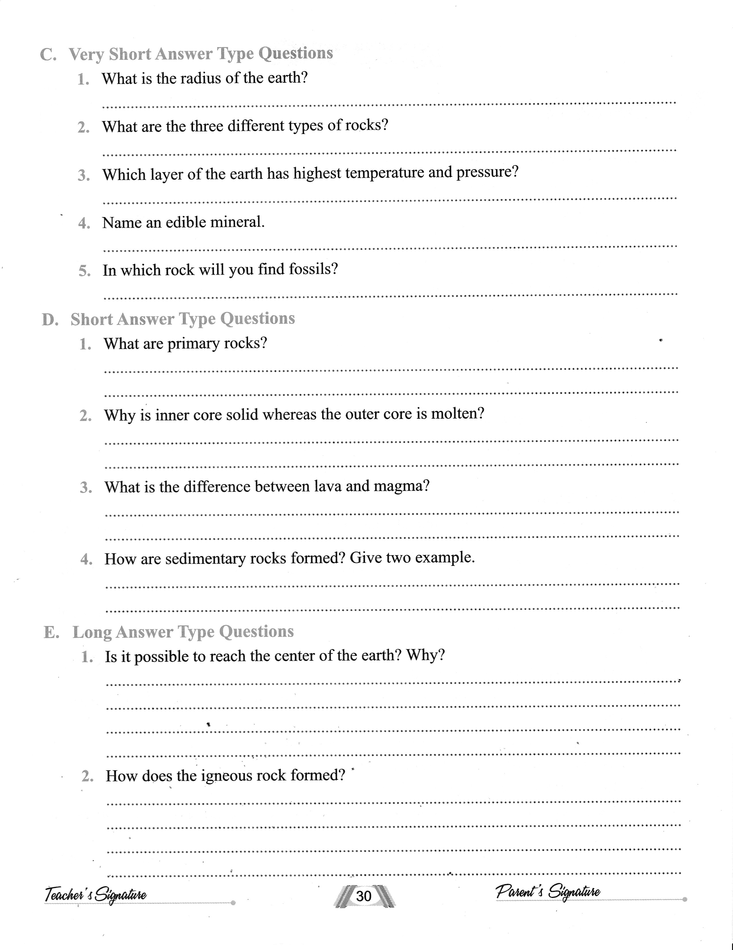
Chapter- 2
INTERIOR OF THE EARTH (C- 2MARK, D- 3MARK)

Chapter-3- Our Changing Earth
All questions are compulsory to answer: ( 1 mark each)
- The lithosphere is broken into a number of plates. What are these broken plates known as?
- In what motion does the molten magma move inside the Earth?
- What are the forces which act in the interior of the Earth called and give example?
- What are the forces which act on the surface of the Earth called and give example?
- Give example of Sudden forces and Diastrophic forces of Endogenic forces.
- The movement of Lithospheric plates causes them to vibrate. These vibrations can travel all round the earth and are known as earthquakes. Where this vibration does starts?
- What is the place on the surface above the focus called?
- What is the machine, through which the earthquake is measured, known as?
- Where should we take shelter during earthquakes?
- What do you mean by erosion and weathering?
- What are various agents of erosion?
- Which activity in a river erodes the landscape?
- What is formed when the river tumbles at steep angle over very hard rocks or down a steep valley side?
- What is formed as the river enters the plain and it twists and turns forming large bends?
- If meander loop cuts off from the river and forms a cut-off lake, what is it called?
- What type of floodplain is formed when river overflows its banks?
- What are the raised banks along floodplains called?
- What do you mean by distributaries?
- Explain delta with a diagram.
- What are the various erosional landforms of sea waves?
- What is a steep rocky coast rising almost vertically above the sea water is called?
- Which agent deposits sediments along the shore forming beaches?
- What are glaciers?
- The material carried by the glacier such as rocks, sand, silt etc gets deposited. What are these deposits called?
- What is the shape of rocks in the deserts?
- What are various landforms of desert area?
- Give reasons: ( 2 mark each)
- The speed of a river decreases as it approaches the sea.
- The lands around the floodplains are mostly fertile.
- Glaciers carve out deep hollows.
- Mushroom rocks are wider at the top and narrower at the bottom.
- The Earth and land under our feet, roads and buildings keeps moving all the time.

