CLASS 9: STORY WRITING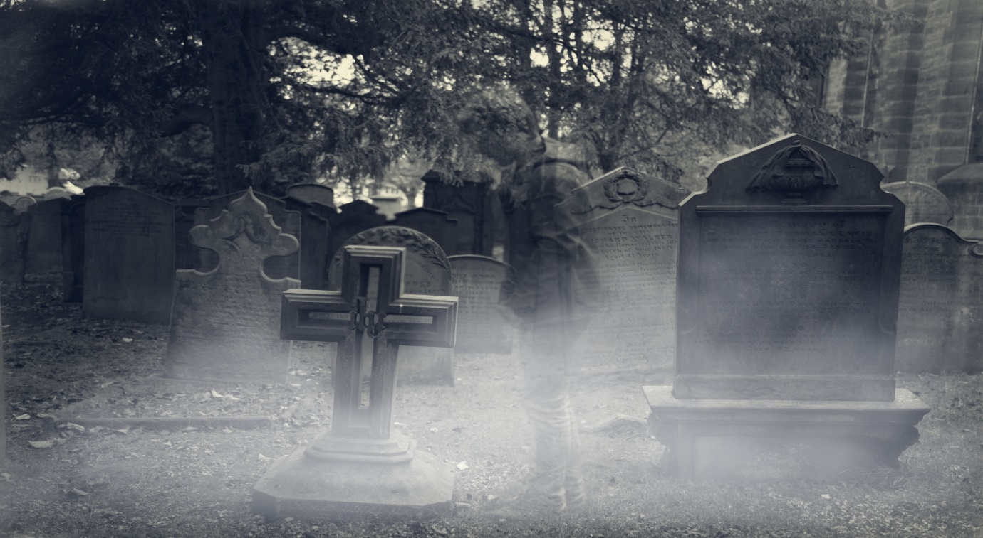



Use the pictures as inspiration to write a scary story. Bring out the horror elements in your description. Make the ghost the main character of your story. Write the assignment within 150 words.

