Major Landforms The landscape is being continuously worn away by two processes – weathering and erosion. Weathering: Weathering is the breaking up of the rocks on the earth’s surface. Erosion: Erosion is the wearing away of the landscape by different agents like water, wind and ice. The eroded material is carried away or transported by water, wind, etc. and eventually deposited.

This process of erosion and deposition creates different landforms on the surface of the earth
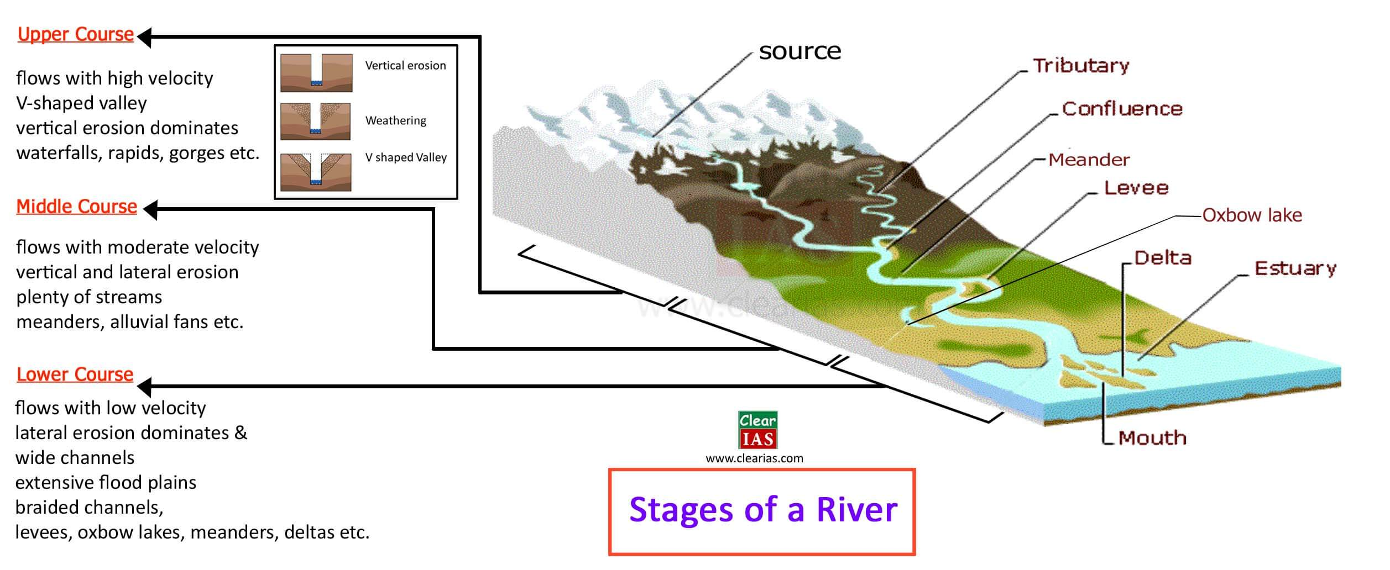
Erosion Activity –
Waterfall: When the river tumbles at steep angle over very hard rocks or down a steep valley side, it forms a waterfall.
Deposition: -
Meanders: As the river enters the plain it twists and turns forming large bends known as meanders. Cut-off Lake: Due to continuous erosion and deposition along the sides of the meander, the ends of the meander loop come closer and closer. In due course of time the meander loop cuts off from the river and forms a cut-off lake, also called an ox-bow lake.
Floodplain: As it floods, the river deposits layers of fine soil and other material called sediments along its banks. This leads to the formation of a flat fertile floodplain. The raised banks are called levees.
Distributaries: When the river approaches the sea, the speed of the flowing water decreases and the river begins to break up into a number of streams called distributaries.
Delta: The river becomes so slow that it begins to deposit its load. Each distributary forms its own mouth. The collection of sediments from all the mouths forms a delta.
Estuary: -
1. The sharp-edged mouth of rivers, devoid of any deposits is known as Estuary.
2. Regions of high tides and rift valleys witness Estuaries.
3. Estuary does not have fertile lands.
4. Narmada and Tapi rivers form Estuaries.

