Question 1.
Read the passage given below. Fill in the blanks by choosing the most appropriate word/phrases from the given options. (3 marks)
One of the (a)_____ problems facing the world today is global warming. Many scientists believe that our production of carbon dioxide and other greenhouse gases is having a heating effect on the atmosphere and this (b)_____ be very dangerous for human life. We (c)____ examine the problem of global warming and suggest some ways of solving it.
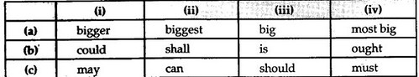
Question 2.
What we call life is a very complex affair. It is not simply eating, reproducing and finally dying. Every creature(a)_____these. Man has to lead a highly complicated life. It is like (b)_____ through a maze and coming out. He is an economic being and a social animal. He has to earn, make a home, look after his people and attend (c)_____ his obligations to the society and the Government. So, in order to be successful he has to develop certain qualities.
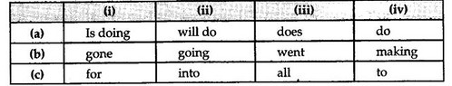
Question 3.
Fill in the blanks with the help of options that follow: (3 marks) (Board Term-12013, Set 5007)
Before alighting, the Wild Pigeon, like the Carolina Parrot and a few other species of birds, breaks die force of its flight by repeated flapping, (a)______ (so/although/even/as if) apprehensive of receiving injury from coming too suddenly (b)______(with/in/inside/at) contact, either with the branch, (c)_______(or/and/neither/nor) the spot of ground on which it intends to settle.
Question 4.
High school is a critical time in the life of young people. On (a) ______(a/the/an/no article) one hand, teenagers are eager to enjoy their freedom and independence, while on the other hand, they must be disciplined enough to keep (b)________(their/ the/our/ there) priorities straight. In my opinion, the family, the peer group and the school impact high school students the (c)______(best/highest/most/maximum) at this vulnerable time.

