GEOGRAPHY WORKSHEET
STD VI
NOTES
- Revolution
  - Earth’s Orbit
- Seasons
  - Solstice- Summer and Winter Solstice
  - Equinoxes- Spring and Autumn Equinox
REVOLUTION OF THE EARTH
- While the Earth spins on its axis, it also goes around the Sun. This movement of the Earth around the Sun is called revolution.
- It takes 365 days or one year to complete the revolution. It follows a path called the orbit. The orbit is not circular but oval or elliptical in shape.
- When the distance between the Earth and the Sun varies from a minimum of roughly 147 million km in January, is called the Perihelion.
- When the distance varies to a maximum of roughly 152 million km in early July, called the Aphelion.
- The plane in which the Earth goes around the Sun is called the ecliptic.
EFFECTS OF THE EARTH’S REVOLUTION
- Revolution of the Earth, along with the tilt in the Earth’s axis, causes:-
- Varying lengths of day and night
- Changing seasons.
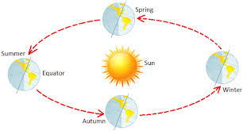
VARYING LENGTHS OF DAY AND NIGHT
- The Earth is tilted on its axis, due to this tilt the pattern of light falling on the Earth is different.
- For the half year, the Northern Hemisphere faces the Sun, while for the next six months, the Southern Hemisphere faces the Sun.
- A larger part of the hemisphere that faces the Sun gets sunlight. This means that the hemisphere facing the Sun gets longer days and shorter nights.
- At the equator, the days and nights are of equal length.

THE CHANGING SEASONS
- The movement of the Earth along its position which changes the amount of the sunlight falling on it.
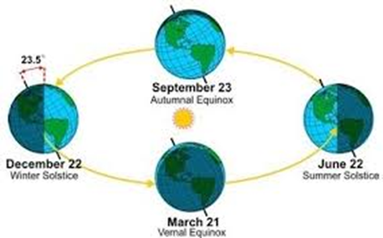
- When the Northern Hemisphere is closer towards the Sun it is summer there. The Southern Hemisphere enjoys the winter season at the same time.

- When the Northern Hemisphere is further from the Sun as compared to the Southern Hemisphere, then it is winter in the Northern Hemisphere and summer in the Southern Hemisphere.
- In between the season of summer and winter, when the Earth’s position is changing, we have the spring and the autumn season.

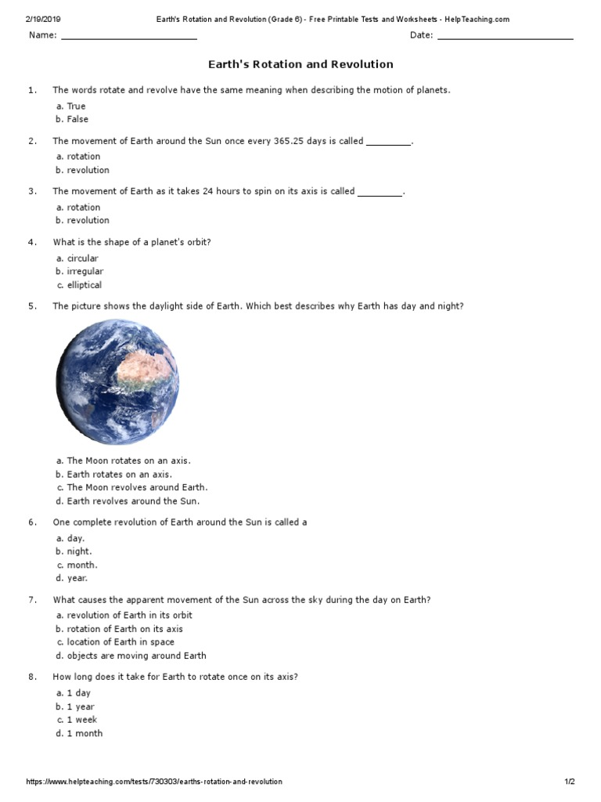
WORKSHEET

