Time: 1 hrs. 30min F.M.-40
- This question paper contains 3 sections.
- Section –A and Section –B is consists of 20 questions each out of which any 16 questions are to be answered from each sections.
- Section –C consists of 2 case based questions.
Students needs to answer 4 questions out of the 5 questions given in each case studies questions.
_____________________________________________________________________________________________
(Section –A)

- Decimal representation or a rational number cannot be
- terminating (b) non-terminating
- Non-terminating repeating (d) non-terminating non-repeating
- The difference of a rational number and an irrational number is
- an integer
- may be a rational number
- always a rational number
- always an irrational number
- The number obtained on rationalizing the donominator of $\frac{1}{\sqrt{7}-2}$ is
- $\frac{\sqrt{7}+2}{3}$ (b) $\frac{\sqrt{7}-2}{3}$ (c) $\frac{\sqrt{7}+2}{5}$ (d) $\frac{\sqrt{7}+2}{45}$
- The value of 0.1$\overline{34}$ is
- $\frac{33}{90}$ (b) $\frac{13}{99}$ (c) $\frac{133}{990}$ (d) $\frac{233}{990}$
- The value of 0.6 + 0.$\overline{7}$ + 0.4$\overline{7}$ in the form $\frac{p}{q}$, where p and q are integers and q ≠ 0, is
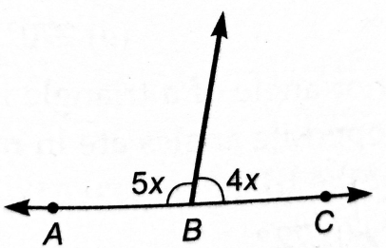
- $\frac{167}{90}$ (b) $\frac{90}{167}$ (c) $\frac{67}{90}$ (d) $\frac{67}{190}$
- In the given figure, the value of x is
- 80⁰ (b) 20⁰ (c) 40⁰ (d) 60⁰
- If the interior angles on the same side of a transversal intersecting two parallel lines are in the ratio 2 : 3, then the greater of the two angles is
- 54⁰ (b) 108⁰ (c) 120⁰ (d) 136⁰

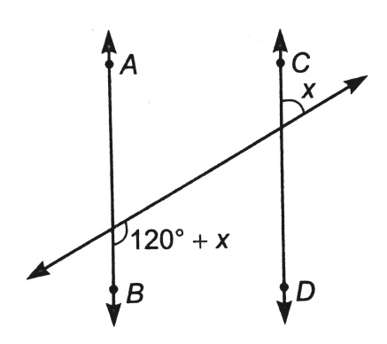
- In the given figure, if AB||CD, then the value of x is

- 20⁰ (b) 30⁰ (c) 45⁰ (d) 60⁰
- Angle of a triangle are in the ratio 2 : 4 : 3. The smallest angle of the triangle is
- 60⁰ (b) 40⁰ (c) 80⁰ (d) 20⁰
- One angle of a triangle is 65⁰. The remaining two angles, if their difference is 25⁰, are
- 70⁰, 45⁰ (b) 60⁰, 35⁰
(c) 75⁰, 50⁰ (d) 65⁰, 40⁰
- An exterior angle of a triangle is 108⁰ and its interior opposite angles are in ratio 4 : 5. The angles of the triangle are
- 48⁰, 60⁰, 72⁰ (b) 50⁰, 60⁰, 70⁰ (c) 52⁰, 60⁰, 70⁰ (d) 42⁰, 60⁰, 76⁰
- In a Δ ABC, the internal bisector of ∠B and ∠C meet at P and the external bisectors of ∠B and ∠C meet at Q, then the value of ∠BPC + ∠BQC is
- 90⁰ (b) 180⁰ (c) 270⁰ (d) 360⁰
- In Δ ABC$≅$ ΔPQR and ΔABC is not congruent to ΔRPQ, then which of the following is not true:
- BC=PQ (b) AC= PR (c) QR= BC (d) AB= PQ
- In a triangles ABC and PQR, if ∠A = ∠R, ∠B = ∠P and AB= RP, then which one of the following congruency criteria can be used?
- SAS (b) ASA (c) SSS (d) RHS
- In triangles ABC and PQR, AB = QP, ∠B = ∠P and BC= QR. The two triangles will be congruent by axiom
- SAS (b) ASA (c) SSS (d) RHS
- In Δ ABC, the altitude AD, BE and CF are equal. Then Δ ABC is
- an acute angled triangle
- a right angled triangle
- a right angled isosceles triangle
- an equilateral triangle
- If Δ ABC is an isosceles triangle, then which is the following is not true.
- bisector of ∠BAC ⊥ BC (b)altitude AD bisects ∠BAC
(c) altitude BE = altitude CF (d) all the three altitudes are equal
- In Δ ABC, BC= AB and ∠B = 80⁰. Then ∠A is equal to
- 80⁰ (b) 40⁰ (c) 50⁰ (d) 100⁰
- Ordinate of all points on the x-axis is
- 0 (b) 1 (c) -1 (d) any number
- The points in which abscissa and ordinate have different signs will lie in
- I and II quadrants (b) II and III quadrants
(c) I and III quadrant (d) II and IV quadrants
(Section –B)
- Point (−3,5) lies in the
- first quadrant (b) second quadrant
(c) third quadrant (d) fourth quadrant
- Point (−10,0) lies
- on the negative direction of the x-axis
- on the negative direction of the y-axis
- in the third quadrant
- in the fourth quadrant
- The point whose ordinate is 4 and which lies on y-axis is
- (4, 0) (b) (0,4) (c) (1, 4) (d) (4, 2)
- If the perpendicular distance of a point P from the x-axis is 15 units and the foot of the perpendicular lies on the negative direction of x-axis, then the point P has
- x-coordinate = −5
- y-coordinate = 5 only
- y-coordinate = −5 only
- y-coordinate = 5 or −5
- If two sides of a right angle triangle are 5 cm and 12 cm, then the third side is
- 17 cm. (b) 13 cm. (c) 4 cm. (d) 7 cm.
- An isosceles right triangle has area 8 cm². The length of its hypotenuse is
- $\sqrt{32}$ cm (b) $\sqrt{16}$ cm (c) $\sqrt{48}$ cm (d) $\sqrt{24}$ cm

- The adjacent sides of a parallelogram are 20 cm and 15 cm in length. Then the ratio of the corresponding altitudes is
- 1 : 2 (b) 2 : 3 (c) 3 : 4 (d) 4 : 3
- The sides of a triangles are 56 cm., 60cm and 52 cm long. Then the area of the triangle is
- 1322 cm² (b) 1311 cm²
(c) 1344 cm² (d) 1392 cm²
- The edges of a triangular board are 6 cm, 8 cm and 10 cm. The cost of painting at the rate of 9 paise per cm² is
- Rs. 2.00 (b) Rs. 2.16 (c) Rs. 2.48 (d) Rs. 3.00
- The sides of a triangle are 35 cm, 54 cm and 61 cm, respectively. The length of its longest altitude is
- 16$\sqrt{5}$ (b) 10$\sqrt{5}$ (c) 24$\sqrt{5}$ (d) 28 cm.
- A linear equation in two variable is of the form ax + by + c = 0, where
- a ≠ 0, b ≠ 0 (b) a = 0, b ≠ 0
(c) a ≠ 0, b = 0 (d) a=0, b =0
- The linear equation 2x − 5y = 7 has
- a unique solution (b) two solutions
(c) infinitely many solutions (d) no solution
- The equation 2x + 5y =7 has a unique solution, if x, y are
- natural numbers (b) positive real numbers
(c) real numbers (d) rational numbers
- if (2, 0) is a solution of the linear equation 2x + 3y =k, then the value of k is
- 4 (b) 6 (c) 5 (d) 2
- The graph of the linear equation 2x + 3y =6 cuts the y-axis at the point
- (2, 0) (b) (0, 3) (c) (3, 0) (d) (0, 2)
- The equation of x-axis is of the form
- x = 0 (b) y =0 (c) x +y =0 (d) x =y
- In the class intervals 10 − 20, 20 − 30, the number 20 is included in
- 10 − 20 (b) 20 − 30
(c) both the intervals (d) none of these
- Given the class intervals 1-10, 11-20, 21-30,…… then 20 is considered in the class
- 11-20 (b) 11-30 (c) 21-30 (d) 15-25
- The class mark of a particular class is 6.5 and class size is 3. Then the corresponding class is

- 3.5 - 6.5 (b) 6.5 -9.5 (c) 5⋅8 (d) 4⋅7
- A person is asked to collect information about the percentage of students passed during the last 5 years in class 10th examination of CBSE, the data so collected is known as
- primary data (b) secondary data
(c) frequency data (d) raw data

Case Study based-1:
Any equation of the form ax + by + c =0, where a, b and c are real numbers and a ≠ 0, b ≠ 0 is known as a linear equation in two variables.
One day Ram and Ankur go to a stationary shop to purchase some stationary. The shopkeeper tells them that cost of a notebook is 3 times of the cost of a pen.

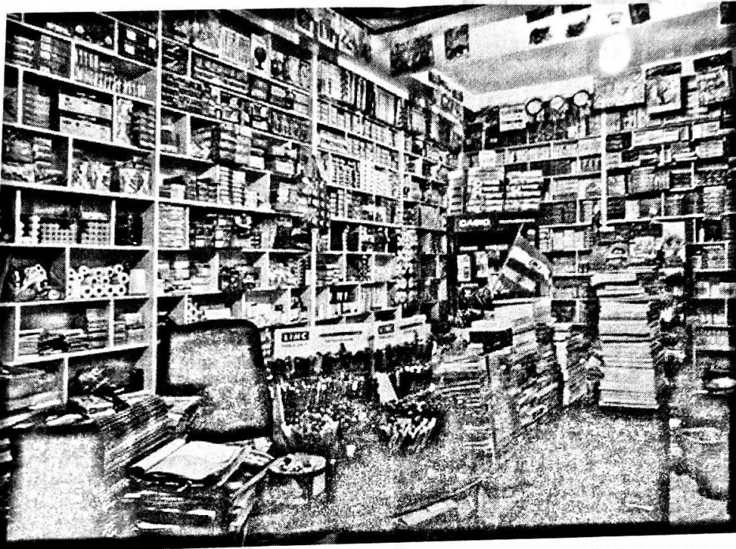
Using the information given above, answer the following questions:

- If cost of a notebook is x and that of a pen is y, then the linear
equation in two variables to represent the given statement is
- 3x =y (ii) x − 3y =0
(iii) x + 3y =0 (iv) 3x + y =0
- One solution of equation 2x − 3y = 5 is
- (4, 1) (ii) (1, 4)
(iii) (3, 2) (iv) (2, 3)
- If the cost of 1 note book is 15, then cost of 1 pen is
- 6 (ii) 10 (iii) 5 (iv) 15
- The linear equation y = 2x + 3 has
- a unique solution (ii) only three solutions
(iii) no solution (iv) infinitely many solutions
- If x = −1 and y = 3 is a solution of the equation 4x + 2y − k=0, then the value of k is
- 1 (ii) 0 (iii) 2 (iv) 3

Case Study based-2:
Given below is the data found on a group of school going students. Study the data and answer the questions that follow:

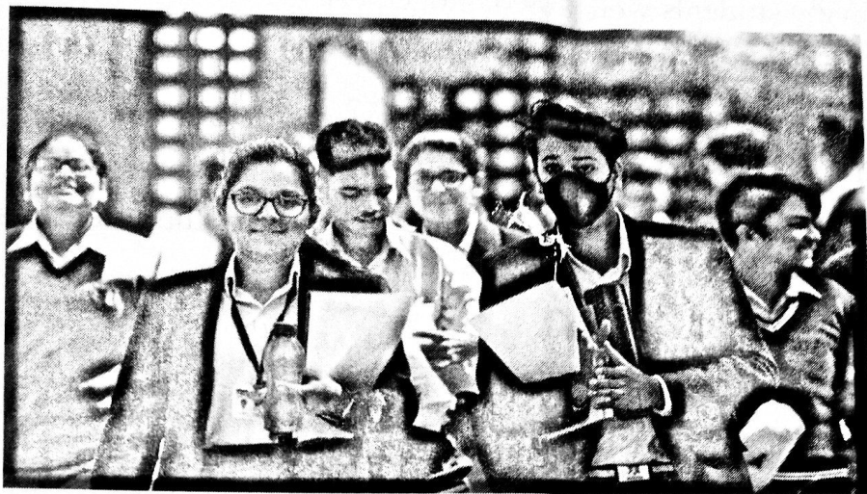
Height Intervals (in cms) | No. of students (F)
131−140 | 1
141−150 | 7
151−160 | 5
161−170 | 9
171−180 | 9
181−190 | 10
Total | 41

- Class size of the 3rd class interval is
- 8 (b) 9 (c) 9.5 (d) 10
- Upper limit of the 5th class interval is
- 180 (b) 170.5 (c) 180.5 (d) 179.5
- Class mark of the 6th class interval is
- 184.5 (b) 185 (c) 185.5 (d) 186
- How many students have their height more than 160 cm?
- 19 (b) 18 (c) 27 (d) 28
- How many students have their height less than or equal to 180 cm?
- 22 (b) 19 (c) 29 (d) 31

