LATITUDES AND LONGITUDES
Exercise
Answer the Following Question
- Define the globe.
Ans- Globe is a miniature form of the Earth.
- Draw a neat diagram showing the temperature zones of the Earth.
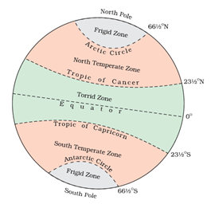
- What makes the torrid zone the hottest among the temperature zones?
The torrid zone lies between the Tropic of Cancer and Tropic of Capricorn. The sun is exactly over the head once a year, on all the latitudes between these two tropics. The sun rays falling exactly overhead gives out more heat than slanting sun rays. Therefore torrid zone the hottest among the temperature zones
4. Why is Bangladesh half an hour ahead of India?
Ans: Bangladesh standard time(BST) is technically GMT (+6:00). Indian standard time(IST) is usually GMT (+5:30) . So there is a 30 minute difference there.
- 'What is 'solar time’?
Solar time is based on the position of the sun. It is the time we all use where a day is defined as 24 hours, the average time that it takes for the sun to return to its highest point. Local noon in solar time is the moment when the sun is at its highest point in the sky.
6. Why is a standard meridian important for a country?
standard meridian is useful for a country because it shows and fixes a particular time for the country. A country may have many longitudes in between and there is a time gap of 4 minutes between each longitude. therefore standard meridian should be there in each country for the equal time.
7. How can we measure the time difference between countries? Explain, giving an example.
The earth has 360 imaginary lines called longitudes or meridians running vertically between the poles. Each of these longitudes is called a degree. The 0 degree longitude passing through Greenwich, near London, is considered as standard and the time of all other time zones are calculated accordingly. The time difference between each longitude (each degree) is 4 minutes. So if it is 12 noon at Greenwich (0 degree), it would be 12:04 pm at 1 degree meridian and so on. In India, the standard meridian is 82-and-half degree. So the time difference between Greenwich and India is 82.5 x 4, which is 330 minutes (5 hours 30 minutes).
8. How are the lines of latitude and longitude useful to us?
As lines of latitudes and longitudes cross each other, they form a grid. Any position on earth can be located if the latitude and longitude are known. The grids on the maps help us find a particular location. Longitudes also help us to calculate the time of a particular place

