Earthquake
All-natural earthquakes occur in the lithosphere.
- Seismic waves studies offer a full picture of the layered interior.
- An earthquake is, simply put, shaking of the earth’s crust.
- It is caused due to the energy release, which triggers waves that travel in all directions.
- The emanation of energy occurs along a fault.
- A fault is a sharp break in the crustal rocks.
Earthquake waves are of two types
P-waves are also known as the Primary waves. They are the first waves to arrive at the surface.
- S- Waves arrive after some time after the happening of earthquake and they are called secondary waves.
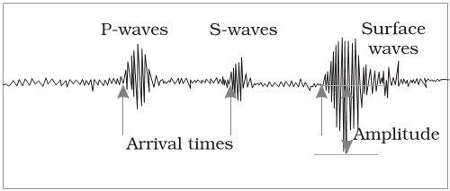
- All earthquakes are different in their intensity and magnitude. The instrument for the measurement of the vibrations is known as Seismograph
- Richter scale is used to measure the magnitude of the earthquake.

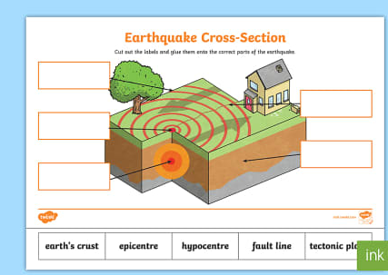
HOME WORK

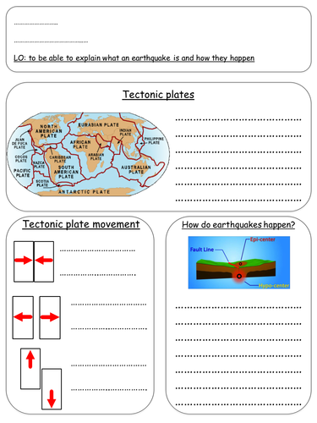

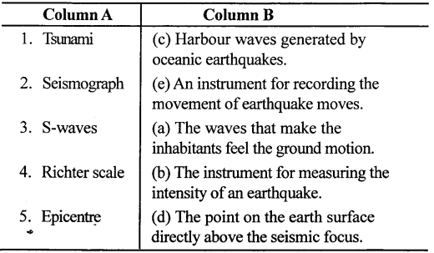

Volcano
Study Notes

What are Volcanoes?

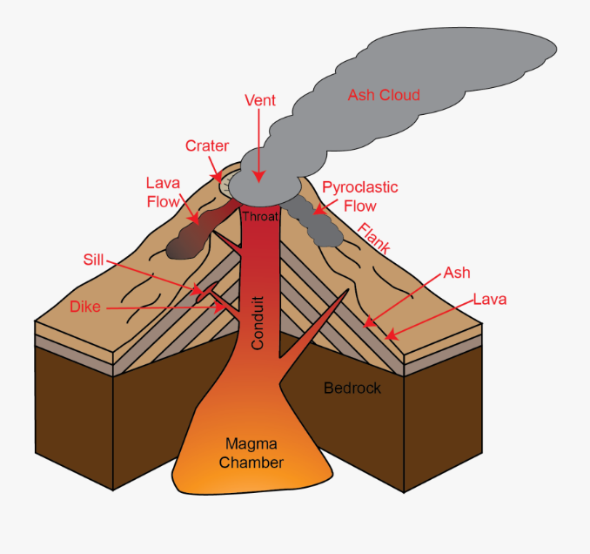
A volcano is a landform, a mountain, where molten rocks erupt through the surface of the planet. The volcano mountain opens downwards to a pool of molten rocks underneath the surface of the earth.

Pressure builds up in the earth’s crust and this is the reason why eruptions occur. Gases and igneous rocks shoot up and splash over or fill the air with lava fragments. The volcano eruption can cause hot ash, lateral blasts and lava flow, mudslides, and more.

Formation of Volcanoes:
A volcano mountain is formed by the surface eruption of magma from within the earth’s upper mantle. The magma that erupts to the surface and forms a lava flow that deposits ash. As the volcano continues to erupt, a new layer of lava is added to the surface accumulating to form a mountain.

Different Stages of Volcanoes:
They tend to be conical although there are a variety of forms, depending upon:
- The nature of the material erupted
- The type of eruption
- The amount of change since the eruption
Volcanoes are categorized into three main categories:
- Active Volcanoes: A volcano will be classified as an active volcano if at the present time it is expected to erupt or is erupting already.
- Dormant Volcanoes: The classification of volcanoes which is called dormant would be a volcano that is not erupting or predicted to erupt in the near future.
- Extinct Volcanoes: An extinct volcano is a volcano that no one expects will ever have another eruption.
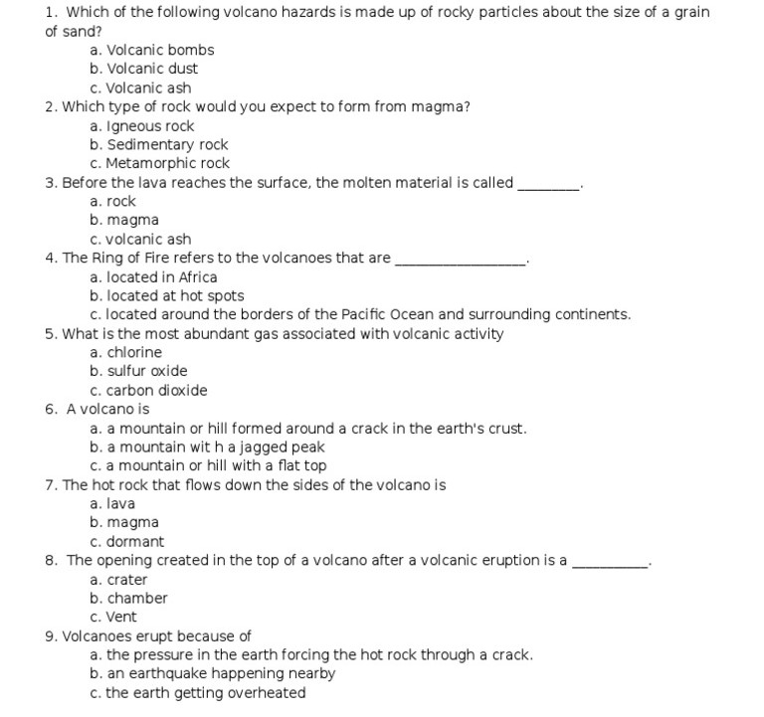
Worksheet

